A Comprehensive Measure of Well-Being

-Human Development Index (HDI) Prediction Using Machine Learning

Submitted By : Uma Puligedda
Internship : SmartBridge AI & ML Internship
Gmail :umapuligedda2023@gmail.com
College :SRKR Engineering College

Abstract:
The Human Development Index (HDI) is an important indicator used to measure the overall development of a country. It considers three major dimensions: health, education, and standard of living. Instead of relying only on economic growth, HDI provides a broader understanding of the quality of life experienced by people.
The objective of this project is to develop a machine learning model capable of predicting the HDI category of a country using indicators such as Life Expectancy, Expected Years of Schooling, Mean Years of Schooling, and Gross Income Per Capita.
Different machine learning algorithms, including Logistic Regression, Decision Tree, Random Forest, and K-Nearest Neighbors, were trained and evaluated. The best-performing model was deployed using the Flask web framework to create a user-friendly web application where users can input development indicators and receive the predicted HDI category.

Problem Statement
Evaluating a country's Human Development Index (HDI) involves analyzing multiple socioeconomic indicators such as health, education, and income. Manual analysis is time-consuming and requires statistical expertise. This project aims to develop a Machine Learning-based system that predicts the HDI category from key development indicators and provides fast, accurate, and user-friendly predictions through a Flask web application.
Many countries have different levels of development depending on their healthcare, education, and economic conditions.Traditional methods of evaluating HDI involve extensive statistical calculations.The objective of this project is to develop an intelligent prediction system capable of classifying countries into:
->Very High
->High
->Medium
->Low

Features:
The objectives of this project are:
To collect Human Development Index data.
To preprocess and clean the dataset.
To analyze relationships among development indicators.
To build multiple Machine Learning models.
To compare model performance.
To deploy the best model using Flask.
To create an easy-to-use web interface.

System Requirements

Hardware Requirements:
- Intel Core i3 Processor or above
- 4 GB RAM
- 10 GB Free Storage
- Internet Connection

Software Requirements:
- Windows 10/11
- Python 3.x
- Anaconda
- Jupyter Notebook
- Git and GitHub
- Flask
- Visual Studio Code

Technologies Used:
Python
Python is the primary programming language used for implementing Machine Learning algorithms.
Pandas
Used for data manipulation and preprocessing.
NumPy
Provides numerical computation support.
Matplotlib
Used for plotting graphs.
Seaborn
Used for statistical visualization.
Scikit-learn
Used for Machine Learning model development.
Flask
Used to deploy the prediction model as a web application.
HTML
Creates the user interface.
CSS
Improves the appearance of the application.
Git & GitHub
Used for version control and project management.

Installation Steps:
Follow the steps below to install and run the project.
Step 1: Install Python
Download and install Python 3.x from the official Python website.
Step 2: Install Anaconda (Optional)
Download and install Anaconda Navigator to simplify package management and use Jupyter Notebook.
Step 3: Create the Project Folder
Create a project directory named HDI_Prediction and organize the project files into appropriate folders such as dataset, model, templates, static, and notebooks.
Step 4: Install Required Libraries
Open Command Prompt or Anaconda Prompt and install the required Python packages:
pip install pandas numpy matplotlib seaborn scikit-learn flask joblib
Alternatively, if a requirements.txt file is available, install all dependencies using:
pip install -r requirements.txt
Step 5: Download the Dataset
Download the Human Development Report (HDR) dataset and place it inside the dataset folder.
Step 6: Train the Machine Learning Model
Run the Jupyter Notebook (HDI_Analysis.ipynb) or execute the training script (train_model.py) to preprocess the data, train the machine learning model, and generate the model.pkl and label_encoder.pkl files.
Step 7: Run the Flask Application
Navigate to the project directory and execute:
python app.py
Step 8: Open the Application
Open a web browser and visit:
http://127.0.0.1:5000
The HDI Prediction web application will be displayed and is ready for use.

Usage Instructions:
The Human Development Index Prediction application provides a simple interface for predicting the HDI category based on development indicators.
Step 1
Launch the Flask application by running:
python app.py
Step 2
Open the application in your browser:
http://127.0.0.1:5000
Step 3
Enter the following input values:
- Life Expectancy
- Expected Years of Schooling
- Mean Years of Schooling
- Gross Income Per Capita
Step 4
Click the Predict button.

Step 5
The machine learning model processes the input values and predicts one of the following Human Development categories:
- Very High
- High
- Medium
- Low
Step 6
The predicted HDI category is displayed on the result page. Users can click Predict Again to return to the input form and make another prediction.

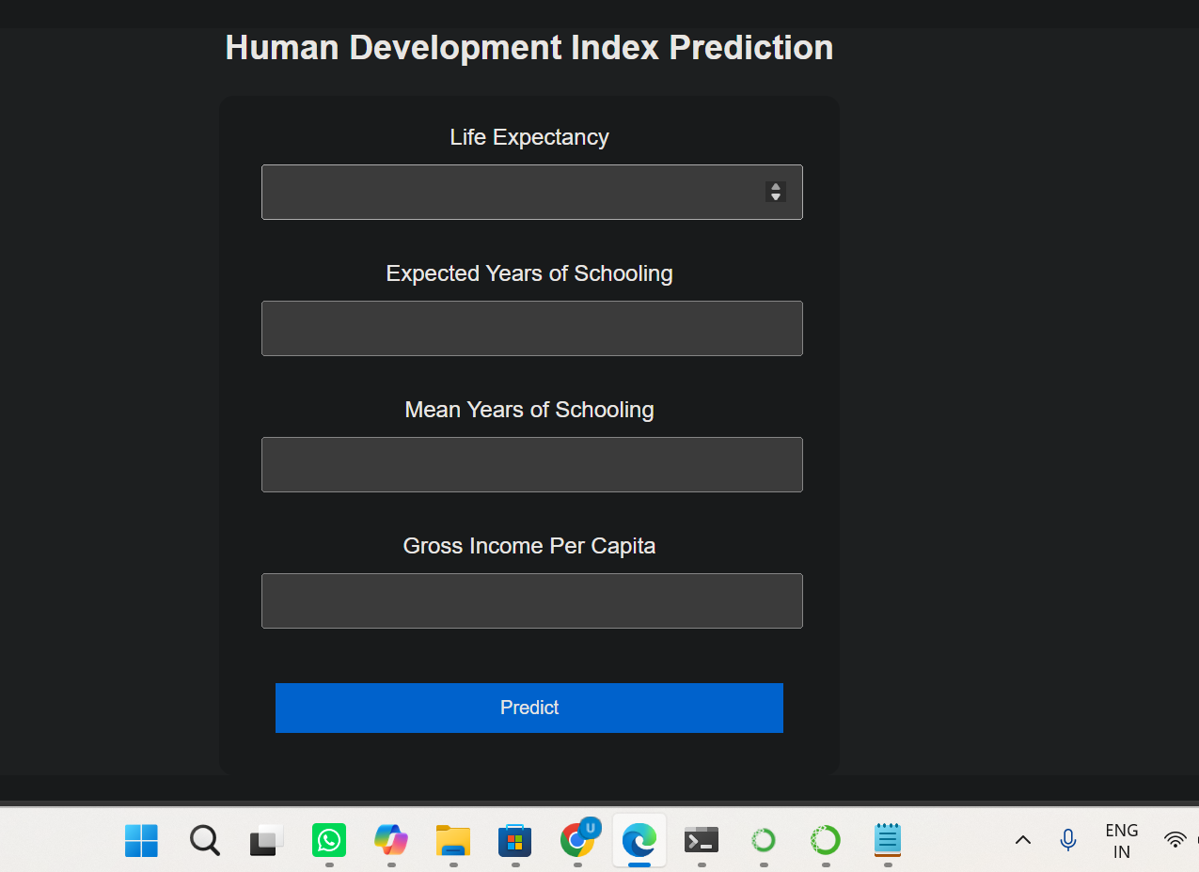
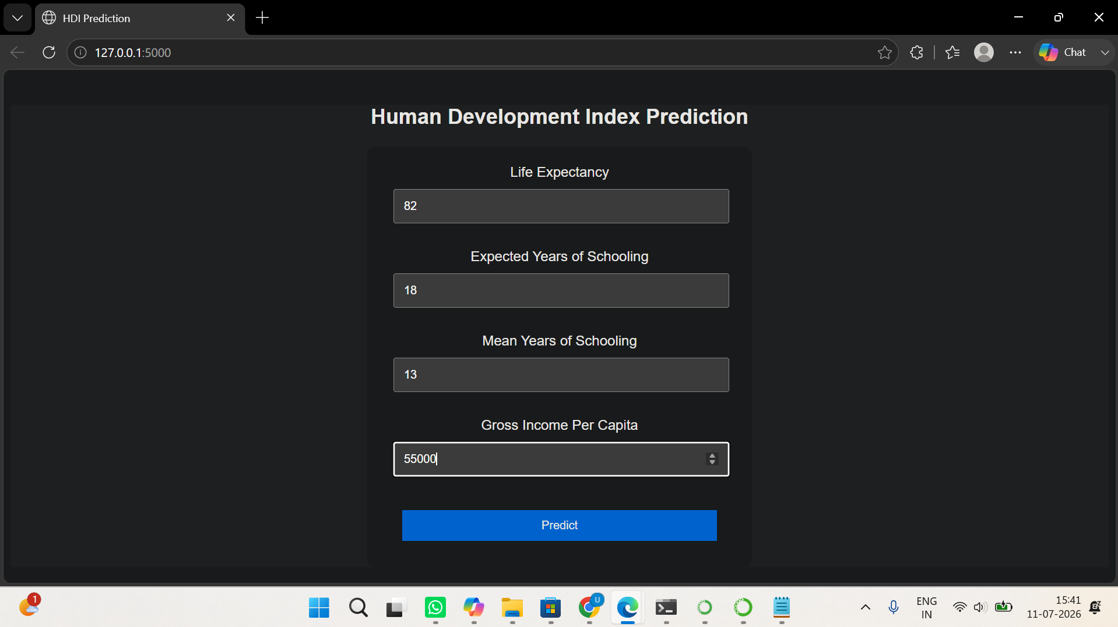
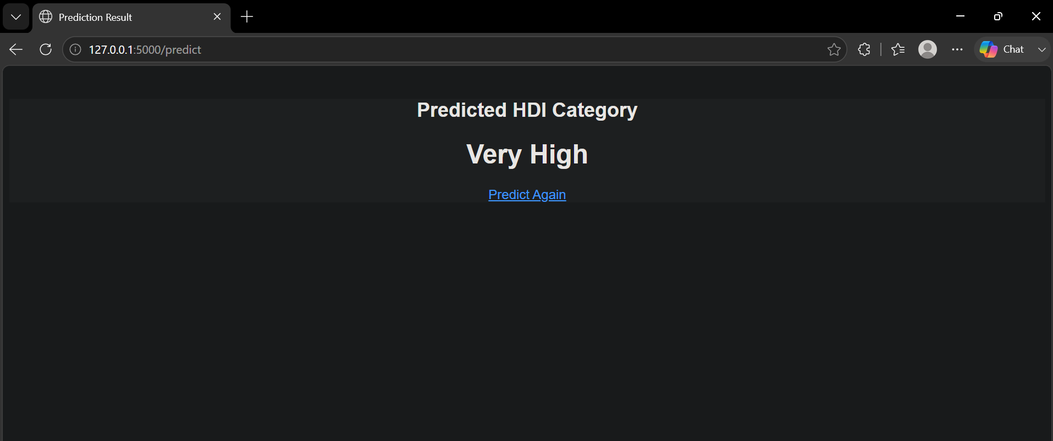

Future Scope:
Although the current application successfully predicts Human Development Index (HDI) categories using machine learning, several enhancements can be made in the future to improve its functionality and performance.
- Integrate real-time Human Development Report (HDR) datasets from the United Nations Development Programme (UNDP) to keep predictions up to date.
- Increase the number of input features by including indicators such as poverty rate, unemployment rate, healthcare expenditure, literacy rate, internet usage, and environmental factors to improve prediction accuracy.
- Evaluate advanced machine learning and deep learning algorithms such as XGBoost, LightGBM, Artificial Neural Networks (ANN), and Deep Neural Networks (DNN) for improved predictive performance.
- Develop interactive dashboards using visualization tools such as Plotly or Power BI to present country-wise development statistics and trends.
- Deploy the application on cloud platforms such as Heroku, Render, AWS, or Microsoft Azure, making it accessible to users worldwide.
- Implement user authentication and role-based access for researchers, policymakers, and administrators.
- Store prediction history in a database such as MySQL or PostgreSQL, allowing users to review previous predictions and analyze trends over time.
- Enhance the user interface with modern responsive frameworks such as Bootstrap or React to improve usability across desktop and mobile devices.
- Extend the application to support comparative analysis between multiple countries based on various development indicators.
- Incorporate explainable AI (XAI) techniques to provide insights into how each feature contributes to the predicted HDI category, improving transparency and interpretability.

