**WebTechnologyLab(BCSL504)**

8a**. DevelopaPHPprogram(withHTML/CSS) tokeeptrackofthenumber ofvisitorsvisitingtheweb page and to display this count of visitors, with relevant headings.**

**8 a. Develop aPHPprogram(withHTML/CSS) to keeptrackofthenumber ofvisitorsvisiting theweb page and to display this count of visitors, with relevant headings.**

<?php

//Definethefilewherethevisitorcountwillbestored

$countFile='visitor_count.txt';

//Checkifthefile exists

if(!file_exists($countFile)){

// Ifnot,createthefileandinitializethecountto0 file_put_contents($countFile, '0');

}

//Readthecurrentcountfromthefile

$count=(int)file_get_contents($countFile);

//Incrementthecountby1

$count++;

// Save the new count back to the file file_put_contents($countFile,$count);

//HTMLandCSSfordisplayingthecount

?>

<!DOCTYPE html>

<htmllang="en">

<head>

<metacharset="UTF-8">

<metaname="viewport"content="width=device-width,initial-scale=1.0">

<title>VisitorCounter</title>

<style>

body{

font-family:Arial,sans-serif; background-color: blue; display: flex;

justify-content:center; align-items: center; height: 100vh;margin: 0;

}

.container{

background-color:red; padding: 20px;

border-radius:8px;

box-shadow:0010pxrgba(0,110,0,0.1); text-align: center;

}

h1 {

color:#333;

}

p{

font-size:1.2em; color: #555;

}

</style>

</head>

<body>

<divclass="container">

<h1>VisitorCounter</h1>

<p>TotalVisitors:

<?phpecho$count; ?>

</p>

</div>

</body>

</html>

Output:

# WheretoStorethephpprogram. Step 1: Go to XAMPP folder

Thensearchfor**htdocs**folder

Inthisfoldercreateonefolderofyourown.Andsavethisprograminthisfolder. By giving the extension program8a.php.

# Step2:

# Torunthisprogramopenbrowser

Then type http://localhost:84/yourfoldername/programname.php

**8b. DevelopaPHPprogram(withHTML/CSS)tosortthestudentrecordswhicharestoredinthe database using selection sort.**

# Database Connectivity With XAMPP:

**1.Creating and managing database and tables in MYSQL in XAMPP.**

Step1:Run Apache and Run MySql in XAMPP controlpanel.

Step2:Open Browser and type

# http://localhost:84/phpmyadmin/

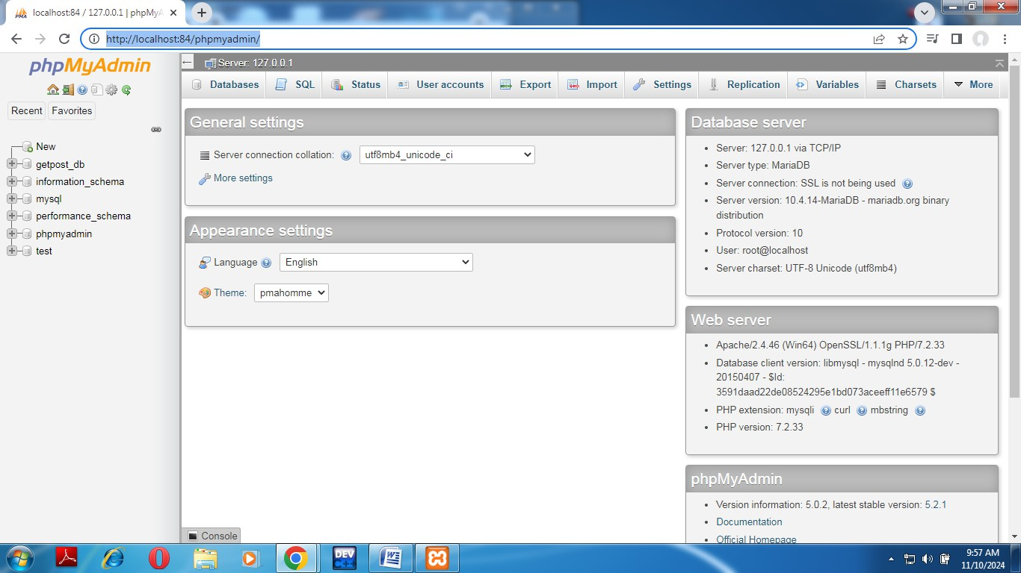

Click on **new** then

First we need to create database by giving the name of the database ie STUDENTDB. Second we need to create the table by giving the name: STUDENT

Number of Columns:3

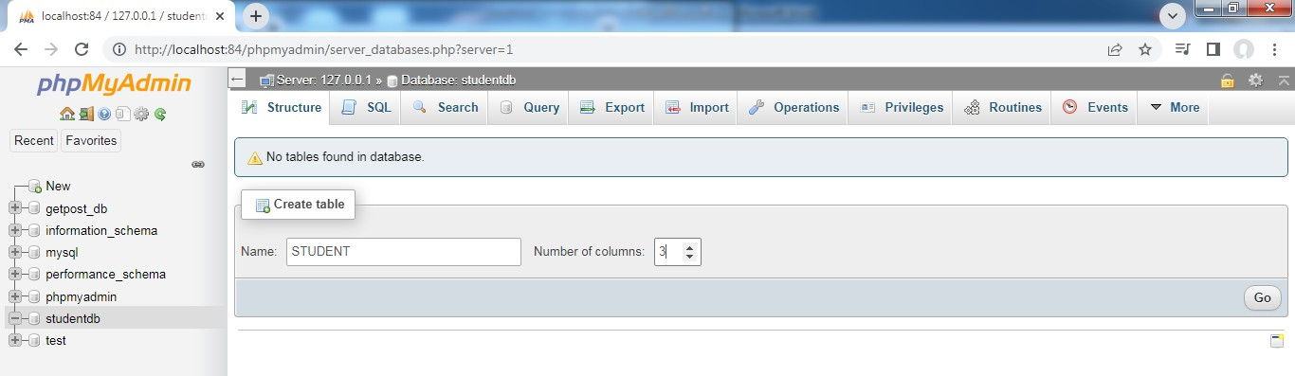

Then press **Go** button

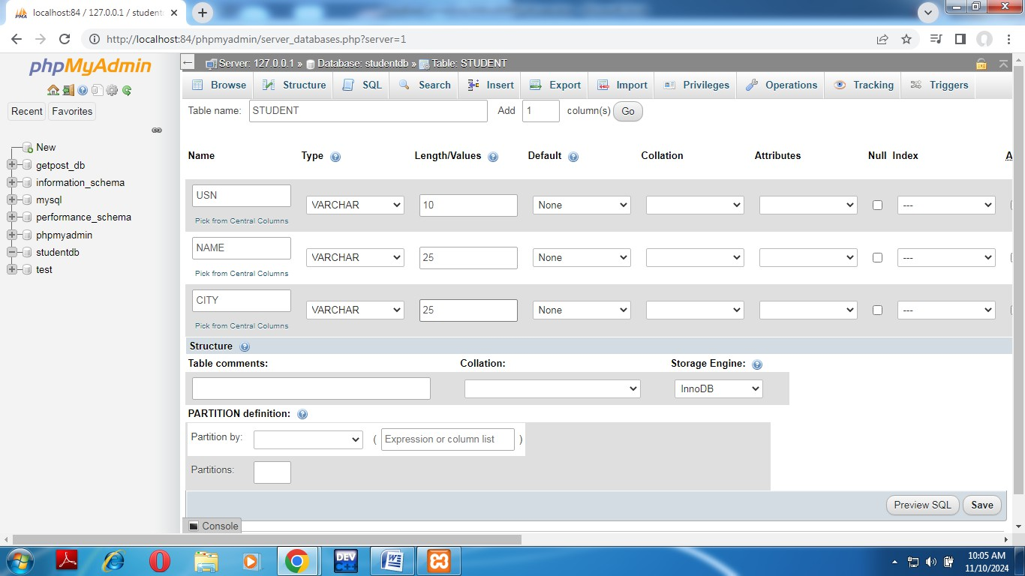

# After creating three columns in your table STUDENT with column name

|  |  |  |
| --- | --- | --- |
| Name | Type | Length/Values |
| USN | VARCHAR | 10 |
| NAME | VARCHAR | 25 |
| CITY | VARCHAR | 25 |

Then press Save Button in the right most corner by the side of Preview SQL.

# *if we give primary key in MySql it will be default sorted, there fore we are not giving any column as Primary Key.

Then Click on Insert button to store the students details.

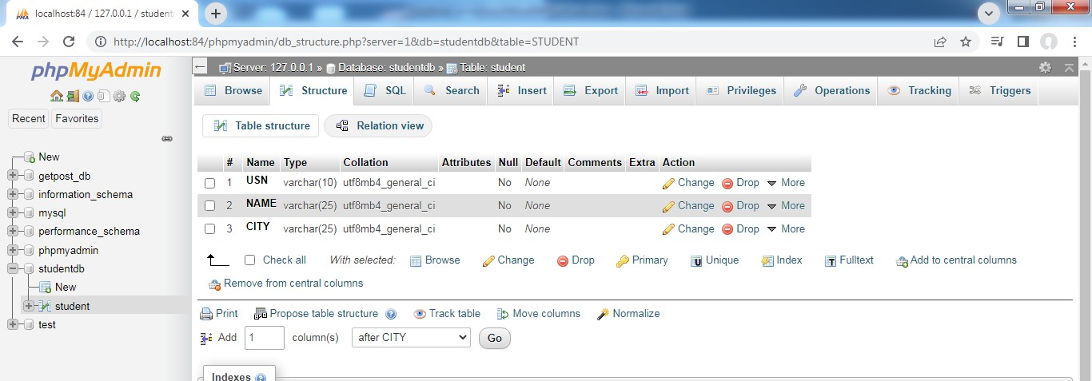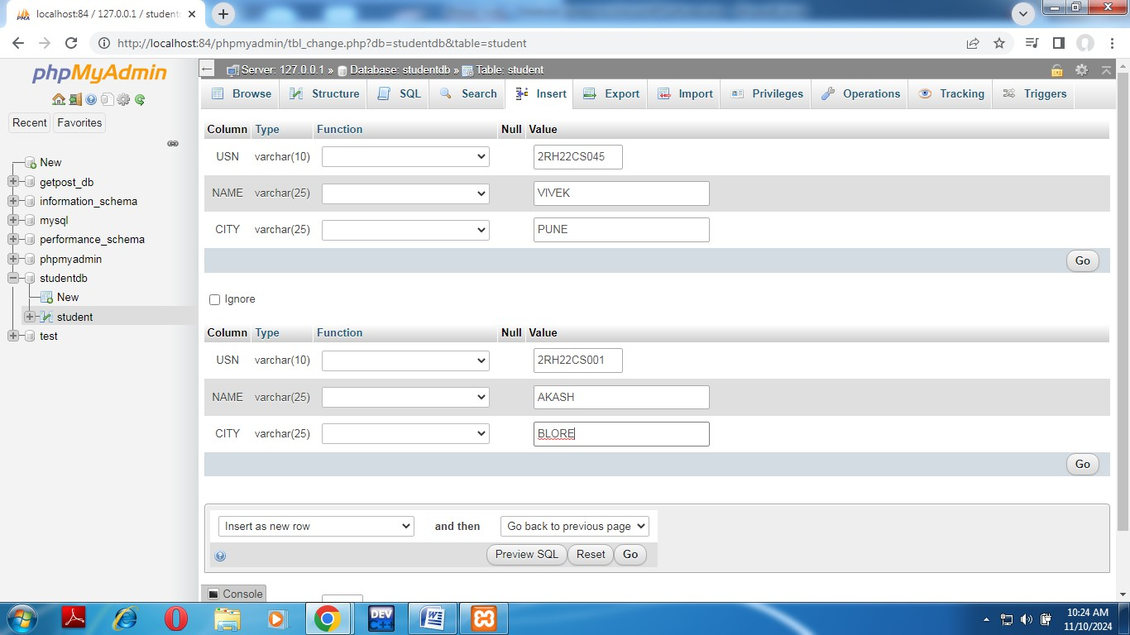

After Inserting the Values click on Go button.

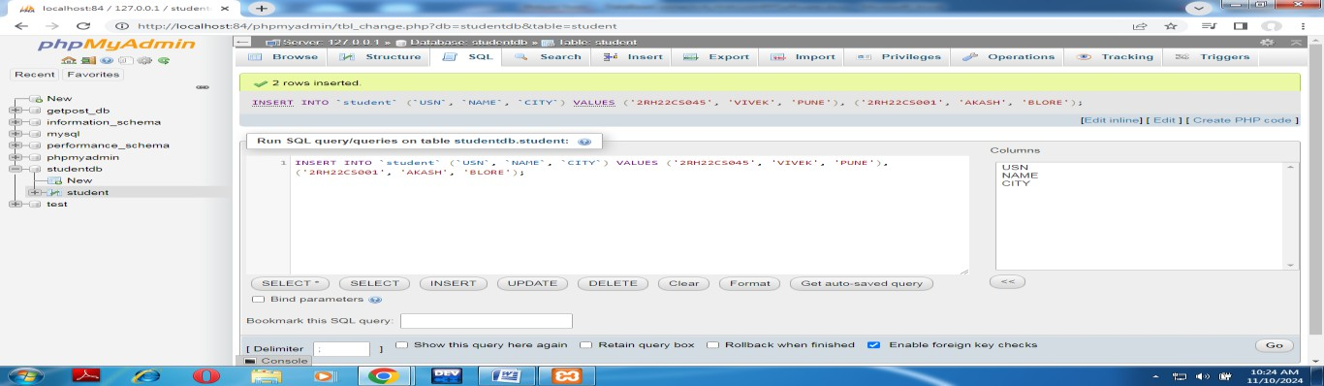

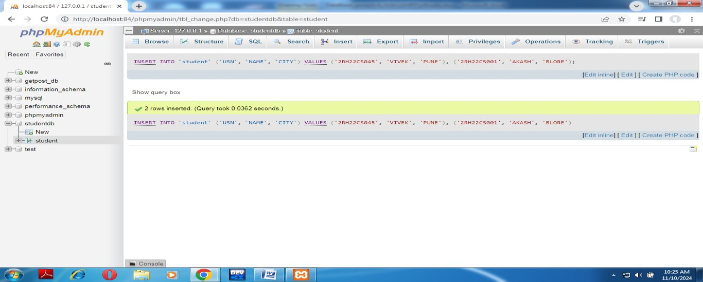

Then go to SQL then execute the query



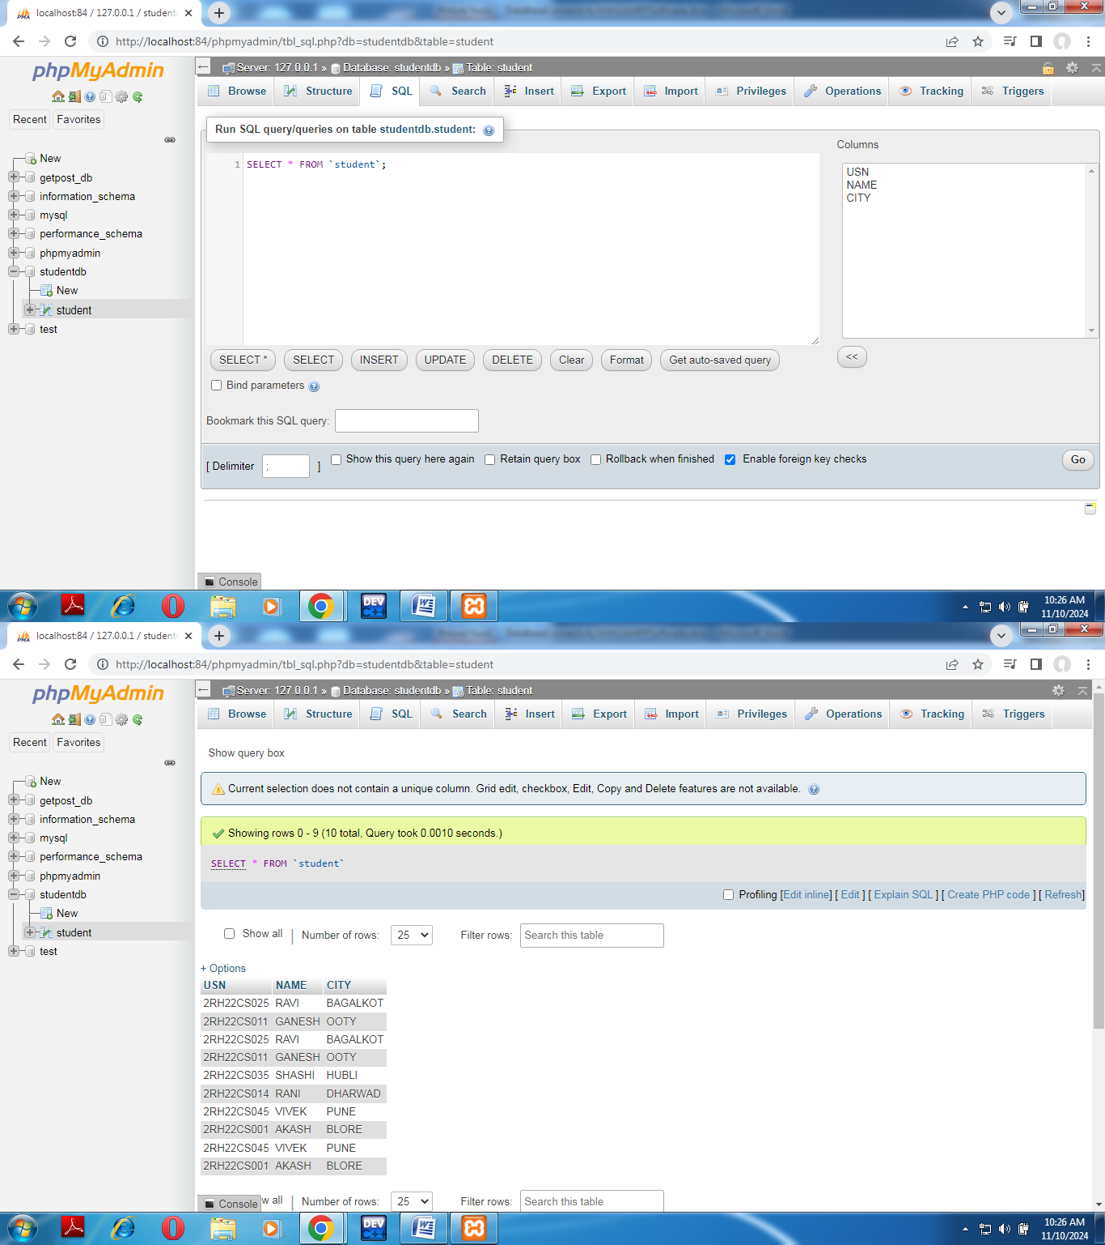

# PHP functions to access Database (Executing MySql queries in PHP)

Important functions of php functions:

1. mysqli_connect

$servername=”localhost”;

$username=”root”;

$password=””;

$dbname=”STUDENTDB”;

$conn=mysqli_connect($servername,$username,$password,$dbname);

1. mysqli_connect_error()

die(mysqli_connect_error());

//Ifanyoftheparameterisnotcorrectthenitwillbeexecutedanditgivestheerrorwhatthe//user has done.

1. mysqli_query();

$sql=“SELECT*FROMSTUDENT”;

//itwillfetchalltherowsof thetablestudent

$result=mysqli_query($conn,$sql);

1. mysqli_num_rows($result)

If(mysqli_num_rows($result)==0)

{

echo“NoRowsareFeteched.”;

}

1. mysqli_fetch_assoc($result)

Thisfunctionreturnseverysinglerowfromfectchedresult.

$row=mysqli_fetch_assoc($result);

//in$rowitwillgetfirstrowinformation andsoon .

//tofetchindividualcolumn$row[usn],

# Where to Store the php program. Step 1: Go to XAMPP folder

Then search for **htdocs** folder

In this folder create one folder of your own. And save this program in this folder. By giving the extension program10.php.

# Step2:

# To run this program open browser

Then type http://localhost:84/yourfoldername/programname.php http://localhost:84/phpprograms/student_database_sort143.php

# Program8b.php

<!DOCTYPEHTML>

<html>

<head>

</head>

<body>

<?php

<title>STUDENTSORTED RECORDS</title>

$servername="localhost";

$username="root";

$password="";

$dbname="STUDENTDB";

$conn=mysqli_connect($servername,$username,$password,$dbname)or

die(mysqli_connect_error());

$sql="SELECT*FROM STUDENT";

$result=mysqli_query($conn,$sql); echo "<br>";

echo"<center><h1>BEFORESORTING</h1></center>"; echo "<table border='1' align='center'>";

echo"<tr>";

echo"<th>USN</th><th>NAME</th><th>CITY</th></tr>";

if(mysqli_num_rows($result)>0)

{

while($row=mysqli_fetch_assoc($result))

{

}

}

else

{

echo"<tr>";

echo"<td>".$row["USN"]."</td>";

echo "<td>".$row["NAME"]."</td>"; echo"<td>".$row["CITY"]."</td></tr>";

echo"</table>";

echo"<h1>TableIsEmpty</h1>"; echo "</table>";

}

$sql="SELECT*FROMSTUDENTorderbyUSN";

$result=mysqli_query($conn,$sql); echo "<br>";

echo"<center><h1>AFTERSORTING</h1></center>"; echo "<table border='1' align='center'>";

echo"<tr>";

echo"<th>USN</th><th>NAME</th><th>CITY</th></tr>"; echo "<br>";

if(mysqli_num_rows($result)>0)

{

while($row=mysqli_fetch_assoc($result))

{

}

}

else

{

echo"<tr>";

echo"<td>".$row["USN"]."</td>";

echo "<td>".$row["NAME"]."</td>"; echo"<td>".$row["CITY"]."</td></tr>";

echo"</table>";

echo"<h1>TableIsEmpty</h1>"; echo "</table>";

}

echo"</table>";

?>

</body>

</html>

Output: