**Web Technology Lab(BCSL504)**

1. **Develop jQuery script (with HTML/CSS) for:**

Note: Download this file and store in your folder

[**https://code.jquery.com/jquery-3.6.0.min.js**](https://code.jquery.com/jquery-3.6.0.min.js) **to execute jquery**

## WebLab9a.html

* 1. **Appends the content at the end of the existing paragraph and list.**

<!DOCTYPE html>

<html lang="en">

<head>

<meta charset="UTF-8">

<meta name="viewport" content="width=device-width, initial-scale=1.0">

<title>Append Content</title>

<style>

body {

font-family: Arial, sans-serif; background-color: #f4f4f4; padding: 20px;

}

.container {

background-color: #fff; padding: 20px;

border-radius: 8px;

box-shadow: 0 0 10px rgba(0,0,0,0.1);

}

p, ul {

margin: 10px 0;

}

</style>

</head>

<body>

<div class="container">

<h1>Append Content Example</h1>

<p id="paragraph">This is an existing paragraph.</p>

<ul id="list">

<li>Item 1</li>

<li>Item 2</li>

</ul>

<button id="appendParagraph">Append to Paragraph</button>

<button id="appendList">Append to List</button>

</div>

<!-- Include jQuery library -->

<script src="E:\WEBDEVELOPMENTBCSL504\jquery-3.6.0.min.js"></script>

<script>

$(document).ready(function() {

$('#appendParagraph').click(function() {

$('#paragraph').append(' This is appended content.');

});

$('#appendList').click(function() {

$('#list').append('<li>New Item</li>');

});

});

</script>

</body>

</html> Output:

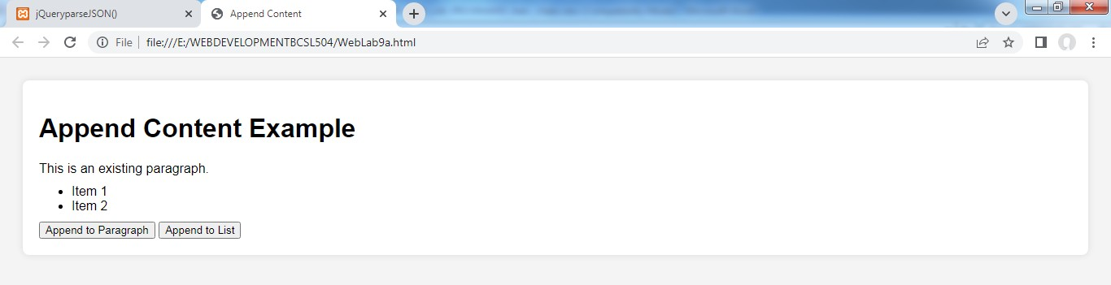

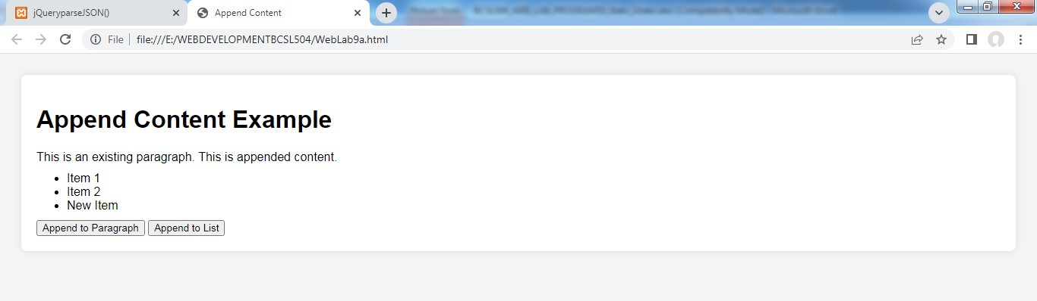

## WebLab9b.html

* 1. **Change the state of the element with CSS style using animate() method**

<!DOCTYPE html>

<html>

<head>

<title> JQuery Animate</title>

</head>

<script src="E:\WEBDEVELOPMENTBCSL504\jquery-3.6.0.min.js"></script>

<style>

body{

font-size:17px; font-family:arial;

background:#f4f4f4; line-height:1.5em;

}

header{

background:#333; color:#fff; padding:20px; text-align:center;

border-bottom:4px #000 solid; margin-bottom:10px;

}

#container{

width:90%; margin:auto; padding:10px;

}

#box{

}

</style>

</head>

<body>

background:blue; color:#fff; width:500px; height:90px; padding:40px; text-align:center;

<header>

<h1> JQuery Animate Demo</h1>

</header>

<center>

<div id="container">

<button id="btnFadeOut">Fade Out</button>

<button id="btnFadeIn">Fade in</button>

<button id="btnFadeTog">Fade Toggle</button>

<br><br><br><br><br>

<div id="box"> <h1> Hai Good Morning!... </h1></div>

</div>

<script>

$(document).ready(function(){

$('#btnFadeOut').click(function(){

$('#box').fadeOut(1000, function(){

$('#btnFadeOut').text('Its Gone');

});

});

$('#btnFadeIn').click(function(){

$('#box').fadeIn(1000);

});

$('#btnFadeTog').click(function(){

$('#box').fadeToggle(1000);

});

</body>

</html> Output:

});

</script>

</center>

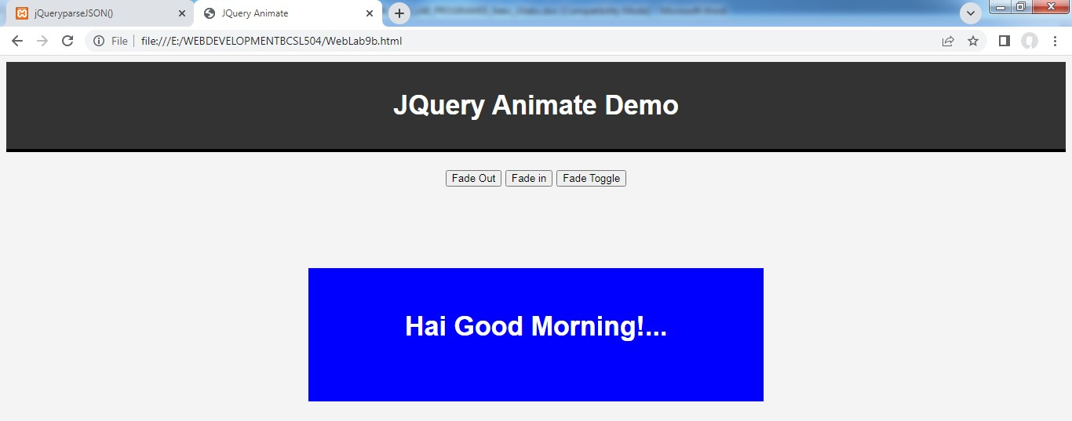

## WebLab9c.html

* 1. **Change the color of any div that is animated.**

<!DOCTYPE html>

<html lang="en">

<head>

<meta charset="UTF-8">

<meta name="viewport" content="width=device-width, initial-scale=1.0">

<title>Color Change on Animation</title>

<style>

body {

font-family: Arial, sans-serif; background-color: #f4f4f4; padding: 20px;

}

.container {

background-color: #fff; padding: 20px;

border-radius: 8px;

box-shadow: 0 0 10px rgba(0,0,0,0.1); text-align: center;

}

.color-box { width: 100px; height: 100px;

background-color: #3498db; margin: 20px auto;

}

</style>

</head>

<body>

<div class="container">

<h1>Change Color on Animation</h1>

<div id="colorBox" class="color-box"></div>

<button id="changeColorButton">Change Color</button>

</div>

<!-- Include jQuery library -->

<script src="E:\WEBDEVELOPMENTBCSL504\jquery-3.6.0.min.js"></script>

<script>

$(document).ready(function() {

$('#changeColorButton').click(function() {

$('#colorBox').animate({ width: '150px',

height: '150px'

}, 1000, function() {

$(this).css('background-color', '#2ecc71');

});

});

});

</script>

</body>

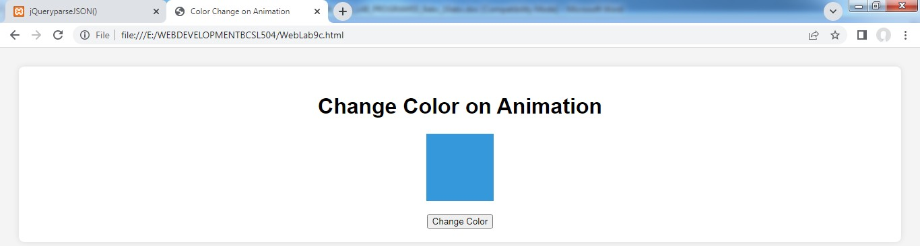</html> Output:

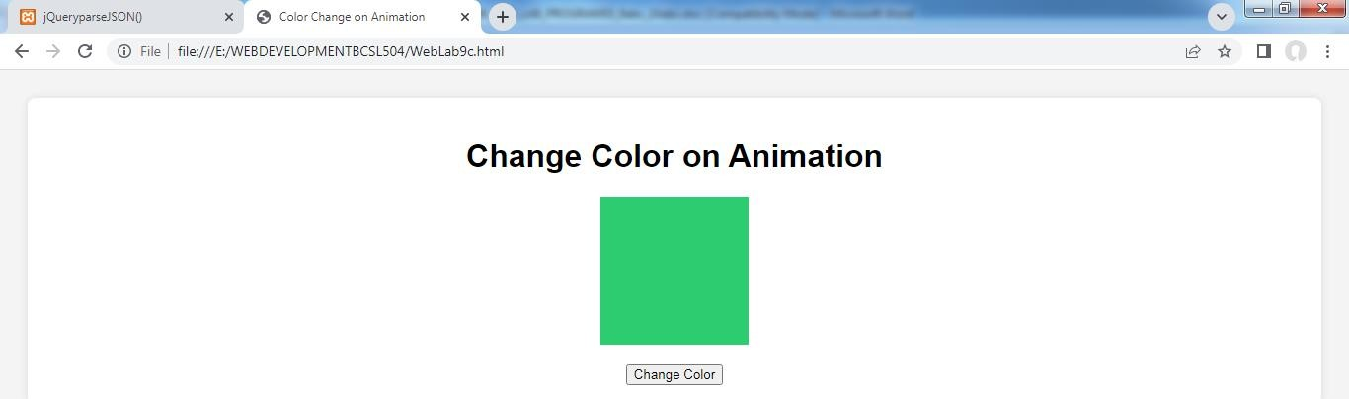

1. **Develop a JavaScript program with Ajax (with HTML/CSS) for:**
   1. **Use ajax() method (without Jquery) to add the text content from the text file by sending ajax request.**
   2. **Use ajax() method (with Jquery) to add the text content from the text file by sending ajax request.**
   3. **Illustrate the use of getJSON() method in jQuery**

**Note: U need to store all these files in this folder C:\xampp\htdocs\**

Note: copy this file here also **C:\xampp\htdocs\** [**https://code.jquery.com/jquery-3.6.0.min.js**](https://code.jquery.com/jquery-3.6.0.min.js)

# WebLab10a.html

1. **Use ajax() method (without Jquery) to add the text content from the text file by sending ajax request.**

## Create one text file for this program in c:\xampp\htdocs\Test.txt and write some contents.

<!DOCTYPE html>

<html lang="en">

<head>

<meta charset="UTF-8">

<meta name="viewport" content="width=device-width, initial-scale=1.0">

<title>AJAX Without jQuery</title>

<style>

body {

font-family: Arial, sans-serif; background-color: #f4f4f4; padding: 20px;

}

.container {

background-color: #fff; padding: 20px;

border-radius: 8px;

box-shadow: 0 0 10px rgba(0,0,0,0.1); text-align: center;

}

#content { margin: 20px 0;

padding: 10px;

border: 1px solid #ddd; background-color: #fafafa;

}

</style>

</head>

<body>

<div class="container">

<h1>AJAX Without jQuery</h1>

<button id="loadText">Load Text Content</button>

<div id="content"></div>

</div>

<script>

document.getElementById('loadText').addEventListener('click', function() { var xhr = new XMLHttpRequest();

xhr.open('GET','Test.txt',true); // Assume 'Text.txt' is the text file to load11 xhr.onload = function() {

if (xhr.status>= 200 &&xhr.status< 300) { document.getElementById('content').textContent = xhr.responseText;

} else {

//console.error('Failed to load text file'); document.getElementById('content').textContent= ' Failed to Load Text File';

}

};

xhr.onerror = function() {

//console.error('Request error'); document.getElementById('content').textContent= ' Request Error';

};

xhr.send();

});

</script>

</body>

</html>

**Output:**

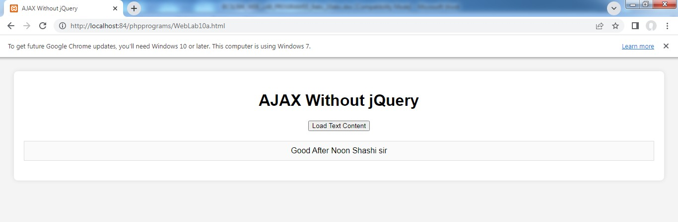

# WebLab10b.html

1. **Use ajax() method (with Jquery) to add the text content from the text file by sending ajax request.**

<!DOCTYPE html>

<html lang="en">

<head>

<meta charset="UTF-8">

<meta name="viewport" content="width=device-width, initial-scale=1.0">

<title>AJAX With jQuery</title>

<style>

body {

font-family: Arial, sans-serif; background-color: #f4f4f4; padding: 20px;

}

.container {

background-color: #fff; padding: 20px;

border-radius: 8px;

box-shadow: 0 0 10px rgba(0,0,0,0.1); text-align: center;

}

#content { margin: 20px 0; padding: 10px;

border: 1px solid #ddd; background-color: #fafafa;

}

</style>

</head>

<body>

<div class="container">

<h1>AJAX With jQuery</h1>

<button id="loadText">Load Text Content</button>

<div id="content"></div>

</div>

<!-- Include jQuery library -->

<script src="jquery-3.7.1.js"></script>

<script>

$(document).ready(function() {

$('#loadText').click(function() {

$.ajax({

url: 'MyFirst.php', // Assume 'MyTextFile.txt' is the text file to load method: 'GET',

success: function(data) {

$('#content').text(data);

},

error: function() { console.error('Failed to load text file');

}

});

});

});

</script>

</body>

</html>

## Note: Create a file my name MyFirst.php and write this content

**<?php**

## echo "Welcome To PHP Scripting Language"; echo " Good Morning HRU";

**?>**

Output:

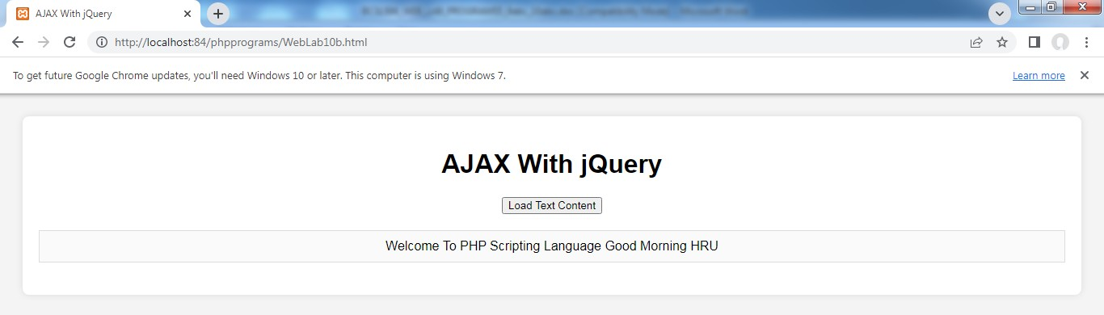

# WebLab10c.html

1. **Illustrate the use of getJSON() method in jQuery**

<!DOCTYPE html>

<html lang="en">

<head>

<meta charset="UTF-8">

<meta name="viewport" content="width=device-width, initial-scale=1.0">

<title>jQuerygetJSON()</title>

<style>

body {

font-family: Arial, sans-serif; background-color: #f4f4f4; padding: 20px;

}

.container {

background-color: #fff; padding: 20px;

border-radius: 8px;

box-shadow: 0 0 10px rgba(0,0,0,0.1); text-align: center;

}

#content { margin: 20px 0; padding: 10px;

border: 1px solid #ddd; background-color: #fafafa;

}

</style>

</head>

<body>

<div class="container">

<h1>jQuerygetJSON() Example</h1>

<button id="loadJSON">Load JSON Content</button>

<div id="content"></div>

</div>

<!-- Include jQuery library -->

<script src="jquery-3.7.1.js"></script>

<script>

$(document).ready(function() {

$('#loadJSON').click(function() {

$.getJSON('data.json', function(data) { // Assume 'data.json' is the JSON file

$('#content').html('<pre>' + JSON.stringify(data, null, 2) + '</pre>');

}).fail(function() {

//console.error('Failed to load JSON file'); document.getElementById('content').textContent = 'Failed To Load JSON File';

});

});

});

</script>

</body>

</html>

## Note: Create a file my name data.json and store this content.

**{**

## "name":"shass", "age":22,

**"dept":"cse"**

## }

Output:

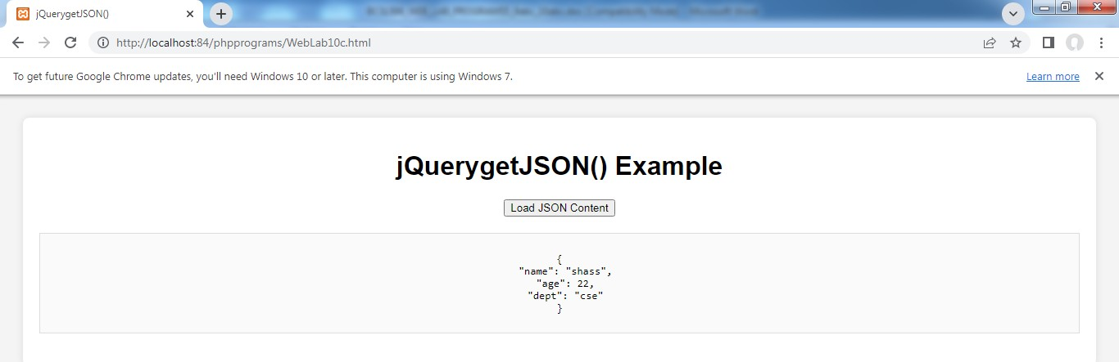

# WebLab10d.html

1. **Illustrate the use of parseJSON() method to display JSON values.**

<!DOCTYPE html>

<html lang="en">

<head>

<meta charset="UTF-8">

<meta name="viewport" content="width=device-width, initial-scale=1.0">

<title>jQueryparseJSON()</title>

<style>

body {

font-family: Arial, sans-serif; background-color: #f4f4f4; padding: 20px;

}

.container {

background-color: #fff; padding: 20px;

border-radius: 8px;

box-shadow: 0 0 10px rgba(0,0,0,0.1); text-align: center;

}

#content { margin: 20px 0; padding: 10px;

border: 1px solid #ddd; background-color: #fafafa;

}

</style>

</head>

<body>

<div class="container">

<h1>jQueryparseJSON() Example</h1>

<button id="parseJSON">Parse JSON Content</button>

<div id="content"></div>

</div>

<!-- Include jQuery library -->

<script src="jquery-3.7.1.js"></script>

<script>

$(document).ready(function() {

$('#parseJSON').click(function() {

var jsonString = '{"name": "shass", "age": 22, "city": "Gadag"}'; var jsonData = $.parseJSON(jsonString);

$('#content').html('<p>Name: ' + jsonData.name + '</p>' + '<p>Age: ' + jsonData.age + '</p>' + '<p>City: ' + jsonData.city + '</p>');

});

});

</script>

</body>

</html>

## Output:

