LABOUR MARKET ANALYTICS:
EMPLOYMENT RESILIENCE ACROSS INDIAN STATES

1. Project Overview and Objective
This project analyse India's labour market using the Periodic Labour Force Survey (PLFS) to understand how employment indicators changed across Indian states before, during and after the COVID-19 pandemic. Using Python, four PLFS datasets (Labour Force Participation Rate, Unemployment Rate, Worker Population Ratio and sector-wise employment) are merged, cleaned and explored, and the results are presented in an interactive Power BI dashboard.
The analysis covers 2019–2024 and focuses on three phases: pre-COVID (2019), pandemic shock (2020) and recovery (2022). It is a descriptive and diagnostic analytics project that uses transparent, rule-based comparisons rather than machine learning.
The primary objective is to identify which states were hit hardest by the pandemic, which recovered fastest, and how participation, unemployment and sector structure differ across states, genders and age groups.

Objectives:
- Merge the PLFS datasets (LFPR, UR, WPR, sector-wise employment) for 22 Indian states and the All-India aggregate into one clean dataset using Python.
- Analyse trends and disparities across states, gender and time, with a focus on the COVID-19 period.
- Compute descriptive statistics (mean, percentage change, year-on-year movement) for each indicator.
- Rank states by employment shock and recovery using rule-based thresholds.
- Study sector-wise shifts (agriculture, secondary, tertiary) to understand structural employment patterns.
- Present the findings in an interactive Power BI dashboard for stakeholders.

2. Data Sources
- Source: Periodic Labour Force Survey (PLFS), published by the Ministry of Statistics and Programme Implementation (MoSPI) and accessed through the India Data Portal (indiadataportal.com/p/employment).
- Raw Data Files: Four files – LFPR, Unemployment Rate (UR), Worker Population Ratio (WPR) and sector-wise employment (sectors).
- Source Timeline: 2018–2024 (2018 was excluded during cleaning).
- Dataset Used for Analysis: 2019–2024, quarterly data.
- Merged Dataset Size: 4,347 records × 12 columns (17 columns after feature engineering).
- Coverage: 22 Indian states plus the All-India aggregate.
- Domain: Government / Public Sector – Labour Market and Employment.
- Dataset Format: CSV.

3. Problem Statement
- To analyse how unemployment, labour force participation and worker population ratio changed across Indian states before, during and after COVID-19.
- To identify the states with the sharpest employment shocks and those that recovered fastest by 2022.
- To compare labour market outcomes across genders and age groups, and measure the gender gap in participation and unemployment.
To study how sector structure (agriculture, secondary, tertiary) relates to participation and unemployment.
- To rank and categorize states on resilience using simple, transparent, rule-based comparisons.
- To present the results through an interactive dashboard and generate recommendations for policy discussion.

4. Attribute (Column / Features) Details:
Attribute Name | Data Type | Description
Year | Numeric (Integer) | Survey year (2019–2024)
Quarter | Categorical | Survey quarter: January-March, April-June, July-September,  October-December
State_name | Categorical | Name of the Indian state, or All-India for the national aggregate
State_code | Numeric (Integer) | Unique code identifying each state
Age_group | Categorical | Age group of the surveyed population: 15-29 Years, 15 Years And  Above, All
Gender | Categorical | Gender category: Male, Female, Person (combined)
LFPR | Numeric (Float) | Labour Force Participation Rate (%)
UR | Numeric (Float) | Unemployment Rate (%)
WPR | Numeric (Float) | Worker Population Ratio (%)
Agriculture_sector | Numeric (Float) | Share of employment in the agriculture sector (%)
Secondary_sector | Numeric (Float) | Share of employment in the secondary / industrial sector (%)
Tertiary_sector | Numeric (Float) | Share of employment in the tertiary / services sector (%)
UR_log | Numeric (Float) | Derived: log transformation of UR, created to reduce right skew
Agri_log | Numeric (Float) | Derived: log transformation of agriculture share, created to reduce right skew
Quarter_no | Numeric (Integer) | Derived: quarter converted to a number (1–4)
Period | String (Text) | Derived: year and quarter label, for example 2019 Q2
Phase | Categorical | Derived: Pre-COVID (2019), Pandemic (2020), Recovery (2022), Other  Years

5. Tools & Technologies
- Python: Data loading, merging, cleaning, transformation, exploratory data analysis and visualization.
- Pandas: Data manipulation, duplicate and missing-value checks, merging and grouping.
- NumPy: Numerical operations, log transformations and statistical calculations.
- Matplotlib: Data visualization and customized charts.
- Seaborn: Statistical visualization (histograms, boxplots, heatmaps, pair plots).
- Power BI: Data modelling, DAX measures, visualization and interactive dashboard development.
- Google Colab: Python development and notebook-based analysis.

6. Data Pre-Processing - EDA
Tasks Performed:
- Load Data – Read the four CSV files (LFPR, UR, WPR, sectors) with pd.read_csv().
Check Dataset Size and Types – Use shape, head() and info() to understand structure and column types.
- Check Missing Values – Use isnull().sum() on every table.
- Check Duplicates – Check full-row duplicates and duplicates on the key columns (state, year, quarter, age group, gender).
- Merge Tables – Combine all four tables into one dataset.
- Outliers, Skewness and Transformations – Detect outliers with the IQR method, check skewness and transform where needed.
Summary of Complete Data Cleaning:
- Unwanted Column: Dropped the id column from all four tables before merging.
- 2018 Data: Excluded all 2018 rows. LFPR and WPR contained 552 conflicting duplicate rows for the same state, period, age group and gender, all in 2018, and the source had no field to tell them apart.
- Duplicates in Sector Table: Duplicate rows differed only in agriculture (0.0 versus NaN). The row with the real value was kept, leaving 0 duplicate keys (1,449 records × 8 columns).
- Missing Values: Missing agriculture shares were filled with 0 after confirming that secondary and tertiary shares already summed to about 100%.
- Merging: LFPR, UR and WPR were merged on state_code, state_name, year, quarter, age_group and gender. The sector table has no age_group, so it was merged on the reduced key (state_code, state_name, year, quarter, gender). Merged size: 4,347 × 12.
- Outliers: The IQR method flagged 136 high values in the Unemployment Rate (above 39.95%). They fall within the valid percentage range and reflect genuine state-level variation, so they were retained.
- Skewness: LFPR 0.10, UR 1.42, WPR 0.27, agriculture 1.67, secondary -0.26, tertiary 0.51. Log transformations (UR_log, agri_log) were applied only to variables with skew above 1; original values are used for reporting.
- Data Types and Renaming: Checked all data types and renamed lfpr and Wpr to LFPR and WPR.
- Derived Columns: Created quarter_no, period and phase (Pre-COVID = 2019, Pandemic = 2020, Recovery = 2022). The 1,863 rows for 2021, 2023 and 2024 have no phase label and were set to Other Years.
- Data Validation: Final check found 0 missing values and 0 duplicate keys.
- Final Dataset: 4,347 records × 17 columns (Cleaned_labour_market_data.csv).

7. Python Visualizations
- Univariate analysis: Count plots (records per year and per gender) to check the data is balanced; histograms for LFPR, UR and agriculture share; boxplots to compare LFPR, UR and WPR and the three sector shares.
- Bivariate analysis: Bar charts for average UR by state, average LFPR by gender and average UR by phase; scatter plots for LFPR versus WPR and UR versus tertiary share; a correlation heatmap of the six labour indicators.
- Multivariate analysis: A pair plot of LFPR, UR and WPR by gender; grouped analysis of phase by gender; a state-by-year heatmap of unemployment; a bubble scatter of LFPR versus UR sized by agriculture share and coloured by tertiary share.
- Interpretation: Every chart is followed by an insight note covering what the chart shows, the features used and what it means for the business story.
These Python visualizations provided an initial understanding of distributions, gender gaps, state differences and the COVID-19 shock, and guided the selection of KPIs and charts for the Power BI dashboard.
Key observations from the Python analysis:
- LFPR has two separate peaks (about 15–20% and 55–58%) because male and female participation form two distinct groups.
- Unemployment is right-skewed (skewness 1.42), with most values between 5% and 15% and a long tail up to about 39%.
- LFPR and WPR are almost perfectly correlated (0.99). Unemployment is moderately negative with LFPR (-0.30) and WPR (-0.40).
- Agriculture-heavy states show lower participation and employment (correlation -0.41 with LFPR and -0.43 with WPR); secondary-sector states show higher (0.56 and 0.58).
- Average unemployment rose from about 9.5% (pre-COVID) to about 13.7% (pandemic) and fell to about
8.8% (recovery), slightly below the starting level.

8. Dashboard Development (Power BI)
An interactive Power BI dashboard was developed to present the cleaned labour market data as clear, filterable visuals.
Dashboard Features:
- Created an interactive two-page dashboard: o Page 1 – Labour Market Overview o Page 2 – Labour Market Resilience
- Used KPI Cards, Line Charts, Donut Chart, Clustered Column Chart, Bar Charts, Treemap and a Table with conditional formatting.
- Implemented interactive Slicers for Gender, Age Group and States.
- Applied conditional formatting (data bars, colour scales and rule-based colours) to the State Resilience Ranking table.
- Added Key Insights and Recommendations text boxes on each page for storytelling.
- Designed the dashboard with a consistent teal theme and clear layout.
Page Contents:
- Overview: KPI cards for Average LFPR (37.46), Average UR (9.16), Average WPR (34.06) and Average Agriculture share (5.66); trend lines for LFPR, UR and WPR from 2019 to 2024; employment share by sector; male versus female comparison; state-wise labour participation.

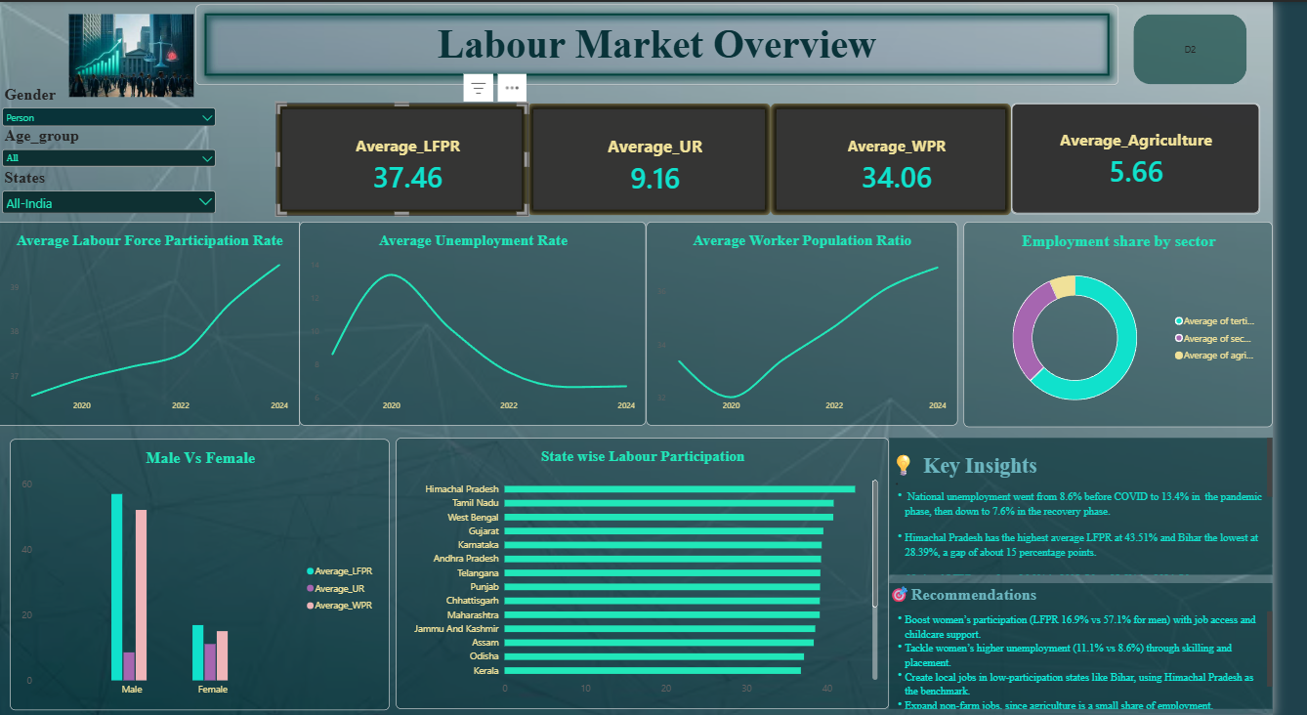
Page 1 – Labour Market Overview

- Resilience: KPI cards for Pre-COVID UR (9.52), Pandemic UR (13.67), Recovery UR (8.79) and UR Rise (4.15); unemployment rise during 2020; unemployment recovery by 2022; State Resilience Ranking table; participation across the three phases; treemap of where unemployment peaked.

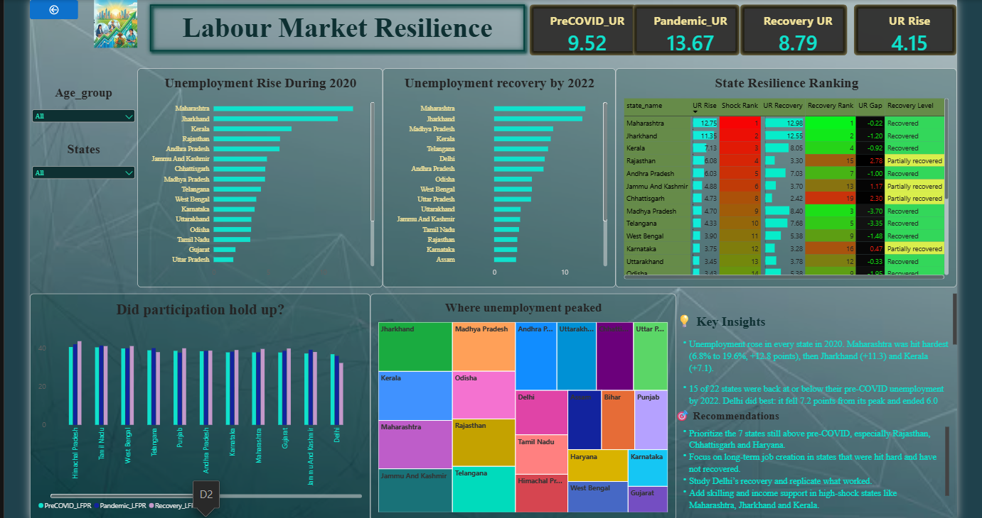

Page 2 – Labour Market Resilience

Calculated Columns & DAX Measures:
Developed DAX measures, stored in a dedicated Labour_Measures table over the Fact_Labour fact table, to calculate the headline averages, phase-wise values, shock and recovery measures, rankings and resilience categories.
List of DAX Measures Used:
Measure Name | Purpose
Average_LFPR | Calculates the average Labour Force Participation Rate
Average_UR | Calculates the average Unemployment Rate
Average_WPR | Calculates the average Worker Population Ratio
Average_Agriculture | Calculates the average share of employment in agriculture
PreCOVID_UR / PreCOVID_LFPR | Average unemployment rate / participation rate in the pre-COVID phase (2019)
Pandemic_UR / Pandemic_LFPR | Average unemployment rate / participation rate in the pandemic phase (2020)
Recovery UR / Recovery_LFPR | Average unemployment rate / participation rate in the recovery phase (2022)
UR Rise | Increase in unemployment from pre-COVID to the pandemic (Pandemic_UR minus  PreCOVID_UR)
UR Recovery | Fall in unemployment from the pandemic peak to the recovery phase (Pandemic_UR minus Recovery UR)
UR Gap | Recovery-phase unemployment minus pre-COVID unemployment; positive means still above the pre-COVID level
Shock Rank | Ranks states by UR Rise, highest rise = rank 1
Recovery Rank | Ranks states by UR Recovery, largest recovery = rank 1
Recovery Ratio | UR Recovery divided by UR Rise; the share of the pandemic rise that was reversed
Status | Labels a state Recovered if Recovery UR is at or below PreCOVID_UR, otherwise  Not yet recovered
Recovery Level | Rule-based category from Recovery Ratio: Recovered (1 or more), Partially recovered  (0.5 to below 1), Slowly recovered (above 0 to below 0.5), Not recovered (0 or below)

Supporting Elements:

- Labour_Measures table – A dedicated table that holds all measures, kept separate from the data table.
- Fact_Labour – The fact table loaded from the cleaned CSV.
- Phase column – Used to separate pre-COVID, pandemic and recovery values in the phase-wise measures.
- Conditional formatting – Data bars on UR Rise and UR Recovery, colour scales on the rank columns, red/green font on UR Gap and rule-based colours on Recovery Level.

9. Insight Generation and Recommendations
The analysis of PLFS data identified clear patterns in how the labour market was hit by COVID-19 and how it recovered, along with persistent gender and state-level gaps.

Key Findings
- Unemployment rose in every state in 2020. Maharashtra was hit hardest (6.8% to 19.6%, +12.8 points), followed by Jharkhand (+11.3) and Kerala (+7.1).
- Nationally, average unemployment moved from about 9.5% (pre-COVID) to 13.7% (pandemic) and 8.8% (recovery), a rise of about 4 points that was fully reversed.
- 15 of 22 states were back at or below their pre-COVID unemployment by 2022. Delhi did best: it fell 7.2 points from its peak and ended 6.0 points below its pre-COVID level.
- Seven states were still above their pre-COVID level: Rajasthan (+2.8), Chhattisgarh (+2.3), Haryana (+2.2), Jammu and Kashmir (+1.2), Bihar (+1.0), Himachal Pradesh (+1.0) and Karnataka (+0.5).
- States hit harder generally recovered more, but Rajasthan and Chhattisgarh took a big hit and had not fully recovered.
- Men's LFPR is 57.1% against women's 16.9%. Women's unemployment is also higher (11.1% versus
8.6%), and women's LFPR has risen from 15.6% to 20.3% since 2019.
- Himachal Pradesh has the highest average LFPR (43.51%) and Bihar the lowest (28.39%), a gap of about 15 percentage points.
- Male unemployment rose about 4.5 points in the pandemic against about 3 for women; men lost more jobs, but female unemployment stayed higher in every phase.
- Services dominate employment (median about 63%), followed by industry (about 30%) and agriculture (about 6%).

Analysis Insights:

Descriptive
- Analysed average LFPR, UR and WPR and their distributions.
- Compared labour market indicators across states, genders, age groups and the three phases.
- Examined the trend in unemployment and participation from 2019 to 2024.
- Described sector-wise employment shares across states.

Diagnostic
- Investigated how sector structure relates to participation and unemployment: agriculture-heavy states show weaker outcomes and secondary-sector states stronger ones.
- Found that LFPR and WPR move almost together (0.99), while unemployment shows only moderate negative relationships.
- Showed that sector structure alone does not explain unemployment; no clear relationship appears between tertiary share and UR.
- Identified states with a sharp shock and fast recovery (Maharashtra, Jharkhand, Karnataka) versus persistently high unemployment (Jammu and Kashmir, Kerala).
Predictive
Historical phase-wise patterns can help monitor how states may respond to future shocks. However, this project focuses on descriptive and diagnostic analysis using basic statistics, not predictive modelling.
Prescriptive
- Prioritize the states still above their pre-COVID unemployment level.
- Support women's participation and reduce the gap in unemployment between women and men.
- Promote non-farm employment, since agriculture-heavy states show weaker outcomes.
- Learn from states that recovered best and monitor unemployment together with participation.

Recommendations
Based on the analysis:
- Target Slow-Recovering States – Prioritize Rajasthan, Chhattisgarh and Haryana with long-term job creation, not short-term relief.
- Boost Women's Participation – Improve job access and childcare support, given LFPR of 16.9% for women against 57.1% for men.
- Reduce Women's Unemployment – Use skilling and placement programmes to address the higher female unemployment rate (11.1% versus 8.6%).
- Expand Non-Farm Jobs – Create local employment in low-participation states such as Bihar, using Himachal Pradesh as the benchmark.
- Learn from Delhi and Strengthen Resilience – Study Delhi's recovery, and add skilling and income support in high-shock states such as Maharashtra, Jharkhand and Kerala.
- Track Participation Alongside Unemployment – Monitor LFPR and WPR with UR to confirm that recovery lasts.

10. Conclusions
- The project transformed four PLFS datasets into a clean, analysis-ready dataset and used Python and Power BI to show how India's labour market responded to COVID-19.
- COVID-19 caused a sharp but temporary rise in unemployment, and the labour market recovered overall by 2022.
- The analysis also showed that the gender gap in participation and the differences between states remain large.
- The interactive dashboard lets users explore these patterns by state, gender and age group, and supports recommendations focused on women's participation, non-farm jobs and the states that have not yet fully recovered.

