Dear Intern

**Info**

* Internship lasts a maximum of 5 days.
* Duration: Wednesday 29 of July to Wednesday 5.
* Work 5 hours a day, 1 hour lunch break ( 10am – 4pm)
* If you complete the work within the 5 days please email us with the final copy and your internship will be completed
* There is **no requirement** to finish the task within the 5 days, not doing so will lead to no repercussions.
* If you don’t have enough time, just email us and we will extend the internship.
* If you are to complete the job we will make you our main programmer for our mini jobs in the near future which will be paid.

**Task**

**Your job**

* **Create the multiple-choice poll as shown below (fig 1.1) on one of the teams’ pages.**
* Ensure that when you vote the percentages are displayed as shown below. (fig 1.2)
* Ensure that every 24 hours at 00:00 the question is changed to a new one.
* We have provided you with 5 questions with their options to use and test with.
* Ensure that a computer can vote once on the daily question and if someone comes back they are shown the percentages as a pose to being able to vote again.
* You will create this poll in the bottom left section of the site as shown below.
* You do not need to focus on the design of the poll but try and keep to the layout in the pictures below

**Coding**

* The technical part of the form will need PHP, MySQL & basic Javascript skills.
* Designing the form ( fonts, button size etc) will require good HTML & CSS skills.
  + If you find difficulties in designing the form, do not spend too much time on it, focus on the technical part.
  + Work with percentages at every opportunity (font-size, button height etc) as the box which the form will be in increases in size as the computer display increase so we want the form to get bigger as well.

**Database details**

* You will need access to MySQL databases whilst coding the form.
* You will be using **hostinger.com** as a web host to test your code. Her are you account details:
  + Email: [firstwhistle@hotmail.com](mailto:firstwhistle@hotmail.com)
  + Password: adebej

* We have created 1 database on that site however we have not created a table, you will have to do that. Here are the details:

Username: u651177071_usern

Password: adebej

Server name: mysql.hostinger.co.uk

Database name: u651177071_datab

* Do whatever you want with the account, it’s created been created for you.

**Code you will be working on**

* As we stated, you will be creating the form in the bottom left section of on of the teams’ page.
* We have attached a zipped file with the CSS & HTML of the page you will be working on.

**Images**

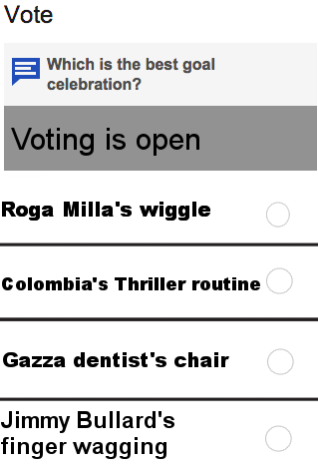

FIG 1.1 :

What the poll should look like if you haven’t voted yet

Ignore the different fonts for the 4 options

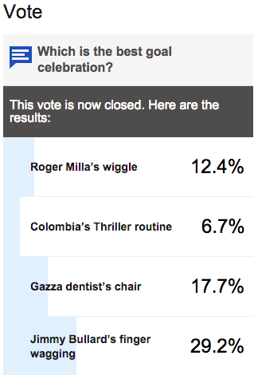

FIG 1.2

What the poll should look like after you voted or when you return later that day after you already voted.

Use the fonts shown on the image.

Sincerely,

Humzah Malik  
humzahmalik@firstwhistle.com