**S3 CHALLENGE**

**Using python and BOTO3:**

Log on to A Cloud Guru Account

1. Create Iam User(programmatic access): IAM -> USERS -> ADD USER ->(NAME, PROGRAMMATIC ACCESS- ACCESS KEY) -> ATTACH EXISTING POLICIES DIRECTLY ( Choose AMAZONS3 FULL ACCESS) ->create( Download.csv)

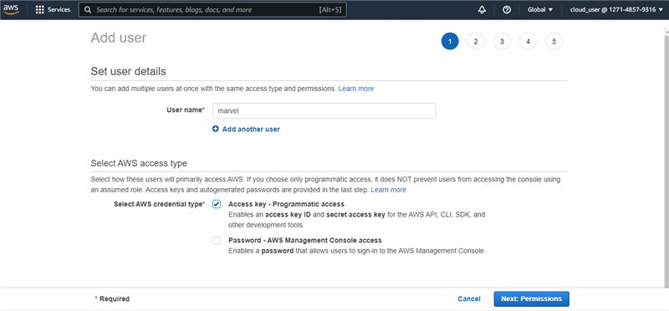

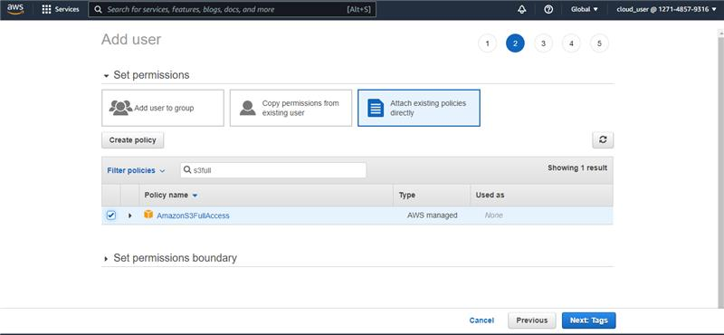

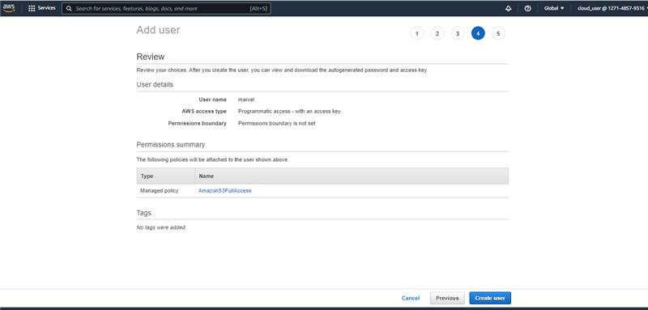

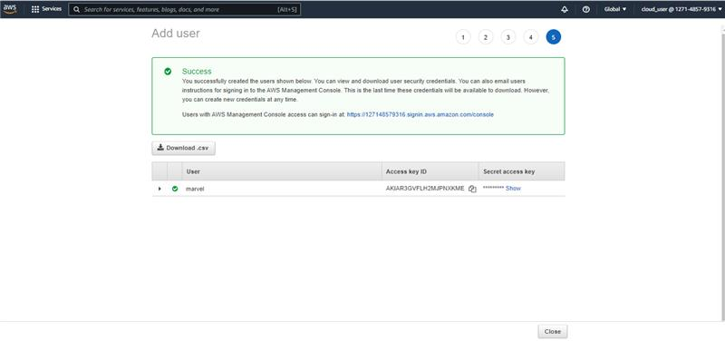

1. Connecting with Boto3 using Access Key ID and Secret Access Key:

import boto3

s3=boto3.client("s3",aws_access_key_id='AKIA************KME',aws_secret_access_key='TWK***********ur8uegiV/5Cra+gGqe8eeF9G2',region_name='us-east-1')

print(s3)

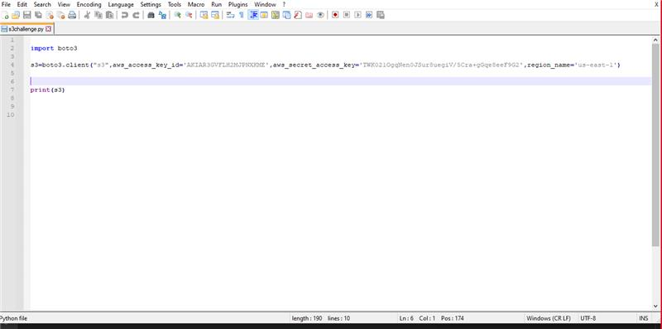

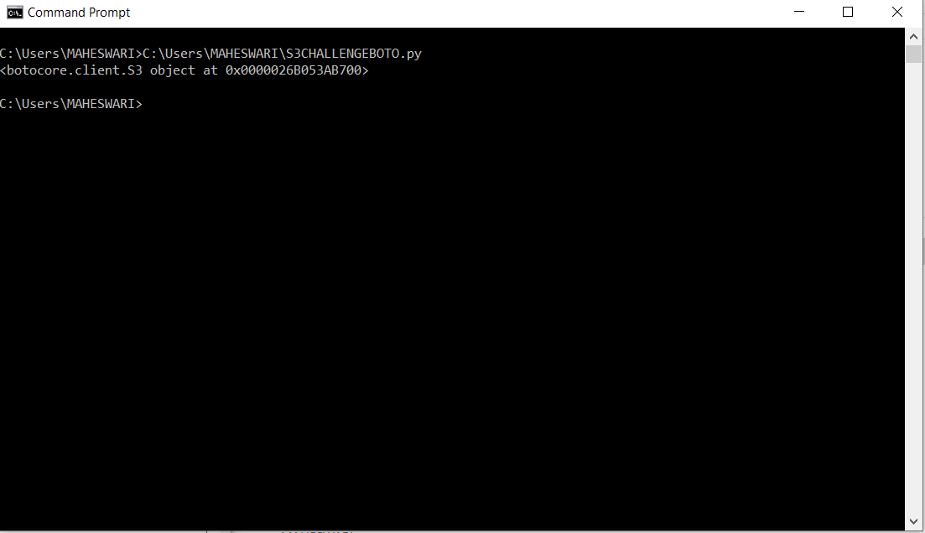

1. Creating 10 s3 buckets :

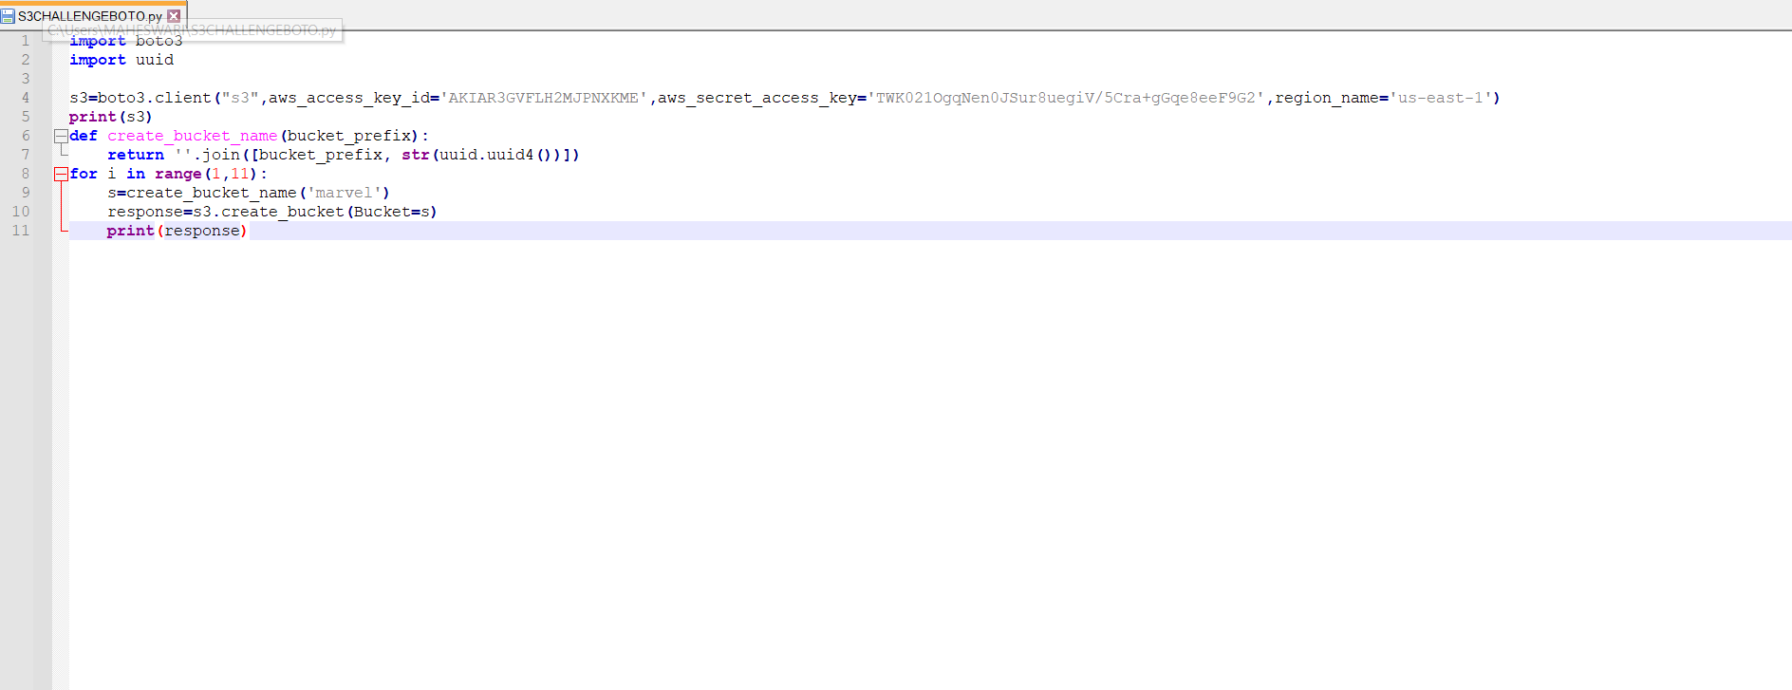

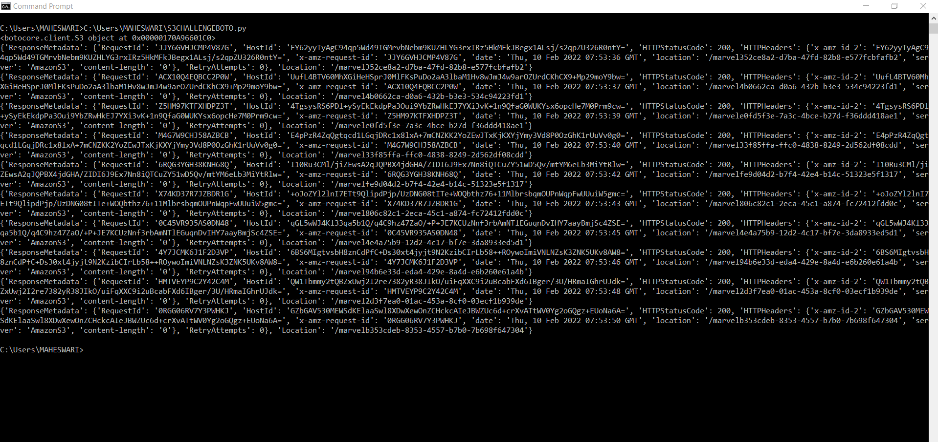

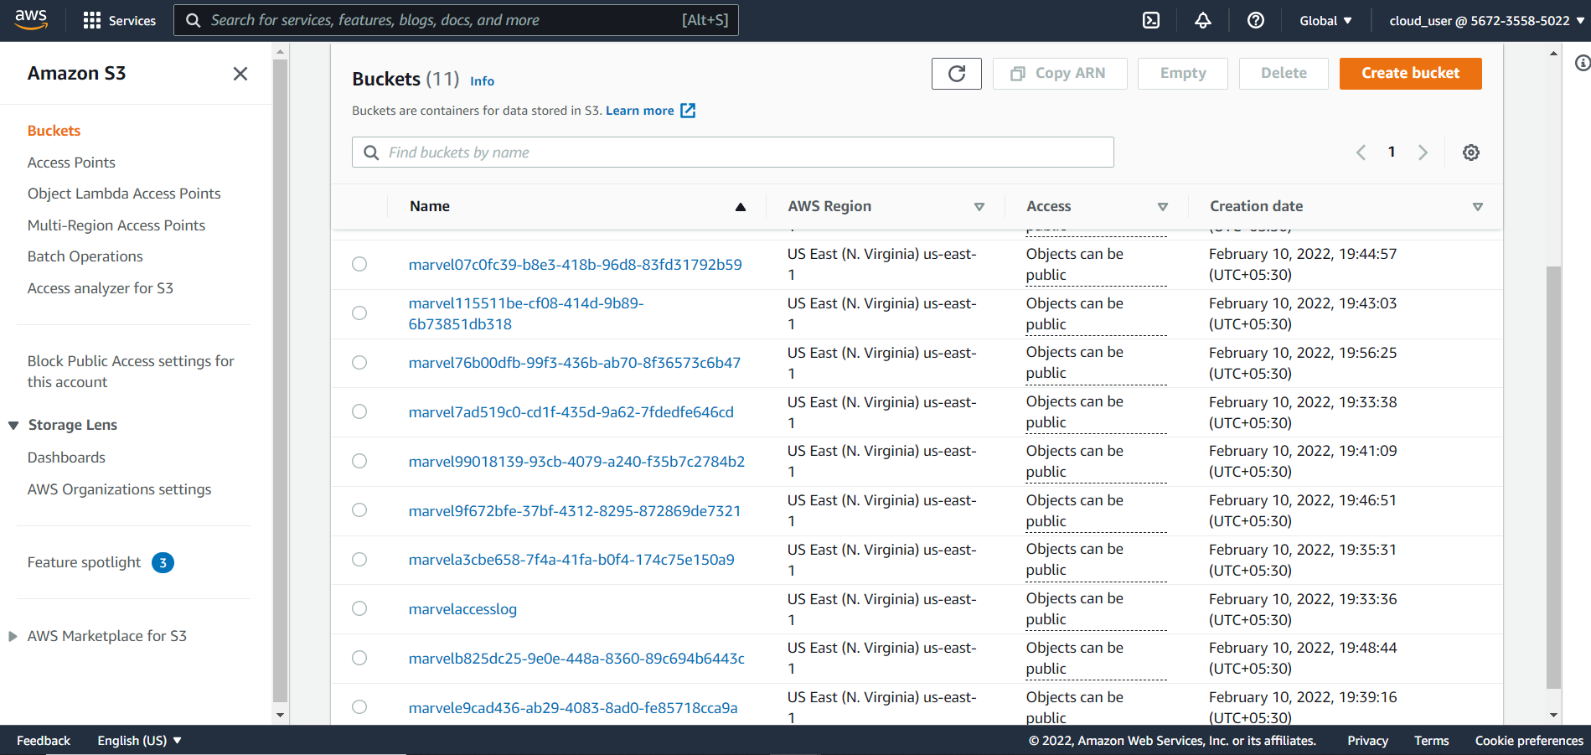

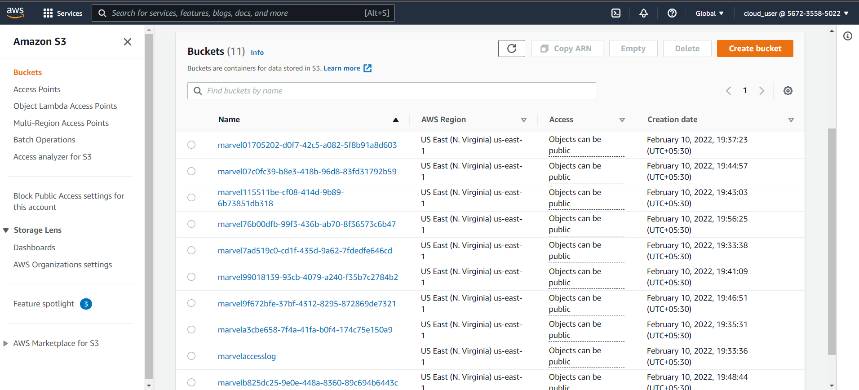

1. **Uploading 100MB+ files data on each bucket:** One bucket can hold different set of files from 1b to 4.5TB. we can have meaningful set of files in one bucket.

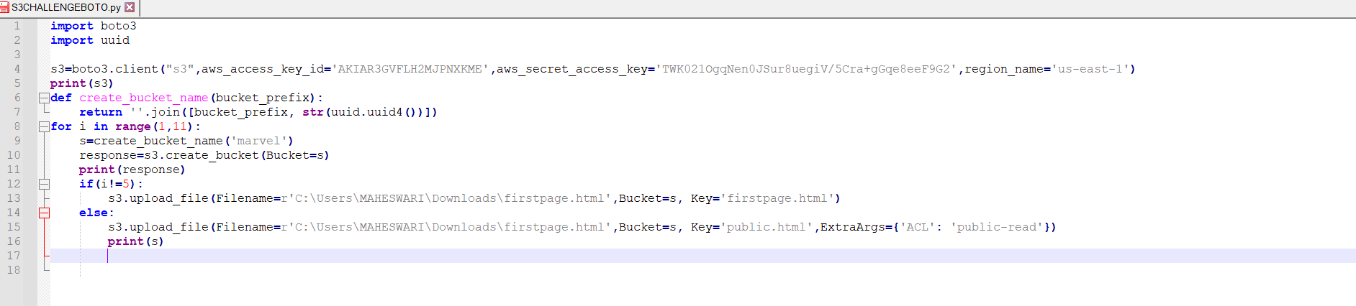

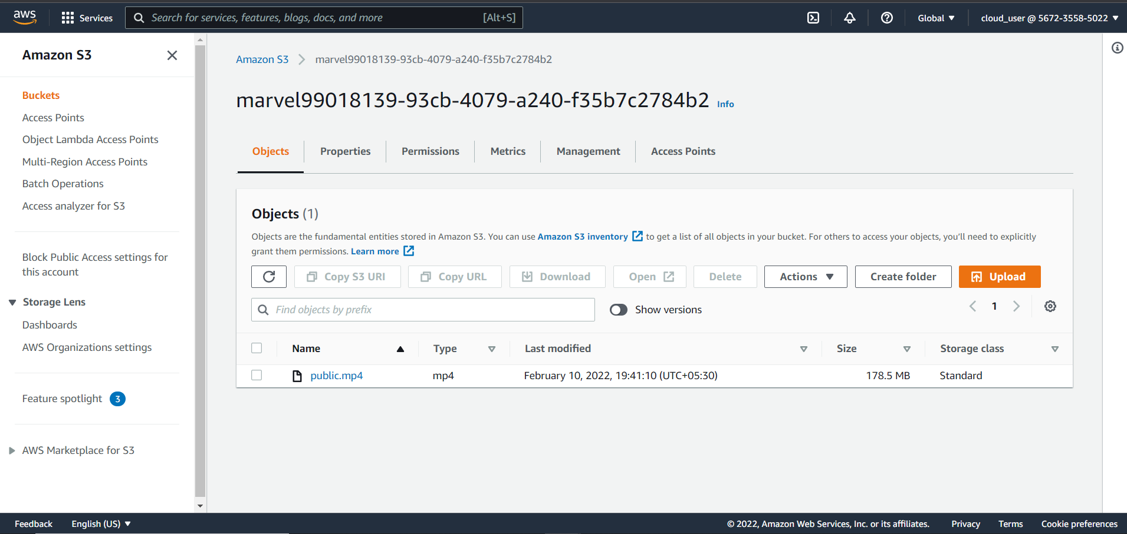

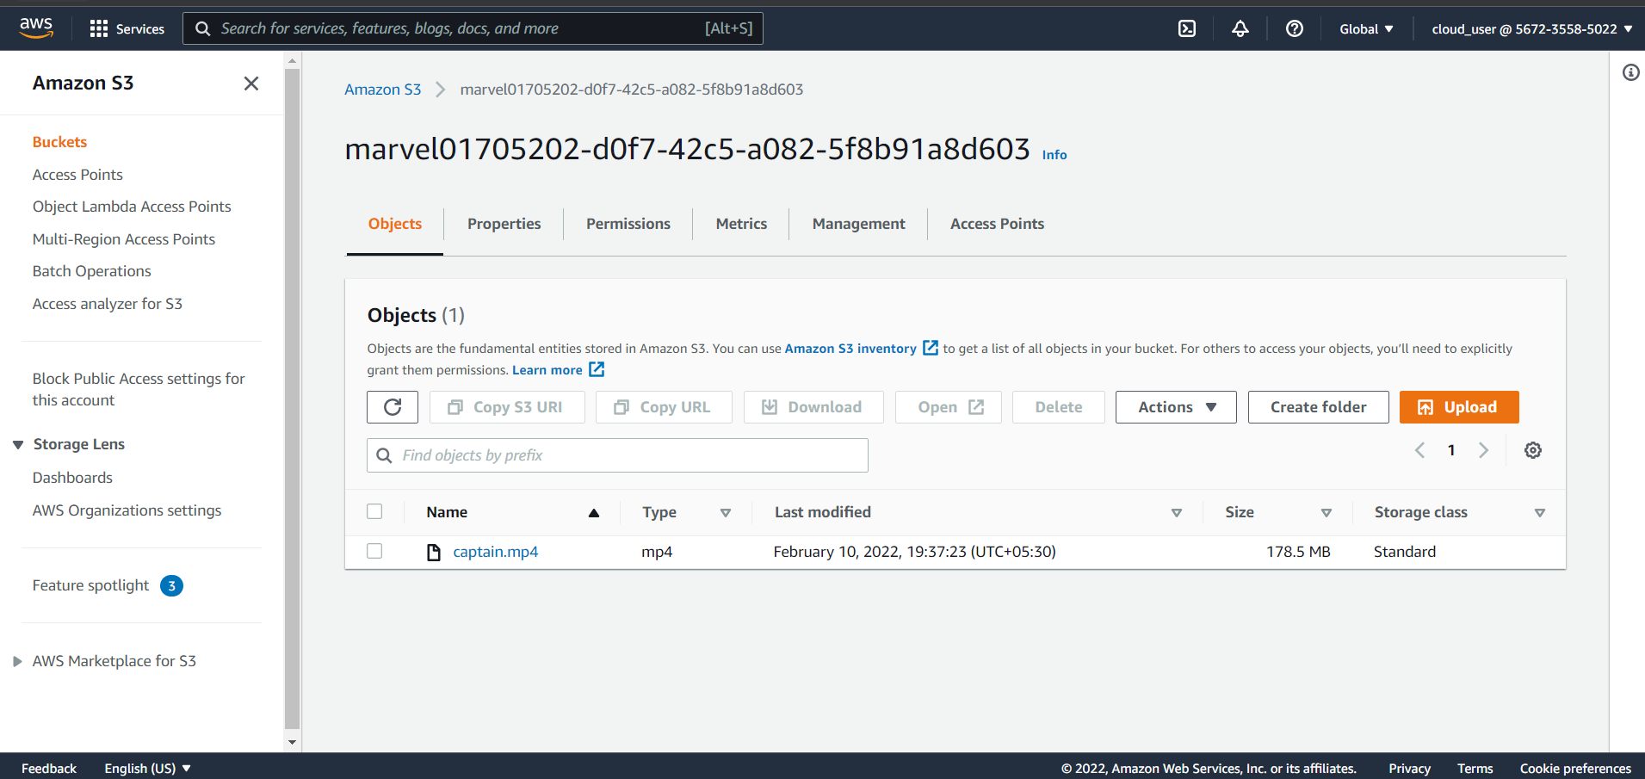

1. **Making one bucket content public, rest all are in private:** Bucket is private state but files can be made public. So that, people can access only files to read but not to edit.

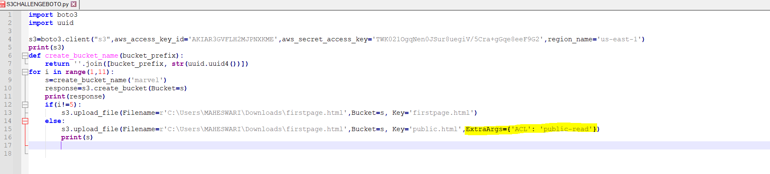

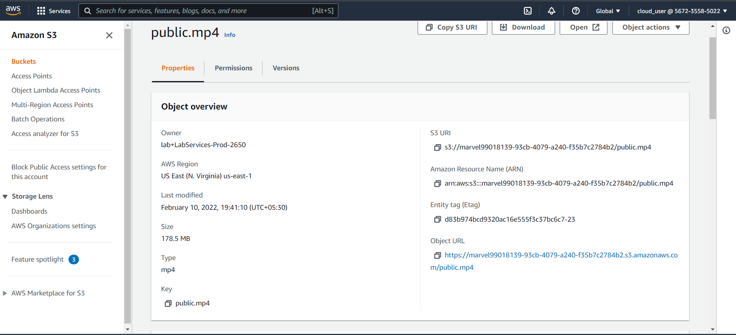



1. **Enabling versioning for one bucket:** Versioning-enabled buckets allow us to recover the objects from the deletion or overwrite. It serves two purposes: If we delete an object, instead of deleting the object permanently, it creates a delete marker which becomes a current version of an object.

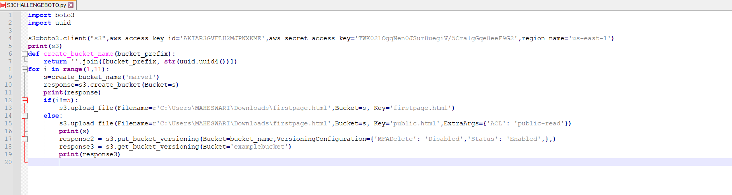



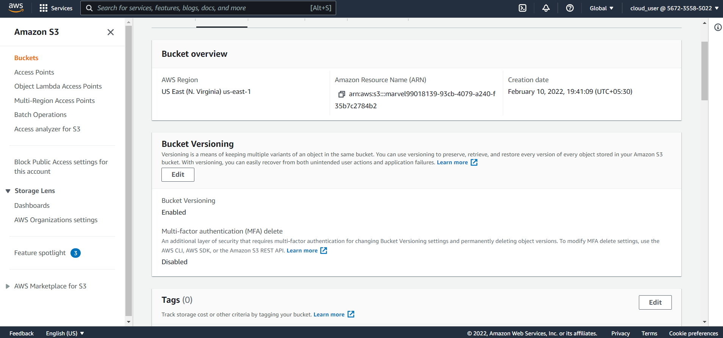

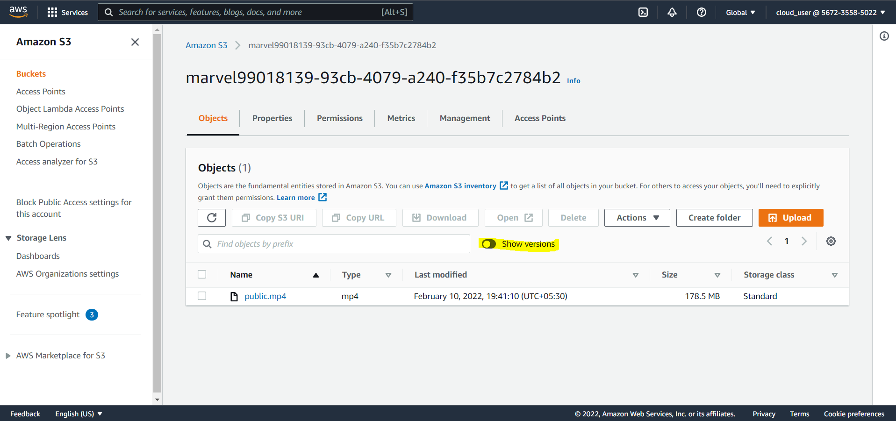

1. **Enabling access logs for one bucket:** An access log is alist of all requests for individual files that people or bots have requested from a website. Log File strings include notes about their requests for the HTML files.

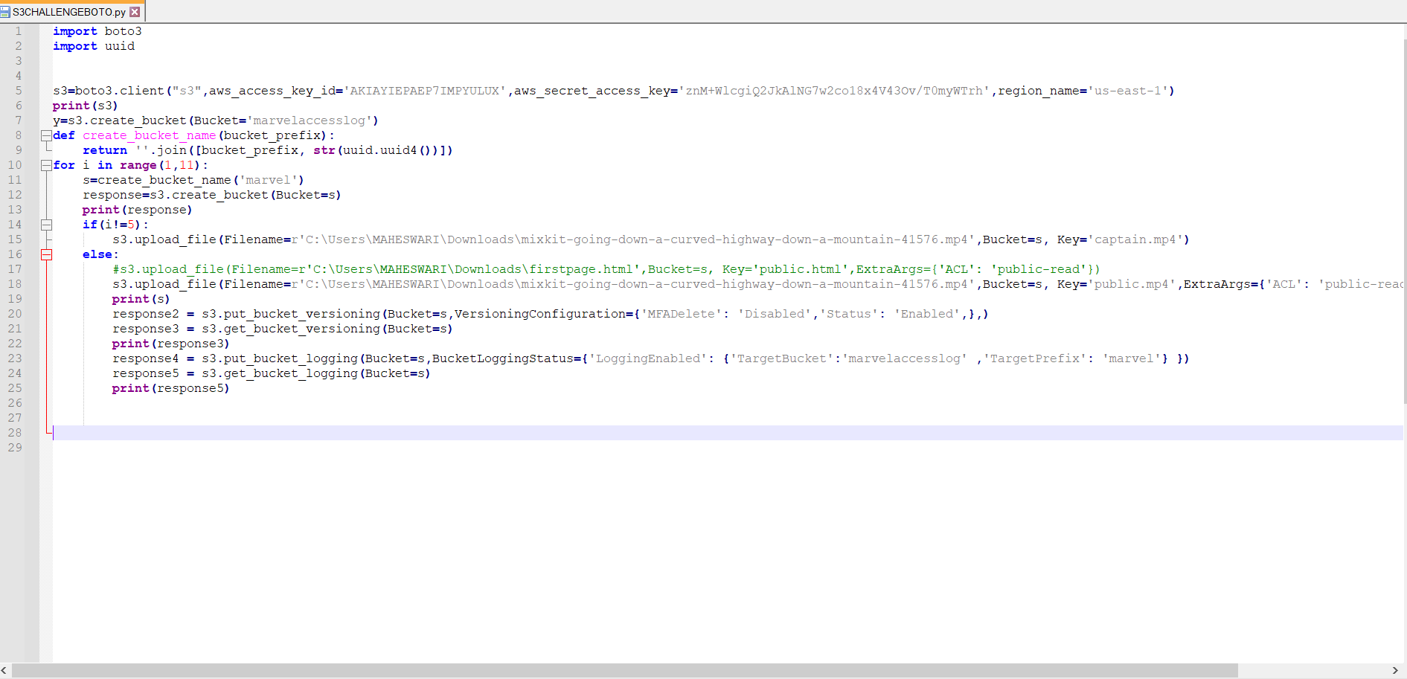

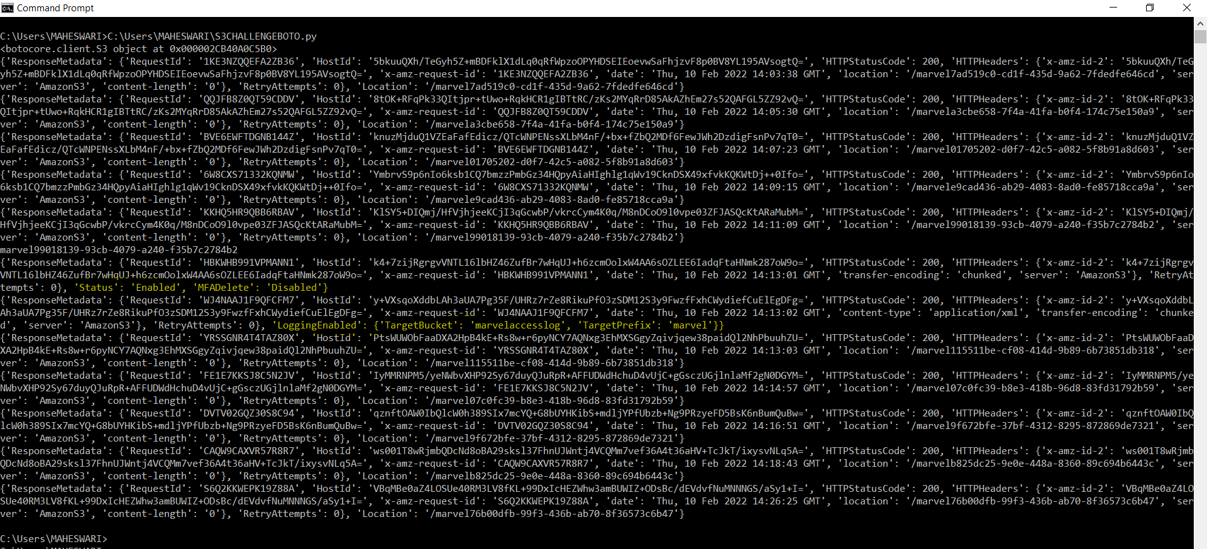

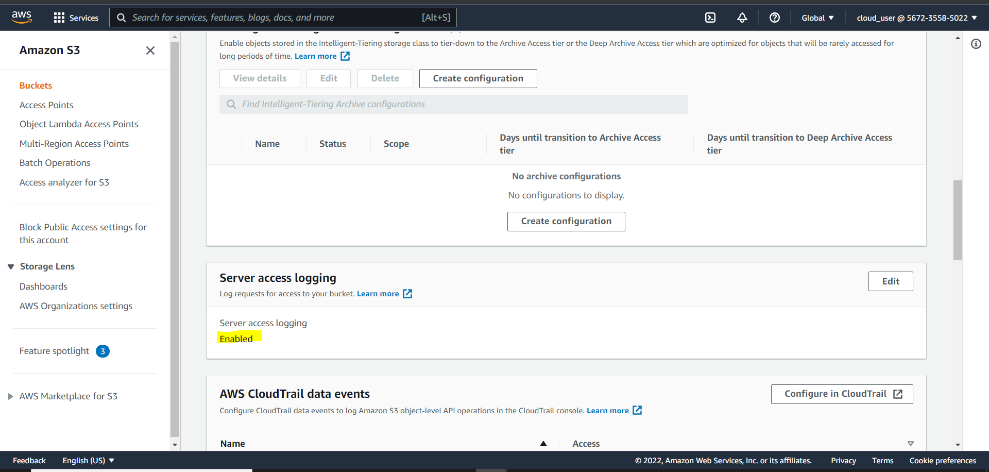

1. Created a Excel file:

