**S3 CHALLENGE**

**Using AWS console:**

Log on to A Cloud Guru Account

1. [Create s3 Bucket > Bucket Name > region select us-east-1 > click on create]:

- Created (marvel1-10) s3 buckets in us-east-1 Region.

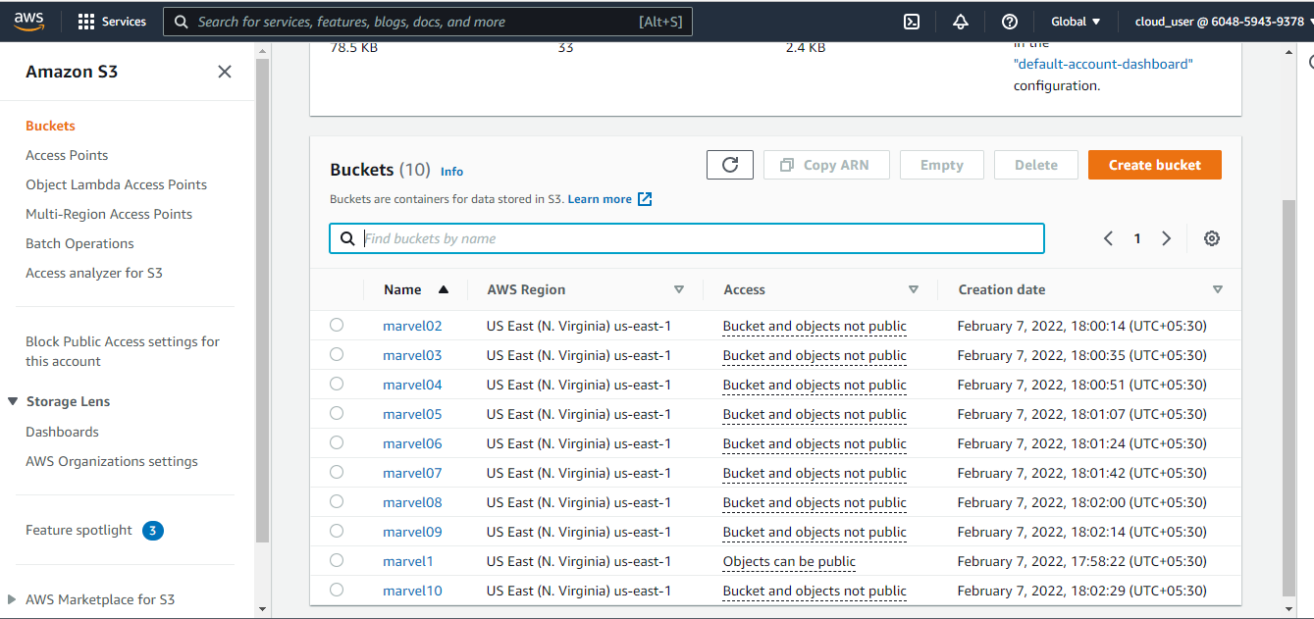

1. [By clicking on bucket name in object page > upload files > select files (100MB+,200mb+..)>upload]: - Uploaded the datafiles in each bucket.

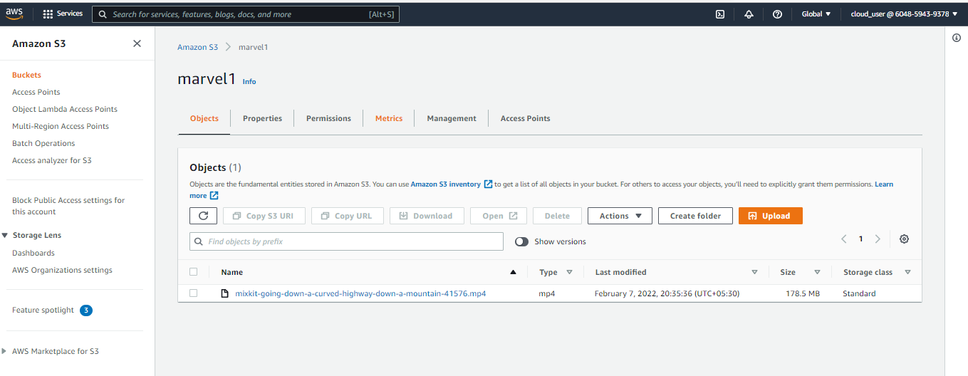

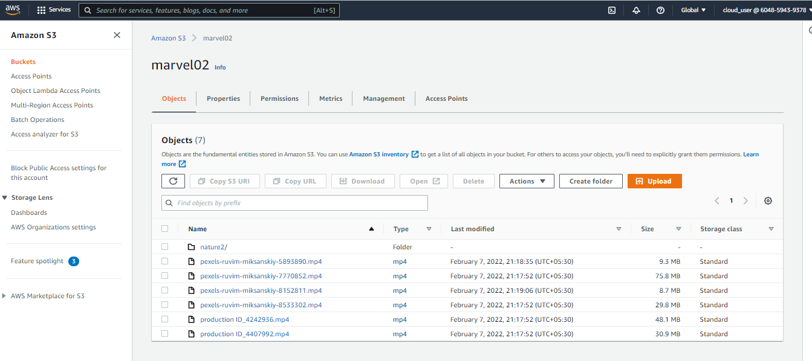

1. [By clicking on (marvel1)bucket name in object page > permissions > Block public access (edit) > uncheck first and second (i.e objects granted through any/new access control lists beacause we are enabling public access through ACL'S enabled) > check third and fourth (i.e objects granted through new/any public bucket or access point policies because we have to give only public access but not the access point policies) >save changes. Permissions> Object Ownership > ACL’S enable> save changes]

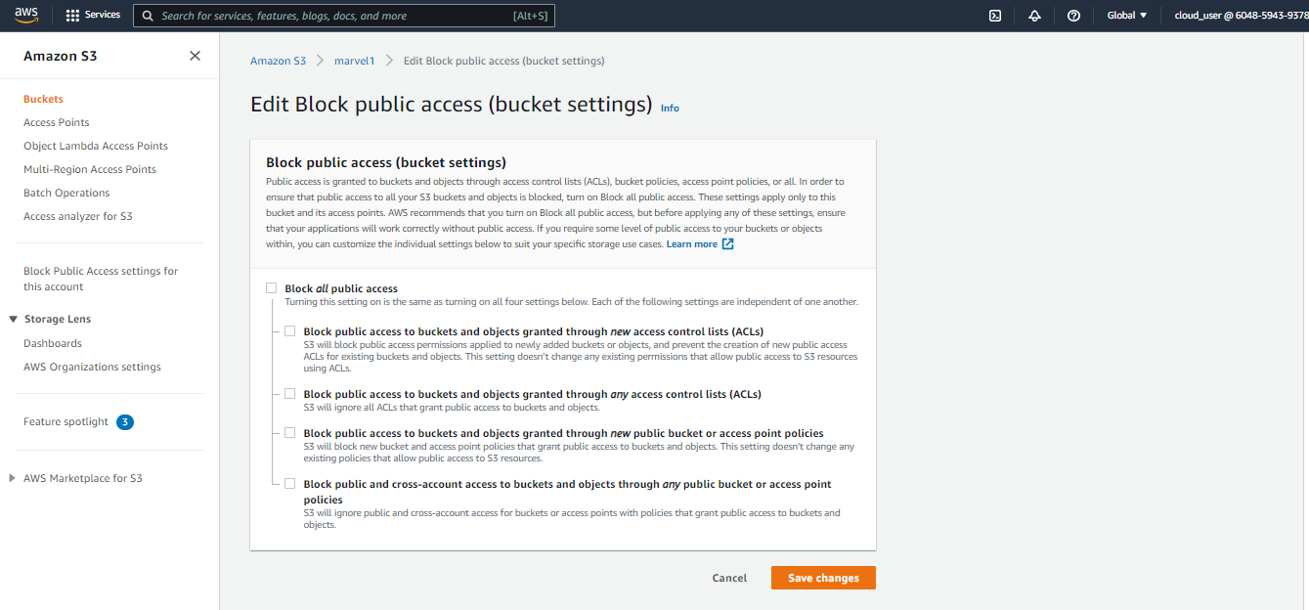

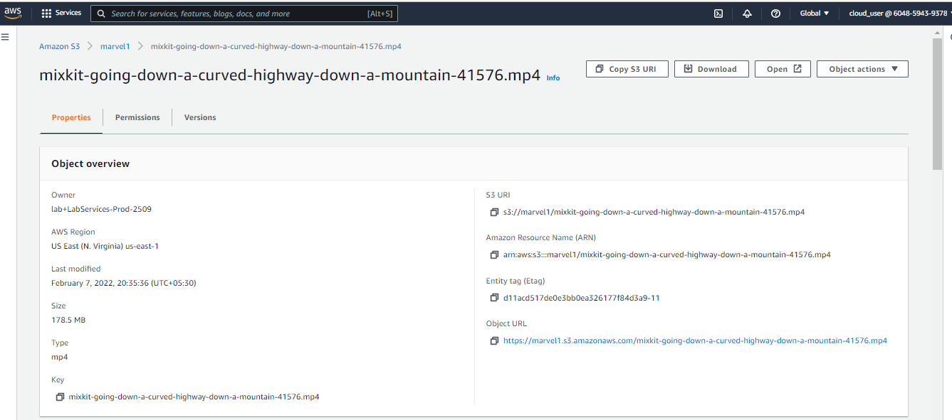

1. [By clicking on (marvel1)bucket name in object page > Actions > Make public using ACL]

* Making marvel1 bucket public and rest all are private

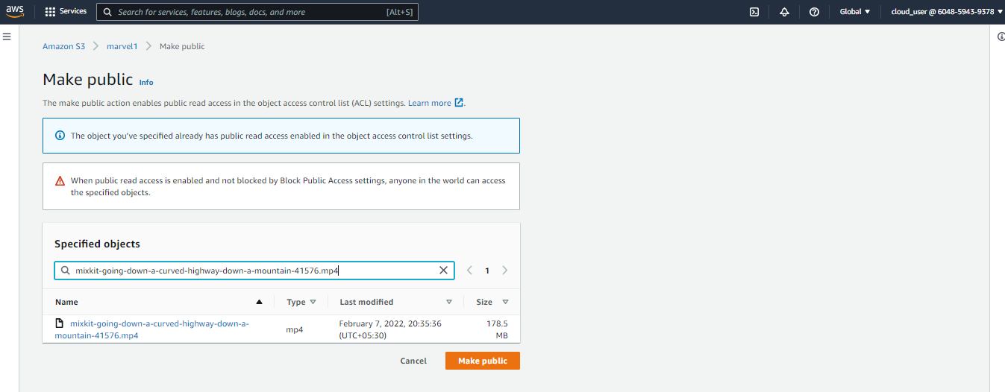



1. [By clicking on (marvel1)bucket name in object page > properties > Bucket versioning > Enable > Save .

* When we enable versioning, we would able to see backend files (delete marker files) that we can able to retrieve it.
* If we disable versioning, we would able to see front end files (able to store in backend by deleting the files from front end).
* If we upload error.txt file and modify, upload error.txt then old versioning attached with the modified file (original files) able to see.

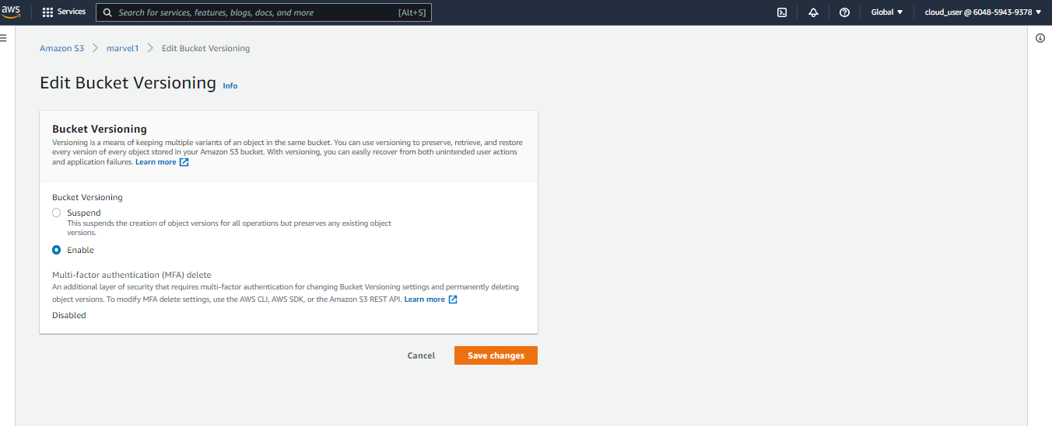

1. [By clicking on (marvel1)bucket name in object page > properties > server access logging select edit > Server Access Logging ENABLE > for Target bucket, enter the name of the bucket that we want to receive the log record objects. The target bucket must be in the same Region as the source bucket and must not have a default retention period configuration > save changes.

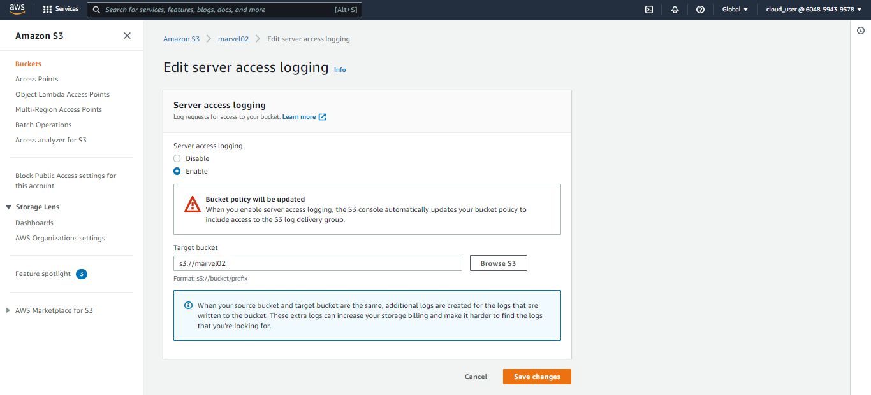

1. **Creating an Excel File with Buckets data:**

