**S3 challenge with AWS CLI and Scripting:-**

->First we have to create an IAM user with S3fullaccess and configure to that user using the “AWS configure “ cli command and use the user’s Access key and id.

**->We** are using for loop to create multiple buckets.

->For creating a bucket we have to use aws s3 mb s3://”bucket-name” command.It create bucket name with specified name.

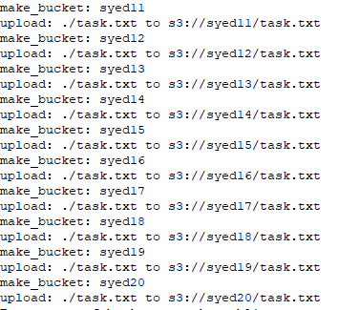

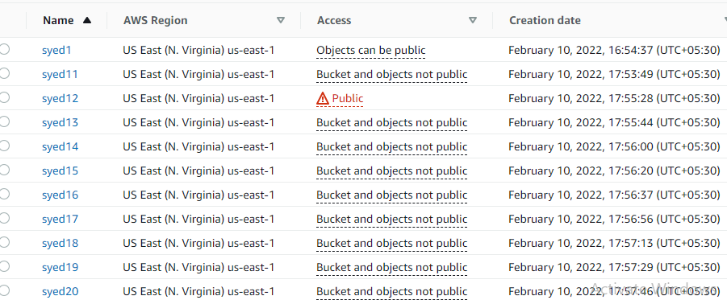

By default buckets are private.

->To make a specific bucket public ,here we used a policy to make bucket public: check publicpolicy **json** file to know about policy.

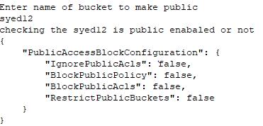

Also verify above console image to check which bucket is public(marked in red).

Aws s3 cp command is used to upload data into bucket.

->aws s3api put-bucket-versioning command is used to enable versioning.

-> aws s3api get-bucket-versioning –bucket is used to check whether the bucket is enabled or not.

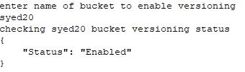

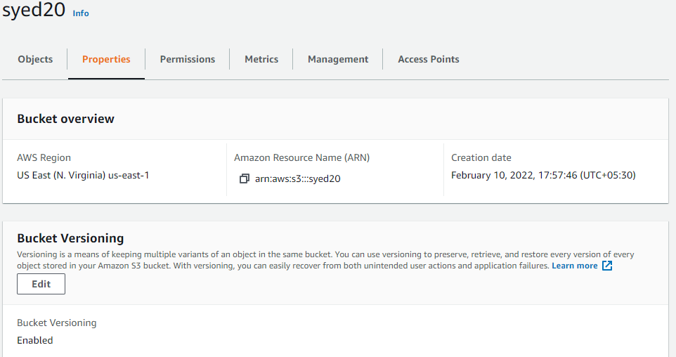

🡪Access logs is enabled by writing policy on that bucket refer policy.json

🡪 aws s3 ls --summarize --human-readable --recursive s3://Bucket-Name is used to get the size of the bucket.

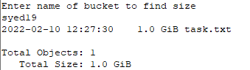

**Creating an Excel File with Buckets data:**

