Homoscadastity:

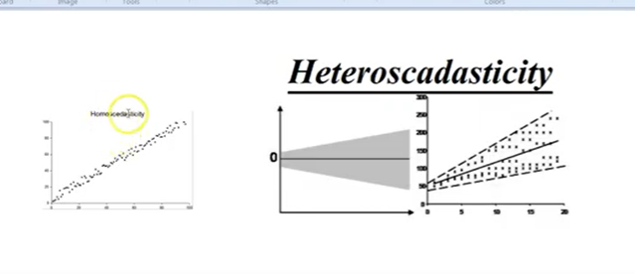

Data shoulbe homoscedastic

For residual the variance between residual is constant

Between- predicted values and errors /residuals

Equal variance-homoscadasticity

Heteroscadasticity – increased variance as predicted value increase

How to avoid: we need to remove insignificant features

