Mlops:

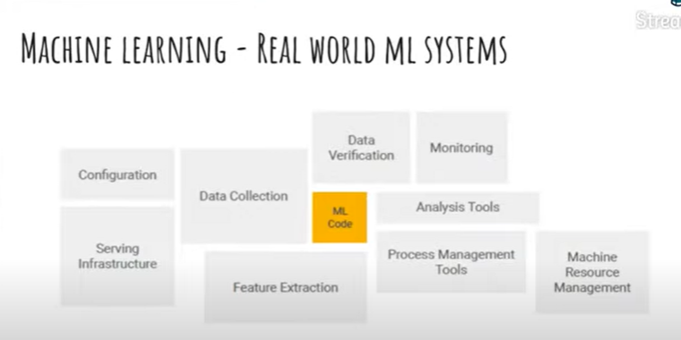

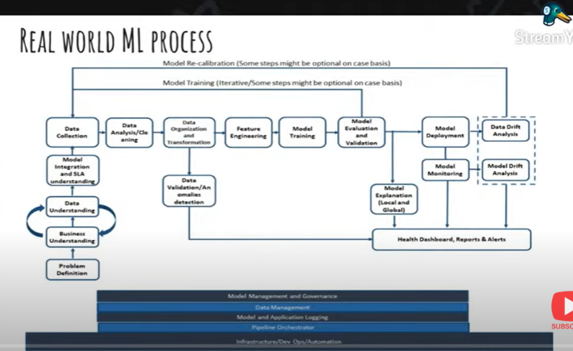



We need to understand non functional requiremts: more transaction per min

Need to scale

**End to End Machine Learning Overview**

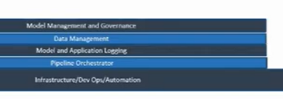

Bottom part: horizontal capability

Cross project capability

We don’t do it for each project separately

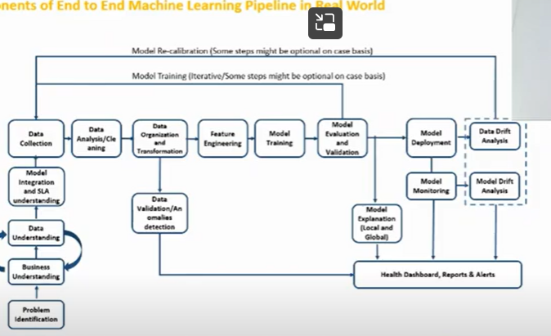

Specific to use case

When should we use ml

If we have 100 customers not require

But 1000s of customers we need to scales – complex to manage

Business understanding:

Where we defined –

What is the process actually does

Understand end to end business process

Business object: detect fraudulent customer

What is his ability to pay

I want to know fraudulent customer

Don’t confuse business object with machine learning object

To know business advantage

Data understanding

Where data originate

How its get processed

What decisions are made and making

Multiple subsystems where it goes

Model integration

When we develop- develop model in batch system

When deploying – we should develop in real time system

Model should respond quickly

We need to accountable for deployment while creating

We need to keep in mind meeting SLA need

Data collection:

Data analysis : understand data

Inferential and descriptive statistics

Exploratory data analysis

What additional transformations

Data validation and anomaly detection :

Feature engineering

Model training

Model evaluation and validation

Model explanation:

Which attribute contributed

Global : feature imp

Model deployment:

Once deployed – monitor

Model drift analysis

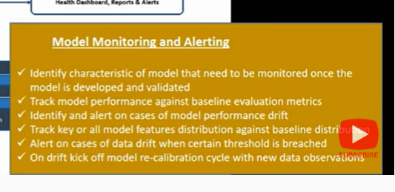

Data drift analysis:

We should see data distribution which our model with incoming data distribution

If the data is completely diff

Then data drifting

Model drift

When we train and evaluate our model

We store our score distribution

Compare with score distribution of new data

Now new data

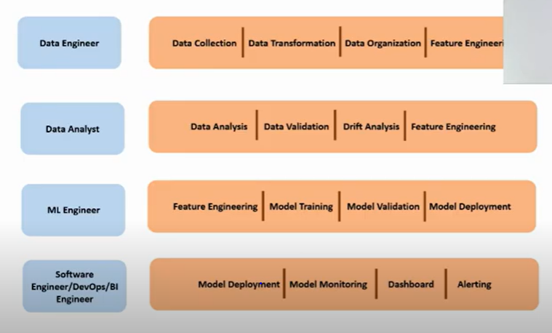

**Identifying Machine Learning Use Cases**

Machine learning is not a sol

Simple solution can also do

Try to use when it actually useful

If cost of making is much high

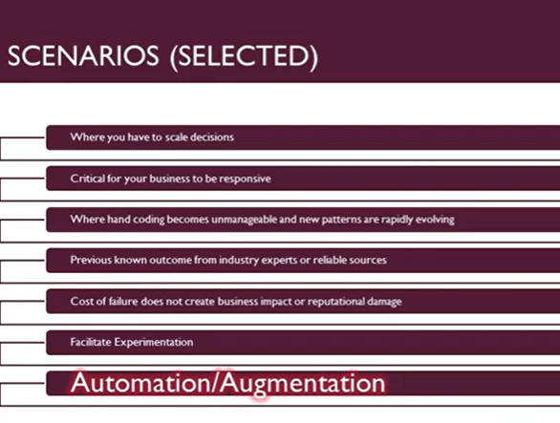

**Model Execution Performance and Integration Understanding**

Non functional requirements:

How much time model gives result

Based one business case

How much volume it handles-

Platforms- auto scale

Understand model integration

**Data Collection - Data Architecture - Part 1**