NLTK:

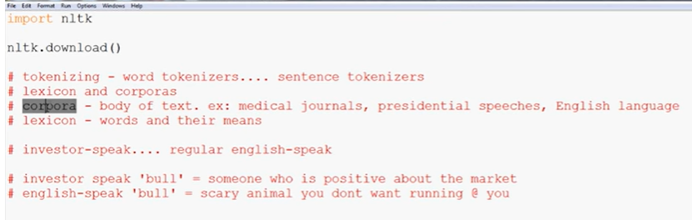

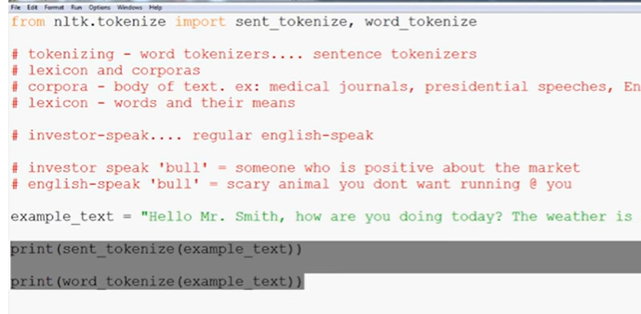

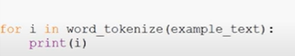

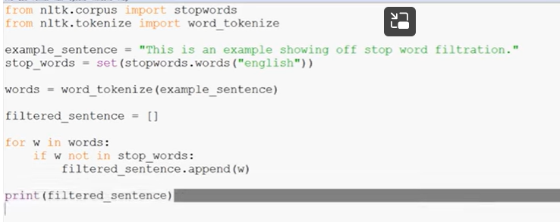

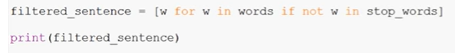

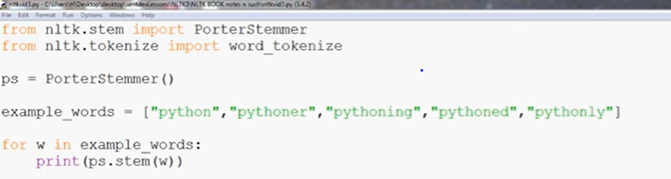

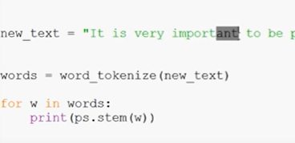

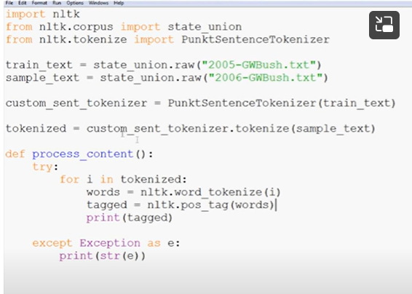

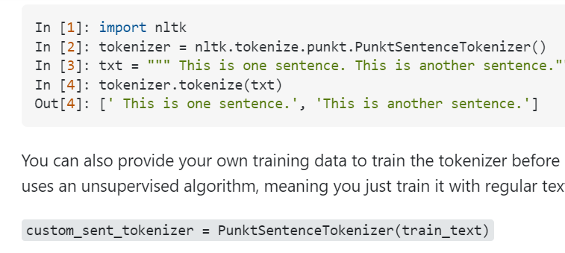

Len:

Number of characters

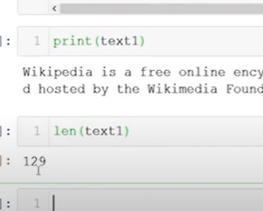

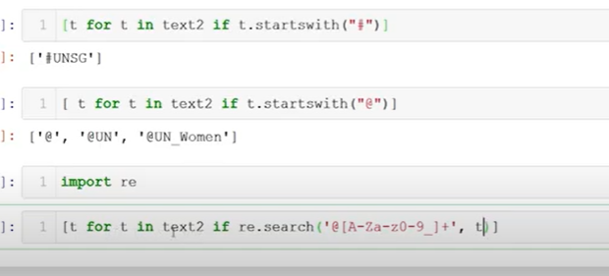starts with @

Alphabates

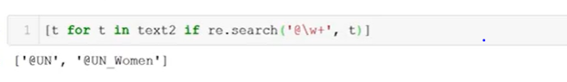

**Top NLP Libraries**

* Natural Language Toolkit (NLTK) NLTK is one of the leading platforms for building Python programs that can work with human language data. ...
* Gensim. ...
* CoreNLP. ...
* spaCy. ...
* TextBlob. ...
* Pattern. ...
* PyNLPl.

Textblob:

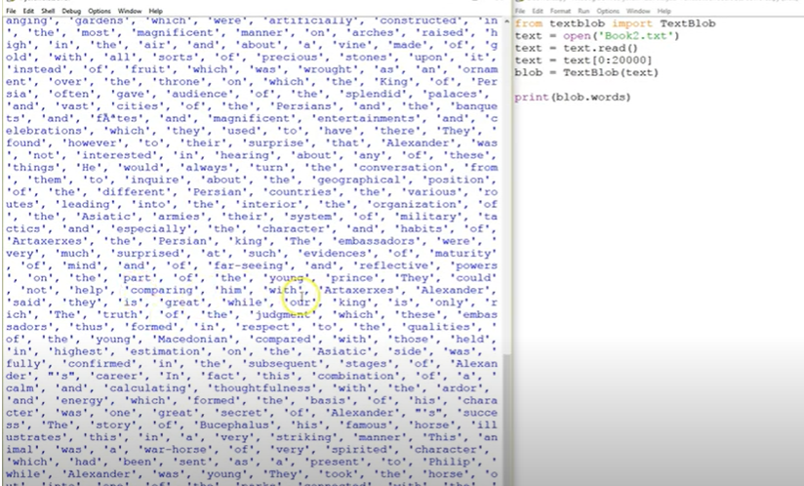

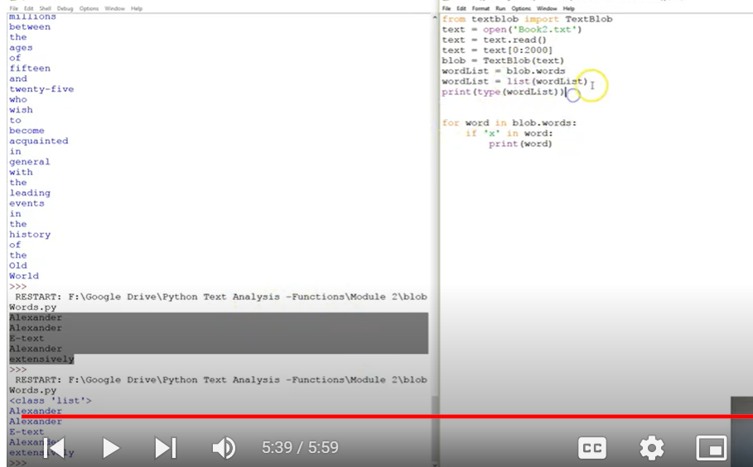

Sentences

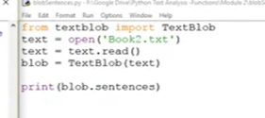

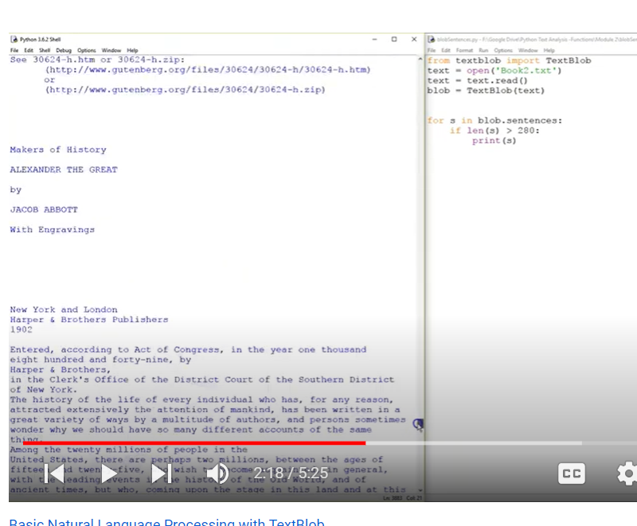

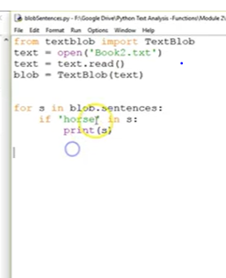

# Generating a list of noun_phrases using TextBllob

Naun phrases

Car: describing noun

Fast driving car

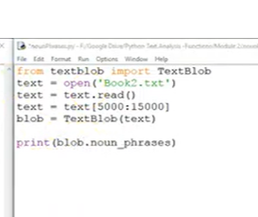

# Easily counting proper nouns in a string using TextBlob

Counts proper nouns in sentence

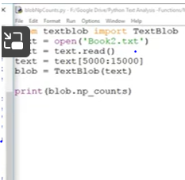

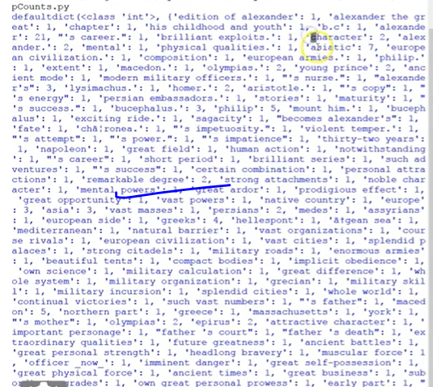

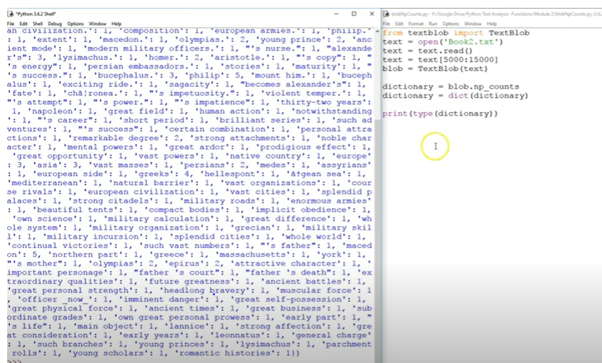

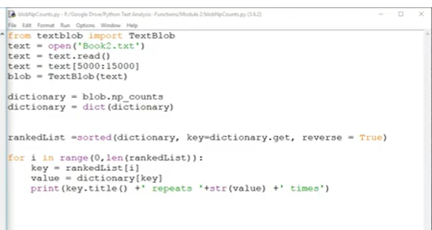

# Finding a polarity of a string with TextBlob (Natural Language Processing)

-1 to 1

Polarity : how happy or sad

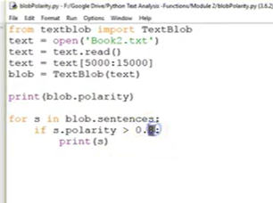

# Sentiment analysis with TextBlob

Blob sentiment is combination of polarity and subjectivity

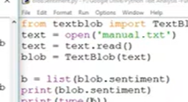

# Measuring language subjectivity with TextBlob and Python

0 t 1

0 fully factual

1 is subjective

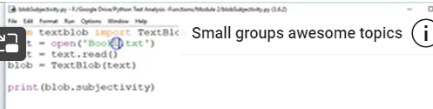

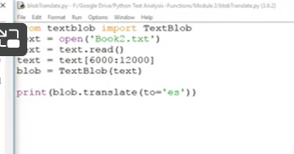

Es = Spanish code

