**Diabetes types**

Diabetes mellitus, -**metabolic disease** that causes **high blood sugar**.

The hormone **insulin** moves sugar from the blood into your cells to be stored or used for energy.

With diabetes, your body **either doesn’t make enough insulin** **or can’t effectively use the insulin** it does make.

Untreated high blood sugar from diabetes can **damage your nerves, eyes, kidneys, and other organs.**

There are a few different types of diabetes:

* [Type 1 diabetes](https://www.healthline.com/health/type-1-diabetes-causes-symtoms-treatments) is an [autoimmune disease](https://www.healthline.com/health/autoimmune-disorders).
* The immune system attacks and destroys cells in the [pancreas](https://www.healthline.com/human-body-maps/pancreas), where insulin is made.
* About [10 percent](https://www.idf.org/aboutdiabetes/what-is-diabetes/types-of-diabetes.html) of people with diabetes have this type.
* [Type 2 diabetes](https://www.healthline.com/health/type-2-diabetes) occurs when your body becomes resistant to [insulin](https://www.healthline.com/health/type-2-diabetes/insulin), and sugar builds up in your blood.
* [Prediabetes](https://www.healthline.com/health/type-2-diabetes/what-is-prediabetes) occurs when your blood sugar is higher than normal, but it’s not high enough for a diagnosis of type 2 diabetes.
* [Gestational diabetes](https://www.healthline.com/health/gestational-diabetes) is high blood sugar during pregnancy. Insulin-blocking hormones produced by the placenta cause this type of diabetes.

A rare condition called [diabetes insipidus](https://www.healthline.com/health/type-2-diabetes/diabetes-insipidus) is not related to diabetes mellitus, although it has a similar name. It’s a different condition in which your kidneys remove too much fluid from your body.

**Symptoms of diabetes**

Diabetes symptoms are caused by rising blood sugar.

**General symptoms**

The general symptoms of diabetes include:

* increased hunger
* increased thirst
* weight loss
* [frequent urination](https://www.healthline.com/health/frequent-urination-diabetes)
* [blurry vision](https://www.healthline.com/health/diabetes/blurry-vision)
* [extreme fatigue](https://www.healthline.com/health/diabetes/fatigue)
* [sores that don’t heal](https://www.healthline.com/health/diabetes/diabetes-and-wound-healing)

**Symptoms in men**

In addition to the general symptoms of diabetes, [men with diabetes](https://www.healthline.com/health/recognizing-diabetes-symptoms-men) may have a [decreased sex drive](https://www.healthline.com/health/type-2-diabetes/sex-health), [erectile dysfunction (ED)](https://www.healthline.com/health/type-2-diabetes/type-2-and-erectile-dysfunction), and poor muscle strength.

**Symptoms in women**

[Women with diabetes](https://www.healthline.com/health/diabetes/symptoms-in-women) can also have symptoms such as [urinary tract infections](https://www.healthline.com/health/urinary-tract-infection-adults), [yeast infections](https://www.healthline.com/health/diabetes/diabetes-and-yeast-infections), and dry, itchy skin.

**Type 1 diabetes**

Symptoms of type 1 diabetes can include:

* extreme hunger
* increased thirst
* unintentional weight loss
* [frequent urination](https://www.healthline.com/health/urination-excessive-volume)
* blurry vision
* tiredness

It may also result in mood changes.

**Type 2 diabetes**

Symptoms of type 2 diabetes can include:

* increased hunger
* increased thirst
* increased urination
* blurry vision
* tiredness
* sores that are slow to heal

**Gestational diabetes**

Most women with gestational diabetes **don’t have any symptoms**. The condition is often detected during a routine blood sugar test or oral glucose tolerance test that is usually performed between the **24th and 28th weeks of gestation.**

In rare cases, a woman with gestational diabetes will also experience increased thirst or urination.

**The bottom line**

**Causes of diabetes**

Different causes are associated with each type of diabetes.

**Type 1 diabetes**

Doctors don’t know exactly what causes type 1 diabetes.

For some reason, the **immune system mistakenly attacks and destroys insulin-producing beta cells** in the [pancreas](https://www.healthline.com/health/diabetes-and-pancreas).

Genes may play a role in some people. It’s also possible that a virus sets off the immune system attack.

**Type 2 diabetes**

 type 2 diabetes, your cells become resistant to the action of insulin, and your pancreas is unable to make enough insulin to overcome this resistance. Instead of moving into your cells where it's needed for energy, sugar builds up in your bloodstream.

Type 2 diabetes stems from a combination of [**genetics**](https://www.healthline.com/health/type-2-diabetes/genetics)**and lifestyle factors. Being overweight or**[**obese**](https://www.healthline.com/health/obesity) increases your risk too. Carrying **extra weight**, especially [in your belly](https://www.healthline.com/nutrition/20-tips-to-lose-belly-fat), makes your cells more resistant to the effects of insulin on your blood sugar.

This **condition runs in families.** Family members share genes that make them more likely to get type 2 diabetes and to be overweight.

Type 2 diabetes usually begins with [insulin resistance](https://www.niddk.nih.gov/health-information/diabetes/overview/what-is-diabetes/prediabetes-insulin-resistance), a condition in which muscle, [liver](https://www.niddk.nih.gov/Dictionary/L/liver), and fat cells do not use insulin well. As a result, your body needs more insulin to help [glucose](https://www.niddk.nih.gov/Dictionary/G/glucose) enter cells. At first, the pancreas makes more insulin to keep up with the added demand. Over time, the pancreas can’t make enough insulin, and blood glucose levels rise.

**Gestational diabetes**

Gestational diabetes is the result of **hormonal changes during pregnancy**. The placenta produces hormones that make a pregnant woman’s cells less **sensitive to the effects of insulin.** This can cause high blood sugar during pregnancy.

Women who are [**overweight when they get pregnant**](https://www.healthline.com/health/pregnancy/obesity)or **who**[**gain too much weight during their pregnancy**](https://www.healthline.com/health-news/gaining-too-much-weight-during-pregnancy) are more likely to get gestational diabetes.

**Diabetes risk factors**

Certain factors increase your risk for diabetes.

**Type 1 diabetes**

You’re more likely to get type 1 diabetes if you’re a child or teenager, you have [a parent or sibling](https://www.healthline.com/health/family-health-history-day) with the condition, or you carry certain **genes** that are linked to the disease.

**Type 2 diabetes**

Your risk for type 2 diabetes increases if you:

* are overweight
* are age 45 or older
* have a parent or sibling with the condition
* aren’t physically active
* have had gestational diabetes
* have prediabetes
* have [high blood pressure](https://www.healthline.com/health/type-2-diabetes/hypertension), [high cholesterol](https://www.healthline.com/health/high-cholesterol/treating-with-statins/guide-to-diabetes-and-high-cholesterol), or [high triglycerides](https://www.healthline.com/health/triglyceride-level)
* have African American, Hispanic or Latino American, Alaska Native, Pacific Islander, American Indian, or Asian American ancestry

**Gestational diabetes**

Your risk for gestational diabetes increases if you:

* are overweight
* are over age 25
* had gestational diabetes during a past pregnancy
* have given birth to a baby weighing [more than 9 pounds](https://www.healthline.com/health/macrosomia)
* have a family history of type 2 diabetes
* have [polycystic ovary syndrome (PCOS)](https://www.healthline.com/health/diabetes/are-pcos-and-diabetes-connected)

Top of Form

**HEALTHLINE RESOURCE**

**Diabetes nutrition made easy — in just 10 mins a week**

Our free weekly micro-lessons can empower you with wisdom you need to make healthy changes for your diabetes. Short and easy to follow tips for the week ahead.

Enter your email

GET FREE ACCESS

also sign up for our popular Type 2 Diabetes Newsletter

Your [privacy](https://www.healthline.com/privacy-policy) is important to us

Bottom of Form

**Diabetes complications**

High blood sugar damages **organs and tissues** throughout your body. The higher your blood sugar is and the longer you live with it, the greater your risk for complications.

Complications associated with diabetes include:

* [heart disease](https://www.healthline.com/health/type-2-diabetes/understanding-cv-disease-diabetes), [heart attack](https://www.healthline.com/health/heart-attack), and [stroke](https://www.healthline.com/health/diabetes/diabetes-and-stroke)
* [neuropathy](https://www.healthline.com/health/type-2-diabetes/diabetic-neuropathy)
* [nephropathy](https://www.healthline.com/health/type-2-diabetes/nephropathy)
* [retinopathy](https://www.healthline.com/health/type-2-diabetes/retinopathy) and [vision loss](https://www.healthline.com/health/diabetes/diabetic-eye-exam)
* [hearing loss](https://www.healthline.com/health/type-2-diabetes/hearing-loss)
* [foot damage](https://www.healthline.com/health/type-2-diabetes/feet) such as infections and sores that don’t heal
* [skin conditions](https://www.healthline.com/health/type-2-diabetes/skin-problems) such as [bacterial](https://www.healthline.com/health/cellulitis) and [fungal](https://www.healthline.com/health/fungal-infection) infections
* [depression](https://www.healthline.com/health/type-2-diabetes/depression)
* [dementia](https://www.healthline.com/health/dementia-risk-factors)

**Gestational diabetes**

Uncontrolled gestational diabetes can lead to problems that affect both the mother and baby. Complications affecting the baby can include:

* [premature birth](https://www.healthline.com/health/pregnancy/premature-infant)
* [higher-than-normal weight at birth](https://www.healthline.com/health/parenting/average-baby-weight)
* increased risk for type 2 diabetes later in life
* [low blood sugar](https://www.healthline.com/health/hypoglycemia)
* [jaundice](https://www.healthline.com/health/newborn-jaundice)
* stillbirth

The mother can develop complications such **as high blood pressure (**[**preeclampsia**](https://www.healthline.com/health/preeclampsia)**)** or type 2 diabetes. She may also require [cesarean delivery](https://www.healthline.com/health/c-section), commonly referred to as a C-section.

**Treatment of diabetes**

Doctors treat diabetes with a few different medications. Some of these drugs are taken [by mouth](https://www.healthline.com/health/diabetes/diabetes-pills-vs-insulin), while others are available as [injections](https://www.healthline.com/health/intravenous-medication-administration).

**Type 1 diabetes**

[Insulin](https://www.healthline.com/health/diabetes/insulin-injection) is the main treatment for type 1 diabetes

There are four types of insulin that are most commonly used. They’re differentiated by how quickly they start to work, and how long their effects last:

* **Rapid-acting insulin** starts to work within 15 minutes and its effects last for 3 to 4 hours.
* **Short-acting insulin** starts to work within 30 minutes and lasts 6 to 8 hours.
* **Intermediate-acting insulin** starts to work within 1 to 2 hours and lasts 12 to 18 hours.
* **Long-acting insulin** starts to work a few hours after injection and lasts 24 hours or longer.

**Type 2 diabetes**

**Diet and exercise** can help some people manage type 2 diabetes. If lifestyle changes aren’t enough to lower your blood sugar, you’ll need to take medication.

These drugs lower your blood sugar in a variety of ways:

|  |  |  |
| --- | --- | --- |
| **Types of drug** | **How they work** | **Example(s)** |
| [Alpha-glucosidase inhibitors](https://www.healthline.com/health/type-2-diabetes/acarbose-miglitol-pramlintide-prevent-glucose-absorption) | Slow your body’s breakdown of sugars and starchy foods | [Acarbose](https://www.healthline.com/health/acarbose-oral-tablet) (Precose) and miglitol (Glyset) |
| Biguanides | Reduce the amount of [glucose](https://www.healthline.com/health/glucose) your liver makes | [Metformin](https://www.healthline.com/health/metformin-oral-tablet) (Glucophage) |
| DPP-4 inhibitors | Improve your blood sugar without making it drop too low | Linagliptin (Tradjenta), saxagliptin (Onglyza), and [sitagliptin](https://www.healthline.com/health/sitagliptin/oral-tablet) (Januvia) |
| Glucagon-like peptides | Change the way your body produces insulin | Dulaglutide (Trulicity), exenatide (Byetta), and liraglutide (Victoza) |
| Meglitinides | Stimulate your pancreas to release more insulin | Nateglinide (Starlix) and repaglinide (Prandin) |
| SGLT2 inhibitors | Release more glucose into the urine | Canagliflozin (Invokana) and dapagliflozin ([Farxiga](https://www.healthline.com/health/dapagliflozin-oral-tablet)) |
| Sulfonylureas | Stimulate your pancreas to release more insulin | [Glyburide](https://www.healthline.com/health/glyburide-oral-tablet) (DiaBeta, Glynase), [glipizide](https://www.healthline.com/health/glipizide-oral-tablet) (Glucotrol), and [glimepiride](https://www.healthline.com/health/glimepiride/oral-tablet) (Amaryl) |
| Thiazolidinediones | Help insulin work better | Pioglitazone (Actos) and rosiglitazone (Avandia) |

You may need to take more than one of these drugs. Some people with type 2 diabetes also take insulin.

**Gestational diabetes**

You’ll need to [monitor your blood sugar level](https://www.healthline.com/health/blood-glucose-monitoring) several times a day during pregnancy. If it’s high, **dietary changes and exercise** may or may not be enough to bring it down.

According to the Mayo Clinic, [about 10 to 20 percent](https://www.mayoclinic.org/diseases-conditions/gestational-diabetes/diagnosis-treatment/drc-20355345) of women with gestational diabetes will need insulin to lower their blood sugar. Insulin is safe for the growing baby.

**Diabetes and diet**

Healthy eating is a central part of managing diabetes. In some cases, changing your diet may be enough to control the disease.

**Type 1 diabetes**

Your blood sugar level rises or falls based on the types of foods you eat.

**Starchy or sugary foods** make blood sugar levels rise rapidly.

Protein and fat cause more gradual increases.

Your medical team may recommend that you [limit the amount of carbohydrates](https://www.healthline.com/nutrition/low-carb-diet-for-diabetes) you eat each day. You’ll also need to [balance your carb intake](https://www.healthline.com/nutrition/diabetes-carbs-per-day) with your insulin doses.

Work with a dietitian who can help you design a diabetes meal plan. Getting the **right balance of protein, fat, and carbs** can help you control your blood sugar. [Check out this guide to starting a type 1 diabetes diet.](https://www.healthline.com/health/type-1-diabetes-diet)

**Type 2 diabetes**

Eating the right types of foods can both control your blood sugar and help you lose any excess weight.

**Carb counting** is an important part of eating for type 2 diabetes. A dietitian can help you figure out how many grams of carbohydrates to eat at each meal.

In order to keep your blood sugar levels steady, try to eat small meals throughout the day. Emphasize healthy foods such as:

* [fruits](https://www.healthline.com/health/best-low-sugar-fruits)
* [vegetables](https://www.healthline.com/nutrition/14-healthiest-vegetables-on-earth)
* [whole grains](https://www.healthline.com/nutrition/9-benefits-of-whole-grains)
* lean protein such as poultry and [fish](https://www.healthline.com/health/food-nutrition/11-best-fish-to-eat)
* [healthy fats](https://www.healthline.com/health/food-nutrition/healthy-fats-guidelines) such as [olive oil](https://www.healthline.com/nutrition/11-proven-benefits-of-olive-oil) and [nuts](https://www.healthline.com/nutrition/9-healthy-nuts)

Certain other foods can undermine efforts to keep your blood sugar in control.[Discover the foods you should avoid if you have diabetes.](https://www.healthline.com/nutrition/foods-to-avoid-with-diabetes)

**Gestational diabetes**

Eating a [well-balanced diet](https://www.healthline.com/health/gestational-diabetes-diet) is important for both you and your baby during these nine months. Making the right food choices can also help you avoid diabetes medications.

Watch your portion sizes, and limit sugary or salty foods. Although you need some sugar to feed your growing baby, you should avoid eating too much.

Consider making an eating plan with the help of a dietitian or nutritionist. They’ll ensure that your diet has the right mix of macronutrients. [Go here for other do’s and don’ts for healthy eating with gestational diabetes.](https://www.healthline.com/health/pregnancy/gestational-diabetes-food-list)

**Diabetes diagnosis**

Anyone who has symptoms of diabetes or is at risk for the disease should be tested. Women are routinely tested for gestational diabetes during their [second](https://www.healthline.com/health/pregnancy/second-trimester-checkups-tests) or [third](https://www.healthline.com/health/pregnancy/third-trimester-checkups-tests) trimesters of pregnancy.

Doctors use these [blood tests](https://www.healthline.com/health/glucose-test-blood) to diagnose prediabetes and diabetes:

* **The fasting plasma glucose** (FPG) test measures your blood sugar after you’ve fasted for 8 hours.
* The [A1C test](https://www.healthline.com/health/type-2-diabetes/ac1-test) provides a snapshot of your blood sugar levels over the **previous 3 months.**

To [diagnose gestational diabetes](https://www.healthline.com/health/pregnancy/gestational-diabetes-test), your doctor will test your blood sugar levels between the [24th](https://www.healthline.com/health/pregnancy/24-weeks-pregnant) and [28th](https://www.healthline.com/health/pregnancy/28-weeks-pregnant) weeks of your pregnancy.

* During the **glucose challenge test**, your blood sugar is checked an hour after you drink a sugary liquid.
* During the 3 hour [glucose tolerance test](https://www.healthline.com/health/glucose-tolerance-test), your blood sugar is checked after you fast overnight and then drink a sugary liquid.

**Diabetes prevention**

**Type 1 diabetes isn’t preventable** because it’s caused by a problem with the immune system. Some causes of type 2 diabetes, such as your genes or age, aren’t under your control either.

Yet many other diabetes risk factors are controllable. Most diabetes prevention strategies involve making simple adjustments to your diet and fitness routine.

If you’ve been diagnosed with prediabetes, here are a few things you can do to delay or prevent type 2 diabetes:

* Get at least 150 minutes per week of [aerobic exercise](https://www.healthline.com/health/fitness-exercise/benefits-of-aerobic-exercise), such as walking or [cycling](https://www.healthline.com/health/fitness-exercise/top-biking-iphone-android-apps).
* Cut [saturated](https://www.healthline.com/health/food-nutrition/saturated-vs-unsaturated-fat) and [trans](https://www.healthline.com/nutrition/why-trans-fats-are-bad) fats, along with [refined carbohydrates](https://www.healthline.com/nutrition/why-refined-carbs-are-bad), out of your diet.
* Eat more [fruits](https://www.healthline.com/nutrition/20-healthiest-fruits), vegetables, and whole grains.
* Eat smaller portions.
* Try to lose [7 percentTrusted Source](https://www.cdc.gov/diabetes/basics/prediabetes.html) of your body weight if you’re overweight or obese.

**Diabetes in pregnancy**

Women who’ve never had diabetes can suddenly develop gestational diabetes in pregnancy. **Hormones produced by the placenta can make your body more**[**resistant to the effects of insulin**](https://www.healthline.com/health/diabetes/insulin-resistance-symptoms)**.**

Some women who had diabetes before they conceived carry it with them into pregnancy. This is called **pre-gestational diabetes.**

**Gestational diabetes should go away after you deliver**, but it does significantly increase your risk for getting diabetes later.

[About half](https://www.idf.org/aboutdiabetes/what-is-diabetes/types-of-diabetes.html) of women with gestational diabetes will develop **type 2 diabetes within 5 to 10 years of delivery,** according to the International Diabetes Federation (IDF).

Having diabetes during your pregnancy can also lead to complications for your newborn, such as **jaundice or**[**breathing problems**](https://www.healthline.com/health/newborn-breathing)**.**

If you’re diagnosed with pre-gestational or gestational diabetes, you’ll need special monitoring to prevent complications. [Find out more about the effect of diabetes on pregnancy.](https://www.healthline.com/health/diabetes/class-c-diabetes)

**Diabetes in children**

Children can get both type 1 and type 2 diabetes. Controlling blood sugar is especially important in young people, because the disease can damage important organs such as the heart and kidneys.

**Type 1 diabetes**

The autoimmune form of diabetes often starts in childhood. One of the main symptoms is [increased urination](https://www.healthline.com/health/overactive-bladder-children). Kids with type 1 diabetes may start wetting the bed after they’ve been toilet trained.

Extreme thirst, fatigue, and hunger are also signs of the condition. It’s important that children with type 1 diabetes get treated right away. The disease can cause high blood sugar and [dehydration](https://www.healthline.com/health/parenting/signs-of-dehydration-in-toddlers), which can be [medical emergencies](https://www.healthline.com/health/childrens-health-symptoms).

**Type 2 diabetes**

Type 1 diabetes used to be called “juvenile diabetes” because type 2 was so rare in children. Now that more children are overweight or [obese](https://www.healthline.com/health/weight-loss/weight-problems-in-children), type 2 diabetes is [becoming more common](https://www.healthline.com/health/type-2-diabetes-age-of-onset) in this age group.

[About 40 percent](https://www.mayoclinic.org/diseases-conditions/type-2-diabetes-in-children/symptoms-causes/syc-20355318) of children with type 2 diabetes don’t have symptoms, according to the Mayo Clinic. The disease is often diagnosed during a physical exam.

Untreated type 2 diabetes can cause lifelong complications, including heart disease, kidney disease, and blindness. Healthy eating and exercise can help your child manage their blood sugar and prevent these problems.

Type 2 diabetes is more prevalent than ever in young people. [Learn how to spot the signs so you can report them to your child’s doctor.](https://www.healthline.com/health/type-2-diabetes-children)

**Risk factors for type 1 diabetes**

Although the exact cause of type 1 diabetes is unknown, factors that may signal an increased risk include:

* **Family history.** Your risk increases if a parent or sibling has type 1 diabetes.
* **Environmental factors.** Circumstances such as exposure to **a viral illness** likely play some role in type 1 diabetes.
* **The presence of damaging immune system cells (autoantibodies).** Sometimes family members of people with type 1 diabetes are tested for the presence of **diabetes autoantibodies**. If you have these autoantibodies, you have an increased risk of developing type 1 diabetes. But not everyone who has these autoantibodies develops diabetes.
* **Geography.** Certain countries, such as Finland and Sweden, have higher rates of type 1 diabetes.

**Risk factors for prediabetes and type 2 diabetes**

Researchers don't fully understand why some people develop prediabetes and type 2 diabetes and others don't. It's clear that certain factors increase the risk, however, including:

* **Weight.** The more fatty tissue you have, the more resistant your cells become to insulin.
* **Inactivity.** The less active you are, the greater your risk. Physical activity helps you control your weight, uses up glucose as energy and makes your cells more sensitive to insulin.
* **Family history.** Your risk increases if a parent or sibling has type 2 diabetes.
* **Race or ethnicity.** Although it's unclear why, certain people — including Black, Hispanic, American Indian and Asian American people — are at higher risk.
* **Age.** Your risk increases as you get older. This may be because you tend to exercise less, lose muscle mass and gain weight as you age. But type 2 diabetes is also increasing among children, adolescents and younger adults.
* **Gestational diabetes.** If you developed gestational diabetes when you were pregnant, your risk of developing prediabetes and type 2 diabetes increases. If you gave birth to a baby weighing more than 9 pounds (4 kilograms), you're also at risk of type 2 diabetes.
* **Polycystic ovary syndrome.** For women, having polycystic ovary syndrome — a common condition characterized by irregular menstrual periods, excess hair growth and obesity — increases the risk of diabetes.
* **High blood pressure.** Having blood pressure over 140/90 millimeters of mercury (mm Hg) is linked to an increased risk of type 2 diabetes.
* **Abnormal cholesterol and triglyceride levels.** If you have low levels of high-density lipoprotein (HDL), or "good," cholesterol, your risk of type 2 diabetes is higher. Triglycerides are another type of fat carried in the blood. People with high levels of triglycerides have an increased risk of type 2 diabetes. Your doctor can let you know what your cholesterol and triglyceride levels are.

**Risk factors for gestational diabetes**

Pregnant women can develop gestational diabetes. Some women are at greater risk than are others. Risk factors for gestational diabetes include:

* **Age.** Women older than age 25 are at increased risk.
* **Family or personal history.** Your risk increases if you have prediabetes — a precursor to type 2 diabetes — or if a close family member, such as a parent or sibling, has type 2 diabetes. You're also at greater risk if you had gestational diabetes during a previous pregnancy, if you delivered a very large baby or if you had an unexplained stillbirth.
* **Weight.** Being overweight before pregnancy increases your risk.
* **Race or ethnicity.** For reasons that aren't clear, women who are Black, Hispanic**, American Indian or Asian American** are more likely to develop gestational diabetes

Complications

* **Cardiovascular disease.** Diabetes dramatically increases the risk of various cardiovascular problems, including coronary artery disease with chest pain (angina), heart attack, stroke and narrowing of arteries (atherosclerosis). If you have diabetes, you're more likely to have heart disease or stroke.
* **Nerve damage (neuropathy).** Excess sugar can injure the walls of the tiny blood vessels (capillaries) that nourish your nerves, especially in your legs. This can cause tingling, numbness, burning or pain that usually begins at the tips of the toes or fingers and gradually spreads upward.

Left untreated, you could lose all sense of feeling in the affected limbs. Damage to the nerves related to digestion can cause problems with nausea, vomiting, diarrhea or constipation. For men, it may lead to erectile dysfunction.

* **Kidney damage (nephropathy).** The kidneys contain millions of tiny blood vessel clusters (glomeruli) that filter waste from your blood. Diabetes can damage this delicate filtering system. Severe damage can lead to kidney failure or irreversible end-stage kidney disease, which may require dialysis or a kidney transplant.
* **Eye damage (retinopathy).** Diabetes can damage the blood vessels of the retina (diabetic retinopathy), potentially leading to blindness. Diabetes also increases the risk of other serious vision conditions, such as cataracts and glaucoma.
* **Foot damage.** Nerve damage in the feet or poor blood flow to the feet increases the risk of various foot complications. Left untreated, cuts and blisters can develop serious infections, which often heal poorly. These infections may ultimately require toe, foot or leg amputation.
* **Skin conditions.** Diabetes may leave you more susceptible to skin problems, including bacterial and fungal infections.
* **Hearing impairment.** Hearing problems are more common in people with diabetes.
* **Alzheimer's disease.** Type 2 diabetes may increase the risk of dementia, such as Alzheimer's disease. The poorer your blood sugar control, the greater the risk appears to be. Although there are theories as to how these disorders might be connected, none has yet been proved.
* **Depression.** Depression symptoms are common in people with type 1 and type 2 diabetes. Depression can affect diabetes management.

**Complications of gestational diabetes**

Most women who have gestational diabetes deliver healthy babies. However, untreated or uncontrolled blood sugar levels can cause problems for you and your baby.

**Complications in your baby** can occur as a result of gestational diabetes, including:

* **Excess growth.** Extra glucose can cross the placenta, which triggers your baby's pancreas to make extra insulin. This can cause your baby to grow too large (macrosomia). Very large babies are more likely to require a C-section birth.
* **Low blood sugar.** Sometimes babies of mothers with gestational diabetes develop low blood sugar (hypoglycemia) shortly after birth because their own insulin production is high. Prompt feedings and sometimes an intravenous glucose solution can return the baby's blood sugar level to normal.
* **Type 2 diabetes later in life.** Babies of mothers who have gestational diabetes have a higher risk of developing obesity and type 2 diabetes later in life.
* **Death.** Untreated gestational diabetes can result in a baby's death either before or shortly after birth.

**Complications in the mother** also can occur as a result of gestational diabetes, including:

* **Preeclampsia.** This condition is characterized by high blood pressure, excess protein in the urine, and swelling in the legs and feet. Preeclampsia can lead to serious or even life-threatening complications for both mother and baby.
* **Subsequent gestational diabetes.** Once you've had gestational diabetes in one pregnancy, you're more likely to have it again with the next pregnancy. You're also more likely to develop diabetes — typically type 2 diabetes — as you get older.

Less common types of diabetes include:

* **Monogenic diabetes syndromes:** These are rare inherited forms of diabetes accounting for up to 4% of all cases. Examples are neonatal diabetes and maturity-onset diabetes of the young.
* **Cystic fibrosis-related diabetes:** This is a form of diabetes specific to people with this disease.
* **Drug or chemical-induced diabetes:** Examples of this type happen after organ transplant, following HIV/AIDS treatment or are associated with glucocorticoid steroid use.

**How is diabetes diagnosed?**

Diabetes is diagnosed and managed by **checking your glucose level in a blood test**. There are three tests that can measure your blood glucose level**:**

**fasting glucose test**

**random glucose test**

**A1c test**.

* [**Fasting plasma glucose test:**](https://my.clevelandclinic.org/health/diagnostics/12363-blood-glucose-test) This test is best done in the morning after an eight hour fast (nothing to eat or drink except sips of water).
* **Random plasma glucose test:** This test can be done **any time without the need to fast.**
* **A1c test:**  HbA1C or [glycated hemoglobin test](https://my.clevelandclinic.org/health/diagnostics/9731-glycolated-hemoglobin-test-a1c), provides your average blood glucose level over the past two to **three months**.
* This test measures the **amount of glucose attached to hemoglobin**, the protein in your red blood cells that carries oxygen. **You don’t need to fast before this test.**
* **Oral glucose tolerance test:** In this test, blood glucose level is first measured after an overnight fast. Then you drink a sugary drink. Your blood glucose level is then checked at hours one, two and three.

| **Type of test** | **Normal (mg/dL)** | **Prediabetes (mg/dL)** | **Diabetes (mg/dL)** |
| --- | --- | --- | --- |
|  |  |  |  |
| **Fasting glucose test** | Less than 100  ​ | 100-125 | 126 or higher |
| **Random (anytime) glucose test** | Less than 140  ​ | 140-199 | 200 or higher |
| **A1c test** | Less than 5.7%  ​ | 5.7 - 6.4% | 6.5% or higher |
| **Oral glucose tolerance test** | Less than 140 | 140-199 | 200 or higher |

**Gestational diabetes tests:** There are two blood glucose tests if you are pregnant. With a **glucose challenge test**, you drink a **sugary liquid** and your glucose level is checked **one hour later**. **You don’t need to fast before this test**. **If this test shows a higher than normal level of glucose (over 140 ml/dL)**, an **oral glucose tolerance test**will follow (as described above).

**Type 1 diabetes:** If your healthcare provider suspects Type 1 diabetes, **blood and urine samples** will be collected and tested. The blood is checked for a**utoantibodies** (an autoimmune sign that your body is attacking itself). The **urine** is checked for the presence of **ketones** (a sign your body is burning fat as its energy supply). These signs indicate Type 1 diabetes.

**Glucometer (or glucose meter)**

Glucometer is a medical tool that is used for measuring the approximate level of glucose in the blood.

**Working principle of a glucometer:**

i. A glucometer determines the concentration of glucose in the solution.

ii. Most of the glucometers are based on electrochemical technology which use electrochemical test strips to perform the measurement.

iii. A small drop of the solution that is to be tested is placed on a disposable test strip that the glucometer uses for the glucose measurement.

iii) As soon as the ferrocyanide has been formed the device (i.e., glucometer) runs an electronic current through the blood sample on the strip. iv) This current thus generated is able to read the ferrocyanide and identify the amount of glucose present in the blood sample on the testing strip. v) That number is then displayed on the screen of the glucometer. Methods that are used in electrochemical measurement of glucose: There are two most common methods that are often used in electrochemical measurement of glucose, they are: . Colorimetric method 2. Amperometric method 1. Colorimetric method This method of electrochemical measurement of glucose is performed using typical sensors such as LEDs or photo sensors that form the analog interface. These sensors are then followed by a Transimpedance Amplifier (TIA) for the measurement of glucose concentration in the solution. This method uses the colour reflectance principle in order to sense the colour intensity in the reaction layer of the glucometer test strip by the photometry.

. Amperometric method This method of electrochemical measurement of glucose, the electrochemical test strip of glucometer which contains a capillary that is used to draw in the solution placed at one end of the test strip. This test strip also contains an electrode containing enzyme, Glucose Oxidase. Glucose undergoes a chemical reaction in the presence of this enzymes and electrons are produced during this chemical reaction. These electrons (i.e., the charge passing through the electrode) thus produced are then measured which is proportional to the concentration of glucose in the solution. The blood sample is placed on the glucometer test strip and the reaction of the glucose with the enzyme occurs, this results in the production of electrons, which flows through. The flow of these electrons corresponds to the flow of current through the electrodes. This current changes according to the concentration of glucose. This current is then measured using a transimpedance amplifier (current-to-voltage converter) and an analogue-to-digital converter (ADC). The output of the transimpedance amplifier is seen as a variation in the voltage with varying glucose concentrations in the solution.





**Data Set Information:**

Diabetes patient records were obtained from two sources: an automatic electronic recording device and paper records. The automatic device had an internal clock to timestamp events, whereas the paper records only provided "logical time" slots (breakfast, lunch, dinner, bedtime). For paper records, fixed times were assigned to breakfast (08:00), lunch (12:00), dinner (18:00), and bedtime (22:00). Thus paper records have fictitious uniform recording times whereas electronic records have more realistic time stamps.  
  
Diabetes files consist of four fields per record. Each field is separated by a tab and each record is separated by a newline.  
  
File Names and format:  
(1) Date in MM-DD-YYYY format  
(2) Time in XX:YY format  
(3) Code  
(4) Value  
  
The Code field is deciphered as follows:  
  
33 = Regular insulin dose  
34 = NPH insulin dose  
35 = UltraLente insulin dose  
48 = Unspecified blood glucose measurement  
57 = Unspecified blood glucose measurement  
58 = Pre-breakfast blood glucose measurement  
59 = Post-breakfast blood glucose measurement  
60 = Pre-lunch blood glucose measurement  
61 = Post-lunch blood glucose measurement  
62 = Pre-supper blood glucose measurement  
63 = Post-supper blood glucose measurement  
64 = Pre-snack blood glucose measurement  
65 = Hypoglycemic symptoms  
66 = Typical meal ingestion  
67 = More-than-usual meal ingestion  
68 = Less-than-usual meal ingestion  
69 = Typical exercise activity  
70 = More-than-usual exercise activity  
71 = Less-than-usual exercise activity  
72 = Unspecified special event

**Attribute Information:**

Diabetes files consist of four fields per record. Each field is separated by a tab and each record is separated by a newline.  
  
File Names and format:  
(1) Date in MM-DD-YYYY format  
(2) Time in XX:YY format  
(3) Code  
(4) Value

| **Attribute** | **Description** | **Type** | **Average/Mean** |
| --- | --- | --- | --- |
| Preg | Number of times pregnant. | Numeric | 3.85 |
| Glucose | Plasma glucose concentration 2 h in an oral glucose tolerance test. | Numeric | 120.89 |
| BP | Diastolic blood pressure (mm Hg). | Numeric | 69.11 |
| SkinThickness | Triceps skinfold thickness (mm). | Numeric | 20.54 |
| Insulin | 2-hour serum insulin (μlU/mL). | Numeric | 79.80 |
| BMI | Body mass index (kg/m2). | Numeric | 32 |
| DPF | Diabetes pedigree function. | Numeric | 0.47 |
| Age | Age (years). | Numeric | 33 |
| Outcome | Diabetes diagnose results (tested_positive: 1, tested_negative: 0) |  |  |

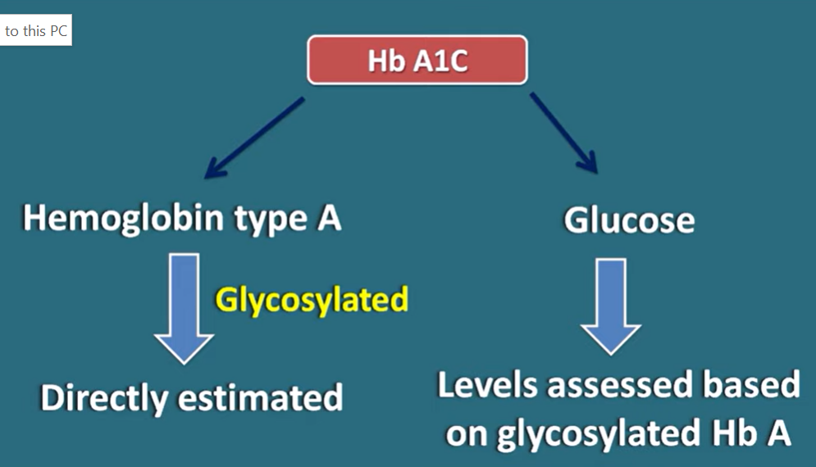

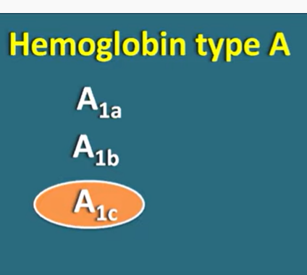

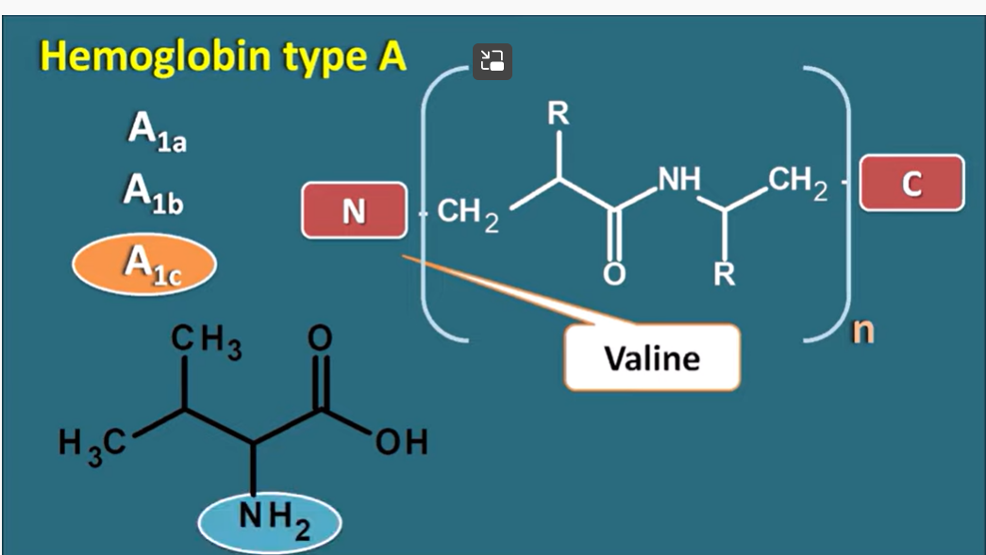

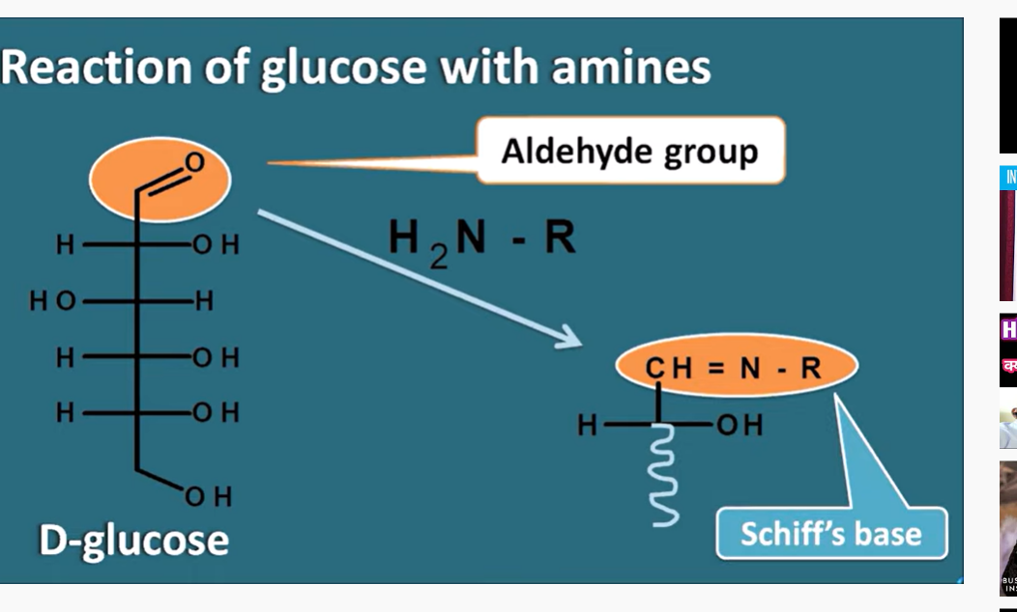



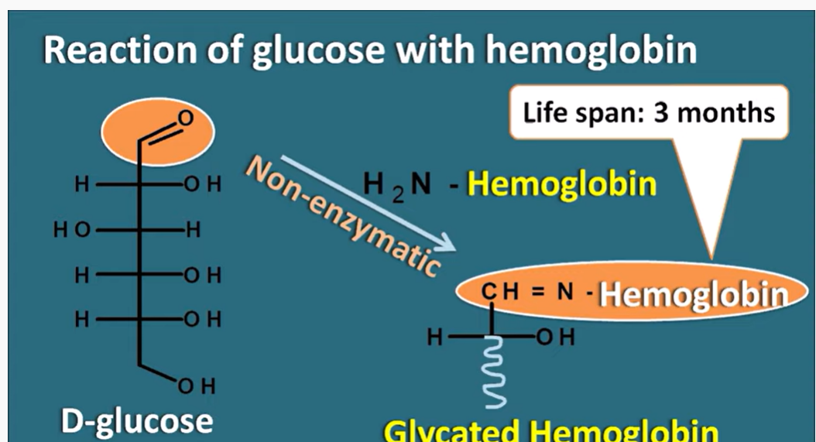

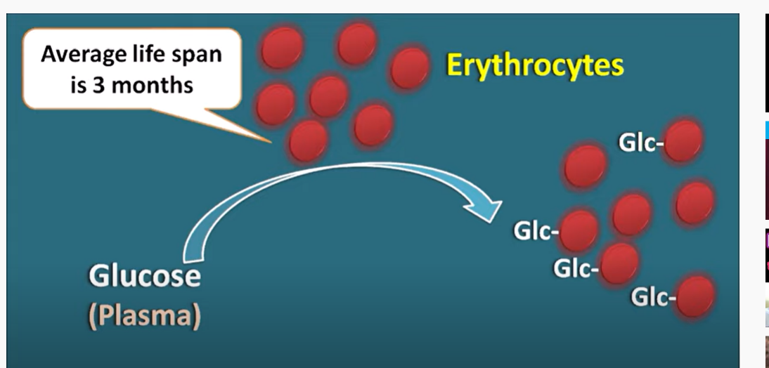



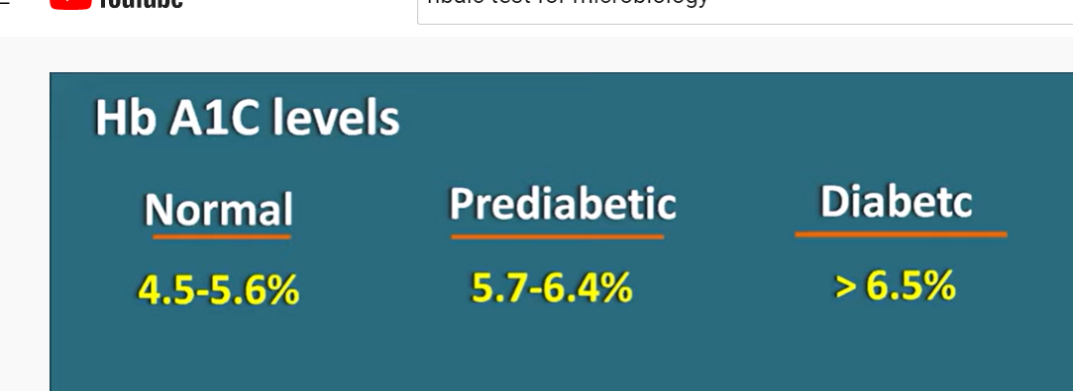

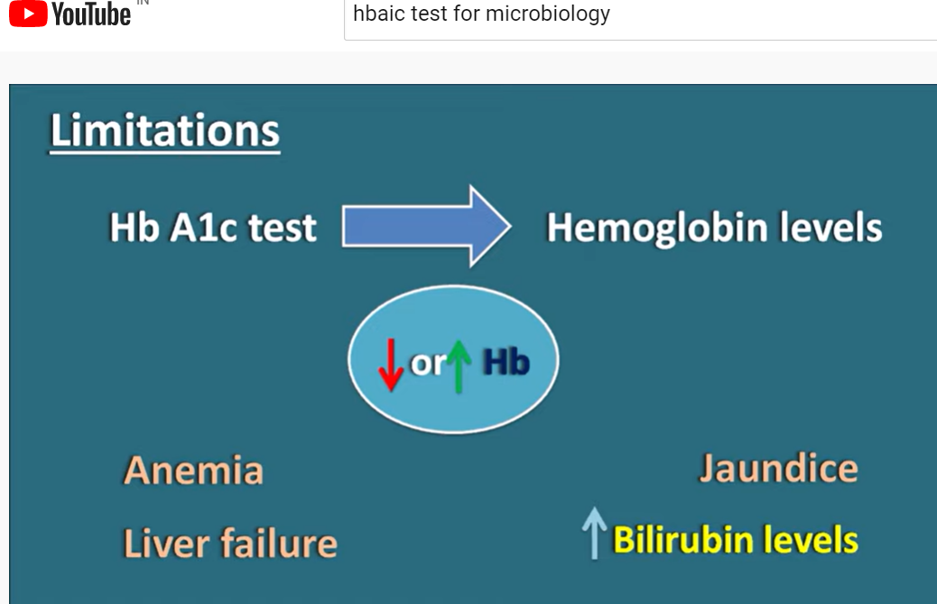

Vector Auto Regression(VAR) Model|

Noom is one app : weight reduction

Fitbit

Mobile health data

Hba1c:

Long term glucose level

Is there any other model

Historical glucose level

Timeseries data

2. predicting trend

3. anomalies detection (hyper glycemia )