“**Healthcare is the maintenance or improvement of health** via the

Prevention

Diagnosis

treatment of illness

injury

disease

other physical or mental impairments” - WHO ▪

**A well-functioning health-care sector ------------is a prerequisite for a well-functioning economy**

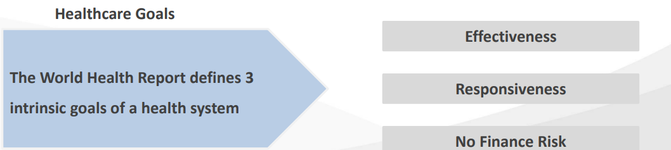

**Players in US healthcare**

1. **Payers**
2. **Provides**
3. **Life-sciences**

**payers**

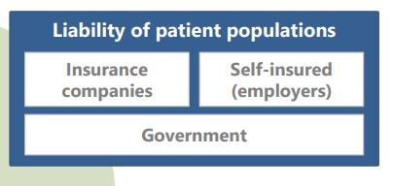

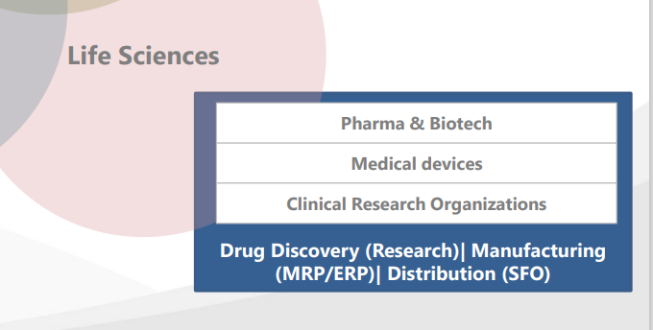

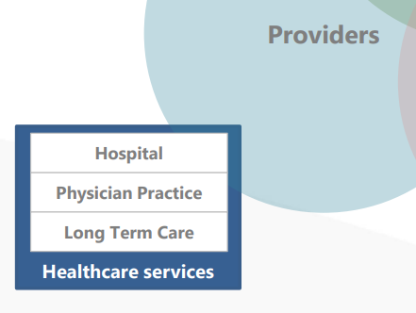

Characteristics of U.S. Healthcare

▪ largest healthcare systems in the world

most complex –

largely **owned and operated by private business** ▪

Has **No Universal Health Program**, unlike most developed nations

▪ Healthcare Spend has **outpaced the growth rate in the gross domestic product (GDP**) ▪

**Predominance of Private insurance**:

Coverage provided primarily by employers ▪

Mixed Healthcare System: **Consists of public and private**, **for-profit and nonprofit insurers** & **health care providers** ▪

**Benefit packages and cost-sharing structure**: **Offered by public & private insurers**-- **governed by federal and state regulations**

The 2019 WHO survey of the healthcare systems found the US healthcare system to be the **most expensive and worst-performing** ▪

**Extremely Complex Adaptive System**

Objectives

how healthcare evolved and grew in the US ▪

Health insurance used as **a tool to attract new employees**

**Medicaid, Medicare** and such programs introduced later to help **elderly and poor to combat rising costs**

**Group insurance** by employers **much cheaper.**

**Self employed/ unemployed have more healthcare related costs**

**Role of Federal Government in Healthcare**

▪ **The Department of Health and Human Services (HHS**) is responsible for **public health** in the US. ▪

**Medicare**: **Government** provides **National insurance coverage program** ---Medicare ▪ (For 65 yrs. and above. Also for **less than 65 yrs. with disabilities/ESRD)** ▪ Medicare dominates & sets benchmark for others on healthcare payments

**Medicaid** is **a state-based insurance coverage program**, **jointly adopted by state and federal**( who sets standards), for **Children & the low-income**

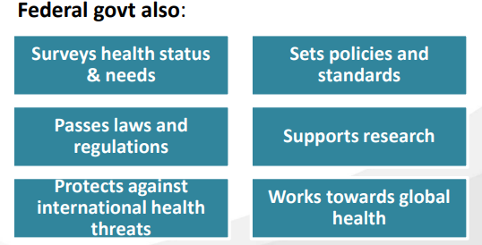

15% of Americans are covered by Medicare

18% by Medicaid

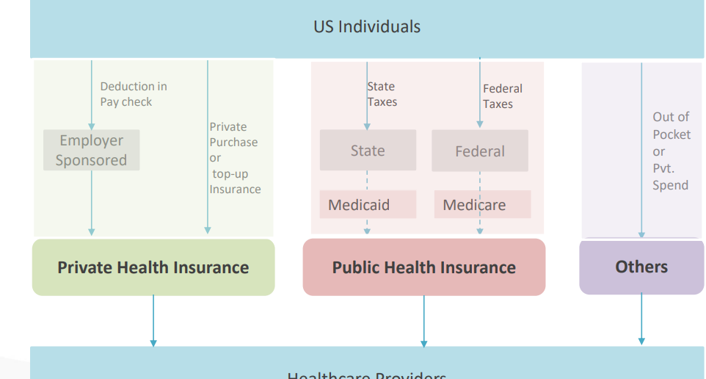

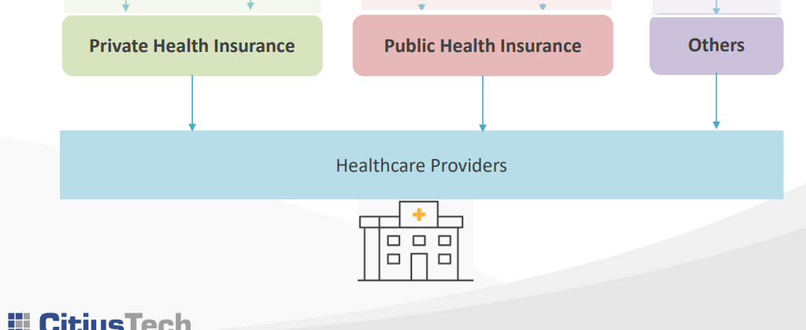

**Us rank in heathcare**

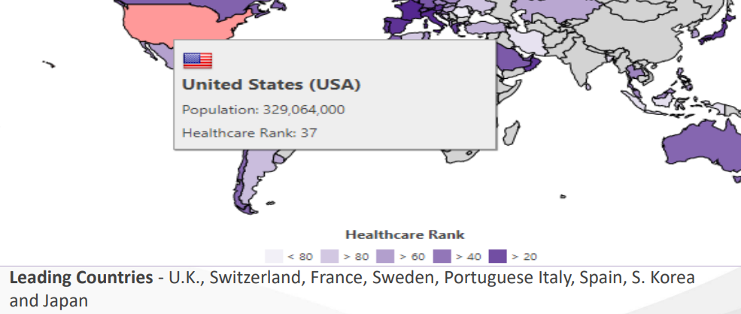

Comparison with Healthcare around World (2019) (2/2)

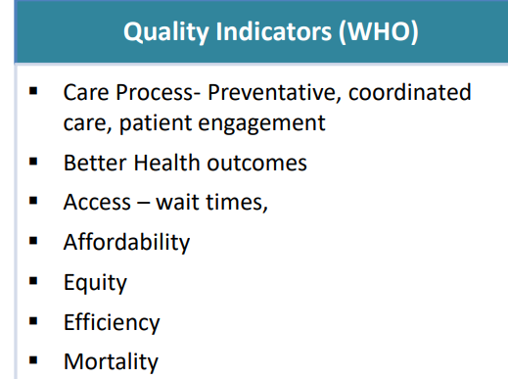

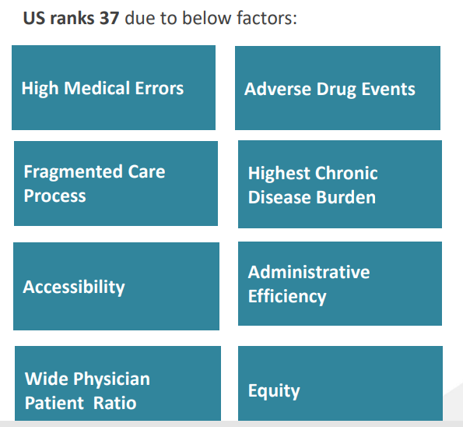

US Healthcare is Most Expensive

US per capita healthcare spend **quadrupled** (From **3.6 %in 1980 to 16.9% in 2018**)

▪ Very high **administrative costs** **- 8% of its healthcare dollar** is spent on admin costs, compared to 1% to 3% in other countries

▪ **30% of total spend goes to unnecessary ineffective, overpriced & wasteful services** ▪ Americans spend **4 times on the prescriptive drugs** compared to average of other countries ▪ **Hospital work as profit centers** and accounts for **33% of the nation’s healthcare costs**

**Older Americans accounting for 16% of the population** increase the healthcare cost

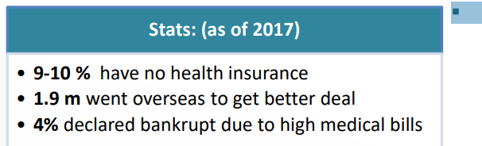

Why is Healthcare Expensive?

Primary ones are **Prescription drugs which are very expensive**

▪ **Duplication of tests** by different care givers for the same patient who are not connected with each other ▪

**Hospital Services, Administrative services for managing paperwork** are few other reasons for expensive health cost

**growing prevalence of chronic disease**.”

▪ “The **current healthcare delivery system is designed for treating acute illnesses”**

▪ Acute Medical Problems

• (curable, self limited)

• Eg- Strep throat, Appendicitis

**▪ Chronic Medical Problems**

• (incurable, control)

• Eg- Diabetes, Hypertension

**▪ Chronic Disease is Different**

• Last for a lifetime

• Cause each other

• Behavior often causal

• Behavior change is crucial to success

• Requires a different care system

• Wellness and prevention are key

**Pros of US Healthcare ▪**

**United States has been the global leader in health technology** Innovation, with **market size of almost $120 billion reigning in biotechnology** ▪

The US scores **high on innovation, patient-centered care, and preventive health measures ▪** The US has some of the **best doctors and hospitals** in the world, for those who can afford them **▪ Patient wait times are much better** in the USA(yes, heard it right!) in comparison with patients in the UK, France, Sweden and Canada as due to bureaucratic government processes ▪ **Physicians and Nurses are much better paid** in the US, thus preventing strikes and demonstrations for high pay like in Germany and elsewhere ▪ **Americans are never checked by government for using too much care like that of government owned healthcare** like Taiwan or UK ▪ **Mixed Payer markets** & also threat of lawsuit drives them to stay cutting edge with latest technology and **best trained professionals in comparison to single payer systems** like Canada

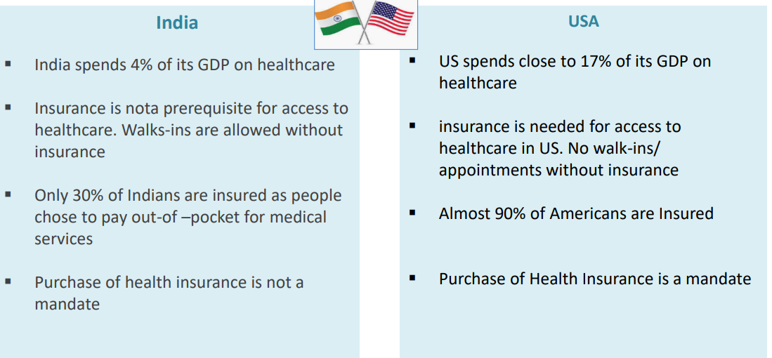

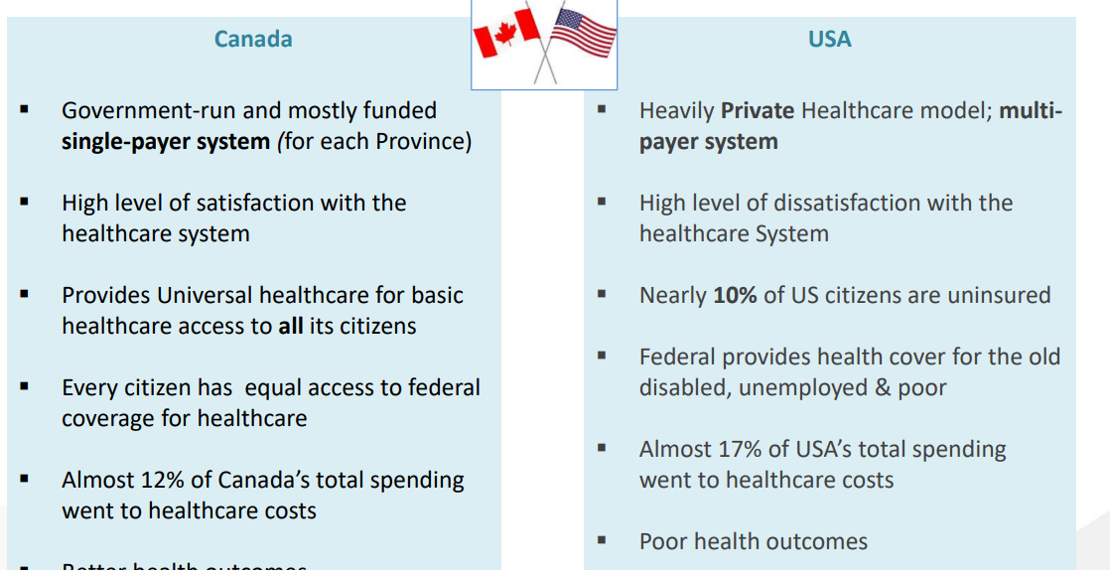

Heath system in Usa

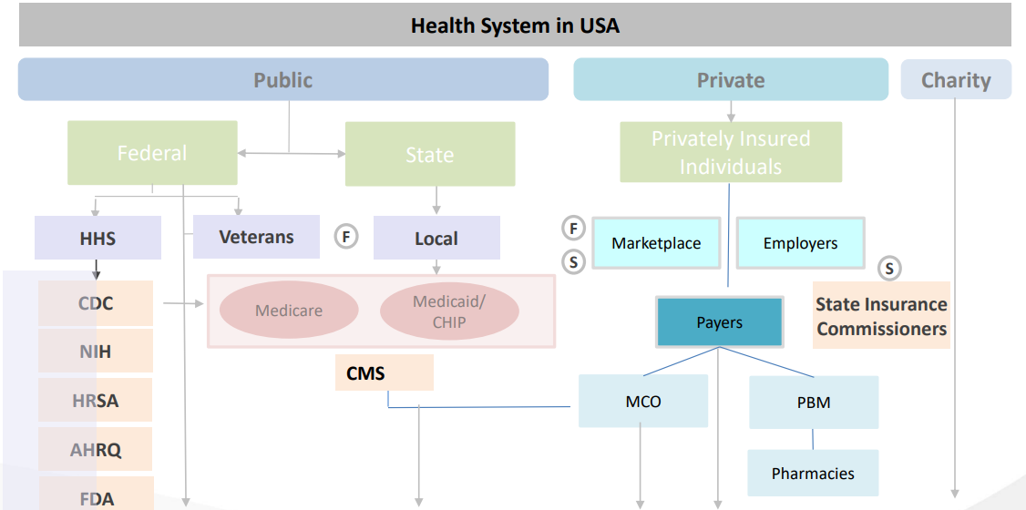

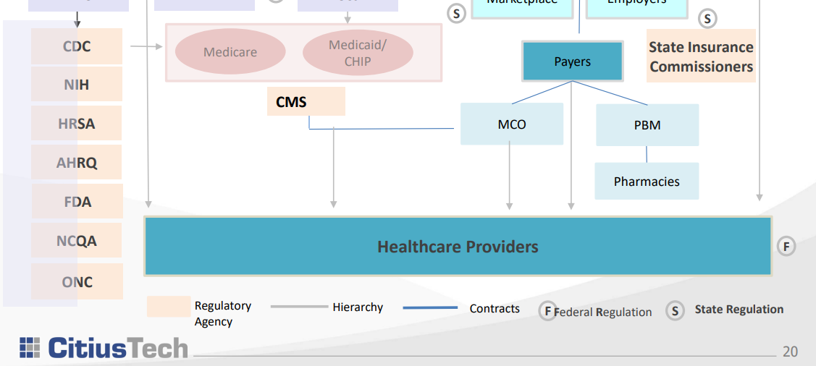

**Regulatory Bodies (1/2)** :

The **Department of Health and Human Services (HHS)** is the U.S. Government’s **principal agency** for protecting the health of all Americans and providing essential human services

Has 11 operating agencies.

Primary ones as below:

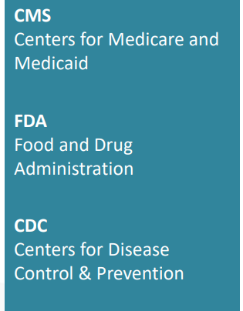

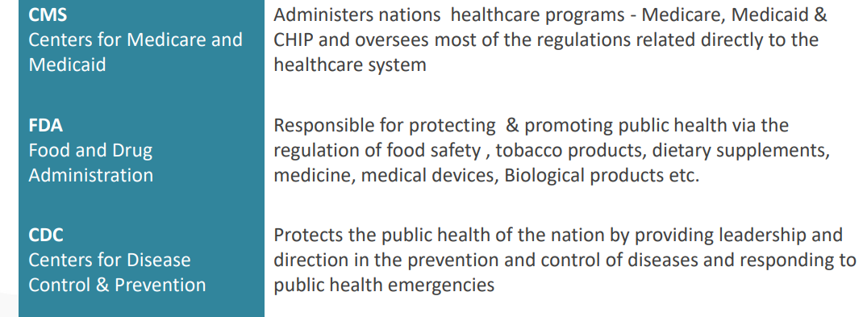

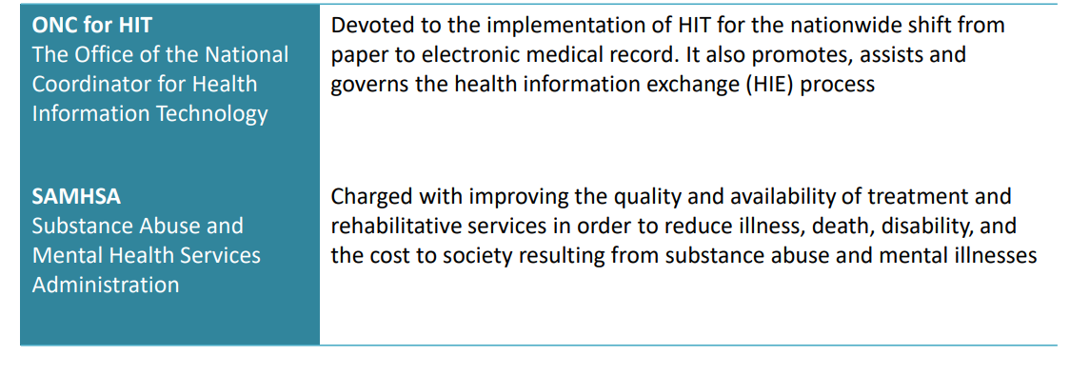

**Quality and Accreditation Agencies**

**Agency of Healthcare Research and Quality (AHRQ)** – conducts research aimed at improving

the quality of healthcare, reducing its costs, and addressing patient safety and medical errors

▪ **The Joint Commission on Accreditation of Healthcare Organizations (JCAHO)** – is an non-forprofit organization which employs a system of examining and accrediting healthcare

organizations, which has an impact on their reimbursement from CMS

▪ **National Committee for Quality Assurance (NCQA)** – is another non-for-profit organization

which ensures the quality of the managed care plans. It also provides accreditation for newer

organizational models e.g. ACOs and PCMHs

▪ **National Quality Forum (NQF)** – is a non-for-profit organization which sets goals for

performance management, endorses standards used for measuring performance and promotes

educational and outreach programs

**Standards Setting and Influencing Bodies**

**Health Level Seven (HL7)** – is a not-for-profit, ANSI-accredited standards organization. The

focus of HL7 work is in supplying a structure for the development and electronic distribution of

health information that is used in clinical practice

**▪ Integrating the Healthcare Enterprise (IHE)** – is an international organization that focuses on

the development of open and global Integration Profiles and on the regional deployment of

interoperable IT systems

**▪ International Health Terminology Standards Developing Organization (IHTSDO)** – is a non-forprofit organization which owns SNOMED-CT - the most comprehensive, multilingual clinical

terminology in the world

▪ **Digital Imaging and Communications in Medicine (DICOM)** – is a standard for handling,

storing, printing, and transmitting information in medical imaging

WHO: World Health Organization

CDC: Centers for Disease Control and Prevention

CMS :Centers for Medicare and Medicaid Services

HHS U.S. :Department of Health and Human Services

FDA :Food and Drug Administration

AHRQ: Agency for Healthcare Research and Quality

NCQA :National Committee for Quality Assurance

ONC: Office of the National Coordinator for Health Information Technology

MCO: Managed Care Organization

PBM: Pharmacy Benefit Manager

ESRD :End Stage Renal Disease

CHIP: Children Health Insurance Program