Sql topics:

Joins

Union and union all

Null, coalesce

In,exits

Sub queries

With

Views

Functions

Stored procedures,packages

Pivot

Case

Cursors

Query optimization: indexes, plans profilings

Transactions: coomit, roll back and error handing

Sql Functions

* String Functions (LEN, SUBSTRING, REPLACE, CONCAT, TRIM)
* Date and Time Functions (datetime, datetime2, smalldatetime)
* Aggregate Functions (COUNT, MAX, MIN, SUM, AVG)
* Mathematical Functions (ABS, POWER, PI, EXP, LOG)
* Ranking Functions (RANK, DENSE_RANK, ROW_NUMBER, NTILE)

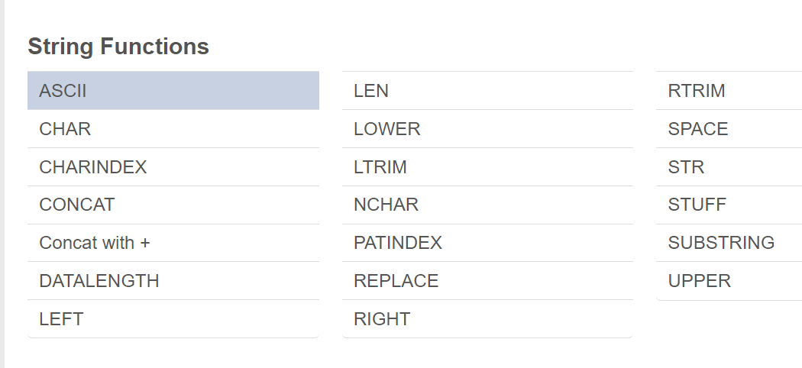

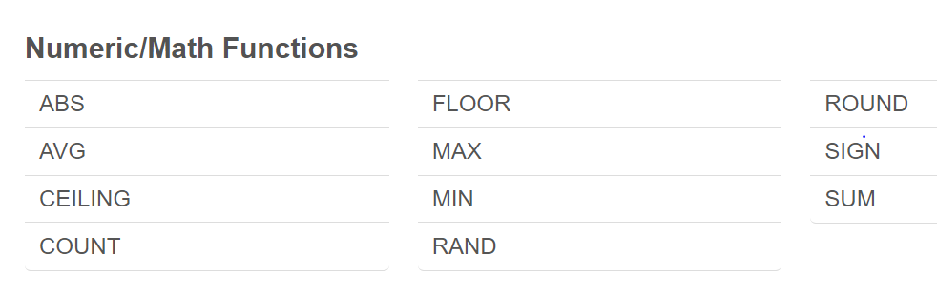

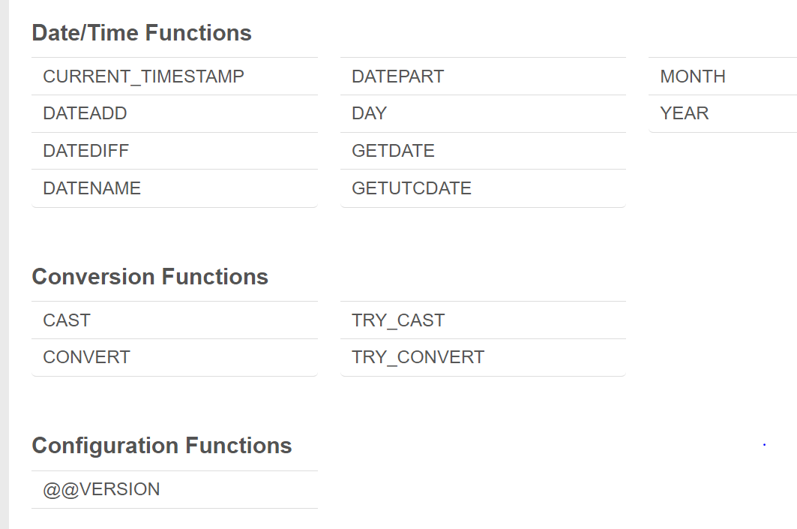

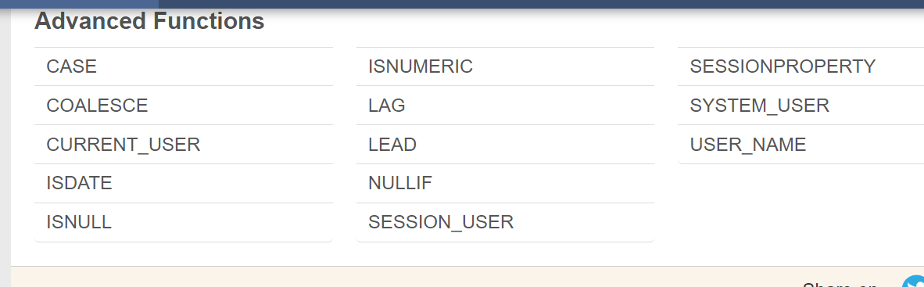

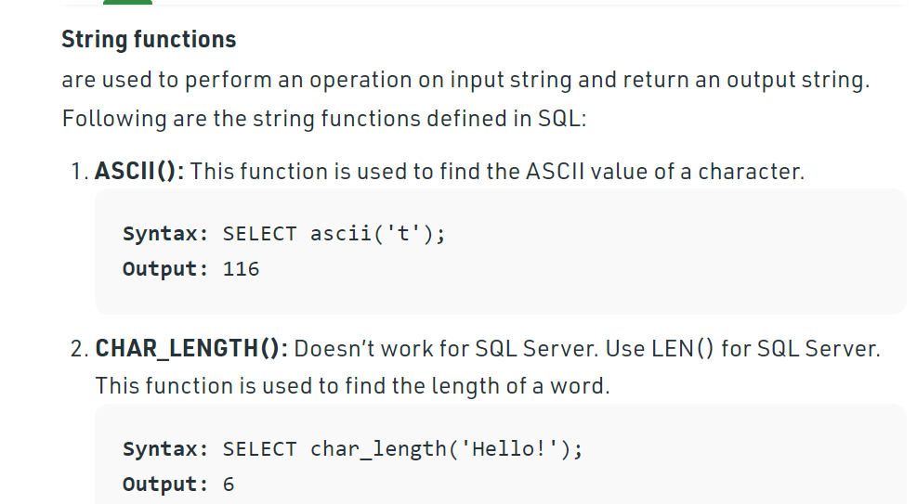

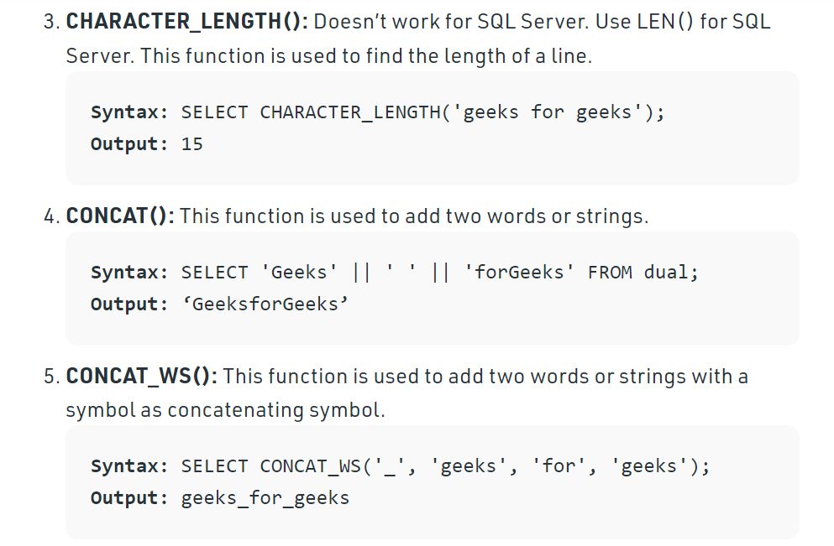

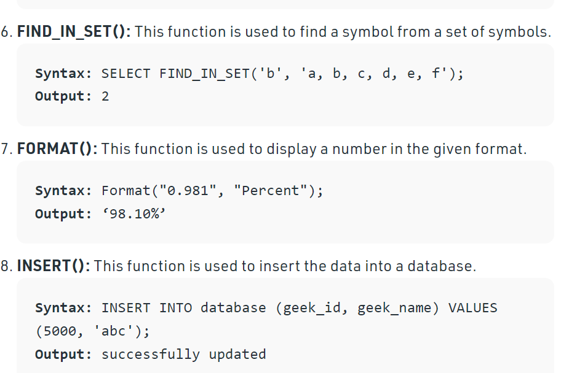

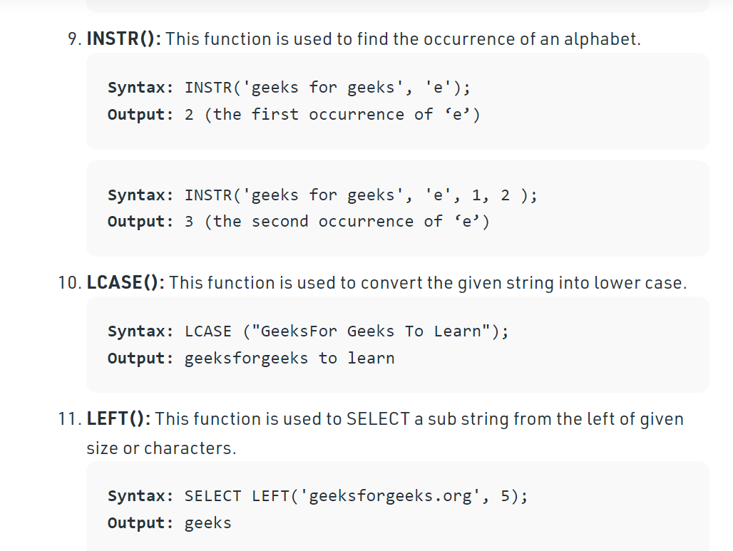

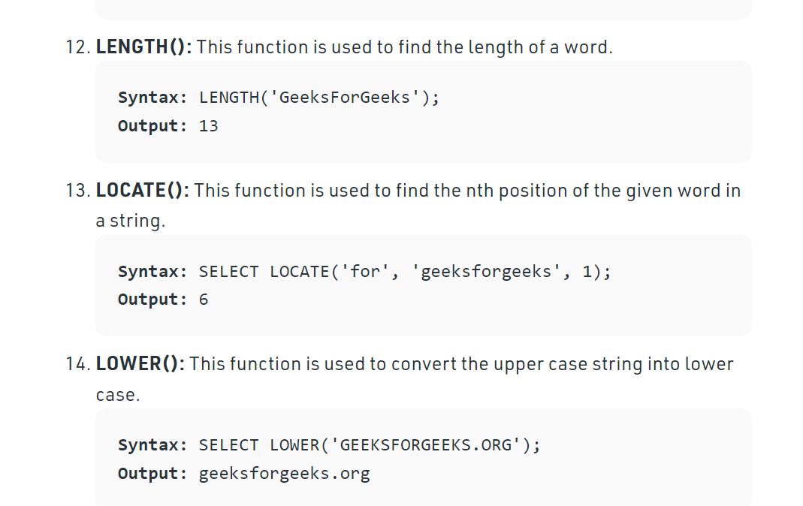

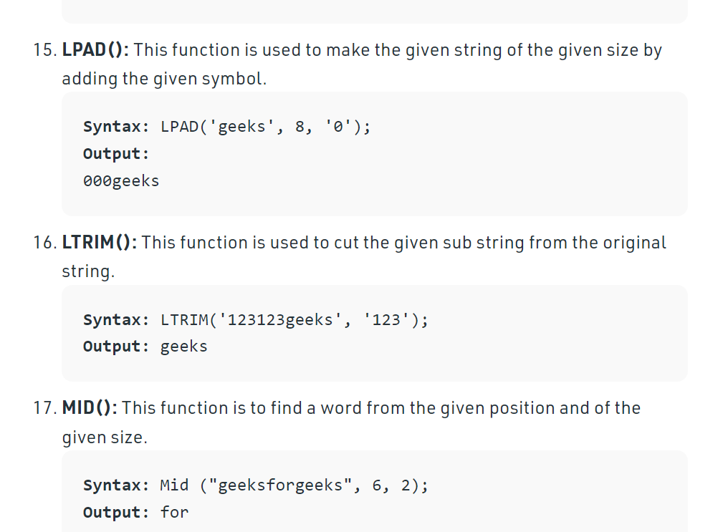

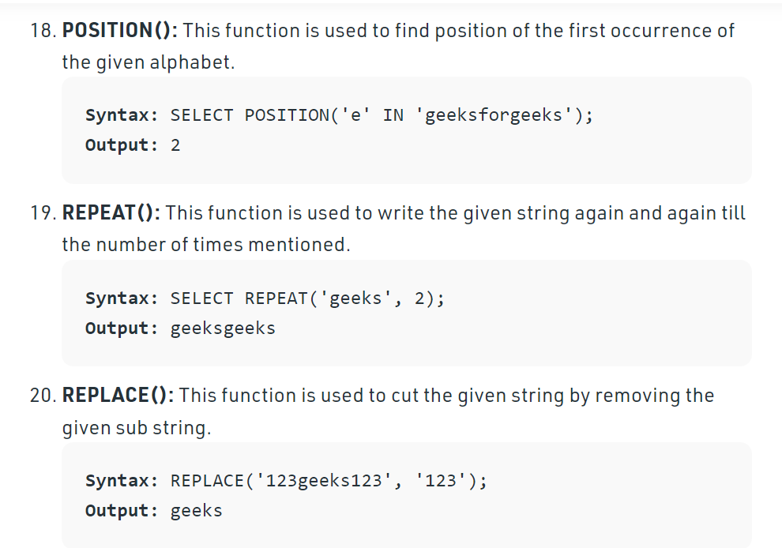

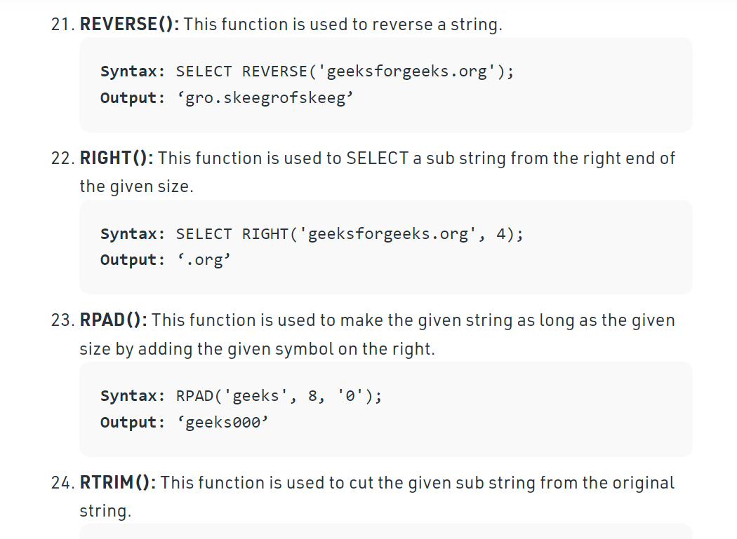

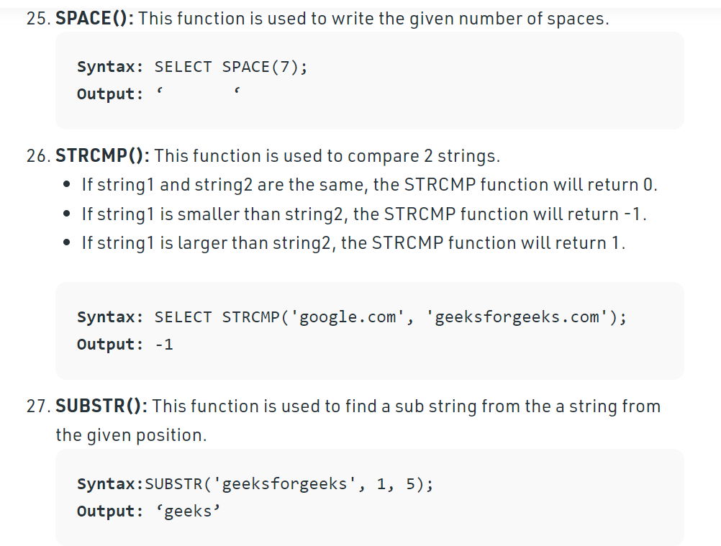

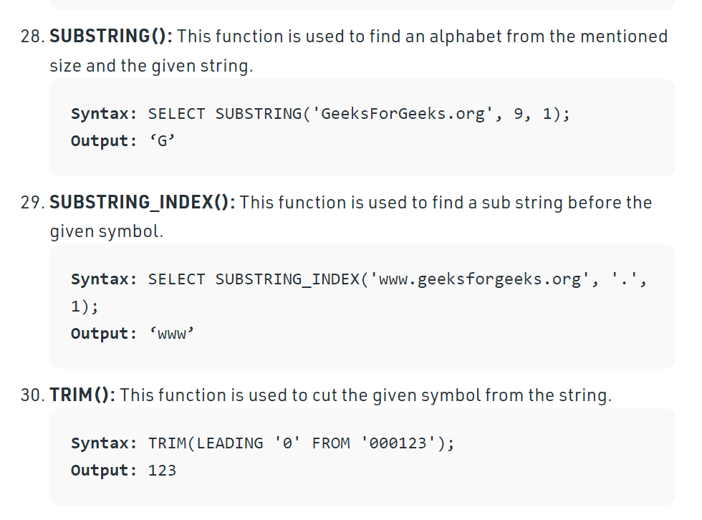

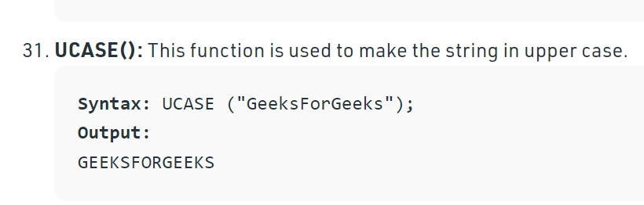

Char

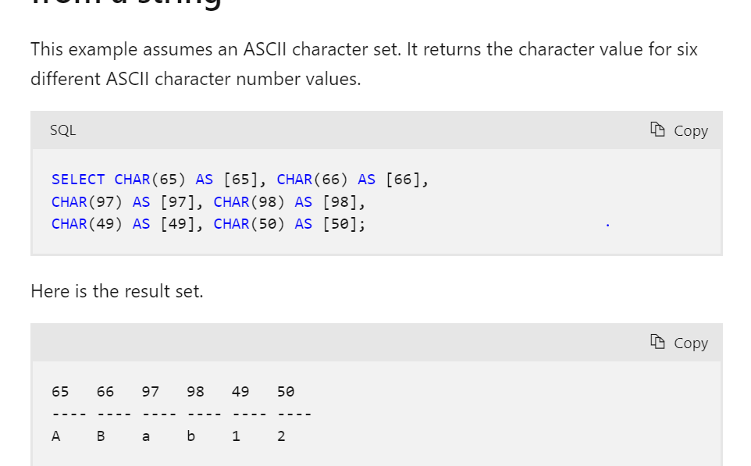

**CHARINDEX**

This function searches for one character expression inside a second character expression, returning the starting position of the first expression if found.

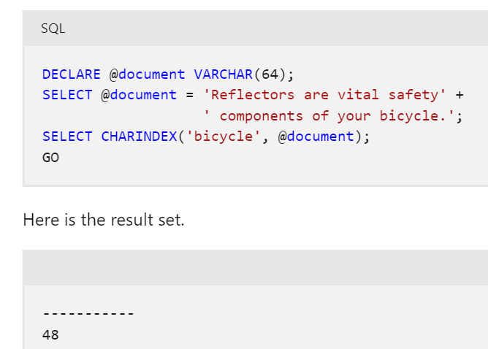

# CONCAT

This function returns a string resulting from the concatenation, or joining, of two or more string values in an end-to-end manner.

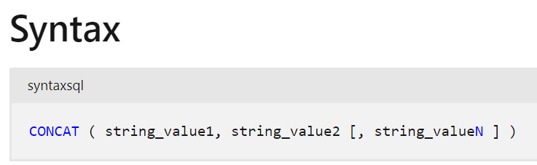

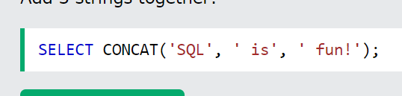

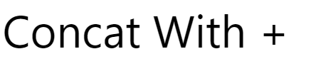

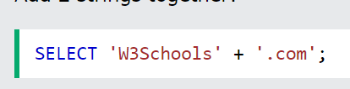

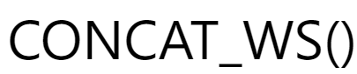



Datalength



FORMAT()

The FORMAT() function formats a value with the specified format (and an optional culture in SQL Server 2017).

Use the FORMAT() function to format date/time values and number values. For general data type conversions, use [CAST()](https://www.w3schools.com/sqL/func_sqlserver_cast.asp) or [CONVERT()](https://www.w3schools.com/sqL/func_sqlserver_convert.asp).

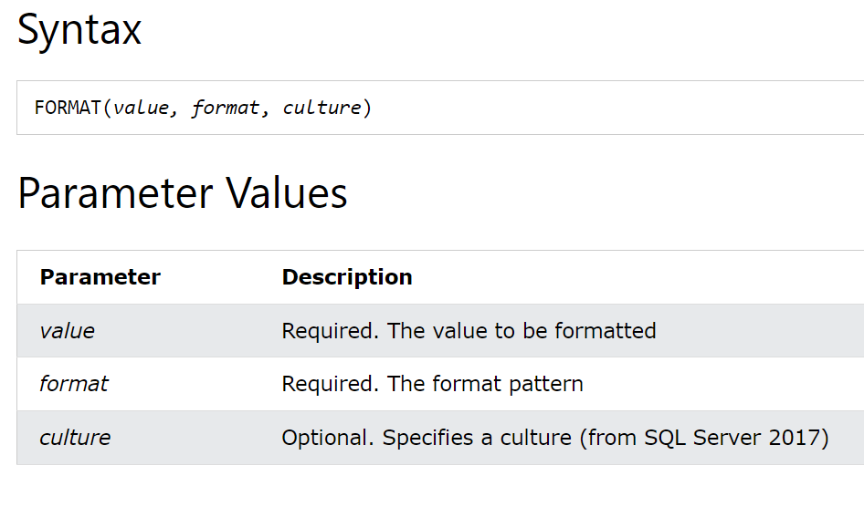

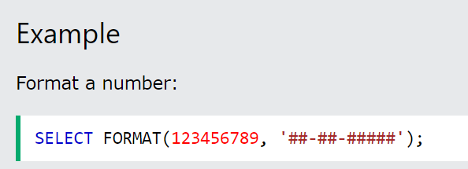

# NCHAR()

# 

# PATINDEX()

# 

# 

# 

# REPLACE()

# 

# 

# 

# REPLICATE()

# 

# 

# 

# SOUNDEX()

# 

# STR()

# 

# STUFF()

# 

# TRANSLATE()

# Return the string from the first argument AFTER the characters specified in the second argument are translated into the characters specified in the third argument:

# 

# Numeric Functions:

**Numeric Functions** are used to perform operations on numbers and return numbers. Following are the numeric functions defined in SQL:

**ABS():** It returns the absolute value of a number.

**Syntax:** SELECT ABS(-243.5);

**Output:**243.5

SQL> SELECT ABS(-10);

+--------------------------------------+

| ABS(10)

+--------------------------------------+

| 10

+--------------------------------------+

**ACOS():** It returns the cosine of a number, in radians.

**Syntax:** SELECT ACOS(0.25);

**Output:**1.318116071652818

**ASIN():** It returns the arc sine of a number, in radians.

**Syntax:** SELECT ASIN(0.25);

**Output:**0.25268025514207865

**ATAN():** It returns the arc tangent of a number, in radians.

**Syntax:** SELECT ATAN(2.5);

**Output:**1.1902899496825317

**CEIL():** It returns the smallest integer value that is greater than or equal to a number.

**Syntax:** SELECT CEIL(25.75);

**Output:**26

**CEILING():** It returns the smallest integer value that is greater than or equal to a number.

**Syntax:** SELECT CEILING(25.75);

**Output:**26

**COS():** It returns the cosine of a number, in radians.

**Syntax:** SELECT COS(30);

**Output:**0.15425144988758405

**COT():** It returns the cotangent of a number, in radians.

**Syntax:** SELECT COT(6);

**Output:**-3.436353004180128

**DEGREES():** It converts a radian value into degrees.

**Syntax:** SELECT DEGREES(1.5);

**Output:**85.94366926962348

SQL>SELECT DEGREES(PI());

+------------------------------------------+

| DEGREES(PI())

+------------------------------------------+

| 180.000000

+------------------------------------------+

**DIV():** It is used for integer division.

**Syntax:** SELECT 10 DIV 5;

**Output:**2

**EXP():** It returns e raised to the power of a number.

**Syntax:** SELECT EXP(1);

**Output:**2.718281828459045

**FLOOR():** It returns the largest integer value that is less than or equal to a number.

**Syntax:** SELECT FLOOR(25.75);

**Output:**25

**GREATEST():** It returns the greatest value in a list of expressions.

**Syntax:** SELECT GREATEST(30, 2, 36, 81, 125);

**Output:**125

**LEAST():** It returns the smallest value in a list of expressions.

**Syntax:** SELECT LEAST(30, 2, 36, 81, 125);

**Output:**2

**LN():** It returns the natural logarithm of a number.

**Syntax:** SELECT LN(2);

**Output:**0.6931471805599453

**LOG10():** It returns the base-10 logarithm of a number.

**Syntax:** SELECT LOG(2);

**Output:**0.6931471805599453

**LOG2():** It returns the base-2 logarithm of a number.

**Syntax:** SELECT LOG2(6);

**Output:**2.584962500721156

**MOD():** It returns the remainder (aka. modulus) of n divided by m.

**Syntax:** SELECT MOD(18, 4);

**Output:**2

**PI():** It returns the value of Pi and displays 6 decimal places.

**Syntax:** SELECT PI();

**Output:**3.141593

**POWER(m, n):** It returns m raised to the nth power.

**Syntax:** SELECT POWER(4, 2);

**Output:**16

**RADIANS():** It converts a value in degrees to radians.

**Syntax:** SELECT RADIANS(180);

**Output:**3.141592653589793

**RAND():** It returns a random number between 0 (inclusive) and 1 (exclusive).

**Syntax:** SELECT RAND();

**Output:**0.33623238684258644

**ROUND():** It returns a number rounded to a certain number of decimal places.

**Syntax:** SELECT ROUND(5.553);

**Output:**6

**SIGN():** It returns a value indicating the sign of a number.  A return value of 1 means positive; 0 means negative.

**Syntax:** SELECT SIGN(255.5);

**Output:**1

**SIN():** It returns the sine of a number in radians.

**Syntax:** SELECT SIN(2);

**Output:**0.9092974268256817

**SQRT():** It returns the square root of a number.

**Syntax:** SELECT SQRT(25);

**Output:**5

**TAN():** It returns the tangent of a number in radians.

**Syntax:** SELECT TAN(1.75);

**Output:**-5.52037992250933

**ATAN2():** It returns the arctangent of the x and y coordinates, as an angle and expressed in radians.

**Syntax:** SELECT ATAN2(7);

**Output:**1.42889927219073

**TRUNCATE():** This doesn’t work for SQL Server. It returns 7.53635 truncated to n places right of the decimal point.

**Syntax:** SELECT TRUNCATE(7.53635, 2);

# 

# 

# Date functions n sql:

# 

# 

# 

# 

# 

# 

# 

# 

# 

# 

# 

# 

# 

# 

# 

# 

# 

# 

# 

# 

# 

# 

# 

# 

# 

# 

# 

# 

# 

# 

# 

# 

# 

# View name:

# 

# 

# 