file

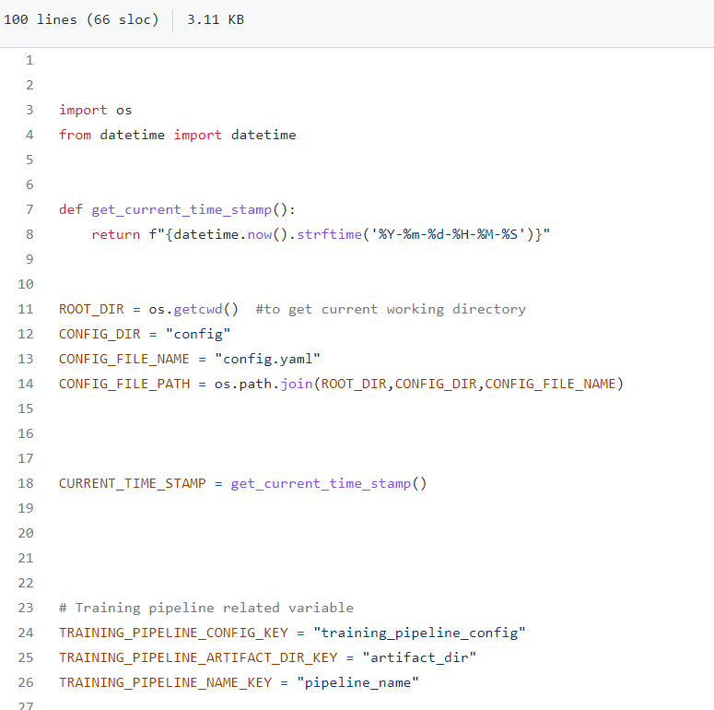

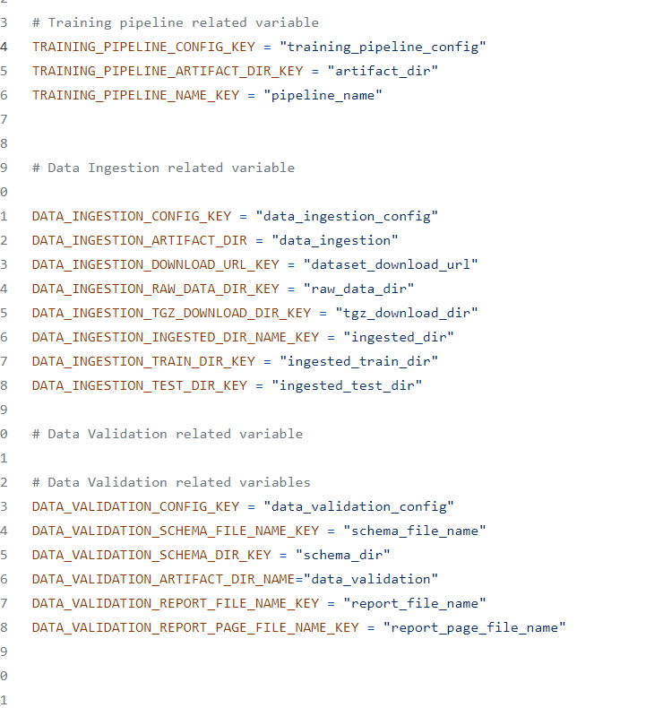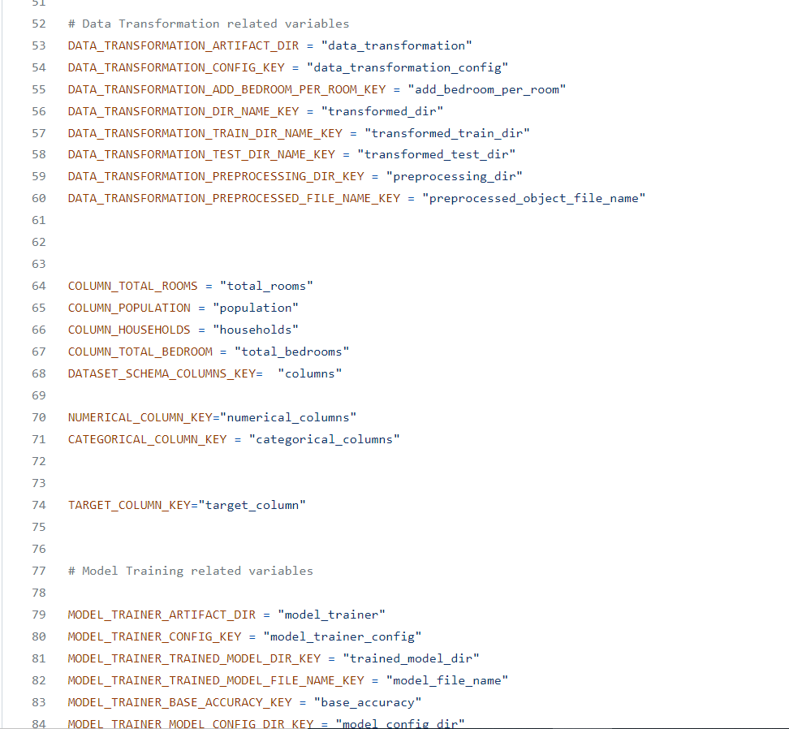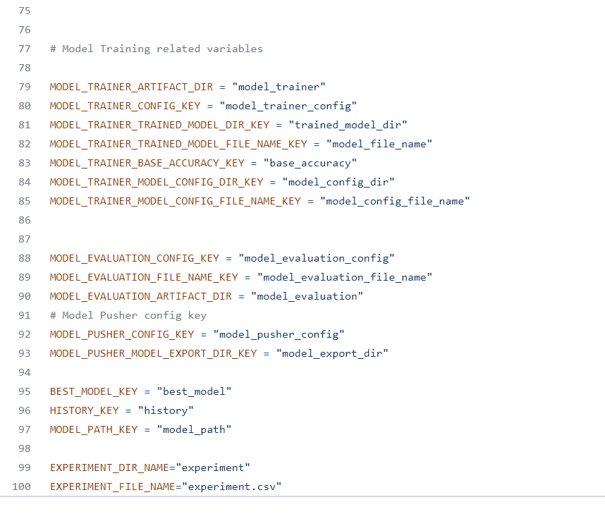

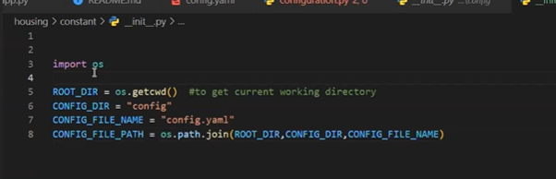

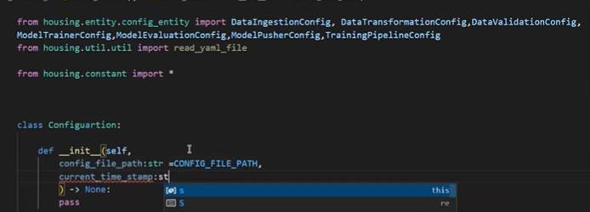

Now working each function in configuration class

First __init__

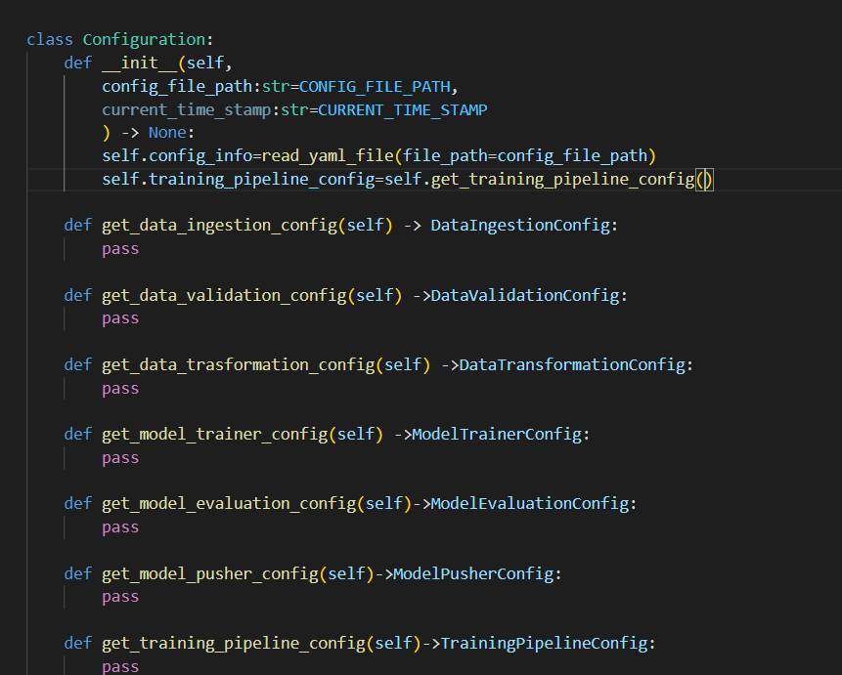

Config_file path and current time stamp: getting from constants

Reading self. config_info== from read yaml func in utils

And

Self. Training_pipeline_config=self.get_training_pipeline_config

Now we will work on

Self.get_traininf_pipeline_config:

Last function in configuration

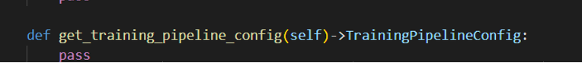

In entity I have written   


In trainingpipelineconfig- I have written artifact directory as artifact_dir

When I write code



When I type. A

Automatically that name will appear I don’t need to remember those names

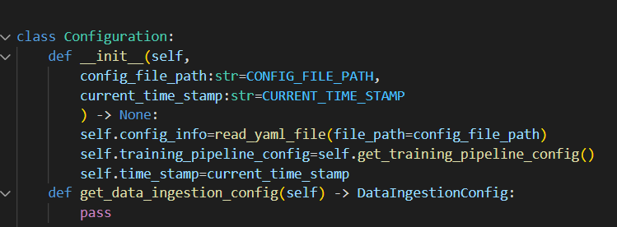

Now afterthis we will work on training_pipeline_config

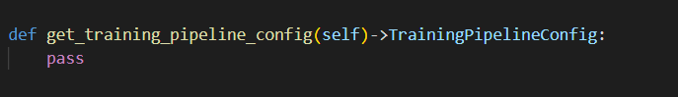

Now create constants

Related to training_pipeline

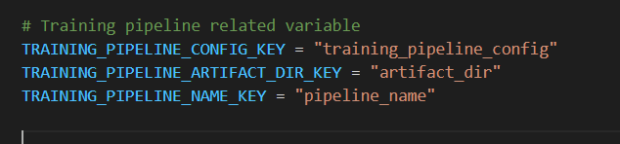

Why we have given these names

In config.yaml of config file

The names are like

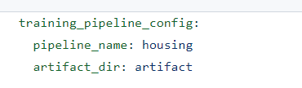

To get the exact values of keys mentioned in yaml file we have used key values as a values to constant variables

Here Constant variable is



Name assigned to it is a key mentioned in yaml file 

Which reads name house

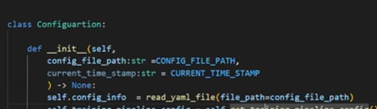

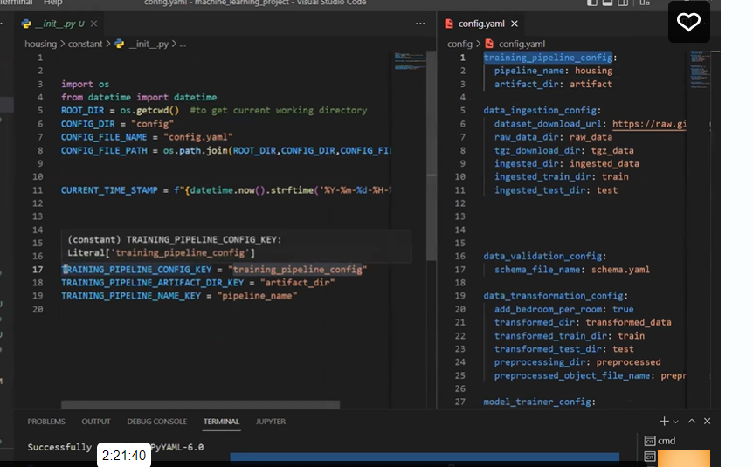

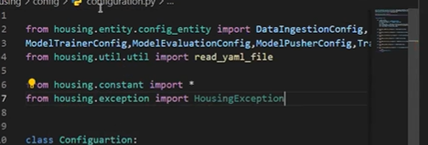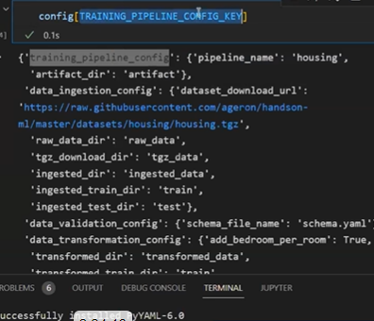

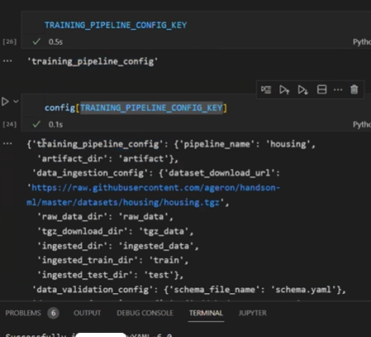

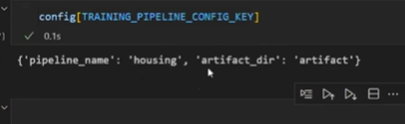

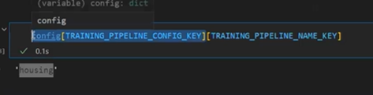

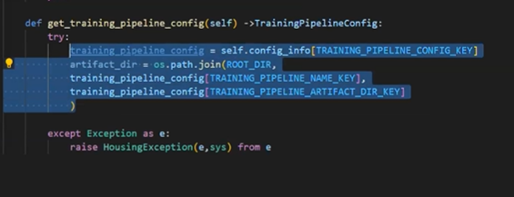

-- housing folder

This we get Housing

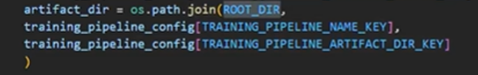

This we get

d:\\Project\\ machine_learning\\housing\\artifact



artifact

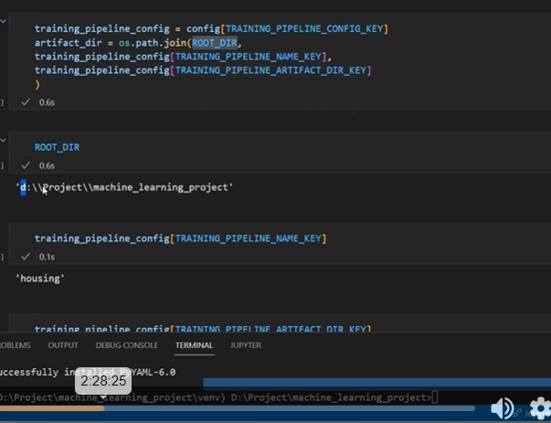

Configuration is just giving folder information

Configuration : nothing to do with creating or updating folder /updating

We are just giving path / info of folder/ what info we need to give

Now we are creating namedtuple



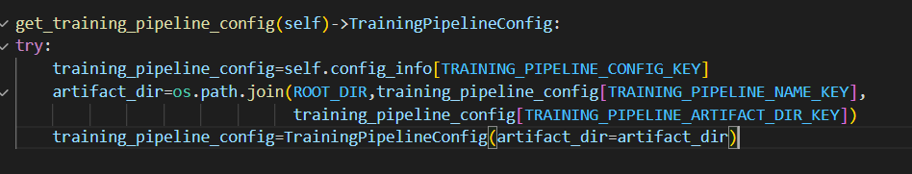

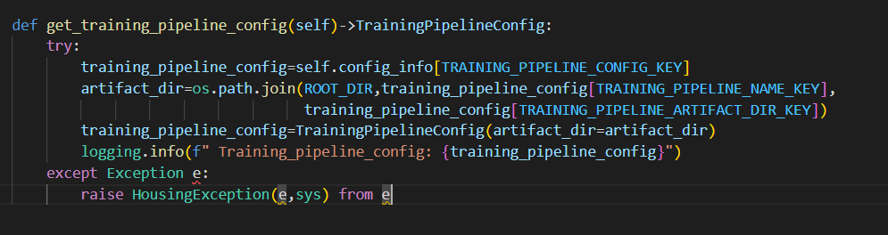

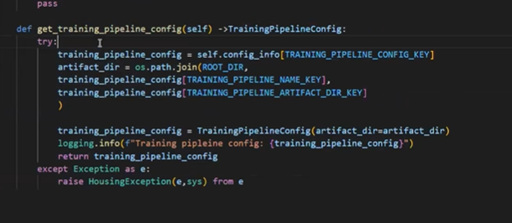

Checking in jupyter notebook

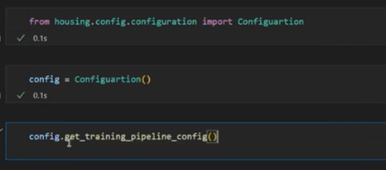

When we call like that we get

TrainingPipelineConfig(artifact_dir=’d:\\project\\machinelearning\\housing\\artifact’)

Flow:

Configuration.py using yaml file then referring entity and then configuration

Now data_ingection_configuration:



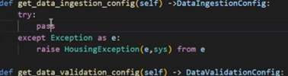

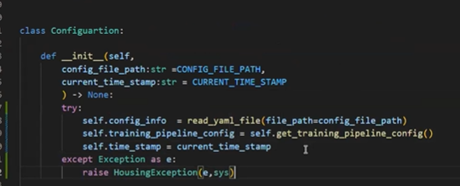

Define constants- data ingestion

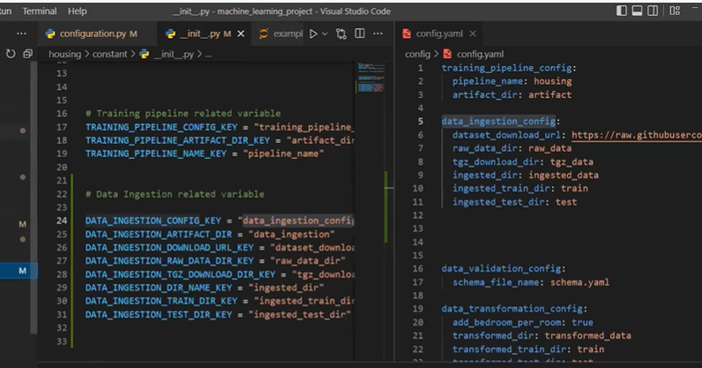

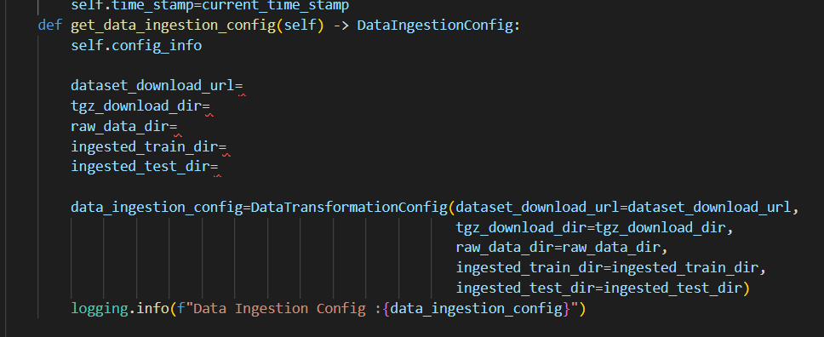

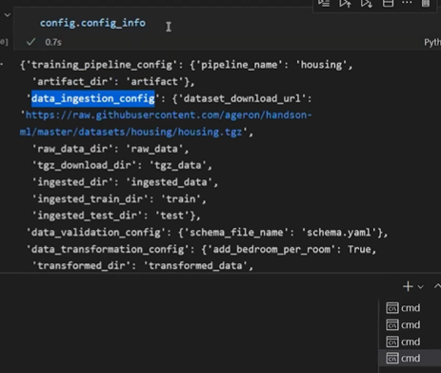

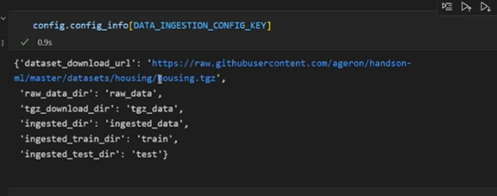

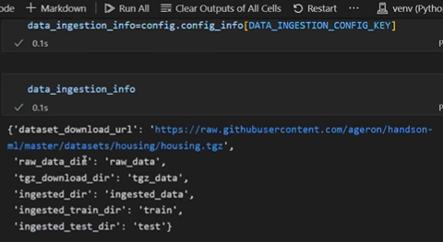

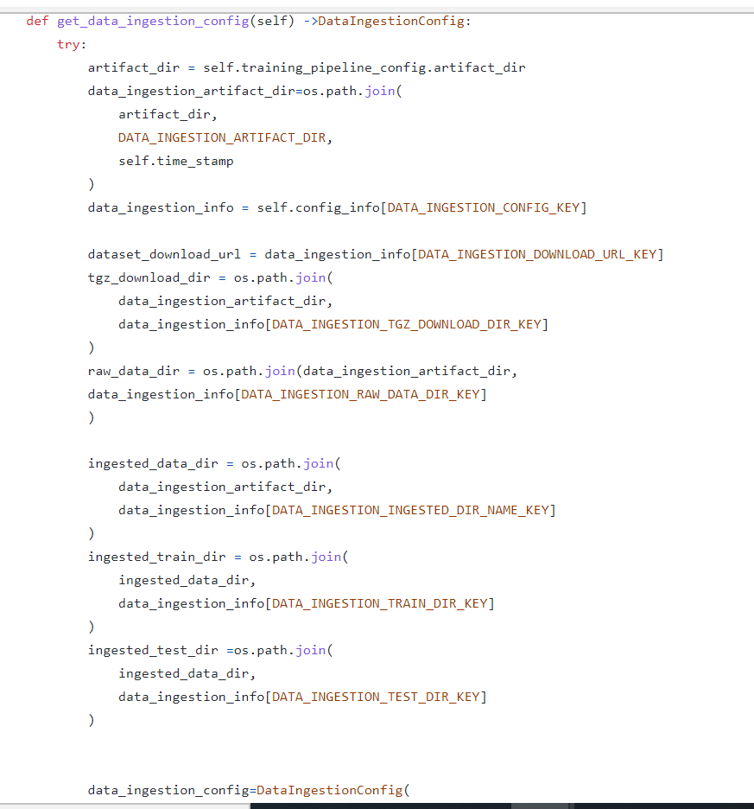

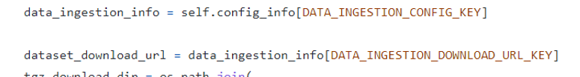

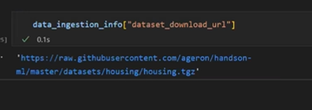

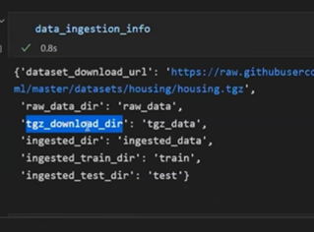

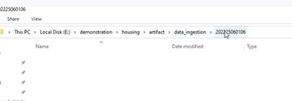

Folder will be created based on time stamp

----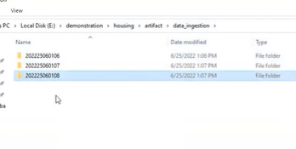

Whenever we run it creates those many folders

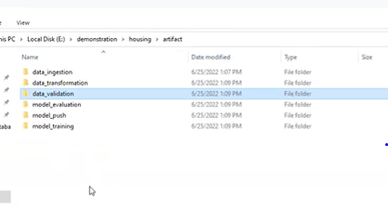

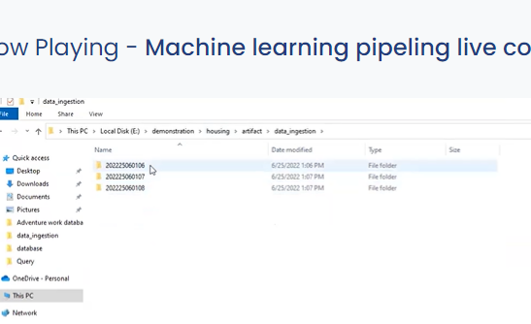

For data injection artifact path should be

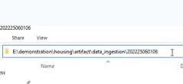

First we need artifact directory

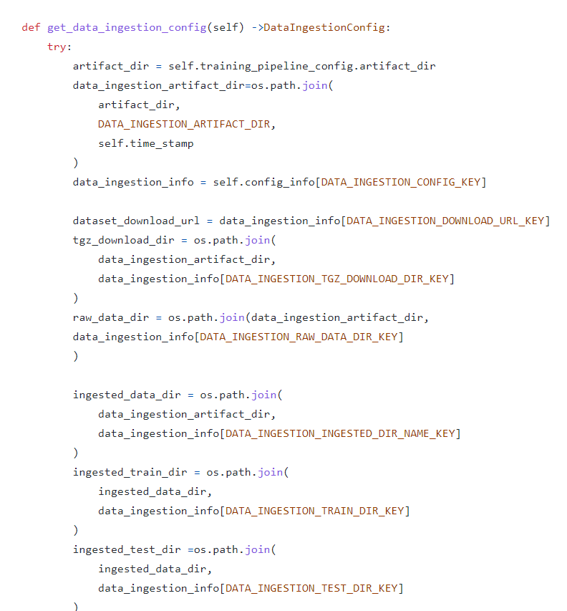

\

Data ingestion_config

In artifact folder we have multiple folders for each components

At each timestamp

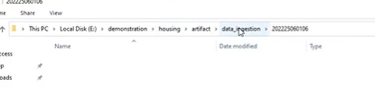

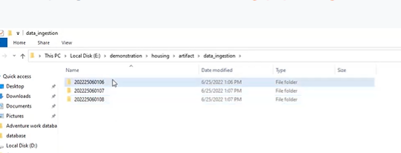

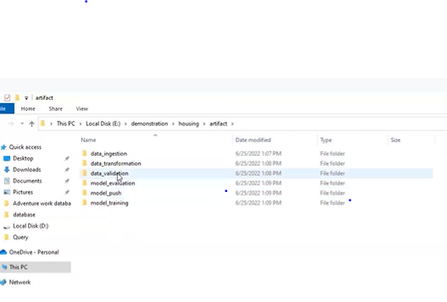

Dataingestion artifact dir

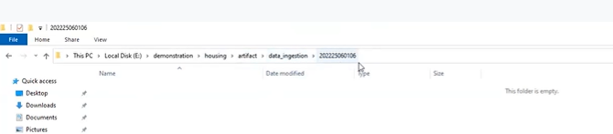

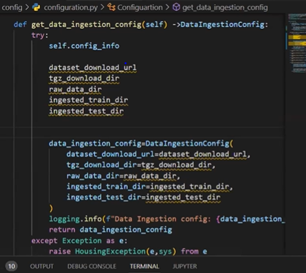

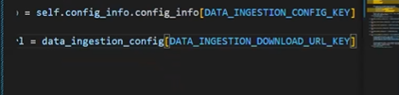

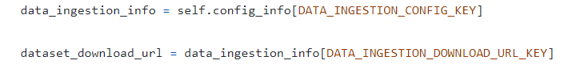within artifact only we need to create all other component artifacts with timestamps

First I need artifact directory

Housing-artifact

Where as for dataingestion -the artifactdirectory is-

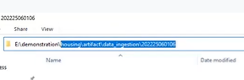

Till training pipeline

We get artifact

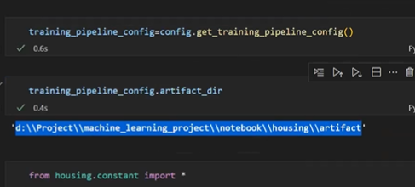

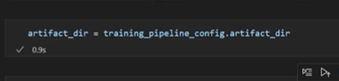

Now we need to add data ingestion and timestamp

From constant file we can get dataingestion and timestamp

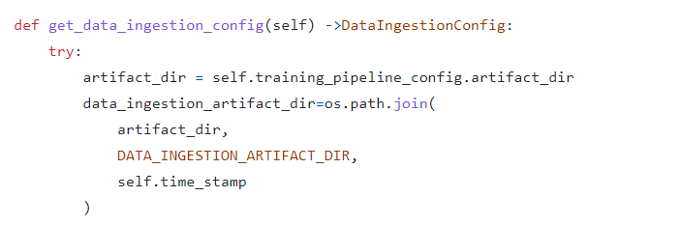

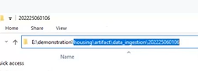

We get this path

Now raw dir



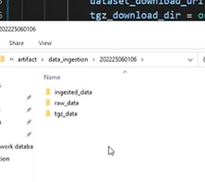

Train and test with in ingested data

Now: validation

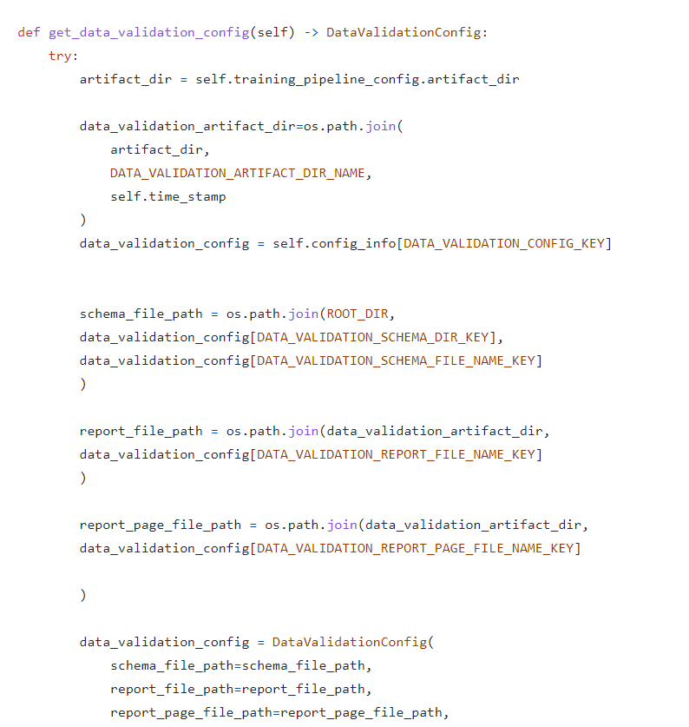

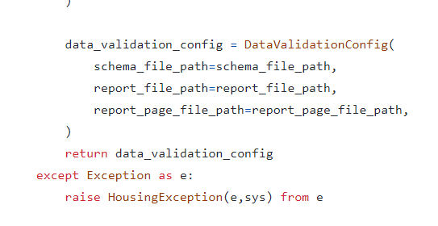

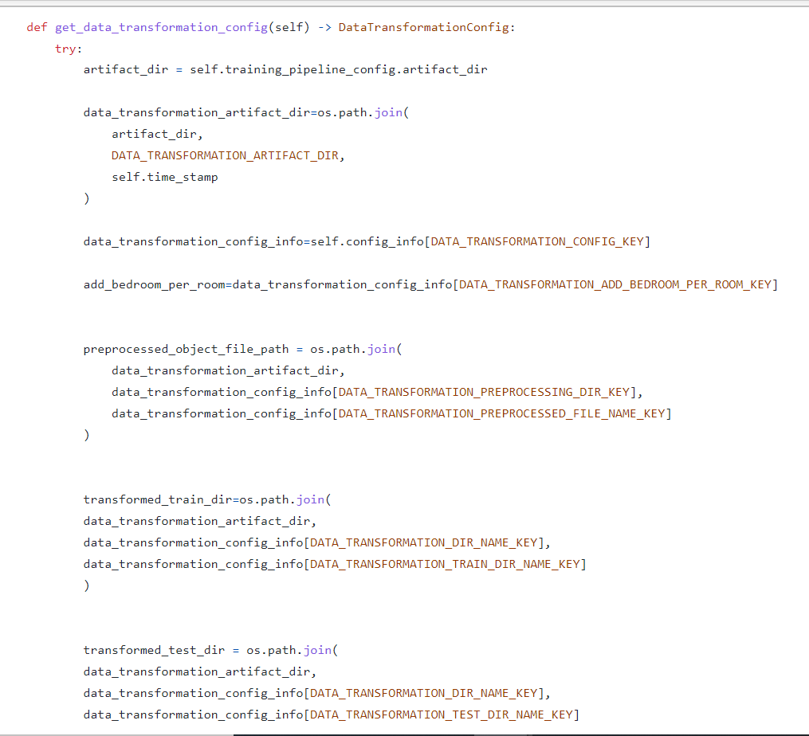

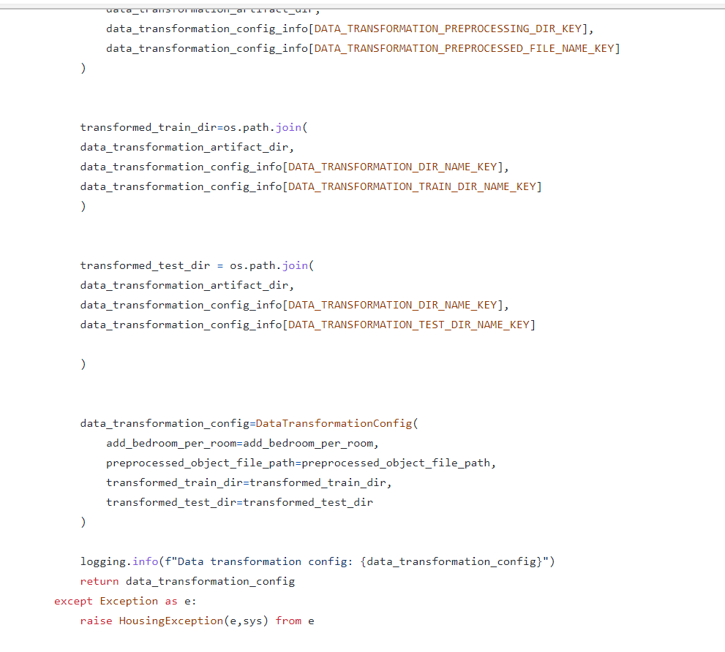

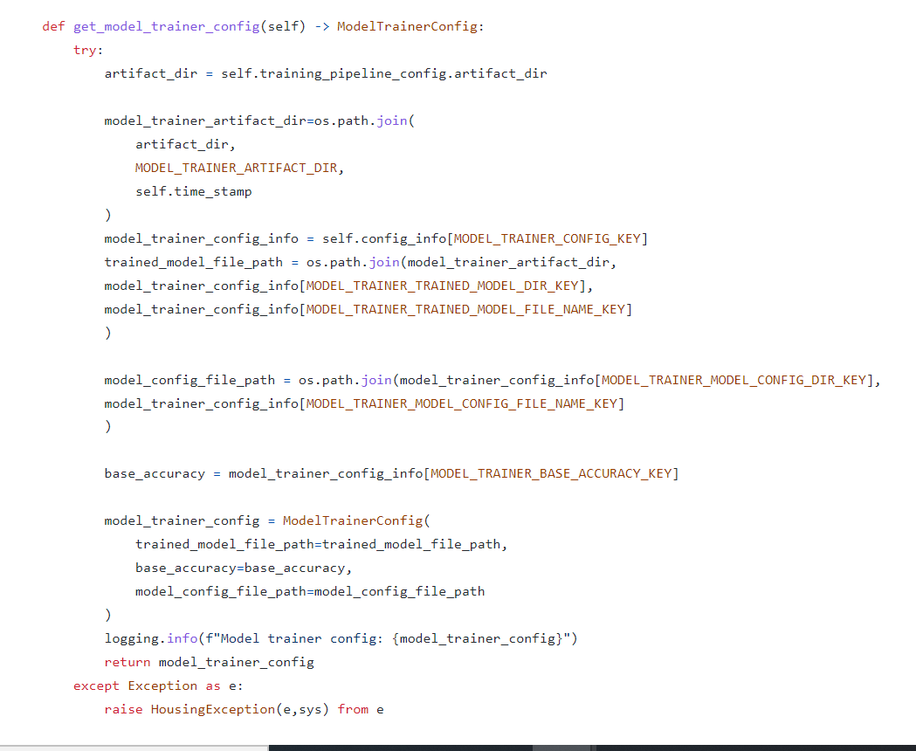

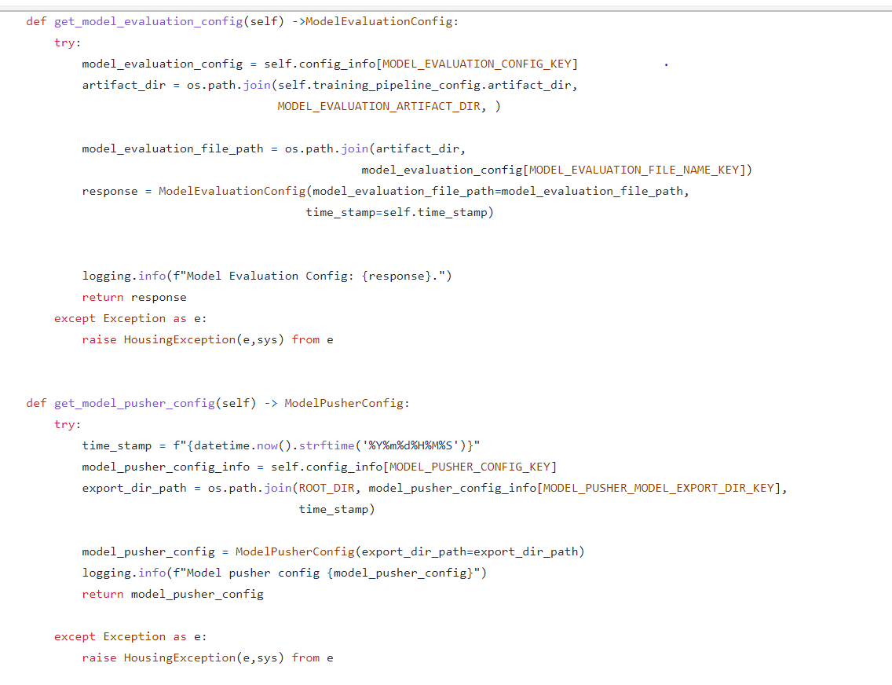

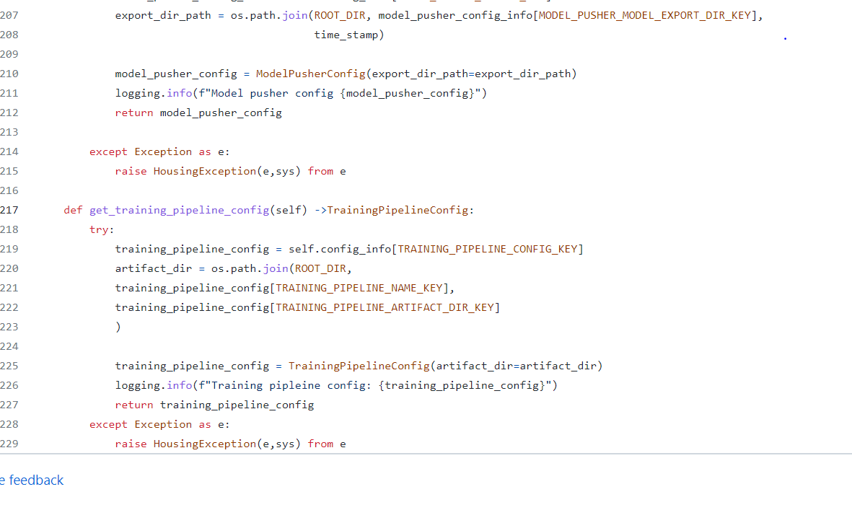

Now we will work with under component

Dataingestion.py

Create class

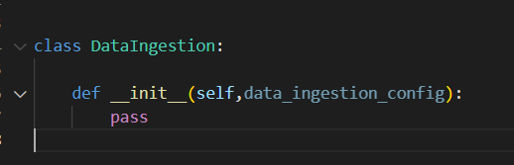

Class 61:

Artifact_entity.py

Create an another file in entity folder

Datainestionartefact:

To save save 1. Trainfile, test file location(datavalidation and transformation, is_inserted to know successful, messgage , )

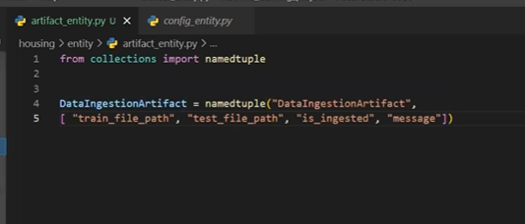

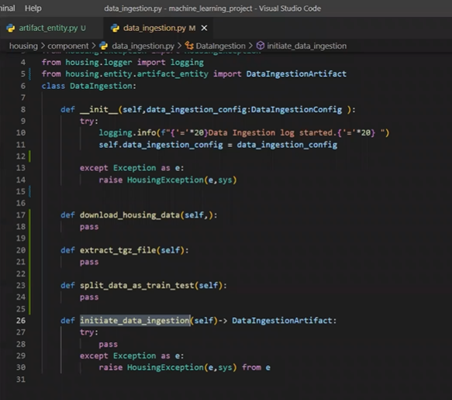

Now create artifact_entity.py in Entity folder

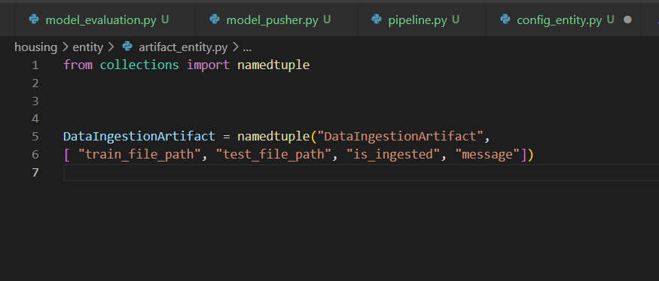

Is_injested: to know whether it was successful or not