CTE:

We will use the SQL Server's Common Table Expressions or CTEs to make **complex joins and subqueries easier.** It also provides **a way to query hierarchical data**, such as an organizational hierarchy.

What is CTE in SQL Server?

**A CTE (Common Table Expression) is a one-time result set that only exists for the duration of the query**. It allows us to refer to data within a single SELECT, INSERT, UPDATE, DELETE, CREATE VIEW, or MERGE statement's execution scope. **It is temporary because its result cannot be stored** anywhere and will be lost as soon as a query's execution is completed.

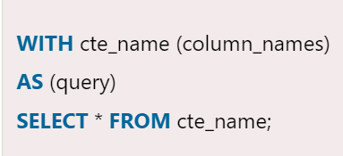

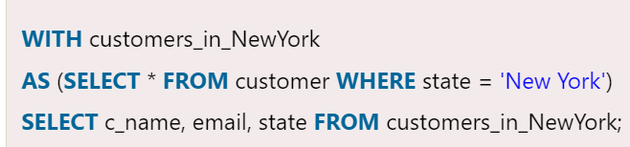

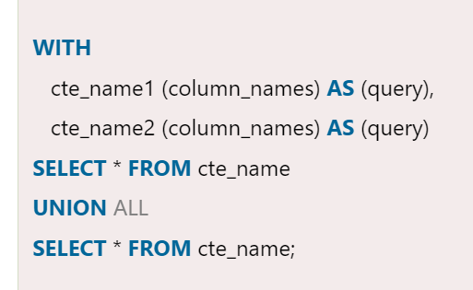

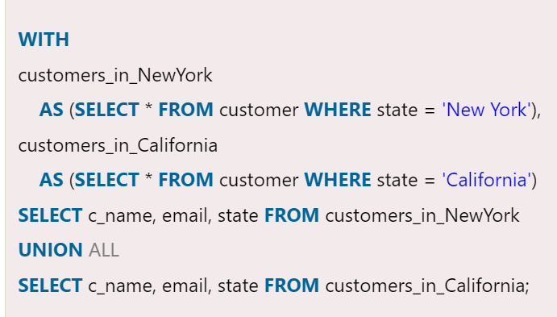

**Some of its use cases are given below:**

* It is useful when we need to define a derived table multiple times within a single query.
* It is useful when we need to create an alternative to a view in the database.
* It is useful when we need to perform the same calculation multiple times on multiple query components simultaneously.
* It is useful when we need to use ranking functions like ROW_NUMBER(), RANK(), and NTILE().

**Some of its advantages are given below:**

* CTE facilitates code maintenance easier.
* CTE increases the readability of the code.
* It increases the performance of the query.
* CTE makes it possible to implement recursive queries easily.

Types of CTE in SQL Server

SQL Server divides the CTE (Common Table Expressions) into two broad categories:

1. Recursive CTE
2. Non-Recursive CTE

### **Recursive CTE**

**A common table expression** is known as **recursive CTE** that references itself. Its concept is based on recursion, which is defined as "**the application of a recursive process or definition repeatedly**."

When we execute a recursive query, it repeatedly iterates over a subset of the data. It is simply defined as a query that calls itself. There is an end condition at some point, so it does not call itself infinitely.

A recursive CTE must have a **UNION ALL** statement and a second query definition that references the CTE itself in order to be recursive.

**Example**

Let us understand how recursive CTE works in SQL Server. Consider the below statement, which **generates a series of the first five odd numbers:**

Disadvantages of CTE

The following are the limitations of using CTE in SQL Server:

* CTE members are unable to use the keyword clauses like Distinct, Group By, Having, Top, Joins, etc.
* The CTE can only be referenced once by the Recursive member.
* We cannot use the table variables and CTEs as parameters in stored procedures.
* We already know that the CTE could be used in place of a view, but a CTE cannot be nested, while Views can.
* Since it's just a shortcut for a query or subquery, it can't be reused in another query.
* The number of columns in the CTE arguments and the number of columns in the query must be the same.

# **SQL Server CASE**

The CASE expression is a **part of the control flow function** that **evaluates a list of conditions** and **gives the output when the first condition is met**. It is primarily used to handle conditional statements, same as **IF-THEN-ELSE statements** in other programming languages.

**A CASE statement evaluates the condition**, and when finds true, it will stop executing and return the result. If it will not find any conditions true, it evaluates the ELSE part to return the value and ends. **It will give NULL value when no ELSE block** is found and no conditions are met true.

The CASE expression can be used anywhere a valid program or query is used **like SELECT, WHERE, and ORDER BY clause**. **Its main function is to manage multiple IF statements in the SELECT clause**. In MS [SQL Server](https://www.javatpoint.com/sql-server-tutorial), the CASE statement allows the user to add several conditions to perform various sets of actions.

## Types of CASE Statement

There are two forms of CASE statement in MS SQL Server:

1. Simple CASE Statement
2. Searched CASE Statement

### **Simple CASE**

We used the simple **CASE statement for equality tests**. It **determines the result by comparing an expression** to a set of multiple values to determine the result. In other words, this s**tatement evaluates conditions one by one and returning the expression specified in the THEN clause** when the condition and expression are matched.

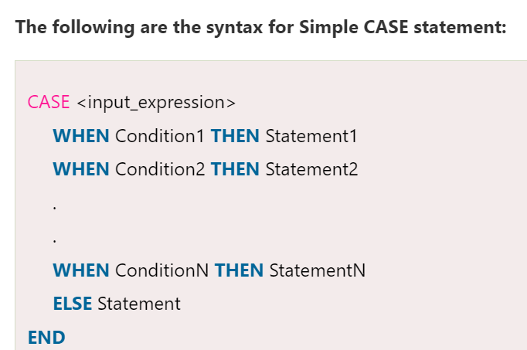

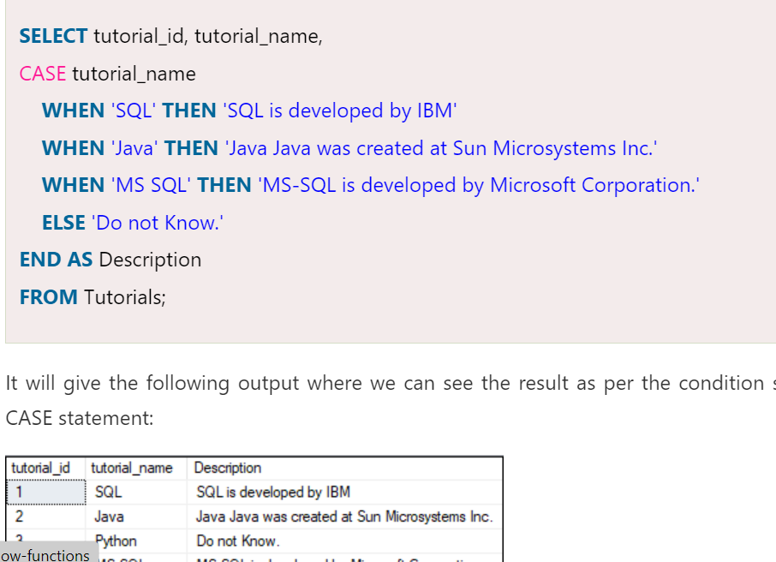

### **Searched CASE Statement**

The searched CASE statement is a **more comprehensive expression** evaluation format that **evaluates a set of Boolean expressions to find the result**. It allows us to use the comparison operators and logical operators within each Boolean expression.

The following are the syntax for a Simple CASE statement:

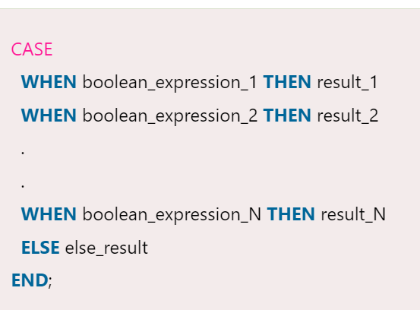

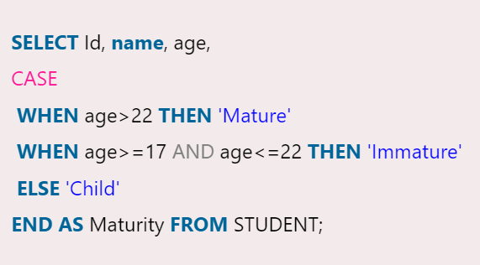

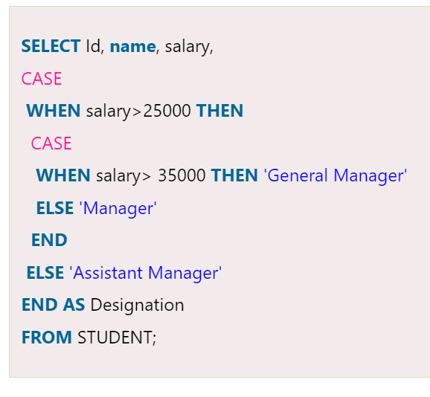

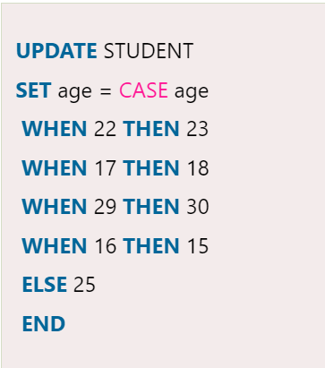

**1st non null value**

# **IF ELSE**

The IF statement is a part of the control flow function in SQL Server. Usually, it is a decision-making statement in various programming languages that **returns a value based on the given conditions**. This statement **executes the code written in IF block** when the given condition evaluates to true and when the condition evaluates false, then the ELSE statement will be executed. 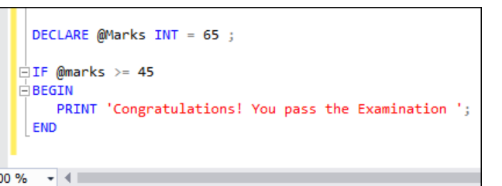



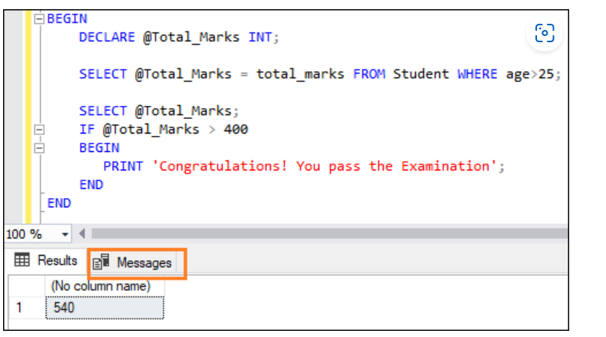

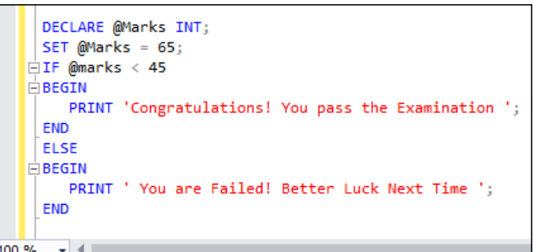 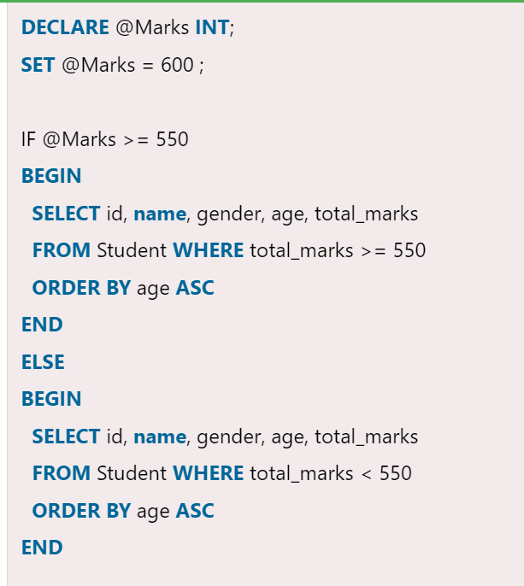

Find duplicate

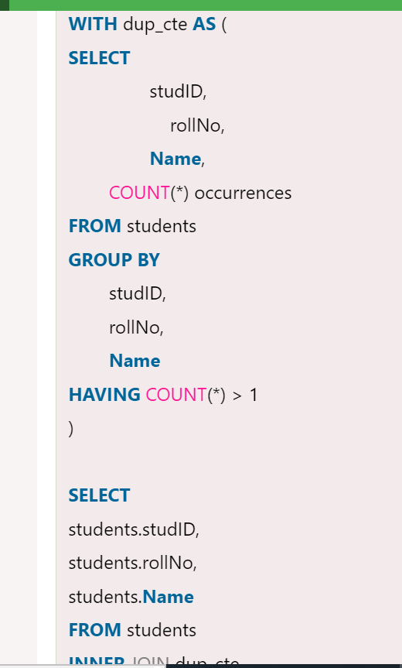

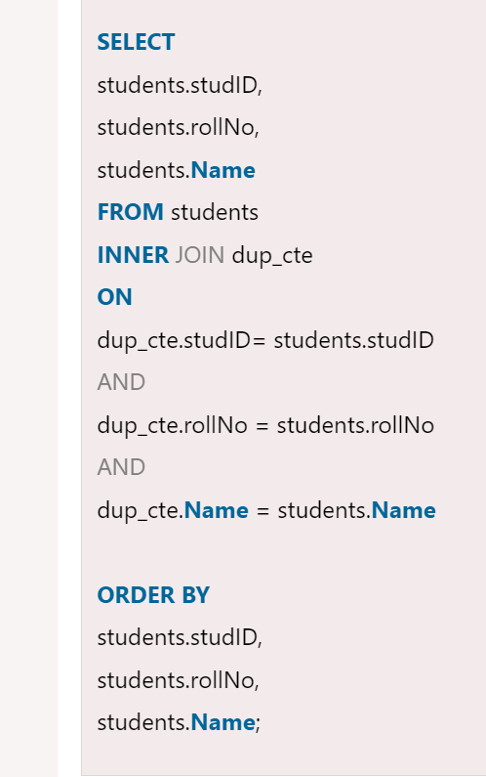

1. **WITH** dup_cte **AS** (
2. **SELECT**
3. studID,
4. rollNo,
5. **Name**,
7. ROW_NUMBER() OVER(
9. PARTITION **BY**
10. studID,
11. rollNo,
12. **Name**
14. **ORDER** **BY**
15. studID,
16. rollNo,
17. **Name**
18. ) row_num
19. **FROM** students
20. )
22. **DELETE** **FROM** dup_cte **WHERE** row_num>1;
24. **SELECT** * **FROM** students;

Merge()



1. MERGE TargetProducts **AS** Target
2. USING Products  **AS** Source
3. **ON** Source.ID = Target.ID
4. **WHEN** NOT MATCHED **BY** Target **THEN**
5. **INSERT** (ID, Product_Name, Price)
6. **VALUES** (Source.ID, Source.Product_Name, Source.Price);

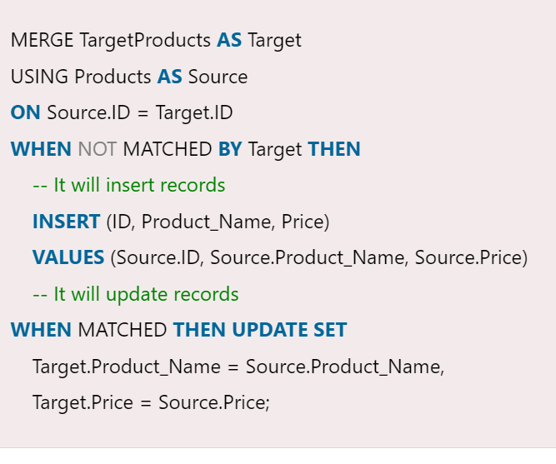 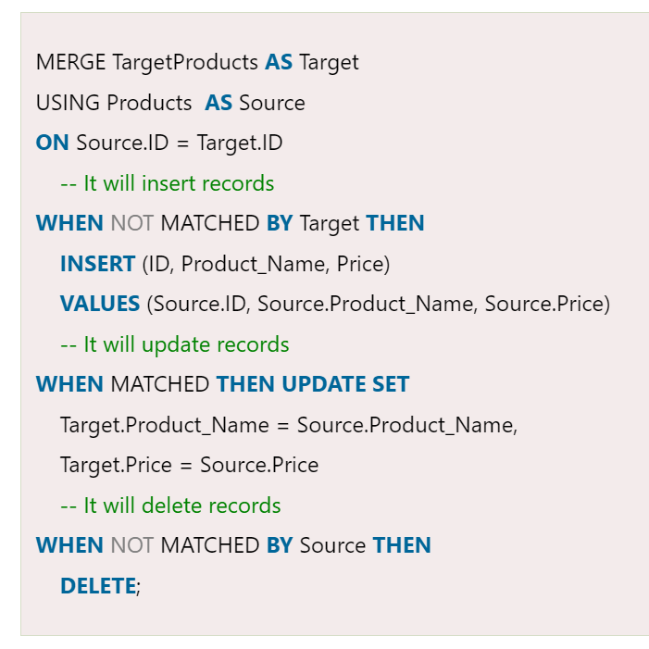

Nullif

The NULLIF function in SQL Server **accepts two arguments and compares them to determine they are the same or different**. If both arguments are **equal**, it will return a **NULL** value. If the arguments are **not identical**, they will return the **first argument**.



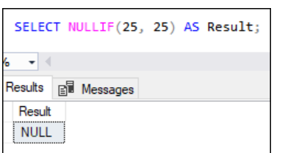

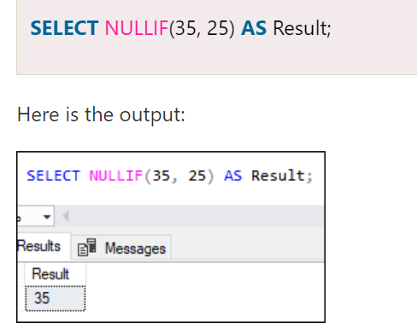

Nullif works with string also

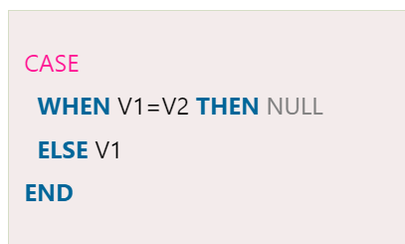

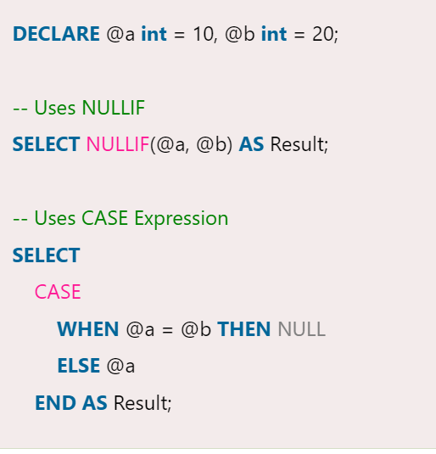

**MySQL Tutorial**

* [MySQL Tutorial](https://www.javatpoint.com/mysql-tutorial)
* [MySQL History](https://www.javatpoint.com/mysql-history)
* [MySQL Features](https://www.javatpoint.com/mysql-features)
* [MySQL Data Types](https://www.javatpoint.com/mysql-data-types)
* [Install MySQL](https://www.javatpoint.com/how-to-install-mysql)

**MySQL Database**

* [Create Database](https://www.javatpoint.com/mysql-create-database)
* [Select Database](https://www.javatpoint.com/mysql-select-database)
* [Drop Database](https://www.javatpoint.com/mysql-drop-database)

**Table & Views**

* [CREATE Table](https://www.javatpoint.com/mysql-create-table)
* [ALTER Table](https://www.javatpoint.com/mysql-alter-table)
* [TRUNCATE Table](https://www.javatpoint.com/mysql-truncate-table)
* [DROP Table](https://www.javatpoint.com/mysql-drop-table)
* [MySQL Views](https://www.javatpoint.com/mysql-view)

**MySQL Queries**

* [MySQL Queries](https://www.javatpoint.com/mysql-queries)
* [INSERT Record](https://www.javatpoint.com/mysql-insert)
* [UPDATE Record](https://www.javatpoint.com/mysql-update)
* [DELETE Record](https://www.javatpoint.com/mysql-delete)
* [SELECT Record](https://www.javatpoint.com/mysql-select)

**MySQL Clauses**

* [MySQL WHERE](https://www.javatpoint.com/mysql-where)
* [MySQL DISTINCT](https://www.javatpoint.com/mysql-distinct)
* [MySQL FROM](https://www.javatpoint.com/mysql-from)
* [MySQL ORDER BY](https://www.javatpoint.com/mysql-order-by)
* [MySQL GROUP BY](https://www.javatpoint.com/mysql-group-by)
* [MySQL HAVING](https://www.javatpoint.com/mysql-having)

**MySQL Conditions**

* [MySQL AND](https://www.javatpoint.com/mysql-and)
* [MySQL OR](https://www.javatpoint.com/mysql-or)
* [MySQL AND OR](https://www.javatpoint.com/mysql-and-or)
* [MySQL LIKE](https://www.javatpoint.com/mysql-like)
* [MySQL IN](https://www.javatpoint.com/mysql-in)
* [MySQL NOT](https://www.javatpoint.com/mysql-not)
* [MySQL IS NULL](https://www.javatpoint.com/mysql-is-null)
* [MySQL IS NOT NULL](https://www.javatpoint.com/mysql-is-not-null)
* [MySQL BETWEEN](https://www.javatpoint.com/mysql-between)

**MySQL Join**

* [MySQL JOIN](https://www.javatpoint.com/mysql-join)

**Aggregate Functions**

* [MySQL count()](https://www.javatpoint.com/mysql-count)
* [MySQL sum()](https://www.javatpoint.com/mysql-sum)
* [MySQL avg()](https://www.javatpoint.com/mysql-average)
* [MySQL min()](https://www.javatpoint.com/mysql-min)
* [MySQL max()](https://www.javatpoint.com/mysql-max)
* [MySQL first()](https://www.javatpoint.com/mysql-first)
* [MySQL last()](https://www.javatpoint.com/mysql-last)

**Differences**

* [MariaDB vs MySQL](https://www.javatpoint.com/mariadb-vs-mysql)
* [PostgreSQL vs MySQL](https://www.javatpoint.com/postgresql-vs-mysql)

**Interview Questions**

* [MySQL Interview](https://www.javatpoint.com/mysql-interview-questions)
* [SQL Interview](https://www.javatpoint.com/sql-interview-questions)
* [PL/SQL Interview](https://www.javatpoint.com/pl-sql-interview-questions)

**MySQL Date/Time Functions**

* [MySQL Date/Time](https://www.javatpoint.com/mysql-date-time)
* [DATE() function](https://www.javatpoint.com/mysql-date-function)
* [ADDDATE() function](https://www.javatpoint.com/mysql-adddate-function)
* [CURDATE() function](https://www.javatpoint.com/mysql-curdate-function)
* [CURRENT_DATE() function](https://www.javatpoint.com/mysql-current_date-function)
* [DATE_ADD() function](https://www.javatpoint.com/mysql-date_add-function)
* [DATE_FORMAT() function](https://www.javatpoint.com/mysql-date_format-function)
* [DATEDIFF() function](https://www.javatpoint.com/mysql-datediff-function)
* [DAY() function](https://www.javatpoint.com/mysql-day-function)
* [DAYNAME() function](https://www.javatpoint.com/mysql-dayname-function)
* [DAYOFMONTH() function](https://www.javatpoint.com/mysql-dayofmonth-function)
* [DAYOFWEEK() function](https://www.javatpoint.com/mysql-dayofweek-function)
* [DAYOFYEAR() function](https://www.javatpoint.com/mysql-dayofyear-function)
* [From_days() function](https://www.javatpoint.com/mysql-from_days-function)
* [Hour() function](https://www.javatpoint.com/mysql-hour-function)
* [ADDTIME() function](https://www.javatpoint.com/mysql-addtime-function)
* [CURRENT_TIME() function](https://www.javatpoint.com/mysql-current_time-function)
* [CURRENT_TIMESTAMP() function](https://www.javatpoint.com/mysql-current_timestamp-function)
* [CURTIME() function](https://www.javatpoint.com/mysql-curtime-function)
* [last_day() function](https://www.javatpoint.com/mysql-last_day-function)
* [localtime() function](https://www.javatpoint.com/mysql-localtime-function)
* [localtimestamp() function](https://www.javatpoint.com/mysql-localtimestamp-function)
* [makedate() function](https://www.javatpoint.com/mysql-makedate-function)
* [maketime() function](https://www.javatpoint.com/mysql-maketime-function)
* [microsecond() function](https://www.javatpoint.com/mysql-microsecond-function)
* [minute() function](https://www.javatpoint.com/mysql-minute-function)
* [month() function](https://www.javatpoint.com/mysql-month-function)
* [monthname() function](https://www.javatpoint.com/mysql-monthname-function)
* [now() function](https://www.javatpoint.com/mysql-now-function)
* [period_add() function](https://www.javatpoint.com/mysql-period_add-function)
* [period_diff() function](https://www.javatpoint.com/mysql-period_diff-function)
* [quarter() function](https://www.javatpoint.com/mysql-quarter-function)
* [sec_to_time() function](https://www.javatpoint.com/mysql-sec_to_time-function)
* [second() function](https://www.javatpoint.com/mysql-second-function)
* [str_to_date() function](https://www.javatpoint.com/mysql-str_to_date-function)
* [Subdate() function](https://www.javatpoint.com/mysql-subdate-function)
* [Subtime() function](https://www.javatpoint.com/mysql-subtime-function)
* [Sysdate() function](https://www.javatpoint.com/mysql-sysdate-function)
* [time() function](https://www.javatpoint.com/mysql-time-function)
* [time_format() function](https://www.javatpoint.com/mysql-time_format-function)
* [time_to_sec() function](https://www.javatpoint.com/mysql-time_to_sec-function)
* [timediff() function](https://www.javatpoint.com/mysql-timediff-function)
* [timestamp() function](https://www.javatpoint.com/mysql-timestamp-function)
* [to_day() function](https://www.javatpoint.com/mysql-to_day-function)
* [weekday() function](https://www.javatpoint.com/mysql-weekday-function)
* [week() function](https://www.javatpoint.com/mysql-week-function)
* [weekofyear() function](https://www.javatpoint.com/mysql-weekofyear-function)

**MySQL Math Functions**

* [MySQL Math](https://www.javatpoint.com/mysql-math)
* [Math ABS() function](https://www.javatpoint.com/mysql-math-abs-function)
* [Math ACOS() function](https://www.javatpoint.com/mysql-math-acos-function)
* [Math SIGN() function](https://www.javatpoint.com/mysql-math-sign-function)
* [Math SIN() function](https://www.javatpoint.com/mysql-math-sin-function)
* [Math SQRT() function](https://www.javatpoint.com/mysql-math-sqrt-function)
* [Math SUM() function](https://www.javatpoint.com/mysql-math-sum-function)
* [Math TAN() function](https://www.javatpoint.com/mysql-math-tan-function)
* [Math TRUNCATE() function](https://www.javatpoint.com/mysql-math-truncate-function)
* [Math ASIN() function](https://www.javatpoint.com/mysql-math-asin-function)
* [Math ATAN2() function](https://www.javatpoint.com/mysql-math-atan2-function)
* [Math ATAN() function](https://www.javatpoint.com/mysql-math-atan-function)
* [Math AVG() function](https://www.javatpoint.com/mysql-math-avg-function)
* [Math CEIL() function](https://www.javatpoint.com/mysql-math-ceil-function)
* [Math CEILING() function](https://www.javatpoint.com/mysql-math-ceiling-function)
* [Math COS() function](https://www.javatpoint.com/mysql-math-cos-function)
* [Math COT() function](https://www.javatpoint.com/mysql-math-cot-function)
* [Math COUNT() function](https://www.javatpoint.com/mysql-math-count-function)
* [Math DEGREES() function](https://www.javatpoint.com/mysql-math-degrees-function)
* [Math DIV() function](https://www.javatpoint.com/mysql-math-div-function)
* [Math EXP() function](https://www.javatpoint.com/mysql-math-exp-function)
* [Math FLOOR() function](https://www.javatpoint.com/mysql-math-floor-function)
* [Math GREATEST() function](https://www.javatpoint.com/mysql-math-greatest-function)
* [Math LEAST() function](https://www.javatpoint.com/mysql-math-least-function)
* [Math LN() function](https://www.javatpoint.com/mysql-math-ln-function)
* [Math LOG10() function](https://www.javatpoint.com/mysql-math-log10-function)
* [Math LOG() function](https://www.javatpoint.com/mysql-math-log-function)
* [Math LOG2() function](https://www.javatpoint.com/mysql-math-log2-function)
* [Math MAX() function](https://www.javatpoint.com/mysql-math-max-function)
* [Math MIN() function](https://www.javatpoint.com/mysql-math-min-function)
* [Math MOD() function](https://www.javatpoint.com/mysql-math-mod-function)
* [Math PI() function](https://www.javatpoint.com/mysql-math-pi-function)
* [Math POWER() function](https://www.javatpoint.com/mysql-math-power-function)
* [Math POW() function](https://www.javatpoint.com/mysql-math-pow-function)
* [Math RADIANS() function](https://www.javatpoint.com/mysql-math-radians-function)
* [Math RAND() function](https://www.javatpoint.com/mysql-math-rand-function)
* [Math ROUND() function](https://www.javatpoint.com/mysql-math-round-function)

**MSQL String Functions**

* [MySQL String](https://www.javatpoint.com/mysql-string)
* [String CONCAT_WS() function](https://www.javatpoint.com/mysql-string-concat_ws-function)
* [String CONCAT() function](https://www.javatpoint.com/mysql-string-concat-function)
* [String CHARACTER_LENGTH() function](https://www.javatpoint.com/mysql-string-character_length-function)
* [String ELT() function](https://www.javatpoint.com/mysql-string-elt-function)
* [String EXPORT_SET() function](https://www.javatpoint.com/mysql-string-export_set-function)
* [String FIELD() function](https://www.javatpoint.com/mysql-string-field-function)
* [String FIND_IN_SET() function](https://www.javatpoint.com/mysql-string-find_in_set-function)
* [String FORMAT() function](https://www.javatpoint.com/mysql-string-format-function)
* [String FROM_BASE64() function](https://www.javatpoint.com/mysql-string-from_base64-function)
* [String HEX() function](https://www.javatpoint.com/mysql-string-hex-function)
* [String INSERT() function](https://www.javatpoint.com/mysql-string-insert-function)
* [String INSTR() function](https://www.javatpoint.com/mysql-string-instr-function)
* [String LCASE() function](https://www.javatpoint.com/mysql-string-lcase-function)
* [String LEFT() function](https://www.javatpoint.com/mysql-string-left-function)
* [String LENGTH() function](https://www.javatpoint.com/mysql-string-length-function)
* [String like() function](https://www.javatpoint.com/mysql-string-like-function)
* [String LOAD_FILE() function](https://www.javatpoint.com/mysql-string-load_file-function)
* [String LOCATE() function](https://www.javatpoint.com/mysql-string-locate-function)
* [String LOWER() function](https://www.javatpoint.com/mysql-string-lower-function)
* [String LPAD() function](https://www.javatpoint.com/mysql-string-lpad-function)
* [String LTRIM() function](https://www.javatpoint.com/mysql-string-ltrim-function)
* [String MAKE_SET() function](https://www.javatpoint.com/mysql-string-make_set-function)
* [String MID() function](https://www.javatpoint.com/mysql-string-mid-function)
* [String OCTET_LENGTH() function](https://www.javatpoint.com/mysql-string-octet_length-function)
* [String OCT() function](https://www.javatpoint.com/mysql-string-oct-function)
* [String ORD() function](https://www.javatpoint.com/mysql-string-ord-function)
* [String POSITION() function](https://www.javatpoint.com/mysql-string-position-function)
* [String QUOTE() function](https://www.javatpoint.com/mysql-string-quote-function)
* [String REPEAT() function](https://www.javatpoint.com/mysql-string-repeat-function)
* [String REPLACE() function](https://www.javatpoint.com/mysql-string-replace-function)
* [String REVERSE() function](https://www.javatpoint.com/mysql-string-reverse-function)
* [String RIGHT() function](https://www.javatpoint.com/mysql-string-right-function)
* [String RPAD() function](https://www.javatpoint.com/mysql-string-rpad-function)
* [String RTRIM() function](https://www.javatpoint.com/mysql-string-rtrim-function)
* [String SOUNDEX() function](https://www.javatpoint.com/mysql-string-soundex-function)
* [String SPACE() function](https://www.javatpoint.com/mysql-string-space-function)
* [String STRCMP() function](https://www.javatpoint.com/mysql-string-strcmp-function)
* [String SUBSTR() function](https://www.javatpoint.com/mysql-string-substr-function)
* [String SUBSTRING_INDEX() function](https://www.javatpoint.com/mysql-string-substring_index-function)
* [String SUBSTRING() function](https://www.javatpoint.com/mysql-string-substring-function)
* [String Trim() function](https://www.javatpoint.com/mysql-string-trim-function)
* [String UCASE() function](https://www.javatpoint.com/mysql-string-ucase-function)
* [String UNHEX() function](https://www.javatpoint.com/mysql-string-unhex-function)
* [String UPPER() function](https://www.javatpoint.com/mysql-string-upper-function)

[Learn MySQL Tutorial - javatpoint](https://www.javatpoint.com/mysql-tutorial)

# Understanding ALL ANY or SOME in SQL

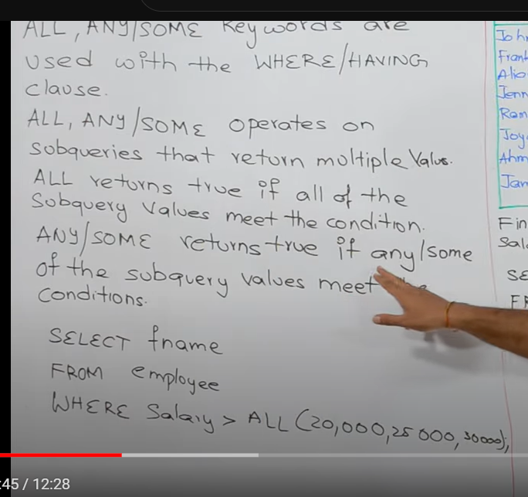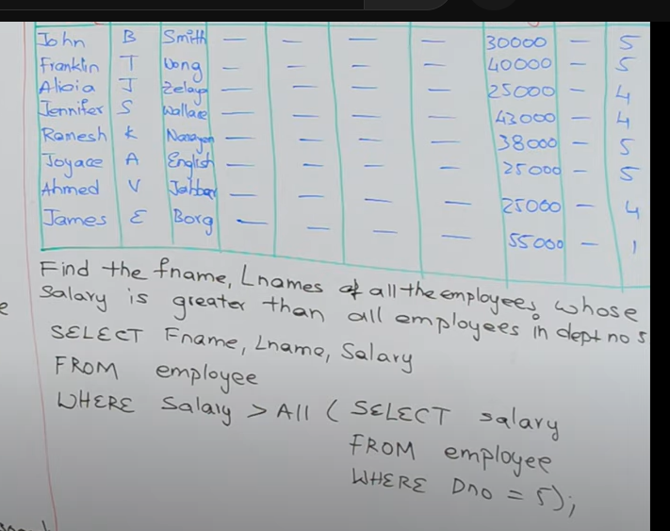

**All means- AND condition- meet all conditions**

**Any means-OR condition- should meat any condition**

