1. Write a valid SQL statement that calculates the total weight of all corn cobs that were picked from the garden:

select sum(picked.weight) from plant join picked where plant.plantid=picked.plantFK and plant.name='Corn';

o/p:

17.54

2. For some reason Erin has change his location for picking the tomato to North.

Write the corresponding query.

update picked set locationFK =(select locationid from location where name='North') where gardenerFK =( select gardenerid from gardener where name='Erin') and plantFK =(select plantid from plant where name='Tomato') ;

select \* from picked ;

o/p:

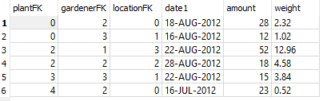

3. Insert a new column 'Exper' of type Number (30) to the 'gardener' table which stores Experience of the of person. How will you modify this to varchar2(30).

alter table gardener add column Exper int(30);

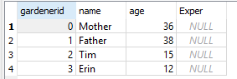

alter table gardener modify column Exper varchar(30);

