PORTFOLIO PROJECT
PeopleOps & Legal Intelligence Hub
A Unified Semantic Data Product for HR and Legal — Governance, AI/ML, and an ROI-Informed Roadmap
Data Product Strategy · Semantic Modeling · AI/ML Product Management · Data Governance · Enterprise Analytics
Role | Type | Domain | Year
Data & AI Product Manager (self-directed) | Zero-to-One Data Product | HR & Legal, Enterprise | 2026

Why This Project
This case study is a self-directed portfolio project, built to work through the same problem a senior Data & AI Product Manager role for enterprise HR and Legal data products would actually pose: unify fragmented data from core systems, govern it properly, and layer AI on top without losing stakeholder trust. It draws on real governance and data-architecture experience from regulated healthcare and banking environments, combined with product and AI/ML thinking developed on other portfolio builds.

The Problem
HR and Legal sit on the same fragmented-data problem, just with different symptoms. HR leaders can't see attrition risk or skills gaps until they show up in an exit interview. Legal Ops can't see where contracts are stuck or which obligations are coming due until someone asks. Both functions run on manual, spreadsheet-stitched reporting pulled from systems that were never designed to talk to each other — Workday, Agiloft, SFDC, ServiceNow — and both carry real governance risk when that stitching happens by hand.
Two functions, one shared pattern:
- HR: reactive attrition management, slow DEI reporting, no forward view on skills gaps
- Legal: contract bottlenecks, missed obligations, compliance gaps that surface too late
- Shared root cause: no single governed source of reference — every report is rebuilt from scratch, by hand, with no lineage back to source

The Product
One semantic layer, governed once, serving two functions. Rather than building two disconnected dashboards, the product unifies HR and Legal source systems under a single semantic model with shared governance rules, then exposes that model through APIs, dashboards, and a conversational AI assistant — so both functions query the same trusted data, not two different versions of the truth.
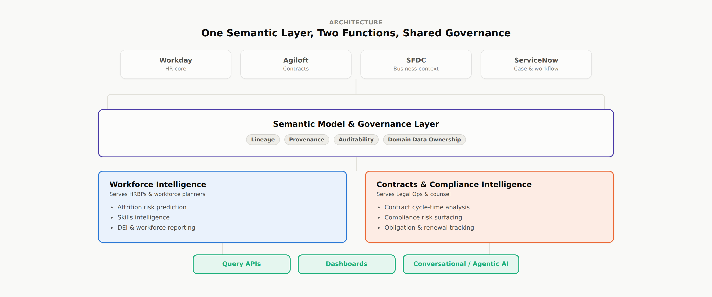
Figure 1 — Shared semantic layer serving two modules through common governance

Semantic Model & Governance
This is the section closest to real prior experience — data masking, metadata management, and schema classification work done in regulated healthcare and banking environments translates directly into the governance backbone this product needs. Four principles hold the model together:
- Lineage — every field traceable back to its source system and transformation
- Provenance — clear ownership of who changed what, and when
- Auditability — every AI-influenced decision logged and reviewable
- Domain data ownership — HR owns HR definitions, Legal owns Legal definitions; the platform team owns the plumbing, not the meaning
Privacy and records-compliance requirements — GDPR data-subject rights, records-of-processing obligations, and standard PII-handling controls — are treated as model constraints from day one, not a review step bolted on before launch.

Roadmap
The roadmap is sequenced to deliver a quick, low-risk win before asking for investment in the harder foundational work — the same pattern that earns the trust needed to get budget for the semantic layer and, later, the AI/ML layer.
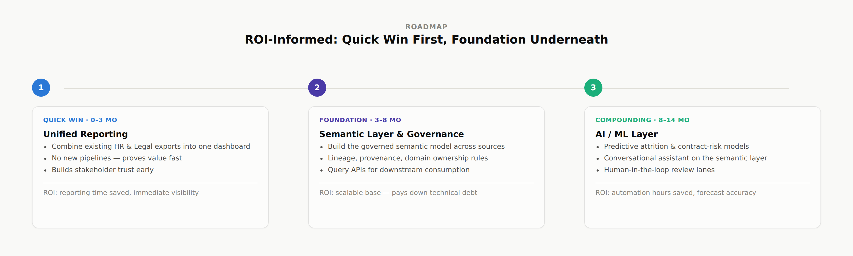
Figure 2 — Three phases: quick win, foundation, then compounding AI/ML value

AI/ML Layer & Responsible AI
Two models sit on top of the semantic layer: an attrition-risk score for HR, and a contract/compliance anomaly flag for Legal. Neither model acts unsupervised — every output routes through a confidence-based review lane, so trust is earned per use case rather than assumed.
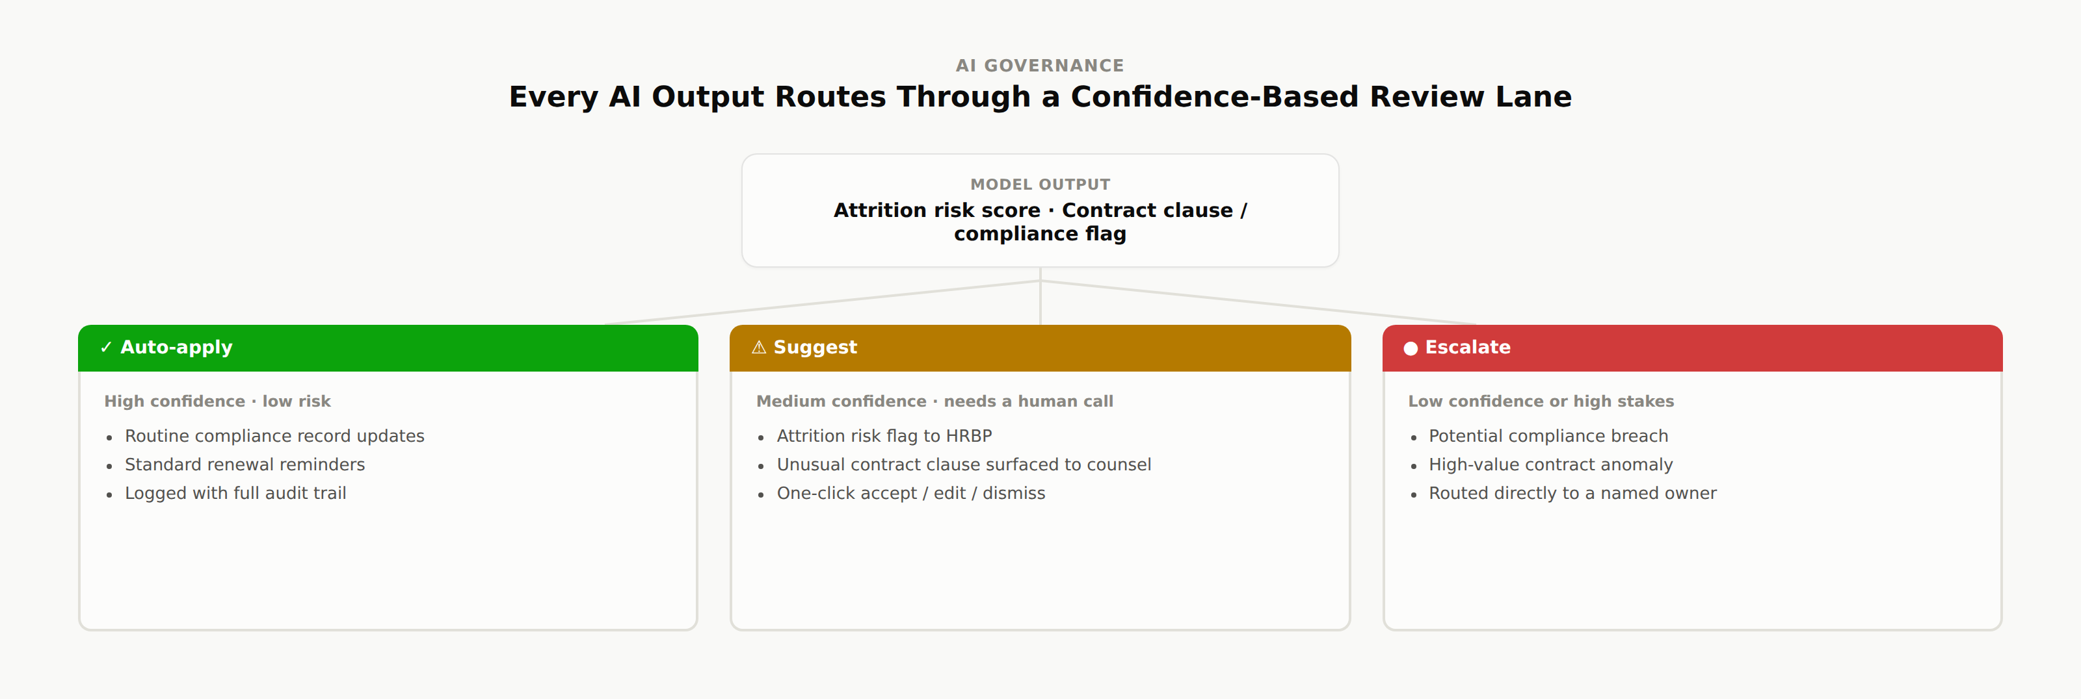
Figure 3 — Auto-apply, suggest, or escalate, based on confidence and stakes
This mirrors how AI/ML products should ship inside a regulated enterprise function: low-risk, high-confidence actions can move automatically; everything else stays a human decision, with the model doing the flagging, not the deciding.

Business Case & Metrics
The metrics are chosen to answer the question every stakeholder actually asks — is this worth what it costs — rather than vanity usage numbers.
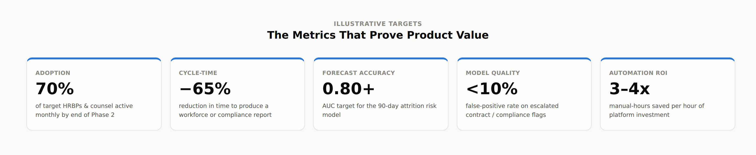
Figure 4 — Illustrative targets across adoption, cycle-time, forecasting, model quality, and ROI

Delivery Approach
Delivery follows an agile release cycle: problem framing and data-feasibility checks with data engineering, a prototype of the semantic model and one dashboard for UAT with HRBPs and Legal Ops, then phased rollout of APIs and the AI layer with data quality and security checks gating each release. Backlog and pipeline design are shared with data platform, data science, and AI/ML teams rather than owned in isolation — the model store and query APIs only stay trustworthy if the teams building the pipelines and the team defining the product logic are working off the same backlog.

Skills Demonstrated
- Translating fragmented stakeholder pain (HR and Legal) into a single governed data product
- ROI-informed roadmap sequencing: quick win, foundation, compounding AI value
- Semantic modeling and data governance: lineage, provenance, auditability, domain ownership
- Shipping an AI/ML product with a human-in-the-loop review model
- Business case construction with named, falsifiable success metrics
- Cross-functional delivery: data engineering, data science, and platform teams on one backlog

Uma Ramanathan — Product, UX & Data Portfolio

