**Write down Linux commands for following statements:**

1. **Redirect the output of ls command to a file named outfile. Use this asaninput file for remaining commands.**

ls > outfile.txt

cat outfile.txt



1. **To select the lines in a file which has digit as one of the character inthatline and redirect the output to the file named list.**

grep “[0-9]” outfile > list

cat list

1. **Assign execute permission to owner and remove read permission from other for an ordinary file named test by relative way.**

chmod u+x outfile.txt

chmod o-r outfile.txt

ls -l outfile.txt

//-rwxr----- 1 root root 566 Dec 12 21:05 outfile.txt

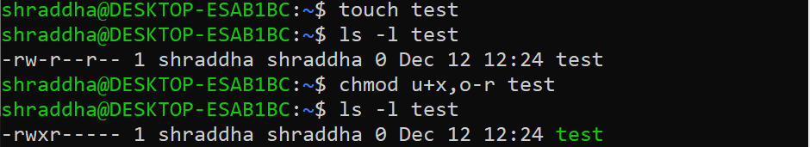

1. **Create an alias named rm that always deletes file interactively.**

alias rm=”rm-i”

1. **Count the currently login users to the system**

w | wc -l



**Write down Linux commands for following statements:**

1. **Redirect the output of cat command to a file named outfile. Use this as an input file for remaining commands.**

cat > outfile

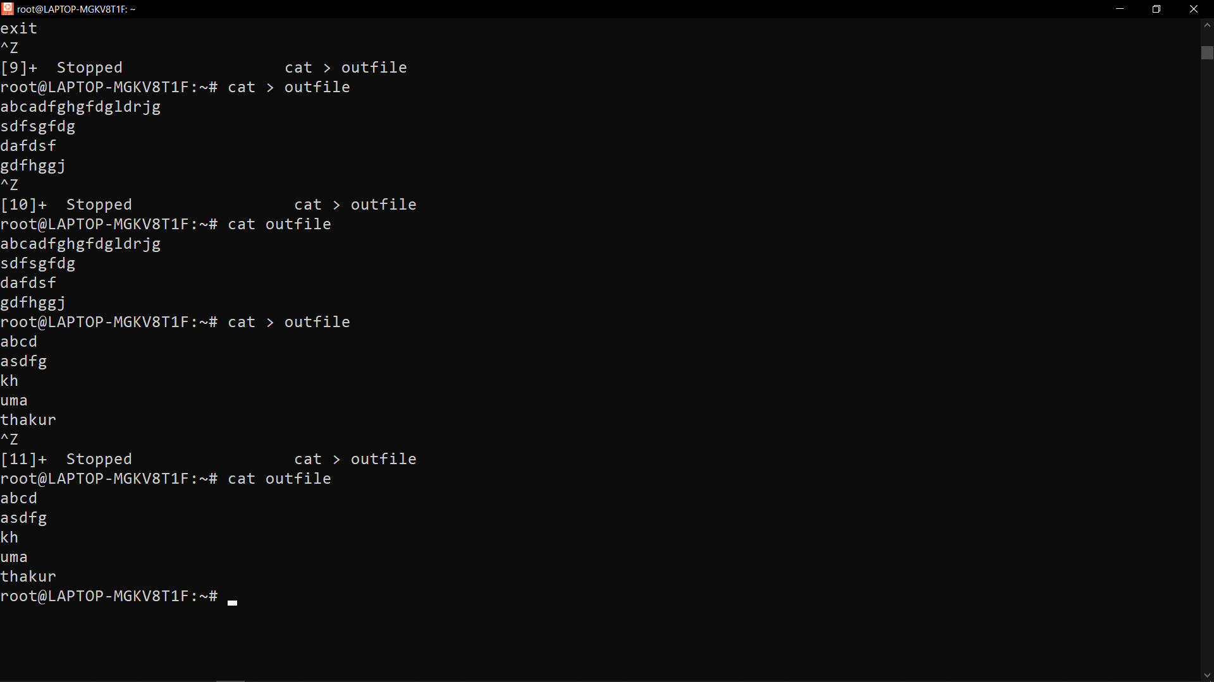

1. **List all hidden files under current directory and store in “hidden” file**

ls -a | grep "^\."pa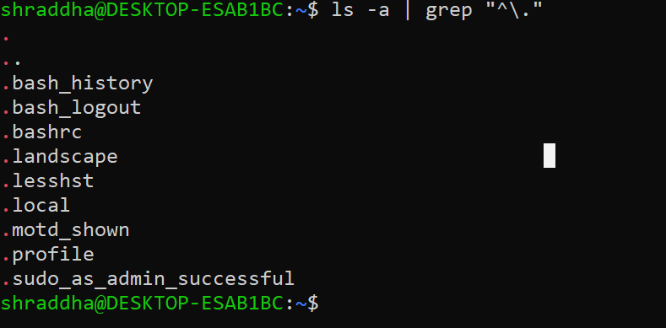

1. **Assign write permission to owner and remove execute permissionfromother for an ordinary file named test by absolute way.**

chmod u+w,o-x /root/outfile

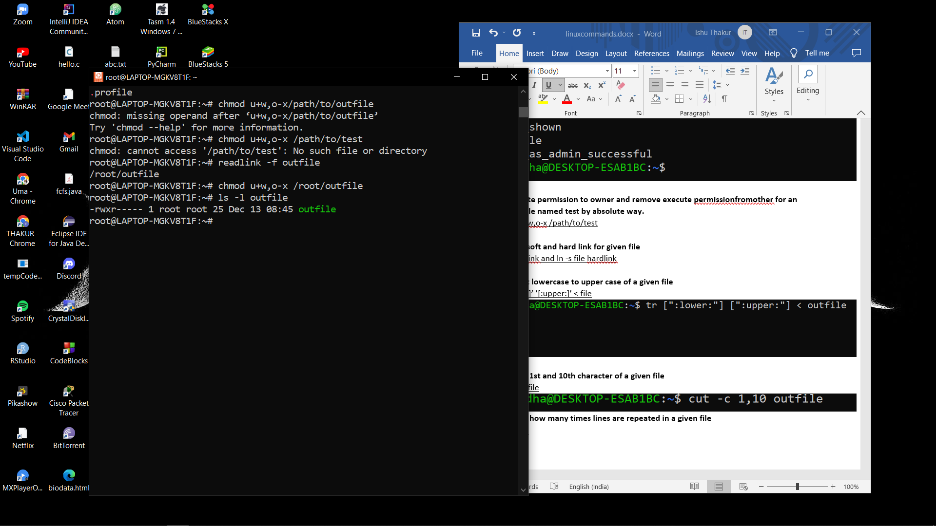

1. **To create soft and hard link for given file**

ln file softlink and ln -s file hardlink

1. **To convert lowercase to upper case of a given file**

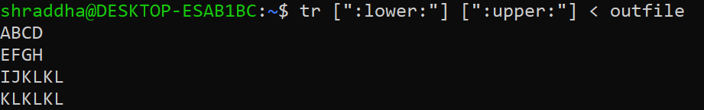

1. **To extract 1st and 10th character of a given file**

cut -c1,10 file



1. **To display how many times lines are repeated in a given file**

Uniq -c file



**Write down Linux commands for following statements:**

**i. To redirect the output of cp command to a file named outfile. Use this**

**as an input file for remaining commands.**

**cp outfile > outfile2**

**ii. To select the lines in a file which has 4 letter words in that line and**

**redirect the output to the file named list.**

**iii. Assign write permission to owner and remove read permission from**

**group user for an ordinary file named test by relative way.**

**iv. Create an alias named ls that always lists all the files including hidden**

**files.**

**v. Count the number of words in the list file.**



**Write down Linux commands for following statements:**

**a. Redirect the output of mv command to a file named outfile. Use this as**

**an input file for remaining commands.**

**b. List all hidden files under current directory and store in “hidden” file**

**c. Assign write permission to group user and remove execute permission**

**from owner for an ordinary file named test by absolute way**

**d. To create soft and hard link for given file**

**e. To convert lowercase to upper case of a given file**

**f. To extract 2nd and 3rd character of a given file**

**g. To display how many times lines are repeated in a given file**