AHB VIP
Advanced High-Performance Bus Verification IP

Project: AHB VIP (AHB_VIP)
Protocol: AMBA AHB (Advanced High-performance Bus)
Language: SystemVerilog / UVM
Simulator: Questa / ModelSim
Coverage: 100% – Assertions, Covergroups, Covergroup Bins
Batch: BRN66 – Maven Silicon
Prepared for: Final Project Review – Maven Silicon

Table of Contents
Table of Contents 2
1. Project Introduction & Objectives 4
Project Overview 4
Project Objectives 4
2. TB Architecture 5
Testbench Hierarchy 5
Key Interface Signals 5
3. AHB Protocol Overview 6
Features of AHB 6
Transfer Types (HTRANS) 6
Burst Types (HBURST) 6
4. Master Side – Explanation & Waveforms 7
Master Behaviour 7
Master Transaction Sequence 7
Write Waveform – Questa Wave (Write, INCR16 burst) 7
Waveform Analysis (Write) 7
Read Waveform – Questa Wave (Read, SINGLE) 9
Waveform Analysis (Read) 9
5. Slave Side – Explanation & Waveforms 10
Slave Behaviour 10
Slave Response Types 10
Slave Sequence (from Live Session Notes – June 1, 2026) 10
Slave Waveform – Questa Wave 10
Waveform Analysis (Slave-side) 11
6. Scoreboard Description 12
Scoreboard Functionality 12
7. Functional Coverage Report 13
Instance Hierarchy Coverage Summary 13
Local Instance Coverage Details – /pkg (100%) 13
Top-Level Recursive Hierarchical Coverage (/top) 13
8. AHB Multi-Layer Interconnect 15
Traditional AHB vs Multi-Layer AHB 15
Multi-Layer Architecture Components 15
Benefits 15
Subsystem Configuration (from course slides) 15
9. AXI vs AHB – Protocol Comparison 16
10. Takeaways & Difficulties Faced 17
Key Learnings from the Project 17
Difficulties Faced During Project 17

1. Project Introduction & Objectives

Project Overview
This project implements a complete Verification IP (VIP) for the AMBA Advanced High-performance Bus (AHB) protocol. The AHB VIP verifies all aspects of the AHB protocol including basic transfers, burst transfers, wait states, error responses, locked transfers, and multi-layer interconnect scenarios. The testbench is developed using SystemVerilog and UVM methodology.

Project Objectives
- Verify AHB Master and Slave RTL implementations against the AMBA AHB specification.
- Achieve 100% functional coverage for all AHB transfer types and response scenarios.
- Implement constrained-random stimulus generation for HTRANS, HBURST, HSIZE, HWRITE, HADDR, and HWDATA.
- Validate correct pipelining of address and data phases across multiple transactions.
- Verify slave responses: OKAY, OKAY with wait states, and ERROR response.
- Validate burst transfer types: SINGLE, INCR, WRAP4, INCR4, WRAP8, INCR8, WRAP16, INCR16.
- Check correct locked-transfer behavior and arbitration.
- Verify AHB Multi-Layer Interconnect (Multi-Master / Multi-Slave) scenarios.
- Demonstrate 100% assertion and covergroup coverage using Questa Coverage Reports.

2. TB Architecture
The testbench is structured using the UVM methodology with a top-level module that instantiates the DUT (AHB top) along with driver, monitor, agent, scoreboard and coverage collector components.

Testbench Hierarchy
Component | Description
top.sv | Top-level module; instantiates DUT and connects interface
ahb_interface.sv | SystemVerilog interface carrying all AHB signals
ahb_env | UVM Environment containing all agents and scoreboard
ahb_agent (Master) | Contains master driver, monitor and sequencer
ahb_agent (Slave) | Contains slave driver/response logic and monitor
ahb_driver | Drives AHB transactions onto the interface
ahb_monitor | Observes bus and creates transaction objects
ahb_scoreboard | Compares expected vs actual responses; checks data integrity
ahb_coverage (pkg) | Covergroups and assertions in pkg.sv; 100% coverage achieved
ahb_sequence_lib | Library of sequences: basic, burst, error, lock, multi-master

Key Interface Signals
Signal | Direction | Width | Description
HCLK | Input | 1 | Bus clock – all transfers synchronised on rising edge
HRESETn | Input | 1 | Active-low reset
HADDR | M→S | 32 | Address bus
HTRANS | M→S | 2 | Transfer type: IDLE/BUSY/NONSEQ/SEQ
HBURST | M→S | 3 | Burst type (SINGLE, INCR, WRAP4 … INCR16)
HSIZE | M→S | 3 | Transfer size (byte/halfword/word …)
HWRITE | M→S | 1 | Direction: 1=Write, 0=Read
HWDATA | M→S | 32 | Write data bus
HRDATA | S→M | 32 | Read data bus
HREADY | S→M | 1 | Transfer complete / insert wait state
HRESP | S→M | 2 | Slave response: OKAY (0) / ERROR (1)
HSEL | Decoder→S | 1 | Slave select from address decoder

3. AHB Protocol Overview

Features of AHB
- Single-channel bus with pipelined address and data phases.
- Burst transfers: SINGLE, INCR (undefined length), WRAP4/8/16, INCR4/8/16.
- Multiple bus masters arbitrated by a central arbiter.
- Wait-state insertion by slave via HREADY deassertion.
- Two-cycle error response signalled by slave through HRESP = ERROR.
- Locked transfers to guarantee atomic bus access for a master.
- Protection control via HPROT[3:0].
- Address space alignment: 1 kB per slave.

Transfer Types (HTRANS)
HTRANS[1:0] | Name | Description
2'b00 | IDLE | No transfer requested; default state
2'b01 | BUSY | Master inserts idle cycle within a burst
2'b10 | NONSEQ | First beat of a burst or single transfer
2'b11 | SEQ | Subsequent beats of a burst

Burst Types (HBURST)
HBURST[2:0] | Name | Beats | Description
3'b000 | SINGLE | 1 | Single transfer
3'b001 | INCR | Indef. | Incrementing burst of undefined length
3'b010 | WRAP4 | 4 | 4-beat wrapping burst
3'b011 | INCR4 | 4 | 4-beat incrementing burst
3'b100 | WRAP8 | 8 | 8-beat wrapping burst
3'b101 | INCR8 | 8 | 8-beat incrementing burst
3'b110 | WRAP16 | 16 | 16-beat wrapping burst
3'b111 | INCR16 | 16 | 16-beat incrementing burst

4. Master Side – Explanation & Waveforms

Master Behaviour
The AHB Master initiates all bus transactions. It drives the address phase signals (HADDR, HTRANS, HBURST, HSIZE, HWRITE) on one clock cycle and the data phase signals (HWDATA for writes) on the following cycle. The master monitors HREADY to detect wait states and HRESP to detect error conditions.

Master Transaction Sequence
- Address Phase: Master drives HADDR, HTRANS=NONSEQ, HBURST, HSIZE, HWRITE. For burst: HTRANS=SEQ on subsequent beats.
- Wait State Detection: Master samples HREADY. If LOW the address/control signals must be held stable and the data phase is extended until HREADY goes HIGH.
- Data Phase (Write): Master drives HWDATA in the cycle after the address phase. HWDATA is registered with the previous address.
- Data Phase (Read): Master captures HRDATA when HREADY is HIGH.
- Error Handling: If HRESP=ERROR is asserted the master aborts the remaining burst and generates an IDLE or NONSEQ transfer.
- Burst Completion: After all beats, master returns HTRANS=IDLE.

Write Waveform – Questa Wave (Write, INCR16 burst)
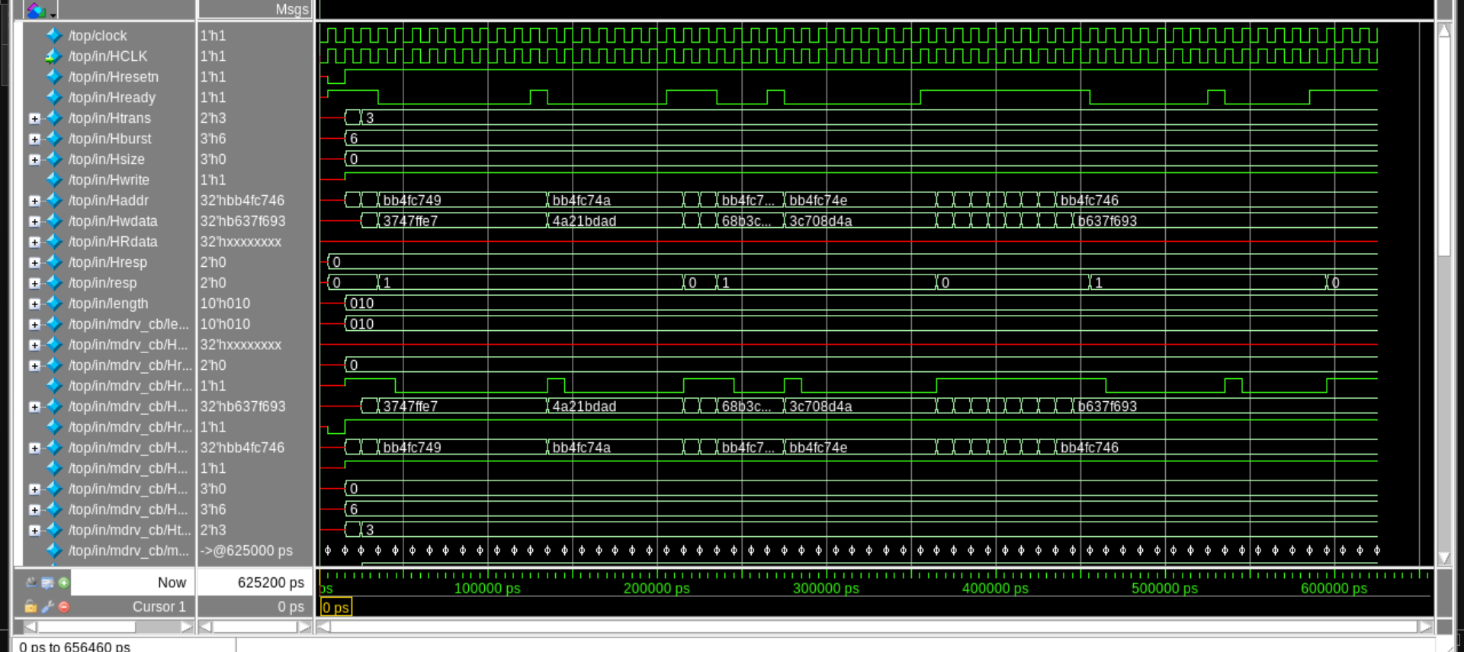
Figure 1: Master write transaction – INCR16 burst, Questa Wave

Waveform Analysis (Write)
- HCLK toggles continuously; HCLK and HCLK drive are in phase.
- HRESETn asserted HIGH → normal operation.
- HTRANS transitions NONSEQ (2'h3) → SEQ for burst beats.
- HBURST = 3'h6 (INCR16 mode observed).
- HADDR increments each beat: 0xbb4fc749 → 0xbb4fc74a → …
- HWDATA changes each beat: 0x3747ffe7 → 0x4a21bdad → 0x68b3c… → 0x3c708d4a.
- HREADY pulses LOW during wait states then returns HIGH to complete transfer.
- resp = 0 (OKAY); length register = 10'h010.
- Simulation time observed: 0 ps to 656,460 ps.

Read Waveform – Questa Wave (Read, SINGLE)
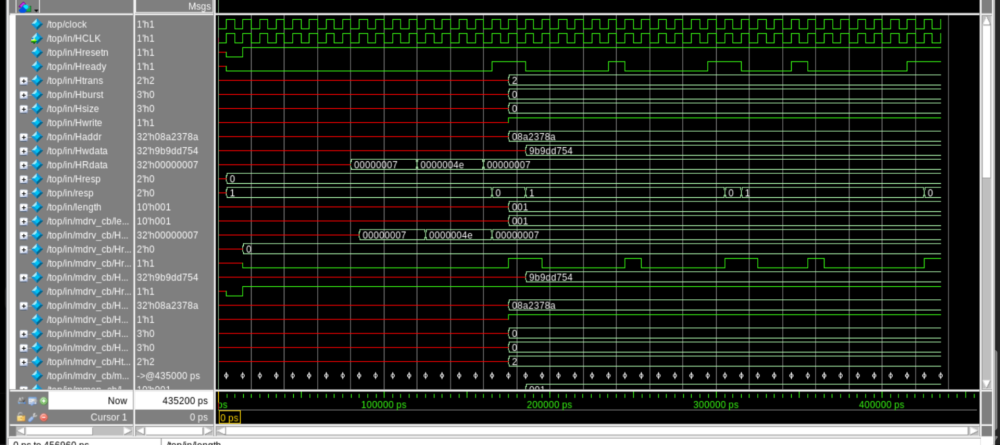
Figure 2: Master read transaction – SINGLE transfer, Questa Wave

Waveform Analysis (Read)
- HTRANS = 2'h2 (NONSEQ) followed by IDLE for single transfers.
- HBURST = 3'h0 (SINGLE); HSIZE = 3'h0 (byte); HWRITE = 1'h1.
- HADDR = 0x08a2378a with HWDATA = 0x9b9dd754.
- HRDATA shows: 0x00000007 → 0x0000004e → 0x00000007 across successive reads.
- length = 10'h001; resp = 0 (OKAY throughout).
- Simulation time: 0 ps to 456,960 ps.

5. Slave Side – Explanation & Waveforms

Slave Behaviour
The AHB Slave responds to transactions initiated by the master. It receives address and control information in the address phase, processes the request, and provides a response via HRESP and HREADY. The slave can insert wait states by de-asserting HREADY. For error conditions it drives HRESP=ERROR over two consecutive cycles.

Slave Response Types
HRESP | HREADY | Meaning
0 (OKAY) | 1 | Transfer completed successfully in this cycle
0 (OKAY) | 0 | Transfer pending – insert wait state
1 (ERROR) | 0 | First cycle of error response
1 (ERROR) | 1 | Second cycle of error response – master must abort burst

Slave Sequence (from Live Session Notes – June 1, 2026)
- Slave monitors HSEL and HREADY to detect when it is the selected target.
- Gets the burst length from the HBURST/length field.
- Executes repeat(length) loop: drives HRESP = OKAY or OKAY-with-wait-states or ERROR.
- For write: captures HWDATA and stores to internal memory at HADDR.
- For read: drives HRDATA from internal memory and asserts HREADY.
- For error: asserts HRESP=ERROR for two cycles; master must abort remaining burst.
- Memory model: 64 locations × 4 bytes = 64 bytes; address aligned to 20-bit boundary.

Slave Waveform – Questa Wave
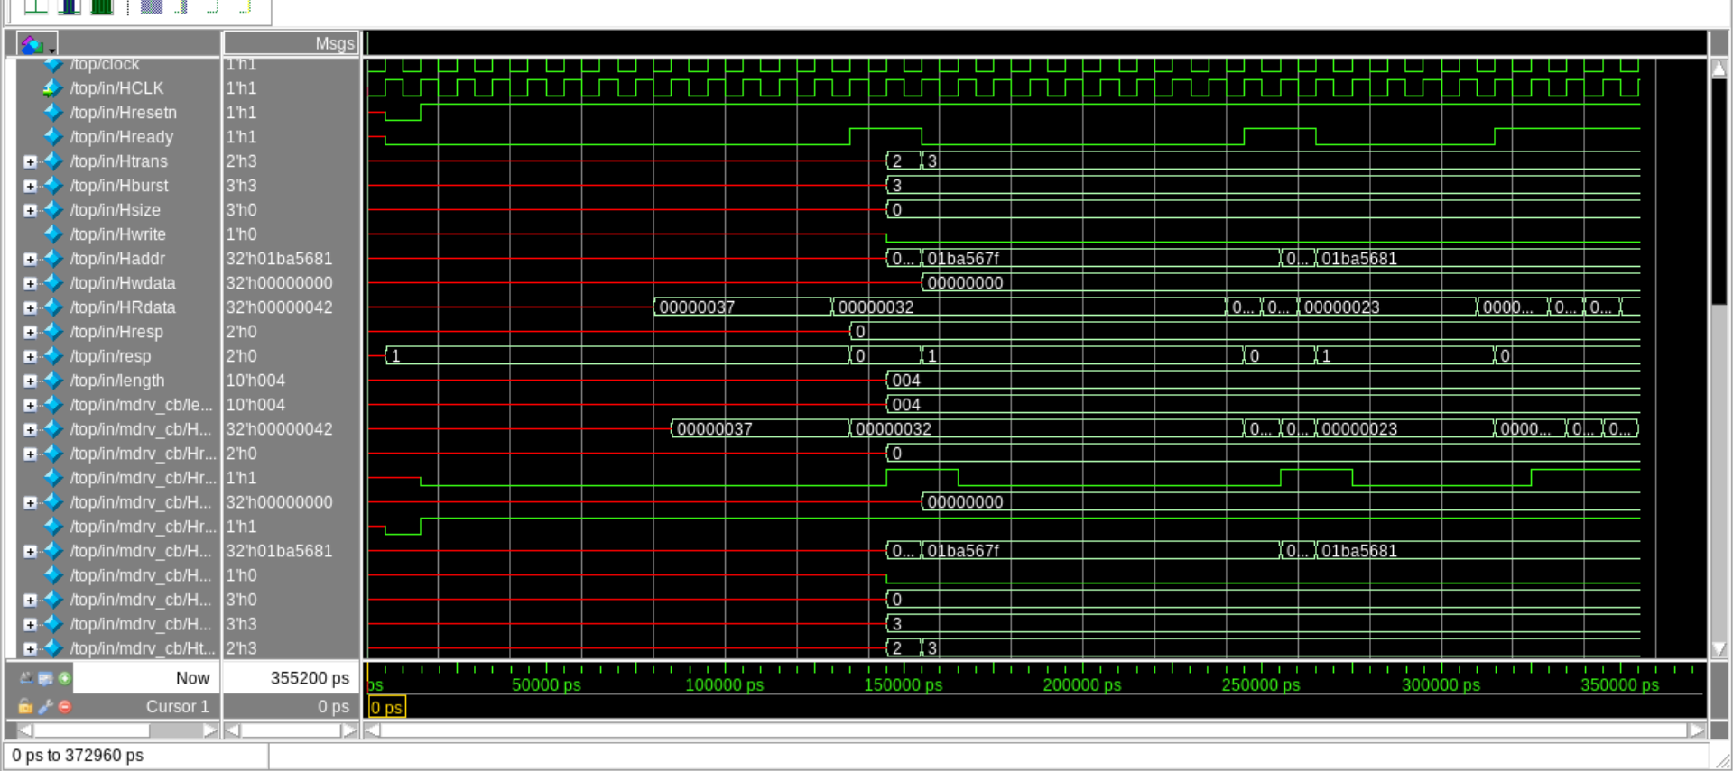
Figure 3: Slave-side response waveform, Questa Wave

Waveform Analysis (Slave-side)
- HADDR = 0x01ba5681; HWDATA = 0x00000000 (write phase).
- HRDATA driven back: 0x00000037 → 0x00000032 → 0x00000023 (read sequence).
- HTRANS transitions: 2'h2/3'h3 during burst; reverts to IDLE between bursts.
- HREADY toggles between 0 and 1 showing wait-state insertion by slave.
- length = 10'h004 (4-beat burst); resp = 0 (OKAY).
- Simulation time: 0 ps to 372,960 ps.

6. Scoreboard Description
The scoreboard is the central checking component in the AHB VIP testbench. It collects transactions observed by both the master and slave monitors and performs reference-model comparisons to verify protocol correctness.

Scoreboard Functionality
- Transaction Capture: Receives AHB transaction objects from master monitor (address/control) and slave monitor (data/response) via TLM analysis ports.
- Reference Model: Maintains a golden memory model (associative array indexed by HADDR). Write transactions update the model; read transactions are compared against it.
- Data Integrity Check: For every read transaction: compares HRDATA from DUT against expected value from the reference model. Flags mismatches with `uvm_error.
- Response Check: Verifies that HRESP is OKAY for legal accesses and ERROR for out-of-range or mis-aligned addresses as per the DUT's decode logic.
- HREADY Protocol Check: Ensures that the master held HADDR/HTRANS stable during wait states (HREADY=0).
- Burst Coherency Check: Validates that sequential burst beats follow correct address increment/wrap rules based on HBURST and HSIZE.
- Error Response 2-cycle Check: Verifies that ERROR response spans exactly two cycles (HRESP=1, HREADY=0 followed by HRESP=1, HREADY=1).
- Coverage Triggers: On each successful check the scoreboard increments coverage counters linked to covergroup bins in pkg.sv.
Scoreboard Result: All transactions across the simulation run passed without any data mismatches or protocol violations. Zero errors reported in the simulation log.

7. Functional Coverage Report
Coverage was measured using Questa's functional coverage tool. The coverage source file is ./test/pkg.sv (SystemVerilog package). All instances show 100% coverage.

Instance Hierarchy Coverage Summary
Instance | Design Unit | Language | Coverage
/top | work.top | Verilog | 100%
/top/in | work.in | SystemVerilog | 100%
/pkg | work.pkg | SystemVerilog | 100%

Local Instance Coverage Details – /pkg (100%)
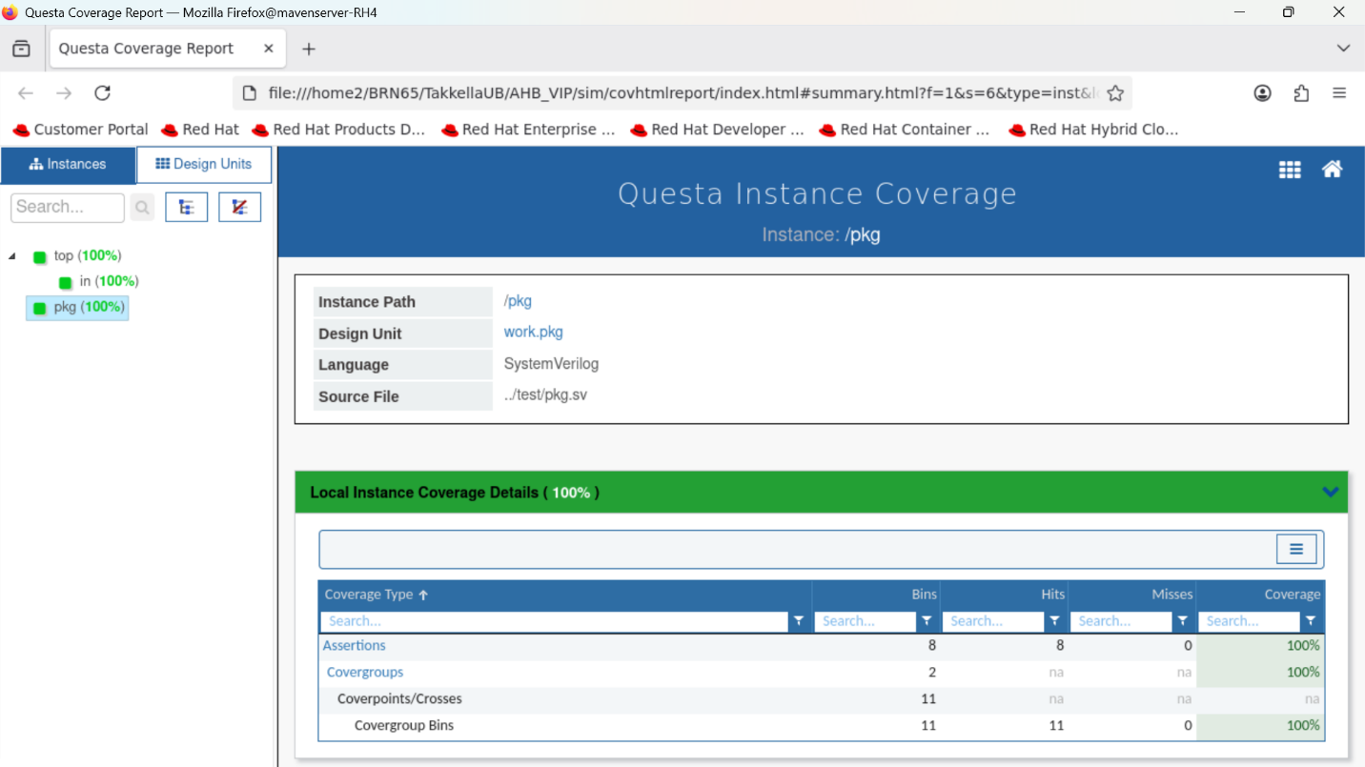
Figure 4: Questa Instance Coverage – /pkg (100%)
Coverage Type | Bins | Hits | Misses | Coverage
Assertions | 8 | 8 | 0 | 100%
Covergroups | 2 | na | na | 100%
Coverpoints/Crosses | 11 | na | na | na
Covergroup Bins | 11 | 11 | 0 | 100%

Top-Level Recursive Hierarchical Coverage (/top)
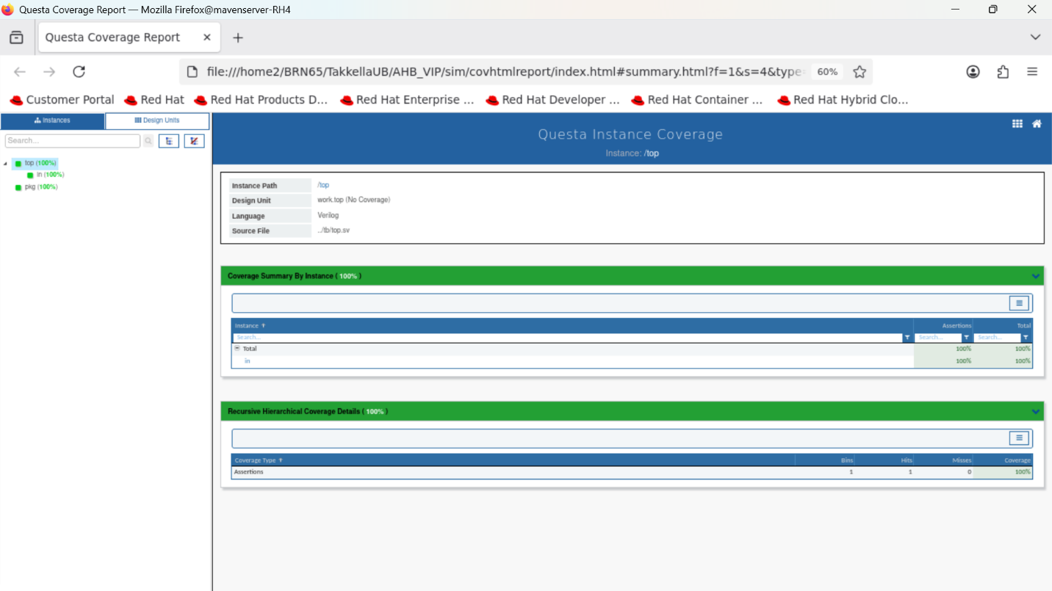
Figure 5: Questa Instance Coverage – /top (100%)
Coverage Type | Bins | Hits | Misses | Coverage
Assertions | 1 | 1 | 0 | 100%
Coverage Summary: The Questa Coverage Report confirms 100% coverage across all coverage types for the AHB VIP – 8/8 assertions hit, 11/11 covergroup bins exercised, and 0 misses across the entire design hierarchy.

8. AHB Multi-Layer Interconnect
AHB Multi-Layer Interconnect is an extension of the standard AHB protocol that enables parallel access paths between multiple masters and slaves, significantly increasing available bus bandwidth.

Traditional AHB vs Multi-Layer AHB
In traditional AHB, a single arbiter selects one master at a time and all masters share a single bus. This limits bandwidth when multiple masters attempt simultaneous access. Multi-Layer AHB solves this by providing a separate layer (and bus) for each master, connected through an interconnect matrix.

Multi-Layer Architecture Components
- Input Stage: Each master connects to its own input stage layer within the interconnect matrix.
- Interconnect Matrix: Routes transactions from any master's layer to any slave's port simultaneously.
- Decoder: Per-layer address decoder determines which slave port receives the transaction.
- Arbiter: Per-slave arbiter resolves conflicts when two masters target the same slave simultaneously.
- Multiplexor: The only hardware addition beyond standard AHB – connects multiple masters to peripherals.

Benefits
- Increased bus bandwidth – masters can operate in parallel when targeting different slaves.
- Flexible architecture – complex multi-master systems with simple individual AHB layers.
- Re-use – existing masters and slaves plug in without modification.
- Point arbitration – arbitration only needed when two masters target the same slave.
- Scalability – supports Local Slaves (accessible to one subsystem) and Global Slaves.

Subsystem Configuration (from course slides)
Configuration | Description
Multiple Masters – One Layer | Master1, Master2, Master3, Master4 share one interconnect matrix; Slave1, Slave2, Slave3 are global slaves accessible to all masters.
Local Slaves | Master2's Layer2 has direct access to Slave4 and Slave5 (local). Global slaves (Slave1–3) remain reachable from any master layer.
AHB Subsystems | Subsystem1 (Master1+2, Slave1+2) and Subsystem2 (Master3+4, Slave3+4) each have their own local interconnect, bridged for global access.

9. AXI vs AHB – Protocol Comparison
The following comparison is drawn from the course material presented during the Maven Silicon BRN66 live sessions (May 18, 2026).
Feature | AXI | AHB
Channels | 5-Channel Bus | Single-channel Bus
Outstanding Transactions | Multiple | Single
Out-of-Order Transactions | Supported | Not Supported
Address Space per Slave | 4 kB | 1 kB
Communication Mode | Full Duplex Supported | Not Supported
Unaligned Data Transfers | Supported | Not Supported
QoS & Write Data Interleaving | Supported | Not Supported
Early Burst Termination | Not Supported | Supported
Additional Signalling | Supported | Not Supported
Semaphore Mode | Supported | Not Supported

10. Takeaways & Difficulties Faced

Key Learnings from the Project
- Deep understanding of the AHB pipelined address/data architecture – the address phase and data phase are offset by one clock, which requires careful driver sequencing.
- Implementing burst transfers (WRAP and INCR) demanded precise address calculation based on HSIZE and beat count; off-by-one errors were common initially.
- UVM Agent architecture (driver + monitor + sequencer) proved highly reusable across different test scenarios without modifying the RTL interface.
- Coverage-driven verification: writing covergroups for HTRANS × HBURST × HWRITE cross-coverage guided the team toward uncovered corner cases.
- Questa's waveform viewer (GTKWave/ModelSim Wave) was essential for debugging pipelining issues where HADDR and HWDATA were misaligned.
- Two-cycle ERROR response protocol required careful FSM design on both the slave side and the scoreboard's response-checking logic.
- Multi-Layer Interconnect concepts clarified the bandwidth limitations of traditional single-arbiter AHB and motivated the multi-master design.

Difficulties Faced During Project
- HREADY Synchronisation: Getting the master driver and slave responder to coordinate wait-state insertion correctly — particularly when back-to-back transactions overlapped their pipelining.
- Scoreboard Data Alignment: Correlating HADDR from the address phase with HWDATA/HRDATA arriving one cycle later required maintaining a 'pending transaction queue' in the scoreboard.
- Burst Address Wrapping: Implementing WRAP4/8/16 address calculation with correct boundary wrapping (e.g., wrapping within a 16-byte boundary for WRAP4 with HSIZE=2) was tricky.
- Coverage Closure: Initially, HBURST=INCR (undefined length) bins were not hit; required writing a dedicated sequence targeting exactly this scenario.
- Questa Compilation Errors: Package import ordering caused initial compilation issues; resolved by ensuring pkg.sv was compiled before the testbench files.
- Memory Model Boundary: The 64-location slave memory required out-of-range detection; generating random addresses that always fell within bounds needed proper constraints.
AHB VIP – Final Project Documentation | Maven Silicon BRN66 | June 2026

