**Exercise 3: Stored Procedures**

**Scenario 1: Process Monthly Interest for Savings Accounts**

CREATE TABLE Accounts (

AccountID NUMBER PRIMARY KEY,

CustomerID NUMBER,

AccountType VARCHAR2(20),

Balance NUMBER,

LastModified DATE

);

INSERT INTO Accounts (AccountID, CustomerID, AccountType, Balance, LastModified)

VALUES (1, 1, 'SAVINGS', 1000, SYSDATE);

CREATE OR REPLACE PROCEDURE ProcessMonthlyInterest IS

BEGIN

FOR acc IN (

SELECT AccountID, Balance

FROM Accounts

WHERE UPPER(AccountType) = 'SAVINGS'

)

LOOP

UPDATE Accounts

SET Balance = Balance + (Balance * 0.01),

LastModified = SYSDATE

WHERE AccountID = acc.AccountID;

END LOOP;

COMMIT;

END;

/

BEGIN

ProcessMonthlyInterest;

END;

/

-- View result

SELECT * FROM Accounts;

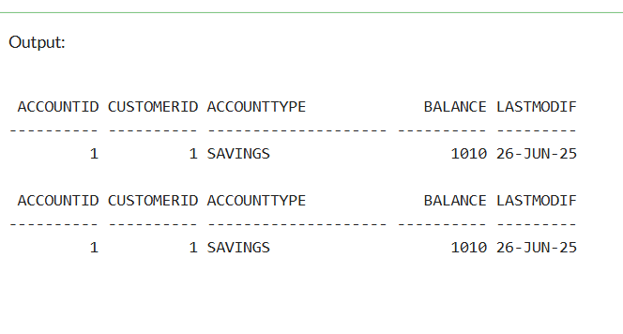

**Scenario 2: Employee Bonus Based on Department and Performance**

CREATE TABLE Employees (

EmployeeID NUMBER PRIMARY KEY,

Name VARCHAR2(100),

Position VARCHAR2(50),

Salary NUMBER,

Department VARCHAR2(50),

HireDate DATE

);

INSERT INTO Employees (EmployeeID, Name, Position, Salary, Department, HireDate)

VALUES (1, 'Alice Johnson', 'Manager', 70000, 'HR', TO_DATE('2015-06-15', 'YYYY-MM-DD'));

INSERT INTO Employees (EmployeeID, Name, Position, Salary, Department, HireDate)

VALUES (2, 'Bob Brown', 'Developer', 60000, 'IT', TO_DATE('2017-03-20', 'YYYY-MM-DD'));

INSERT INTO Employees (EmployeeID, Name, Position, Salary, Department, HireDate)

VALUES (3, 'Chirag Patel', 'Analyst', 58000, 'HR', TO_DATE('2018-09-10', 'YYYY-MM-DD'));

INSERT INTO Employees (EmployeeID, Name, Position, Salary, Department, HireDate)

VALUES (4, 'Sneha Reddy', 'QA Engineer', 61000, 'IT', TO_DATE('2019-12-01', 'YYYY-MM-DD'));

CREATE OR REPLACE PROCEDURE UpdateEmployeeBonus(

dept_name IN VARCHAR2,

bonus_percent IN NUMBER

) AS

BEGIN

UPDATE Employees

SET Salary = Salary + (Salary * (bonus_percent / 100))

WHERE UPPER(Department) = UPPER(dept_name);

DBMS_OUTPUT.PUT_LINE('Bonus updated for department: ' || dept_name);

EXCEPTION

WHEN OTHERS THEN

DBMS_OUTPUT.PUT_LINE('Error: ' || SQLERRM);

END;

/

BEGIN

UpdateEmployeeBonus('IT', 15);

END;

/

SELECT * FROM Employees;--

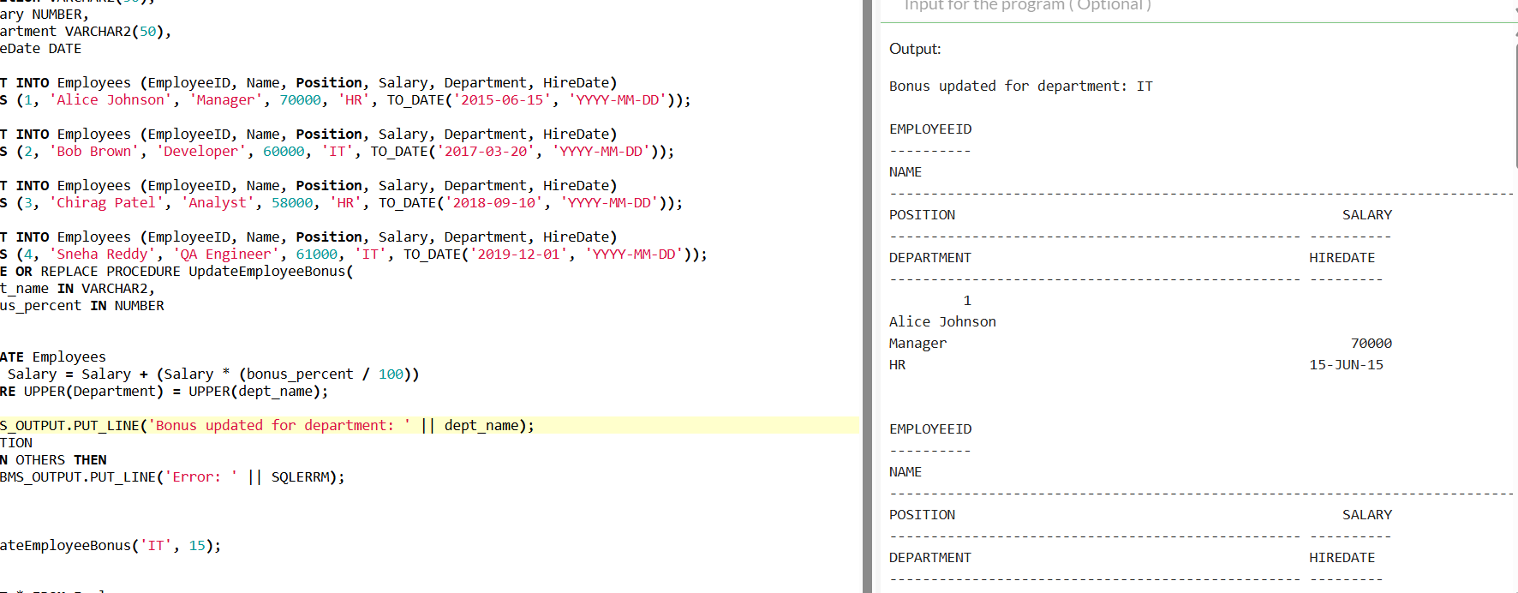

**Scenario 3: Transfer Funds Between Accounts**

CREATE TABLE Accounts (

AccountID NUMBER PRIMARY KEY,

AccountType VARCHAR2(20),

Balance NUMBER,

LastModified DATE

);

INSERT INTO Accounts (AccountID, AccountType, Balance, LastModified)

VALUES (1, 'Savings', 1000, SYSDATE);

INSERT INTO Accounts (AccountID, AccountType, Balance, LastModified)

VALUES (2, 'Checking', 1500, SYSDATE);

CREATE OR REPLACE PROCEDURE TransferFunds(

from_account_id IN NUMBER,

to_account_id IN NUMBER,

amount IN NUMBER

) AS

insufficient_balance EXCEPTION;

v_balance NUMBER;

BEGIN

-- Check balance of source account

SELECT Balance INTO v_balance FROM Accounts WHERE AccountID = from_account_id;

IF v_balance < amount THEN

RAISE insufficient_balance;

END IF; UPDATE Accounts

SET Balance = Balance - amount,

LastModified = SYSDATE

WHERE AccountID = from_account_id;

UPDATE Accounts

SET Balance = Balance + amount,

LastModified = SYSDATE

WHERE AccountID = to_account_id;

DBMS_OUTPUT.PUT_LINE('Transfer successful!');

EXCEPTION

WHEN insufficient_balance THEN

DBMS_OUTPUT.PUT_LINE('Transfer failed: Insufficient balance.');

WHEN OTHERS THEN

DBMS_OUTPUT.PUT_LINE('Error: ' || SQLERRM);

END;

/

BEGIN

TransferFunds(1, 2, 500);

END;

/

