**WEEK7**

**ListOfplayers.js**

import React from 'react';

const ListofPlayers = () => {

  const players = [

    { name: 'Virat', score: 85 },

    { name: 'Rohit', score: 65 },

    { name: 'Rahul', score: 90 },

    { name: 'Dhawan', score: 55 },

    { name: 'Pant', score: 75 },

    { name: 'Jadeja', score: 45 },

    { name: 'Hardik', score: 80 },

    { name: 'Ashwin', score: 60 },

    { name: 'Bumrah', score: 95 },

    { name: 'Shami', score: 50 },

    { name: 'Siraj', score: 88 }

  ];

  const below70 = players.filter(player => player.score < 70);

  return (

    <div>

      <h2>List of Players:</h2>

      <ul>

        {players.map((player, index) => (

          <li key={index}>{player.name} - {player.score}</li>

        ))}

      </ul>

      <h2>Players with scores below 70:</h2>

      <ul>

        {below70.map((player, index) => (

          <li key={index}>{player.name} - {player.score}</li>

        ))}

      </ul>

    </div>

  );

};

export default ListofPlayers;

**InidanPlayers.js**

import React from 'react';

const IndianPlayers = () => {

  const players = ['Virat', 'Rohit', 'Rahul', 'Dhawan', 'Pant', 'Jadeja', 'Hardik', 'Ashwin', 'Bumrah', 'Shami', 'Siraj'];

  const oddTeam = players.filter((_, index) => index % 2 === 0); // 0,2,4,...

  const evenTeam = players.filter((_, index) => index % 2 !== 0); // 1,3,5,...

  const T20players = ['Virat', 'Rohit', 'Pant', 'Hardik'];

  const RanjiTrophy = ['Pujara', 'Saha', 'Karun Nair'];

  const mergedPlayers = [...T20players, ...RanjiTrophy];

  return (

    <div>

      <h2>Odd Team Player:</h2>

      <ul>

        {oddTeam.map((player, index) => (

          <li key={index}>{player}</li>

        ))}

      </ul>

      <h2>Even Team Player:</h2>

      <ul>

        {evenTeam.map((player, index) => (

          <li key={index}>{player}</li>

        ))}

      </ul>

      <h2>Merged Players (T20 + Ranji):</h2>

      <ul>

        {mergedPlayers.map((player, index) => (

          <li key={index}>{player}</li>

        ))}

      </ul>

    </div>

  );

};

export default IndianPlayers;

**APP.js**

import React from 'react';

import ListofPlayers from './components/ListofPlayers';

import IndianPlayers from './components/IndianPlayers';

function App() {

  const flag = true; // ← Set to true or false to see the required output

  return (

    <div className="App">

      <h1> Welcome to Cricket App</h1>

      {flag ? <ListofPlayers /> : <IndianPlayers />}

    </div>

  );

}

export default App;

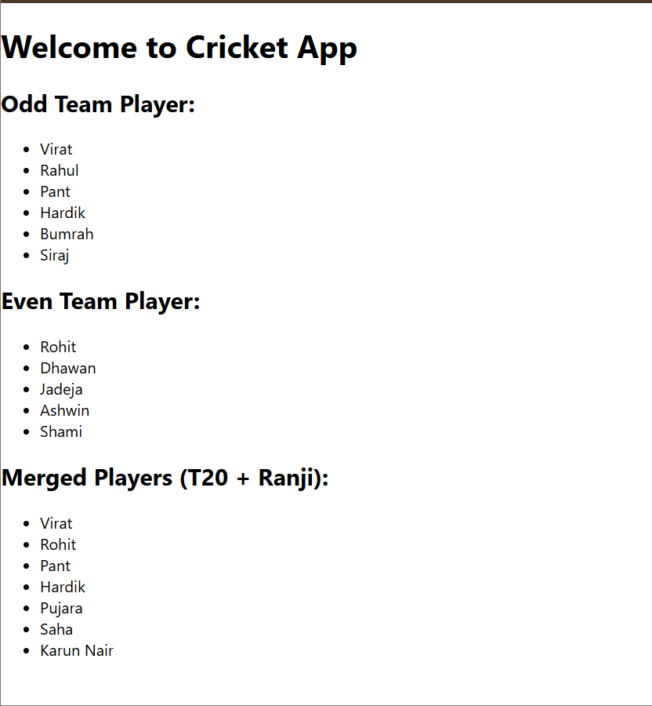when flag=true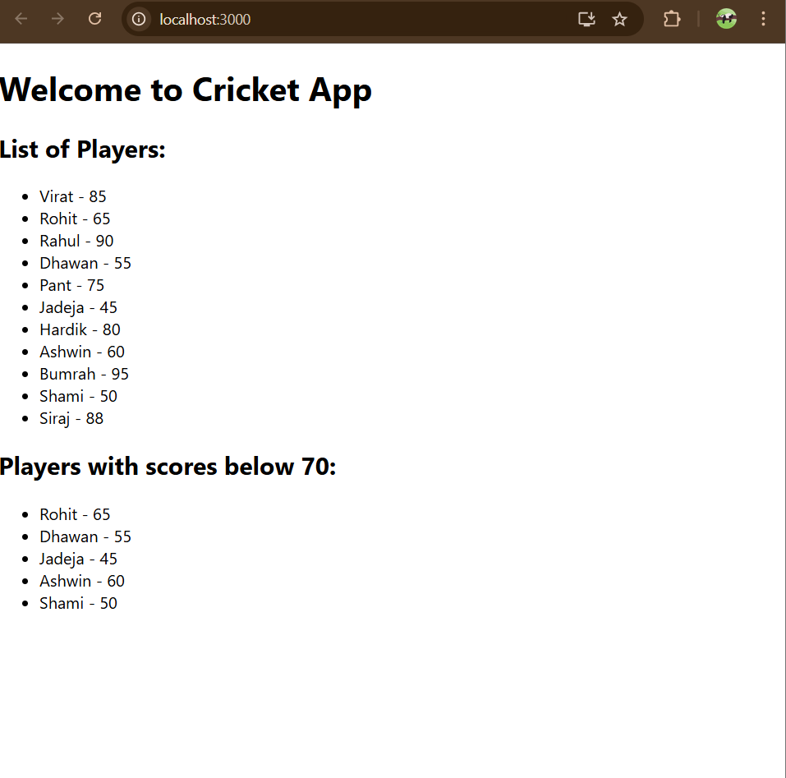

When flag=false