
INDUSTRY INTERNSHIP REPORT
On

“ADVANCE JAVA”

By

RAVISETTY UMADEVI (229X1A0589)

Submitted in accordance with the requirement for the degree of B-Tech in

Department of Computer Science and Engineering

G. PULLA REDDY ENGINEERING COLLEGE (Autonomous): KURNOOL

(Affiliated to JNTUA, ANANTHAPURAMU) KURNOOL - 518007
2025 – 2026

Department of Computer Science and Engineering

G. PULLA REDDY ENGINEERING COLLEGE (Autonomous): KURNOOL

(Affiliated to JNTUA, ANANTHAPURAMU)

CERTIFICATE
This is to certify that the internship titled ‘Advance Java’ is a bonafide record of work carried out by RAVISETTY UMADEVI (229X1A0589), and the Internship report is submitted in partial fulfillment of requirements for the award of degree of Bachelor of Technology in Computer Science and Engineering.


……………………………..
Internship Guide
Dr . Rameshwar Reddy
Assistant Professor
Department of C.S.E.,
G. Pulla Reddy Engineering College, Kurnool.
……………………………..
HEAD OF THE DEPARTMENT
Dr. N. Kasiviswanath
Professor & Head of the Department, Department of C.S.E.,
G. Pulla Reddy Engineering College, Kurnool.

INTERNSHIP DETAILS

Name of the College: G. Pulla Reddy Engineering College Department: Computer Science and Engineering
Name of the Student: R.Umadevi
Register Number: 229X1A0589
Name of the Faculty Guide: Dr. Rameshwar Reddy
Duration of the Internship: From 01-12-2025 To 01-03-2026 Name and address of the Organization: Global Quest Technologies, Yelhanka, Bangalore.
Internship Domain: Advance Java Internship Title: Advance Java Internship Stipend: N/A
Date of Internship Report Submission:

Internship Coordinator
Dr. B. Geetha Vani Professor
CSE Department
GPREC

DECLARATION

I Ravisetty Umadevi , a student bearing the Roll No. 229X1A0589, of the Department of Computer Science and Engineering, G. Pulla Reddy Engineering College, do hereby declare that the I have completed the mandatory internship titled Advance java from 01-12-2025 to 01-03-2026 in Global Quest Technologies, Bangalore under the Faculty Guide ship of G. R. Narendra Reddy.

(Student Signature and Date)

Certificate From Organization


Internship Project completion certificate



ACKNOWLEDGEMENT

I wish to express my deep sense of gratitude to my internal supervisor Dr. Rameshwar Reddy, Assistant Professor of Computer Science and Engineering Department, G. Pulla Reddy Engineering College.
My sincere thanks to our Internship Coordinator Dr. B. GeethaVani for her immaculate guidance, constant encouragement and cooperation which have made possible to bring out this internship work.
My sincere thanks to Mr. G. R. Narendra, Director, of Organization , for helping me and giving me the required information needed for my internship work.
I am thankful to our Head of the Department Dr. N. Kasiviswanath for his whole hearted support and encouragement during the internship.
We are grateful to our Internship Dean Dr. Y. V. Siva Reddy and to our respected Principal Dr. B. Sreenivasa Reddy for providing requisite facilities and helping us in providing such a good environment.
I wish to convey my acknowledgements to all the staff members of the Computer Science and Engineering Department for giving the required information needed for my internship work.
Finally, I wish to thank all our friends and well wishers who have helped me directly or indirectly during the course of this internship work.

Table of Contents
Chapter 1: INTRODUCTION 1
  - About the Internship Company/Organization 2
  - Virtual/Offline Internship details 4
Chapter 2: WORK DONE DURING INTERNSHIP 5
  - About Course/Domain 6
  - Technologies learnt during internship 9
  - Assessments/Tasks assigned details 10
Chapter 3: PROJECTS/MODULES COMPLETED 11
  - About Project -1 12
  - About Project - 2 …………………………………………………………….23
  - About Project - 3 ....………………………………………………………….29
  - About Project – 4 ……………………………………………………………37
Chapter 4: ACTIVITY LOG 46
Chapter 5: CONCLUSION 49
REFERENCES 51

LIST OF FIGURES

FIGURE NO. | FIGURE NAME | PAGE NO.
3.1.1  3.1.2  3.1.3  3.2.1  3.2.2  3.2.3  3.3.1  3.3.2  3.3.3  3.3.4  3.3.5  3.4.1  3.4.2  3.4.3  3.4.4 | Home Page of Amazon clone Services Page of Amazon clone  Footer Page of Amazon clone  Register Form  Registration Successful  Invalid USN  Visual Chart Diagram  Registering Users  Rules of Quiz  Playing the Quiz  Ending the Quiz  Adding new Department to the Database  List of Departments in the Database  Adding new Employee to the Database  List all the Employees in the Database | 21  21  22  27  27  28  33  34  34  35  36  41  42  42  43

INTRODUCTION

INTRODUCTION

ABOUT THE INTERNSHIP COMPANY/ORGANIZATION

Introduction of the Organization

Global Quest Technologies (GQT), incorporated in 2019, is a corporate training and placement firm based in Bangalore, India. Its mission to add 100,000 technically sound graduates to the IT sector has led GQT to provide full-fledged training programs in IT and non-IT fields, serving students and corporate customers across the globe.
GQT's training solutions cover a broad spectrum of training programs such as Data Science, Data Analytics, Programming Basics, Amazon Web Services, Microsoft Azure, MEAN Stack, MERN Stack, MBA in HR and Finance, DevOps, Salesforce, Ethical Hacking, and Digital Marketing. The company focuses on hands-on training, industry-oriented curricula, and real-time projects to make the students job-ready at the time of course completion.
Led by Managing Directors and Founders KT Sreedhar and G.R. Narendra, GQT has played a vital role in determining the careers of many technical graduates. The organization partners with SMEs, education institutions, local governments, and government agencies to strengthen its services and broaden its reach.
GQT's dedication to excellence is evident through its core values: stability, availability, sustainability, leadership in learning, honesty, transparency, and customer focus. With its committed team and student-focused culture, Global Quest Technologies continues to contribute significantly to the professional development landscape of India

Vision, Mission and Values of the Organization

GQ Tech's vision is to make itself a global leader in the EdTech space based on a solid emphasis on IT education and placement in upcoming and emerging technologies. With its goal of bridging the education-employment gap, GQ Tech is committed to shaping technology professionals of tomorrow through industry-focused, hands-on learning experiences to meet the challenges of the changing digital era.

The mission of GQ Tech is to foster a culture of lifelong learning, equip the next generation of IT talent, and accelerate knowledge through provision of comprehensive training programs and sure placement. By being learner-focused, GQ Tech helps learners acquire relevant skills, develop sound foundations, and transition successfully into the competitive employment market.
Core values in GQ Tech encompass Excellence, Innovation, Integrity, and Commitment. GQ Tech offers superior quality training services, always aligns its course content to capture the recent advancements in technologies, and deals openly and ethically. Primarily, GQ Tech works in pursuit of its students' achievement and professional progression, contributing towards development in both the educational and technological areas.

Policy of the Organization, in relation with the intern role
Global Quest Technologies provides formal internship programs that are designed to give students direct industry experience. Interns are involved in live projects, where they can put theoretical knowledge into practice. The company partners with well-known firms to provide internship opportunities that meet the career objectives of the interns.
GQ Tech Mentorship is an integral part of the internship program. The interns are guided by industry professionals, allowing them to develop skills and advance their careers. Soft skill development is also given prominence, equipping the interns for successful careers in the IT sector.

Organizational Structure
Global Quest Technologies functions with a lean organizational framework to effectively provide training and placement services.
- Leadership Team: Made up of seasoned professionals who manage strategic planning and organizational development.
- Training Department: Deals with curriculum design and conducting training sessions on different IT and non-IT fields.
- Placement Cell: Acts as a connecting link between trained candidates and their prospective employers to achieve successful placements.
- Support Staff: Manages administrative functions, student guidance, and inter-department coordination.
This framework allows GQT to pursue a mission-driven strategy towards empowering students by providing quality education and career development opportunities.

Roles and responsibilities of the employees in which the intern is placed.

Interns in Global Quest Technologies are placed in different departments according to their interest and field of work. Responsibilities and duties include:

- Training Support: Helping to develop and present training material, presenting workshops, and offering technical assistance during the session.​

- Project Assistance: Working on live projects, contributing towards coding, testing, and documentation under the guidance of lead developers.

- Research and Development: Participating in research works to remain abreast of new technological developments and integrating results into training modules.

- Administrative Work: Assisting in the organization of training timelines, student records management, and interdepartmental communication.

These tasks enable interns to acquire real-world experience, develop technical capabilities, and be ready for eventual employment in the IT industry.

VIRTUAL/OFFLINE INTERNSHIP DETAILS
Company Name: Global Quest Technologies (GQT)
Internship Role: Java Developer Intern
Team Mentors: Narendra Reddy
Projects Worked: GQT Student Management, Amazon Clone.
Skills Acquired: Core Java and Advanced Java.

WORKDONE DURING INTERNSHIP

WORKDONE DURING INTERNSHIP

ABOUT COURSE/DOMAIN

Introduction:
The Java Developer Intern is a formal learning and working opportunity for students or fresh graduates looking for practical experience in Java development. It fills the gap between academic and industry requirements by providing hands-on training in real-world software development with Core Java, frameworks, tools, and project-based training. The internship focuses on object-oriented programming, back-end development, API integration, database management, and team collaboration in a professional setup.
          - Core Java Programming: Interns learn a strong foundation of Java syntax, object-oriented programming (OOP), exception handling, collections, multithreading, and I/O streams. They are necessary to write clean, efficient, and manageable Java code.

          - Development Platforms: Interns generally use integrated development environments (IDEs) such as Eclipse, IntelliJ IDEA, or NetBeans, which are productivity-enhancing and provide debugging, refactoring, and version control capabilities.

          - Frameworks: Working with lightweight and enterprise-level Java frameworks like Spring, Spring Boot, Hibernate, or JPA is commonly a part of training. These frameworks allow for rapid development of applications and support modular, scalable back-end systems.

          - Databases: Java Developer Interns learn how to work with relational databases such as MySQL, PostgreSQL, or Oracle, and perform CRUD operations using JDBC or ORM tools.

          - Tools: Interns employ tools like Git for version control, Maven/Gradle for project management, Postman for API testing, and Jira/Trello for task management and Agile methodology implementation.

          - Processes: Interns adhere to software development life cycle (SDLC) methodologies such as requirement analysis, design, coding, testing, deployment, and maintenance. They might also take part in Agile or Scrum sprints, daily stand-ups, and code reviews.

          - Individuals: Interns work with senior developers, mentors, QA engineers, and product managers to learn about workflows and contribute to development projects. This collaboration develops communication, problem-solving, and time management skills.

          - Abilities: Interns hone technical (Java coding, debugging, Git, API integration) as well as soft skills (communication, teamwork, flexibility). Regular feedback and mentorship enable them to grow from learners to junior-level contributors.

          - Organizations: Java Developer Interns are employed in IT service firms, product companies, and startups. Based on the industry, they can create web applications, REST APIs, or backend services according to business requirements.

          - Methods: Interns are taught best practices like writing clean code, applying design patterns, following SOLID principles, and unit testing using JUnit or Mockito. These practices improve code quality and readability.

          - Procedures: Typical Java interns' tasks are writing functions/modules, debugging, updating documentation, and peer review. Well-defined procedures facilitate quality contribution and learning consistency.

          - Rules: Interns adhere to company-specific coding standards, security practices, and project guidelines. Rules facilitate safe, optimized, and professional development practices.

          - Practices: Interns are trained and use industry practices like Agile development, Continuous Integration/Continuous Deployment (CI/CD), and Test-Driven Development (TDD). These increase project agility, reliability, and delivery speed.

The Java Developer Intern position is an entry point for prospective developers to shift from theory to practice. Through systematic learning, live project exposure, and corporate guidance, the interns gain technical and professional competence needed for software development jobs on a full-time basis. From learning Core Java to working on backend APIs and working in Agile teams, this internship serves as a stepping stone to a successful career in Java development.

Stages of Learning & Contribution:
- Fundamentals and Onboarding:
- Introduction to Java and Tools: Basic Java language training, OOP principles, IDE configuration, and use of Git.
- Grasping Project Requirements: Familiarization with the current codebase, documentation reading, and coordination with team objectives.

- Backend Development:
- REST API Development: Endpoints creation using Spring Boot and database connections using Hibernate or JDBC.
- Code Contribution: Development of modules or features in a guided manner, bug fixes, and implementation of learned Java concepts.

- Testing and Optimization:
- Debugging & Unit Testing: Acquiring the skill of tracking and resolving errors, and creating test cases with JUnit/Mockito.
- Performance Tuning: Fine-tuning code for improved runtime performance and memory usage.

- Deployment & Collaboration:
- CI/CD Integration: Involvement in automated build and deployment workflows through Jenkins or GitHub Actions.
- Team Meetings & Reviews: Involved in Agile ceremonies, code breakdown, and learning from peer reviews.

- Final Evaluation & Project Submission:
- Project Presentation: Presenting the module developed, justifying design choices, and discussing key learnings.
- Feedback & Certification: Getting feedback on performance, determining areas for improvement, and obtaining internship certification

2.2 TECHNOLOGIES LEARNT DURING INTERNSHIP

Used Technologies:
- Core Java
- Advance Java

Core Java:
- Core Java is the core portion of the Java programming language utilized in developing general-purpose applications.
- Imparts solid concepts of object-oriented programming (OOP) ideas such as inheritance, encapsulation, polymorphism, and abstraction.
- Contains important concepts like variables, data types, operators, control statements, arrays, strings, and exception handling.
- Trains collection frameworks such as ArrayList, HashMap, HashSet, etc.
- Takes up core classes and packages such as java.lang, java.util, java.io, and java.math.
- Multithreading and basic file handling are supported.
- Provides the foundation knowledge necessary to create applications and lead into more sophisticated subjects.
- Extensively applied in desktop application development and serves as the foundation for studying frameworks such as Spring and Hibernate.

Advance Java

  - Advanced Java places emphasis on areas like networking, database connectivity, and web technology.
  - Comprises JDBC (Java Database Connectivity) for linking Java applications with relational databases like MySQL.
  - Introduces Servlet and JSP (JavaServer Pages) technologies to develop dynamic web applications.
  - Deals with session management, handling request/response, cookies, and filters.
  - Provides a good grasp of server-side programming.
  - Forms the building block for understanding enterprise-level frameworks like Spring, Hibernate, and Struts.
  - Beneficial in creating full-stack Java web applications and enterprise solutions.

2.3 TASKS ASSIGNED DETAILS
Tasks Assigned: I was given a few assignments on Core Java and Advanced Java. These assignments were designed to reinforce my programming skills and prepare me to develop real-world backend applications with Java. The assignments were a combination of theoretical problems, hands-on coding exercises.
Advance Java – Practice Tasks:
- Understand and implement basic OOP concepts:
  - Write a Java program to demonstrate inheritance using classes like Person, Student, and Teacher.
  - Implement method overloading and overriding in a sample employee management system.
- Servlet and JSP Control Flow:
  - Create a Servlet that handles GET and POST methods and displays different responses based on user actions.
  - Implement Session Management in Servlets using HttpSession, Cookies, and URL Rewriting.
- JSP (Java Server Pages) :
  - Develop a JSP application that uses JSTL core tags to dynamically display content from Java objects.
  - Develop a JSP program to simplify data access from request, session, and application scopes.
- Exception Handling:
  - Create a program that handles multiple exceptions using try-catch-finally.
  - Write a custom exception class and use it in a banking application scenario.
- Hibernate (ORM Framework) :
- Create a Hibernate application to map Java classes to database tables using an XML mapping.

3.PROJECT COMPLETED

3. PROJECT COMPLETED

3.1 PROJECT - 1
Project Name: Amazon Clone

Technologies Used: HTML, CSS.
Problem Statement: In today's digital age, online shopping sites such as Amazon have transformed the online consumer experience. These sites are remarkable for their simplicity of use, responsive designs, and easy-to-navigate layouts. For aspiring web developers, rebuilding such websites from scratch is an ideal means of learning front-end web development basics. But creating an e-commerce design that closely looks like a professionally built site requires learning the page structure (HTML) and styling (CSS) of a website, which might be difficult for newbies.
Goal: The primary goal of this project is to create a visually correct Amazon Clone with the help of HTML and CSS alone. The emphasis is on duplicating the structure and styling of major sections like the homepage, header, navigation bar, product grid, and footer. This project is designed to reinforce the knowledge of web page layout, box models, responsive design principles, and reusable CSS elements. Through this project, the intern had a good understanding of front-end development practices by the end of the project and was able to build actual web interfaces from scratch.
HTML Code for the Project:
<!DOCTYPE html>
<html lang="en">
<head>
<meta charset="UTF-8">
<meta name="viewport" content="width=device-width, initial-scale=1.0">
<title>Amazon</title>
<link rel="stylesheet" href="https://cdnjs.cloudflare.com/ajax/libs/font-awesome/6.7.2/css/all.min.css">
<link rel="stylesheet" href="style.css">
</head>
<body>
<header>
<nav>
<div class="navbar">
<div class="nav_logo border">
<div class="logo">
</div>
</div>
<div class="nav_address border">
<p class="add-first">Deliver to</p>
<div class="add-icon">
<i class="fa-solid fa-location-dot"></i>
<p class="add-second">India</p>
</div>
</div>
<div class="nav-search">
<select class="search-select">
<option >All</option>
</select>
<input value="text" placeholder="Search Amazon" class="input">
<div class="search-icon">
<i class="fa-solid fa-magnifying-glass"></i>
</div>
</div>
<div class="nav-sign">
<p><span>Hello, Sign in</span></p>
<p class="nav-second">Account & Lists
<i class="fa-solid fa-caret-down"></i></p>
</div>
<div class="return"><p><span>Return</span></p>
<p class="nav-second border">& Orders</p>
</div>
<div class="nav-cart border">
<i class="fa-solid fa-cart-shopping"></i>
cart</div>
</div>
<div class="panel"><div class="panel-all">
<i class="fa-solid fa-bars"></i>
All
</div>
<div class="panel-ops">
<p>
Today's Deals</p>
<p>Customer Service</p>
<p>Registry</p>
<p>Gift Cards</p>
<p>Sell
</p>
</div>
<div class="panel-deals">
Shop deals in Electronics
</div>
</div>
</nav>
</header>
<div class="hero-section">
<div class="hero-message">
<p>You are on amazon.com. You can also shop on Amazon India for millions of products with fast local delivery.<a href="">Click here to go to amazon.in</a>
</p>
</div>
</div>
<div class="shop-section">
<div class="box1 box">
<div class="box-content"> <h2>Clothes</h2>
<div class="box-img" style="background-image: url('box1_image.jpg');"></div>
<p>See more</p>
</div>
</div>
<div class="box2 box"><div class="box-content"> <h2>Health&personal care</h2>
<div class="box-img" style="background-image: url('box2_image.jpg');"></div>
<p>See more</p>
</div></div>
<div class="box3 box"><div class="box-content"> <h2>Furniture</h2>
<div class="box-img" style="background-image: url('box3_image.jpg');"></div>
<p>See more</p>
</div></div>
<div class="box4 box"><div class="box-content"> <h2>Mobiles</h2>
<div class="box-img" style="background-image: url('box4_image.jpg');"></div>
<p>See more</p>
</div></div>
<div class="box1 box">
<div class="box-content"> <h2>Cosmetics</h2>
<div class="box-img" style="background-image: url('box5_image.jpg');"></div>
<p>See more</p>
</div>
</div>
<div class="box2 box"><div class="box-content"> <h2>Pets care</h2>
<div class="box-img" style="background-image: url('box6_image.jpg');"></div>
<p>See more</p>
</div></div>
<div class="box3 box"><div class="box-content"> <h2>Travel</h2>
<div class="box-img" style="background-image: url('box7_image.jpg');"></div>
<p>See more</p>
</div></div>
<div class="box4 box"><div class="box-content"> <h2>Men&women Wear</h2>
<div class="box-img" style="background-image: url('box8_image.jpg');"></div>
<p>See more</p>
</div></div>
</div>
<footer>
<div class="foot-panel1">
Back to Top
</div>
<div class="foot-panel2">
<ul>
<p>Get to Know Us</p>
<a href="">Careers</a>
<a href="">Blog</a>
<a href="">About Amazon</a>
<a href="">Investor Relations</a>
<a href="">Amazon Devices</a>
<a href="">Amazon Science</a>

</ul>
<ul>
<p>Get to Know Us</p>
<a href="">Careers</a>
<a href="">Blog</a>
<a href="">About Amazon</a>
<a href="">Investor Relations</a>
<a href="">Amazon Devices</a>
<a href="">Amazon Science</a>

</ul>
<ul>
<p>Get to Know Us</p>
<a href="">Careers</a>
<a href="">Blog</a>
<a href="">About Amazon</a>
<a href="">Investor Relations</a>
<a href="">Amazon Devices</a>
<a href="">Amazon Science</a>

</ul>

</div>
<div class="foot-panel3">
<div class="logo"></div>
</div>
<div class="foot-panel4">
<div class="pages">
<a href="">conditons of use</a>
<a href="">your adss Privacy</a>
<a href="">Privacy notes</a>
</div>
<div class="copyright">
© 1996-2025, Amazon.com, Inc. or its affiliates
</div>
</div>
</footer>

</body>
</html>

CSS Code for the Project:
*{
margin: 0;
font-family: Arial;
border:border-box;
}
.navbar{
height:60px;
background-color: #0F1111;
color: white;
display: flex;
align-items: center;
justify-content: space-evenly;
}
.nav_logo{
height: 50px;
width: 100px;
}
.logo{
background-image: url(amazon_logo.png);
height: 50px;
background-size: cover;
}
.border{
border: 1.5px solid transparent;
}
.border:hover{
border: 1.5px solid white;
}
.add-first{
color: #cccccc;
font-size: 0.85rem;
margin-left: 15px;
}
.add-second{
font-size: 1rem;
margin-left: 3px;
}
.add-icon{
display: flex;
align-items: center;
}
.nav-search{
display: flex;
background-color: pink;
width: 620px;
height: 40px;
border-radius: 4px;
}
.search-select{
background-color: #f3f3f3;
width: 50px;
text-align: center;
border-top-left-radius: 4px;
border-bottom-left-radius: 4px;
border: none;

}.search_input{
width: 500px;

}
.input{
width: 100%;
}
.search-icon{
width: 45px;
display: flex;
justify-content: center;
align-items: center;
font-size: 1.2rem;
background-color: rgba(210, 169, 8, 0.891);
border-top-right-radius: 4px;
border-bottom-right-radius: 4px;
}
.nav-search:hover{
border: 2px solid orange;
}
span{
color: #FFFFFF;
font-size: 0.7rem;
}
.nav-second{
font-size: 0.85rem;
font-weight: 700;
}

.nav-cart i{
font-size: 35px;
}
.nav-cart{
font-size: 0.85rem;
font-weight: 700;
}
.panel{
height: 40px;
width: 100%;
justify-content: space-evenly;
background-color: #222f3d;
align-items: center;
color: white;
margin-right: 600px;
display: flex;
}
.panel-ops p{
display: inline;
margin-left: 10px;
}
.panel-ops{
width: 60%;
font-size: 0.85rem;
}
.panel-deals
{
font-size: 0.9rem;
font-weight: 700;
}
/**hero section**/
.hero-section{
background-image: url(hero_image.jpg);
background-size: cover;
height: 400px;
display: flex;
align-items: flex-end;
justify-content: center;
}
.hero-message {
background-color: white;
color: black;
height: 40px;
display: flex;
align-items: center;
justify-content: center;
size: 14px;
font-size: 0.85rem;
bottom: 25px;
width: 80%;
margin: 25px;

}
.hero-msg a{
color:#007185
}
/**shop section**/
.shop-section{
display: flex;
justify-content: space-evenly;
background-color: #e2e7e6;
flex-wrap: wrap;
}
.box{
width: 23%;
height: 400px;
background-color: white;
padding: 20px 0px 15px;
margin-top: 15px;
}
.box-img{
height: 300px;
background-size: cover;
margin-top: 1rem;
margin-bottom: 1rem;

}
.box-content{
margin-left: 1rem;
margin-right: 1rem;
}
.box-content p{
color: #007185;
}
footer{
margin-top: 15px;
}
.foot-panel1{
color: white;
display: flex;
justify-content: center;
align-items: center;
font-size: 0.85rem;
background-color: #37475a;
height: 50px;
}
.foot-panel2{
height: 300px;
display: flex;
background-color: #222f3d;
justify-content: space-evenly;
}
.foot-panel2 p{
color: white;
}
ul {
margin-top: 20px;
}
ul a{
display: block;
font-size: 0.85rem;
margin-top: 15px;
color: #dddddd;
}
.foot-panel3{
background-color: #222f3d;
color: white;
border-top: 0.5px solid white;
height: 70px;
display: flex;
justify-content: center;
align-items: center;
}
.logo{
background-image: url(amazon_logo.png);
background-size: cover;
height: 50px;
width: 100px;
}
.foot-panel4{
background-color: #0f1110;
color: white;
height: 80px;
}
.foot-panel4 a{
color: white;
background-color: #222f3d;
}
.pages{
display: flex;
justify-content: center;
font-size: 0.7rem;
padding-top: 25px;
}
.copyright{
display: flex;
justify-content: center;
margin-top: 10px;
font-size: 0.7rem;
padding-top: 5px;
}

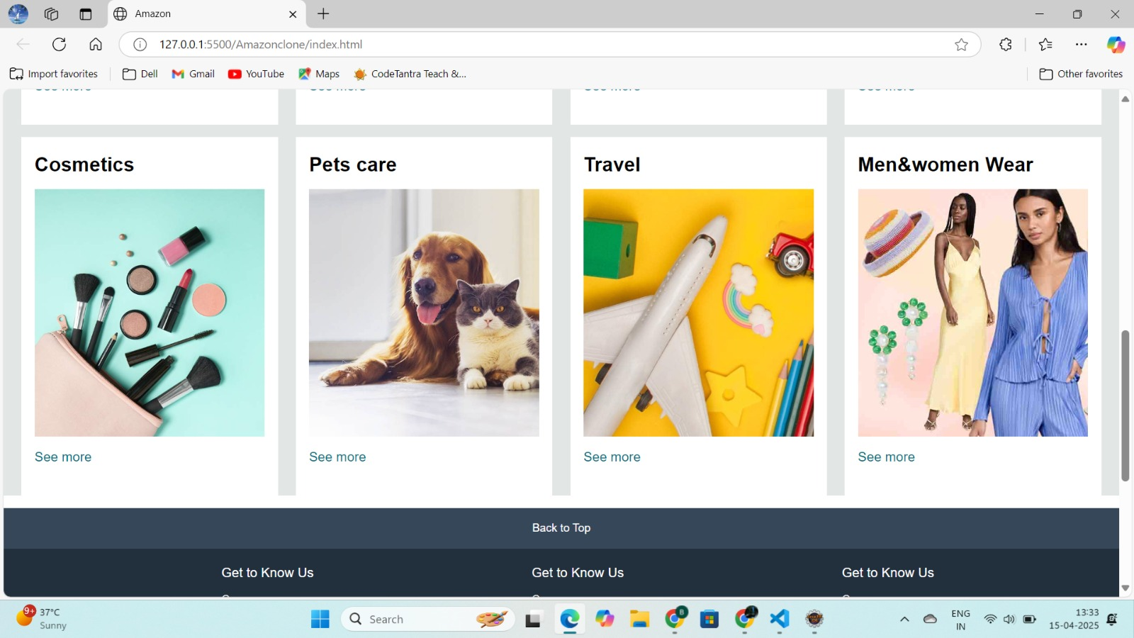

Fig 3.1.1 Home page of Amazon clone
Fig 3.1.2 Services page of Amazon clone

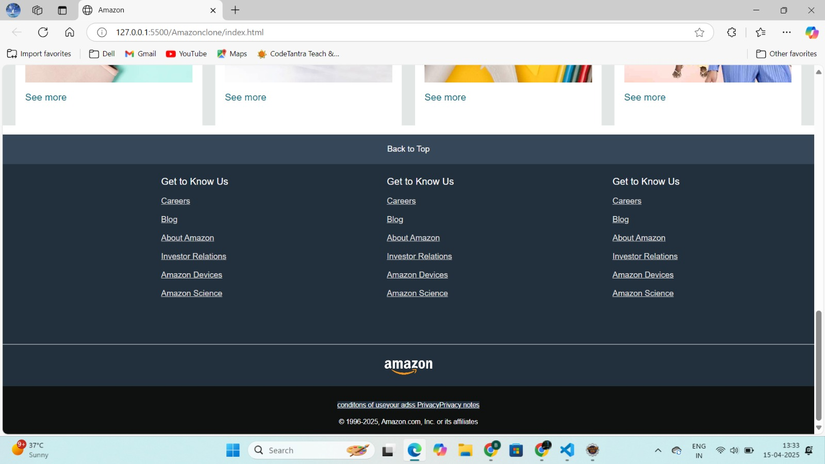
Fig 3.1.3 Footer page of Amazon clone

3.2 Project : 2

Project Name : MVC Based Registration form.

Technologies Used : JDBC, java.

Problem Statement: To design and develop a console-based user registration system using Java and JDBC following the Model-View-Controller (MVC) design pattern. The system allows users to register by providing basic personal information, which is securely stored in a MySQL database. It also ensures data validation and prevents duplicate email registrations.

Goal: The primary goal of this project is to design and implement a user registration system using Java and JDBC that follows the Model-View-Controller (MVC) architecture. The system should allow users to register by entering their personal details through a console-based interface and store this information securely in a MySQL database.

1.User.java:

package model;

public class User {
private String name;
private String email;
private String password;

public User(String name, String email, String password) {
this.name = name;
this.email = email;
this.password = password;
}

// Getters
public String getName() { return name; }
public String getEmail() { return email; }
public String getPassword() { return password; }
}

2.UserDAO.java:

package dao;

import model.User;
import java.sql.*;

public class UserDAO {
private final String jdbcURL = "jdbc:mysql://localhost:3306/your_db";
private final String jdbcUsername = "root";
private final String jdbcPassword = "your_password";

public Connection getConnection() throws Exception {
Class.forName("com.mysql.cj.jdbc.Driver");
return DriverManager.getConnection(jdbcURL, jdbcUsername, jdbcPassword);
}

public boolean isEmailExist(String email) throws Exception {
String query = "SELECT * FROM users WHERE email = ?";
try (Connection conn = getConnection();
PreparedStatement ps = conn.prepareStatement(query)) {
ps.setString(1, email);
ResultSet rs = ps.executeQuery();
return rs.next();
}
}

public boolean registerUser(User user) throws Exception {
if (isEmailExist(user.getEmail())) return false;

String query = "INSERT INTO users (name, email, password) VALUES (?, ?, ?)";
try (Connection conn = getConnection();
PreparedStatement ps = conn.prepareStatement(query)) {
ps.setString(1, user.getName());
ps.setString(2, user.getEmail());
ps.setString(3, user.getPassword());
ps.executeUpdate();
return true;
}
}
}

3.Registration.java:

package view;

import java.util.Scanner;

public class RegistrationView {
private final Scanner scanner = new Scanner(System.in);

public String getInput(String prompt) {
System.out.print(prompt);
return scanner.nextLine().trim();
}

public void showMessage(String message) {
System.out.println(message);
}
}

4.RegistrationController.java:

package controller;

import model.User;
import dao.UserDAO;
import view.RegistrationView;

public class RegistrationController {
private final RegistrationView view;
private final UserDAO dao;

public RegistrationController(RegistrationView view, UserDAO dao) {
this.view = view;
this.dao = dao;
}

public void register() {
try {
String name = view.getInput("Enter your name: ");
String email = view.getInput("Enter your email: ");
String password = view.getInput("Enter your password: ");

if (name.isEmpty() || email.isEmpty() || password.isEmpty()) {
view.showMessage("All fields are required!");
return;
}

User user = new User(name, email, password);
boolean success = dao.registerUser(user);

if (success) {
view.showMessage("Registration successful!");
} else {
view.showMessage("Email already exists.");
}
} catch (Exception e) {
view.showMessage("Error: " + e.getMessage());
}
}
}

5.Main.java:

import controller.RegistrationController;
import dao.UserDAO;
import view.RegistrationView;

public class Main {

public static void main(String[] args) {
RegistrationView view = new RegistrationView();
UserDAO dao = new UserDAO();
RegistrationController controller = new RegistrationController(view, dao);

controller.register();
}
}

6.SQL Table:

CREATE TABLE users (
id INT AUTO_INCREMENT PRIMARY KEY,
name VARCHAR(100),
email VARCHAR(100) UNIQUE,
password VARCHAR(100)
);

Output:

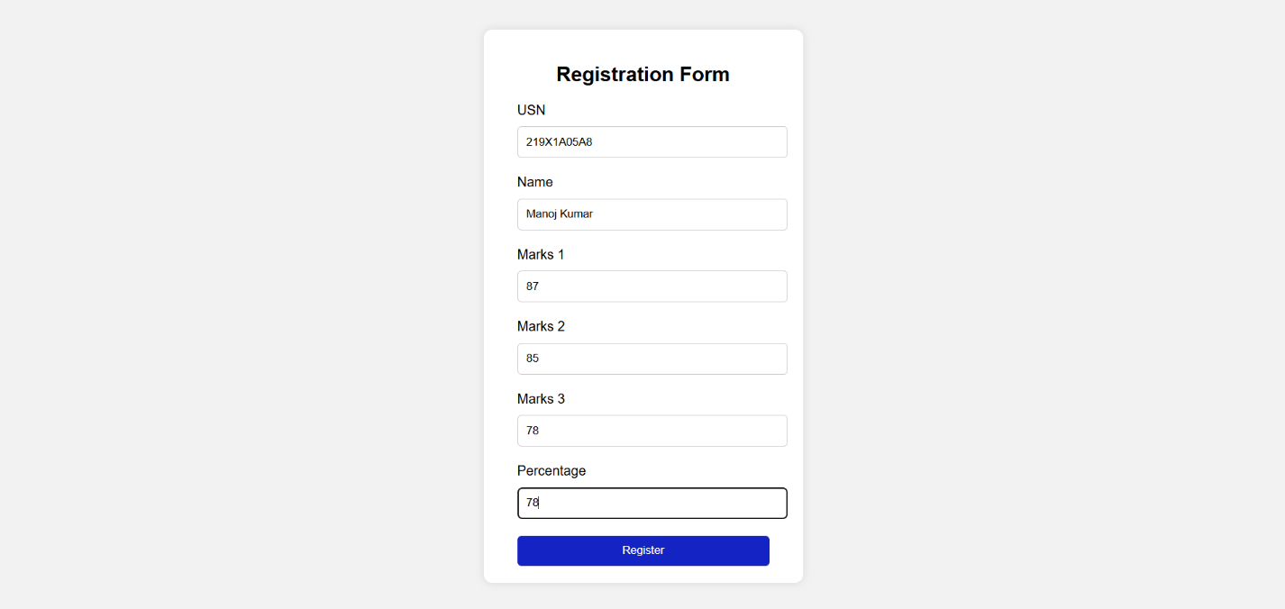

Fig 3.2.1 Register Form

Output :



Fig 3.2.2 Registration Successful

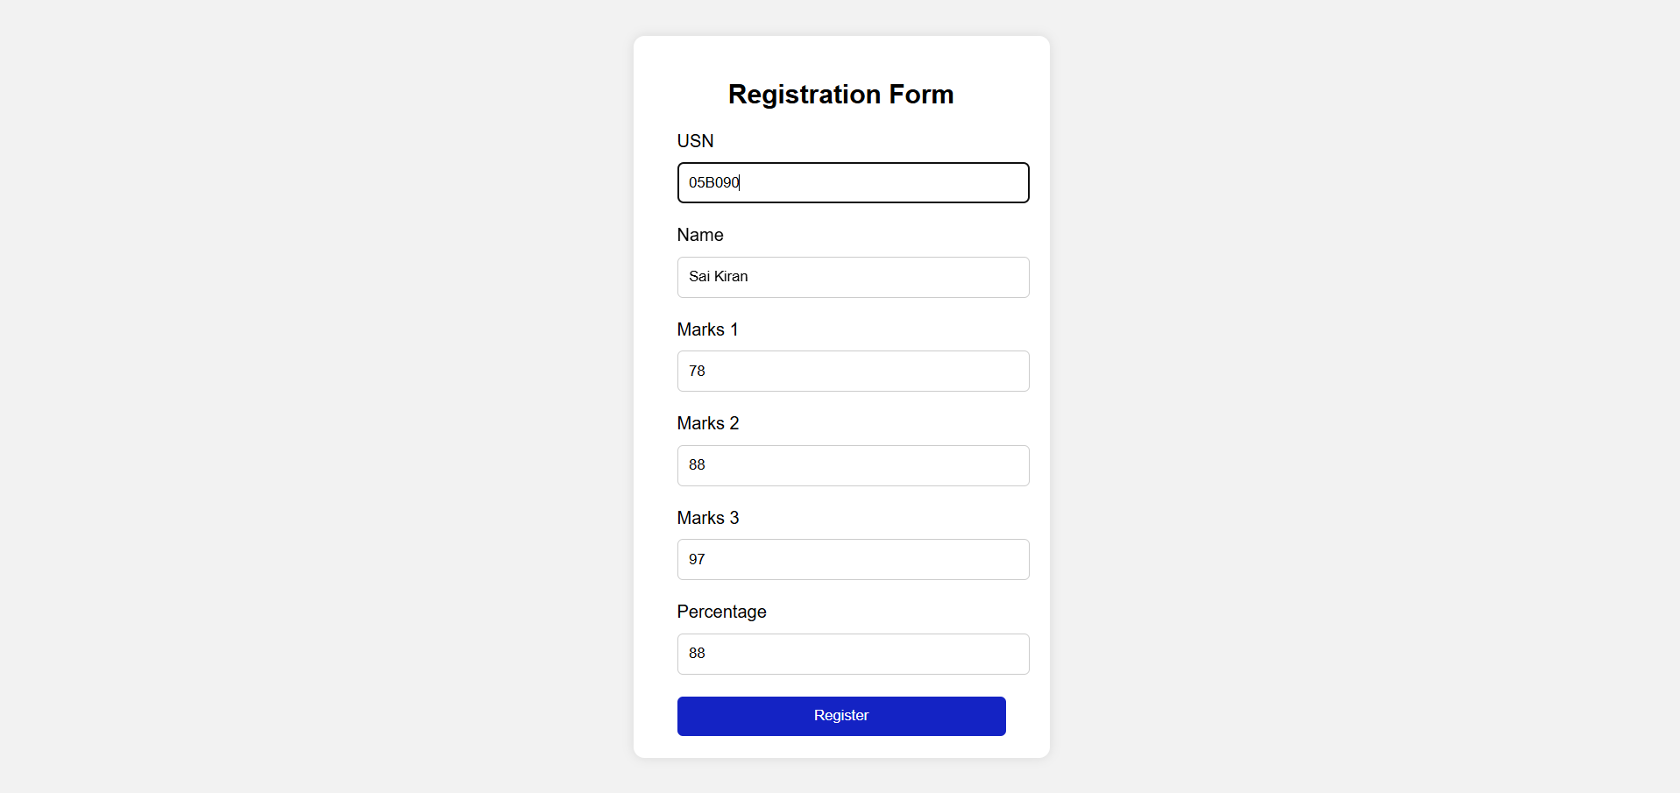

Fig: 3.2.3 Invalid USN

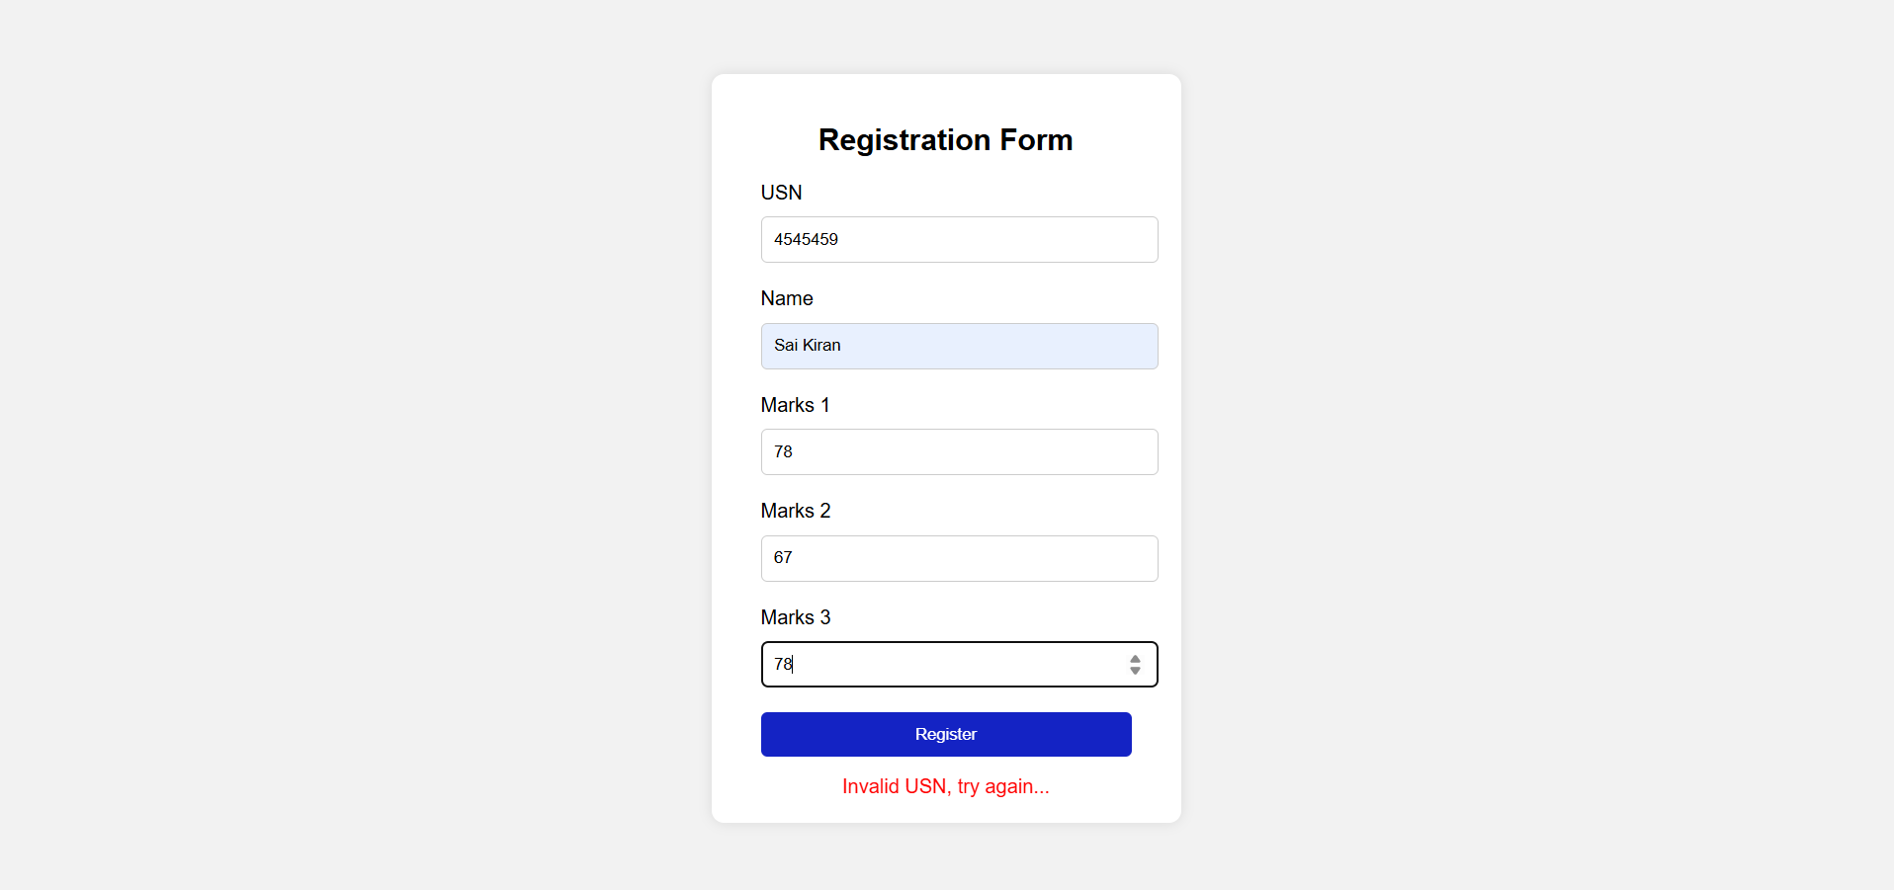

Fig : 3.2.4 Error Message

3.3 PROJECT – 3

Project Name: Quiz Application using Core Java

Technologies Used: Core Java (OOP, Collections), Optional Swing for GUI, JUnit for unit testing

Problem Statement: Instructors and students alike need an efficient, automated way to administer quizzes and instantly assess performance. Manual paper quizzes are cumbersome to distribute, collect, and grade, and they don’t easily adapt to interactive or timed formats. A console- or GUI-based Java quiz application can streamline question delivery, answer validation, and score calculation—all while demonstrating core Java principles.
Goal: Develop a Java application that presents a series of multiple-choice questions, captures the user’s answers, and provides immediate feedback and a final score. The system should support easy question updates, timed quizzes, and result summaries.

Key Requirements:
- Data Model: Use Java classes to represent questions (prompt, options, correct answer) and quizzes (list of questions, current index, score).
- User Interface:
  - Console Version: Read/write via Scanner and System.out.
  - GUI Version (optional): Leverage Swing/AWT to render question panels, radio buttons, and “Next” controls.
- Control Flow: Loop through questions, validate input, update score, and proceed until completion.
- Persistence (optional): Store questions in a text or CSV file and read them at runtime; use File I/O APIs.
- Testing: Write JUnit tests to verify that the scoring logic, question parsing, and user-answer validation behave correctly under various scenarios.

DESCRIPTION

The Quiz Application is a console-based Java project developed using Core Java concepts. The primary goal of this project is to test the user’s general knowledge or subject-specific understanding by presenting a series of multiple-choice questions and evaluating their performance.

The application begins by welcoming the user and collecting basic information such as name and selected category (if applicable). A set of questions is predefined in the code or loaded from a file, and each question includes four options with only one correct answer. The user is prompted to choose an option, and the system evaluates the response, updates the score, and then moves to the next question.

Functionality Description:
- Welcome & User Input:
  - Upon starting the program, the application welcomes the user and requests basic input, such as user name.
  - (Optional) If categories are implemented, the user may also select a quiz topic (e.g., Java, Science, Math, History).
- Question Flow:
  - The quiz contains predefined questions, each with four options (A, B, C, D).
  - Questions can be hardcoded in the program or dynamically loaded from an external source like a text file or CSV.
  - For each question, the user selects an answer, and the application checks the response against the correct option.
  - Score is updated in real-time based on correct answers.
- Result Evaluation:
  - After completing all questions, the system calculates and displays:
    - Total score out of total questions
    - Correct answers for each question
    - Performance feedback, such as "Excellent", "Good", or "Needs Improvement"
  - The final summary provides clear feedback on user performance.

Key Java Concepts and Their Implementation:

1. Object-Oriented Programming (OOP):
  - The quiz logic is built using classes like:
  - Question: Represents a single quiz question, its options, and the correct answer.
  - Quiz: Manages the overall quiz logic, such as storing questions, navigating between them, checking answers, and calculating score.
  - User (optional): Holds user information such as name and selected category.
  - Concepts such as encapsulation, abstraction, and modularity are employed for better code structure and reuse.
  - The use of inheritance or interfaces enables the addition of advanced features like different quiz types or difficulty levels.

2. Arrays and ArrayLists:
  - ArrayLists are used to store a dynamic list of questions and options, making it easy to add, remove, or iterate through them.
  - Arrays or ArrayLists hold:
  - The list of Question objects
  - Multiple choice options per question
  - This provides flexibility to scale the quiz and organize data efficiently.

3. Exception Handling:
  - The application handles unexpected user inputs gracefully using try-catch blocks.
  - Example: If the user enters an invalid option (e.g., a number instead of a letter), the program catches the exception and prompts for re-entry.
  - Prevents the application from crashing and ensures a smooth user experience.

4. Loops and Conditional Statements:
  - Iterating through the list of questions using for or while loops.
  - Checking user input and validating answers with if-else statements.
  - Displaying scores and providing feedback based on score thresholds.

5. User Experience and Interaction:
  - The entire application runs in the console/terminal, where users interact through keyboard input.
  - Clear instructions and prompts guide users through the quiz process.
  - Immediate feedback is provided after each question (if desired), followed by a summary report at the end.

At the end of the quiz, the application displays the final score, along with correct answers and performance remarks.

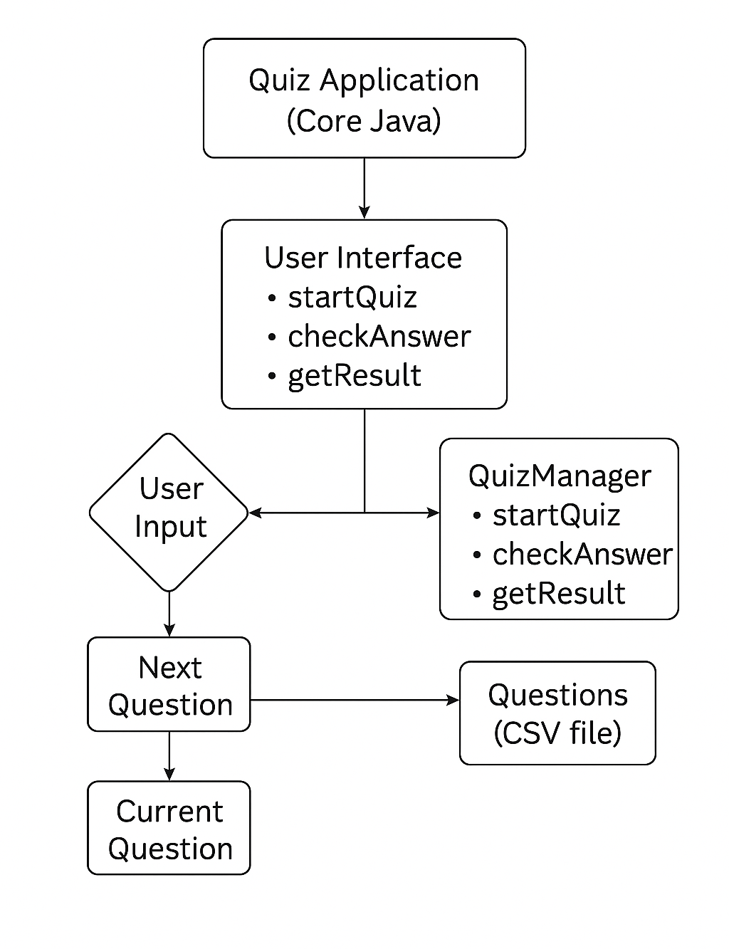
Fig: 3.3.1: Visual Chart Diagram
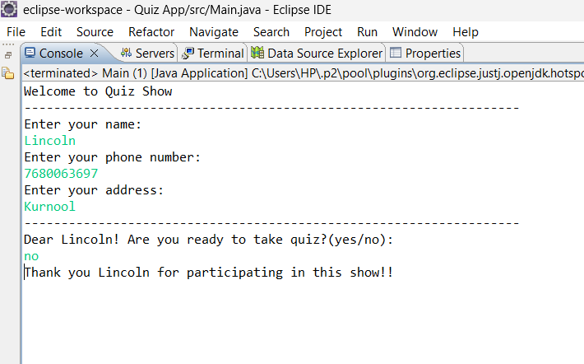
Fig: 3.3.2: Registering Users

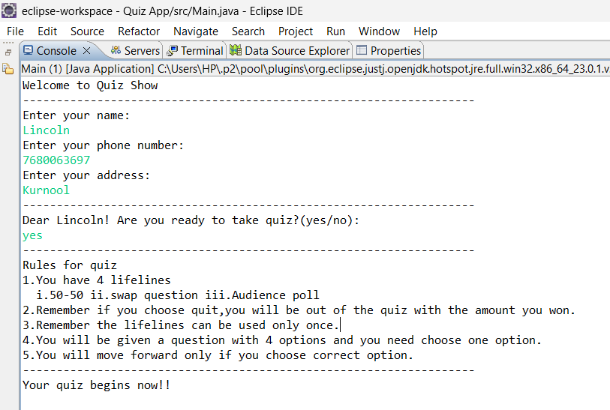
Fig: 3.3.3: Rules of Quiz

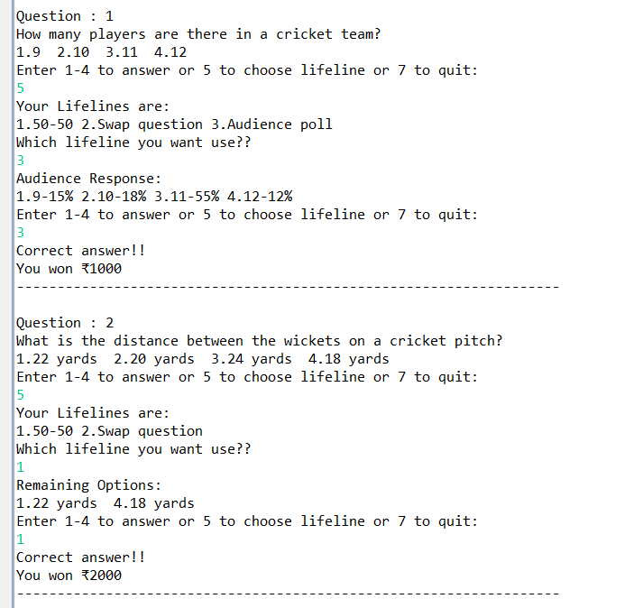
Fig 3.3.4: Playing the Quiz

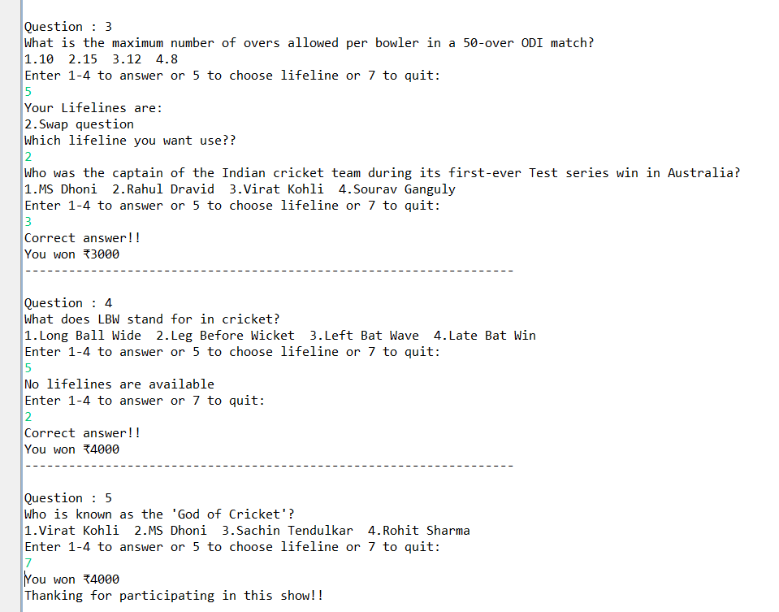
Fig: 3.3.5 Ending the Quiz

3.1 Project : Employee Management System
Problem Statement
Manual employee record-keeping leads to errors, duplication, and difficulty in retrieving information. HR teams struggle to maintain accurate records, track departments, and ensure secure access to sensitive data. A dynamic, database-backed system provides centralized, reliable, and efficient employee management.
Goal
Develop a Spring Boot application using Spring MVC, REST API, and Spring Data JPA to manage employee and department records. The system supports CRUD operations, ensures data integrity, and allows administrators to query and update employee information seamlessly.
Key Requirements & Design Highlights
- Database Schema
  - employees (eid, name, email, password, designation, dept_id)
  - departments (dept_id, dept_name, manager)
- Spring Data JPA Layer
  - Repository interfaces for employees and departments
  - Secure parameterized queries with JPA methods
- Functional Modules
  - Admin: Add/update/delete employees, manage departments, view employee lists
  - Employee: View profile, update limited details, check assigned department
- Error Handling & Transactions
  - Multi-step operations wrapped in transactions for atomicity
  - Graceful exception handling with meaningful error messages
- Testing
  - Unit tests for service and repository layers using in-memory H2 database
Description
The Employee Management System is a full-fledged Spring Boot web application. Admins manage employees and departments; employees can view and update their profiles. Authentication and authorization are handled via Spring Security. REST APIs expose endpoints for CRUD operations, while the frontend (HTML/CSS/Thymeleaf or Angular/React) provides dashboards for interaction.
Technical Stack
- Frontend: HTML/CSS (or Thymeleaf/React/Angular) for login, profile, dashboard
- Backend: Spring Boot, Spring MVC, REST API, Spring Security
- Database: Spring Data JPA + MySQL (employees, departments tables)
- Security: Input validation, role-based access control, session management
Learning Outcomes
- Mastery of backend integration using Spring Boot and JPA
- Understanding of MVC architecture in Spring
- Building secure, stateful web applications with REST APIs
- Handling user inputs and transactions securely

Project Employee Management System:
//Department controller
package net.javaguides.ems.controller;
import lombok.AllArgsConstructor;
import net.javaguides.ems.dto.DepartmentDto;
import net.javaguides.ems.service.DepartmentService; import org.springframework.http.HttpStatus;

import org.springframework.http.ResponseEntity; import org.springframework.web.bind.annotation.*;
import java.util.List;
@CrossOrigin("*") @AllArgsConstructor @RestController @RequestMapping("/api/departments") public class DepartmentController {
private DepartmentService departmentService;
// Build Create or Add Department REST API @PostMapping
public ResponseEntity<DepartmentDto> createDepartment(@RequestBody DepartmentDto departmentDto){
DepartmentDto department = departmentService.createDepartment(departmentDto); return new ResponseEntity<>(department, HttpStatus.CREATED);
}

Figure 3.1.1 Adding new Department to the Database

This figure shows the interface used to enter details of a new department into the system. It typically includes fields like department name, ID, and description for data entry.
// Build Get Department REST API
@GetMapping("{id}")
public ResponseEntity<DepartmentDto> getDepartmentById(@PathVariable("id") Long departmentId){
DepartmentDto departmentDto = departmentService.getDepartmentById(departmentId); return ResponseEntity.ok(departmentDto);
}
// Build Get All Departments REST API @GetMapping
public ResponseEntity<List<DepartmentDto>> getAllDepartments(){ List<DepartmentDto> departments = departmentService.getAllDepartments(); return ResponseEntity.ok(departments); }

Figure 3.1.2 List of Departments in the Database

Figure 3.1.3 Adding new Employee to the Database

Figure 3.1.4 List all the Employees in the Database

4. ACTIVITY LOG

4. ACTIVITY LOG FOR THE WEEK

Weeks | Description of the weekly activity | Learning Outcome | Person In- Charge Signature
Week–1 | Introduction program and about the organization’s functionalities and business operations. | Learnt about the organization conditions and functionalities.
Week-2 | About the current projects in the organization and knowledge transfer regarding the projects. | Got the information about the several projects.
Week-3 | Introduction to the core concepts of the java. | Got the information of the core concepts of java.
Week-4 | Project Allocation and discussion regarding the projects. | Discussions regarding the projects.
Week-5 | Design Document Submission | Learnt how to create the document and the process of documentation.
Week-6 | Referred several technologies for the project completion. | Got the information regarding the several new technologies.
Week-7 | Learnt about the streams(java) and the different ways to make execute my project. | Learnt about the several platforms where I can able to run my project.

Week-8 | Introduction to Advance java concepts like JDBC, SpringBoot | Got to know about the several technologies like connectivity through JDBC etc.,
Week-9 | Project allocation and the discussion regarding the technologies used in the project. | Learnt about the technologies like SpringBoot pages etc.,
Week-10 | Testing the projects regarding their specifications. | Learnt how to debug my project and solved several cases.
Week-11 | Internship and project report updates. | Followed the updates given by the mentor.
Week-12 | Project Report Submission | Given a Demo using ppt and the reports of the project.

5.CONCLUSION

5.CONCLUSION
In the future, there is immense scope to further augment the learning and development experience gained during the Java Developer Internship at Global Quest Technologies (GQT). The internship gave a strong foundation in both Core Java and Advanced Java, allowing me to develop logic-based applications and gain insight into real-time backend development practices. Completing assignments like solving OOP problems, JDBC connectivity implementation, and designing web applications using Servlets and JSP enabled me to learn in-depth and gain confidence in coding clean and effective code.
This internship not only refined my programming abilities but also instructed me on the value of formal learning, reasoning, and creating software with practical insight. It was a stepping stone to becoming a proficient backend developer, and it exposed me to the practices adopted in the software development field.

Future Enhancements
In the future, the internship program can be improved with some worthwhile enhancements that would greatly enhance its overall value and effectiveness. First, incorporating frameworks like Spring Boot and Hibernate would enable interns to go beyond the fundamentals of Java and explore industry-specific tools utilized in enterprise-level applications. This would make the program more relevant and prepare interns better for full-stack positions.
Also, incorporating version control tools such as Git and platforms such as GitHub in the internship would get students accustomed to collaborative development, tracking versions, and contributing to projects, all of which are critical in actual software teams.
Further, including cloud platform experience such as uploading Java projects onto AWS or Heroku would be an excellent addition, enabling interns to grasp cloud-based application deployment and scalability.
Another important enhancement would be implementing a task tracking and feedback system, allowing interns to monitor their progress, get formalized evaluations, and remain motivated during the internship. Periodic feedback would also assist in recognizing areas of improvement and matching learning goals with project needs.
Finally, including mock interview practice sessions, resume writing workshops, and soft skills training would immensely assist interns in preparing themselves for employment prospects after the internship, filling gap between technical training and career preparedness.

REFERENCES

- Official Java Documentation: https://docs.oracle.com/javase/tutorial/
- Object-Oriented Programming in Java - https://www.geeksforgeeks.org/object-oriented-programming-oops-concept-in-java
- JDBC (Java Database Connectivity) Guide - https://docs.oracle.com/javase/tutorial/jdbc/basics/index.html
- Spring – SpringBoot, Spring MVC
🔗 Spring | Home
- TutorialsPoint - Java JDBC
🔗 https://www.tutorialspoint.com/jdbc/index.htm
- JournalDev - MVC Pattern in Java
🔗 https://www.journaldev.com/1430/java-design-patterns-example-tutorial

