**InterQuaratile Range**

Quartiles:

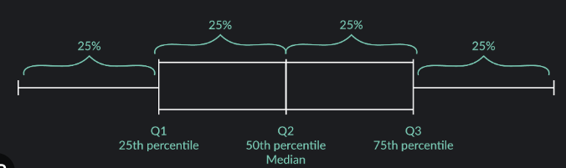

The data is divided into four equal parts known as quartiles.

The first quartile (Q1) is the value below which 25% of the data falls.

The third quartile (Q3) is the value below which 75% of the data falls.

The second quartile is the median, representing the middle value.

IQR Calculation:

The IQR is the range between the first quartile (Q1) and the third quartile (Q3).

Mathematically, **IQR=Q3−Q1.**

1.5 times IQR Rule:

The 1.5 times IQR rule is used to identify potential outliers in a dataset.

Upper Outlier Threshold:

Calculate an upper threshold for potential outliers:

**Q3+1.5×IQR.**

Lower Outlier Threshold:

Calculate a lower threshold for potential outliers:

**Q1−1.5×IQR.**

Identifying Outliers:

Any data point above the upper threshold is considered a potential upper outlier.

Any data point below the lower threshold is considered a potential lower outlier.

Uses:

If a data point falls significantly outside this 1.5 times IQR range, it may be flagged as a potential outlier. This rule is a compromise between being sensitive to potential outliers and avoiding labeling too many points as outliers. Using this rule to identify the outliers in the dataset and we can replace it for further calculations.