**Report for InterQuaratile Range**

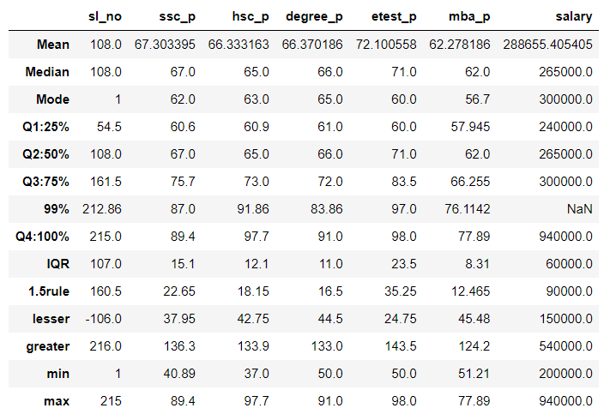

In this table, we identify the IQR(InterQuartile Range) using the calculation Q3-Q1,and 1.5rule to find lesser& greater value ,used to identify the outliers comparing with minimum and maximum values.

SSC analysis

IQR value for SSC is 15.1 calculated using the formula Q3-Q1,and 1.5 rule value is calculated as 22.65 using 1.5*IQR, which is used to calculated lesser& greater value.

Lesser outlier is calculated using Q1-1.5*IQR, the value for SSC is 37.95 & greater outlier is calculated using Q3+1.5*IQR is 136.3

The minimum value is calculated for the dataset is 40.89,and maximum value is 89.4

**HSC analysis**

IQR value for SSC is 12.1 calculated using the formula Q3-Q1,and 1.5 rule value is calculated as 18.15 using 1.5*IQR, which is used to calculated lesser& greater value.

Lesser outlier is calculated using Q1-1.5*IQR, the value for SSC is 42.75 & greater outlier is calculated using Q3+1.5*IQR is 133.9

The minimum value is calculated for the dataset is 37.0,and maximum value is 97.7

**Degree analysis**

IQR value for SSC is 11.0 calculated using the formula Q3-Q1,and 1.5 rule value is calculated as 16.5 using 1.5*IQR, which is used to calculated lesser& greater value.

Lesser outlier is calculated using Q1-1.5*IQR, the value for SSC is 44.5 & greater outlier is calculated using Q3+1.5*IQR is 133

The minimum value is calculated for the dataset is 50,and maximum value is 91

**Etest analysis**

IQR value for SSC is 23.5 calculated using the formula Q3-Q1,and 1.5 rule value is calculated as 35.25 using 1.5*IQR, which is used to calculated lesser& greater value.

Lesser outlier is calculated using Q1-1.5*IQR, the value for SSC is 24.75 & greater outlier is calculated using Q3+1.5*IQR is 143.5

The minimum value is calculated for the dataset is 50,and maximum value is 98

**MBA analysis**

IQR value for SSC is 8.31 calculated using the formula Q3-Q1,and 1.5 rule value is calculated as 12.4 using 1.5*IQR, which is used to calculated lesser& greater value.

Lesser outlier is calculated using Q1-1.5*IQR, the value for SSC is 45.48 & greater outlier is calculated using Q3+1.5*IQR is 124.2

The minimum value is calculated for the dataset is 51.2,and maximum value is 77.89