Forecastability
Forecastability means how easy it is to predict the future of a time series (like stock prices, temperature, or sales) using past values. If the series has a clear pattern, it is forecastable; if it looks random, it is not.

Approximate Entropy (ApEn) & Sample Entropy (SpEn)
These are two measures of forecastability based on randomness (entropy):
- Forecastability = how predictable data is.
- ApEn = basic randomness measure.
- SpEn = refined randomness measure.
- Both help in checking if a series can be forecasted.
- ApEn: A 'randomness score'. Low ApEn → predictable, High ApEn → random.
- SpEn: Improved version of ApEn (ignores self-matches). More reliable.
👉 Example:
• A clock ticking every second → Low entropy (predictable)
• Stock prices with sudden jumps → High entropy (unpredictable)
APEN
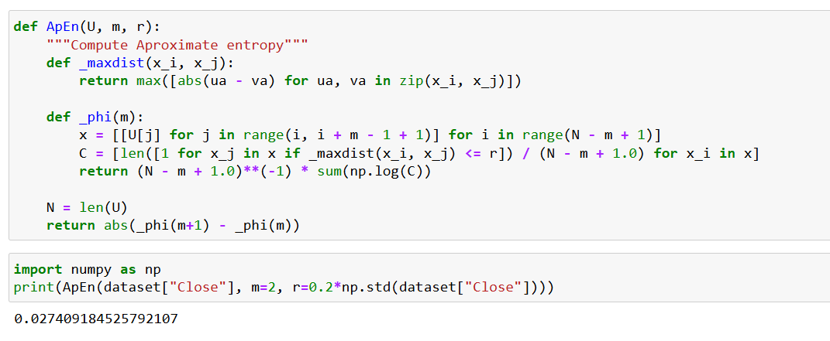
SPEN
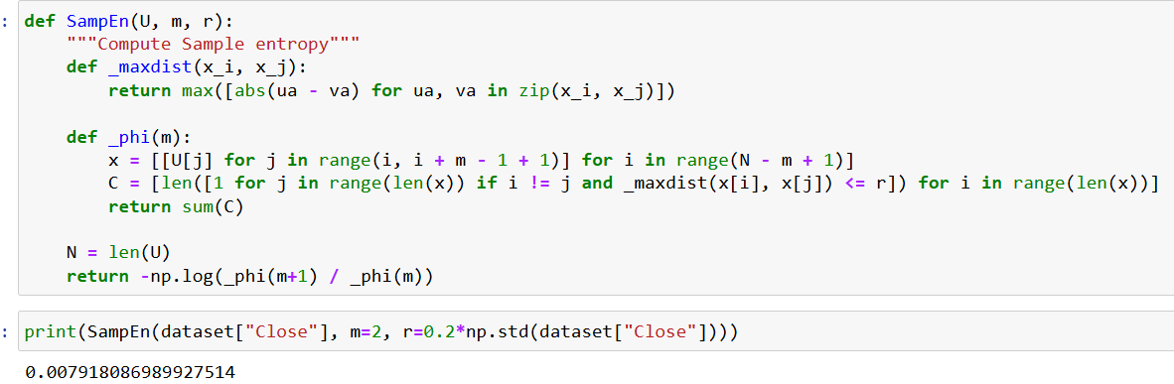

Code Summary
- 1. Break the series into small subsequences of length m.
2. Compare subsequences and count how many are 'similar' within a tolerance r.
3. ApEn = difference in probabilities for subsequences of length m and m+1.
4. SpEn = ratio of matches for m+1 vs m, without self-matching.
→ Smaller values = more predictable, Larger values = more random.
- Output -APEN-0.0274 very small → data is predictable. SPEN- Output: 0.0079 → very small → predictable data.

