WPL Problem-Based Learning (PBL)
Name: Muhammad Umair
ID: IU04-0122-0158
Problem:
Q. create crud operations and include prepared statement to prevent sql injection.

Code:

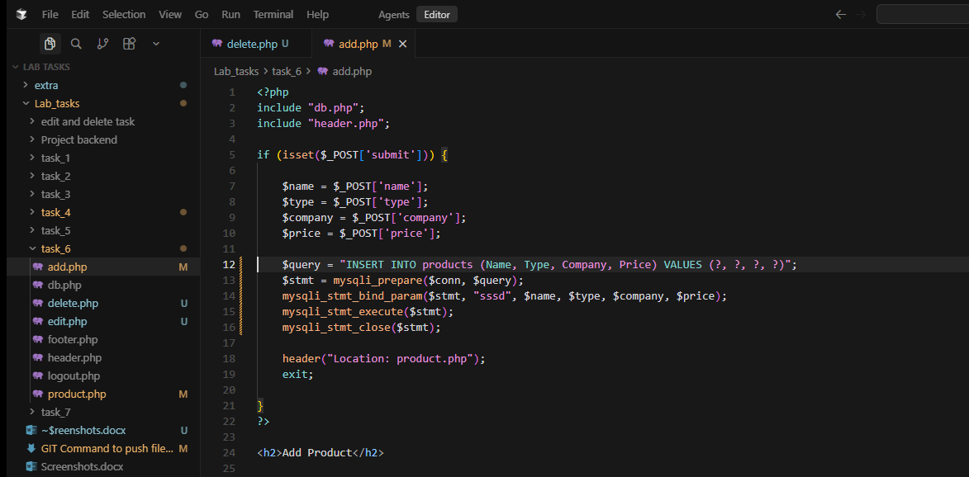
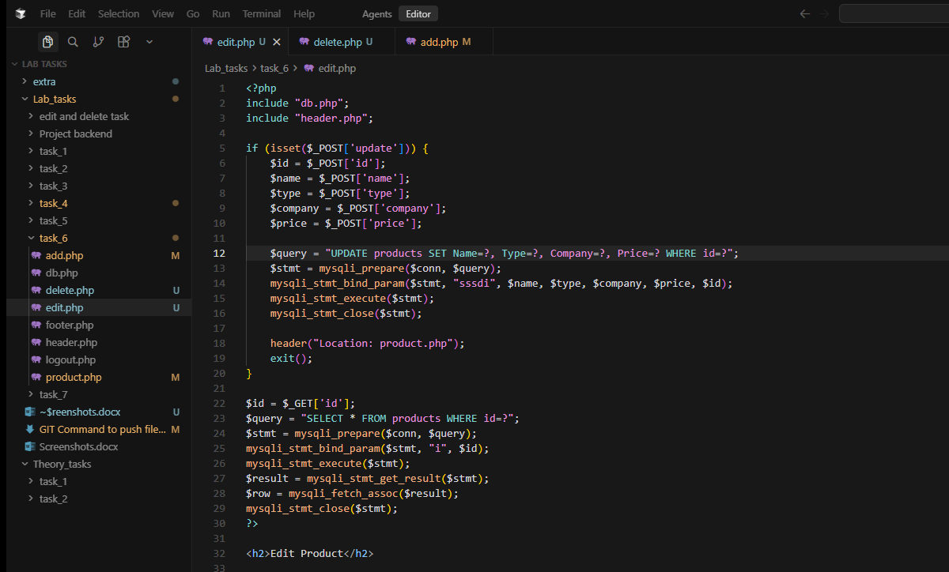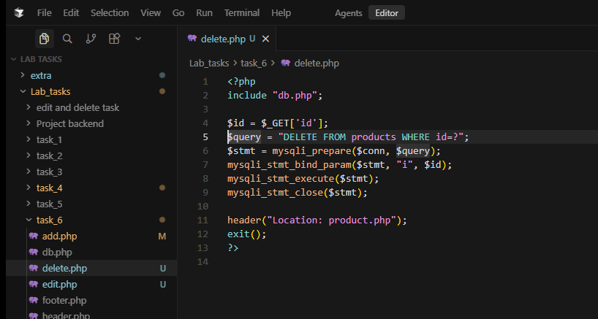

Screenshot:
: