Final Project Report

Rice Plant Disease Detection



Project Supervisor
Muhammad Kamran

Submitted By

S25PROJECTD5623

Umed Ali BC220207743

Software Projects & Research Section,
Department of Computer Sciences,
Virtual University of Pakistan


CERTIFICATE

This is to certify that Umed Ali (BC220207743) have worked on and completed their Software Project at Software & Research Projects Section, Department of Computer Sciences, Virtual University of Pakistan in partial fulfillment of the requirement for the degree of BS in Computer Sciences under my guidance and supervision.

In our opinion, it is satisfactory and up to the mark and therefore fulfills the requirements of BS in Computer Sciences.

Supervisor / Internal Examiner

Muhammad Kamran
Supervisor,
Software Projects & Research Section,
Department of Computer Sciences
Virtual University of Pakistan

___________________
(Signature)

External Examiner/Subject Specialist
<<External Supervisor Name>>

___________________
(Signature)

Accepted By:

_____________
(For office use)

EXORDIUM

In the name of Allah, the Compassionate, the Merciful.

Praise be to Allah, Lord of Creation,
The Compassionate, the Merciful,
King of Judgment-day!

You alone we worship, and to You alone we pray for help,
Guide us to the straight path

The path of those who You have favored,

Not of those who have incurred Your wrath,
Nor of those who have gone astray.

DEDICATION

I dedicate this project to my loving parents and family, whose constant support, prayers, and encouragement have been the foundation of my journey. Their belief in me kept me going even during the toughest times.

ACKNOWLEDGEMENT

First and foremost, I am truly grateful to Allah Almighty for giving me the strength and ability to complete this project.
I would also like to sincerely thank my supervisor, Mr. Muhammad Kamran for his valuable guidance, patience, and support throughout this project. His feedback played a key role in shaping my work.
Lastly, heartfelt thanks to my friends, mentors, and everyone who offered help, motivation, or a kind word during this journey. This achievement wouldn’t have been possible without them.

PREFACE

This project, Rice Plant Disease Detection System, is a part of my Final Year Project at Virtual University of Pakistan. It aims to assist farmers by providing an AI-based tool for early detection of rice leaf diseases.
The journey of building this project helped me apply practical knowledge in AI and web development. I am especially thankful to my supervisor, Mr. Muhammad Kamran, for his guidance, encouragement, and continuous support throughout the project.

Table of Contents
Gathering & Analyzing Info 7
1.1 Introduction 7
1.2 Purpose 8
1.3 Scope of the project 8
1.4 DEFINITIONS, acronyms and abbreviations 8
1.5 Project requirements 9
1.5.1 Functional Requirements 9
1.5.2 Non-Functional Requirements 9
1.6 use cases and usage scenarios 10
1.6.1 Use Case Diagrams 10
1.6.2 Usage Scenarios 10
1.7 DEVELOPMENT METHODOLOGY 17
1.7.1 Chosen Methodology 19
1.7.2 Reason for Chosen Methodology 20
1.7.2 Work Plan (Gantt Chart) 21
1.7.2 Project Schedule (Submission Calendar) 21
Designing the Project 22
2.1 Introduction 22
1. Entity Relationship Diagram (ERD) 22
2. Sequence Diagrams 23
3. Architecture Design Diagram 23
4. Class Diagram 23
5. Database Design 23
6. Interface Design 23
7. Test Cases 24
2.2 purpose 24
2.3 scope 24
2.4 definitions, acronyms and abbreviations 24
2.5 Architectural Representation (Architecture Diagram) 25
2.6 Dynamic Model: Sequence Diagrams 26
2.7 Object Model/Logical Model: Class Diagram 29
2.8 Database Model (Database Diagram) 30
2.9 Graphical User Interfaces 31
Development 33
3.1 Deployment Plan (Architecture Diagram) 33
REFERENCES 35
APPENDIX 36

<<Dear Students, you have to take special care of page numbers, which are written against each Chapter and sub headings. You have to mention your own page numbers and correct one against each document heading. Make proper table of contents. Remember that if there are any new headings or you have included more headings in your documents then you also have to write these in table of contents and modify table of contents according to your documents material>>
<<Dear Students, before starting each chapter the following would be the title page for each chapter on a separate page>>

CHAPTER 1

Gathering & Analyzing Info

1.1 Introduction
- The project focuses on developing an AI-powered web application for detecting rice plant leaf diseases using image inputs.
- It addresses the drawbacks of manual disease detection, which is often slow, expensive, and error-prone.
- The system uses image processing and deep learning (CNN) to classify rice leaf diseases with high accuracy.
A curated image dataset will include six common rice leaf diseases:
- Leaf Smut
- Brown Spot
- Bacterial Leaf Blight
- Leaf Scald
- Sheath Blight
- Leaf Blast

- Preprocessing steps like resizing, normalization, and augmentation will prepare the dataset for model training.
- Multiple CNN architectures will be explored to find the most effective model.
- The dataset will be divided into training, validation, and testing sets.
- Key hyperparameters like learning rate, batch size, and epochs will be tuned for optimal performance.
A real-time web application will allow users to:
- Upload rice leaf images
- Instantly receive disease predictions
- View side-by-side visual feedback of the input and results

the types of users (actors) for this application are:
- User
- Admin
- System

1.2 Purpose

The purpose of this project is to help farmers and agriculture workers quickly find out if a rice plant leaf has a disease or not. By just uploading a photo of the leaf, the system will use AI to check and tell which disease it might have. This makes the process faster, easier, and more accurate than checking by hand.

1.3 Scope of the project
This project is about developing a smart web app that helps farmers detect diseases in rice plants just by uploading a photo of the leaf. Since rice is a major food crop around the world, keeping it healthy is very important. Diseases like Leaf Smut, Brown Spot, Bacterial Leaf Blight, Leaf Scald, Sheath Blight, and Leaf Blast can seriously affect crop growth and yield. Traditionally, identifying these diseases takes time and expert knowledge. With this AI-powered system, the process becomes fast, easy, and more accurate. The app will instantly analyze the image and tell the user which disease is present, helping farmers take timely action and protect their crops.

1.4 DEFINITIONS, acronyms and abbreviations

Term | Definition
CNN | Convolutional Neural Network – a deep learning method used to recognize images.
GUI | Graphical User Interface – the screen or layout users interact with in the app.
OpenCV | Open Source Computer Vision Library – used to work with images and videos in Python.
Image Augmentation | A technique to increase training data using flipped, rotated, or zoomed versions of images.
Dataset | A collection of images or data used to train and test the AI model.
Model Training | The process of teaching the AI system to recognize patterns from image data.

1.5 Project requirements

1.5.1 Functional Requirements
- Image Upload: The system should allow users to upload images of rice plant leaves through a simple interface.
- Disease Detection: Once an image is uploaded, the system must analyze it using a trained CNN model to detect and classify the disease (Leaf Smut, Brown Spot, Bacterial Leaf Blight, Leaf Scald, Sheath Blight, and Leaf Blast).
- Real-time Feedback: The system should provide fast and accurate disease predictions with visual output.
- User Interface: The web app should display the uploaded image along with the disease name and confidence score.
- Model Training (Backend): The system must be capable of training and storing the deep learning model based on preprocessed and labeled datasets.
- Database (optional): If needed, the system should maintain records of image uploads and results for analysis or future reference.

1.5.2 Non-Functional Requirements
- Accuracy: The disease prediction model should maintain a high accuracy rate (ideally above 90%) after proper training and validation.
- Performance: Image upload and result display should be processed within a few seconds to ensure a smooth user experience.
- Scalability: The system should be able to handle multiple user requests without crashing or slowing down.
- Usability: The interface should be simple, clean, and easy to use even for non-technical users like farmers.
- Security: Uploaded images and any user data should be kept private and handled securely.
- Compatibility: The web app should work across all major browsers and devices, including smartphones.
- Maintainability: The system should be easy to update, especially when retraining models or improving UI features.

1.6 use cases and usage scenarios

1.6.1 Use Case Diagrams
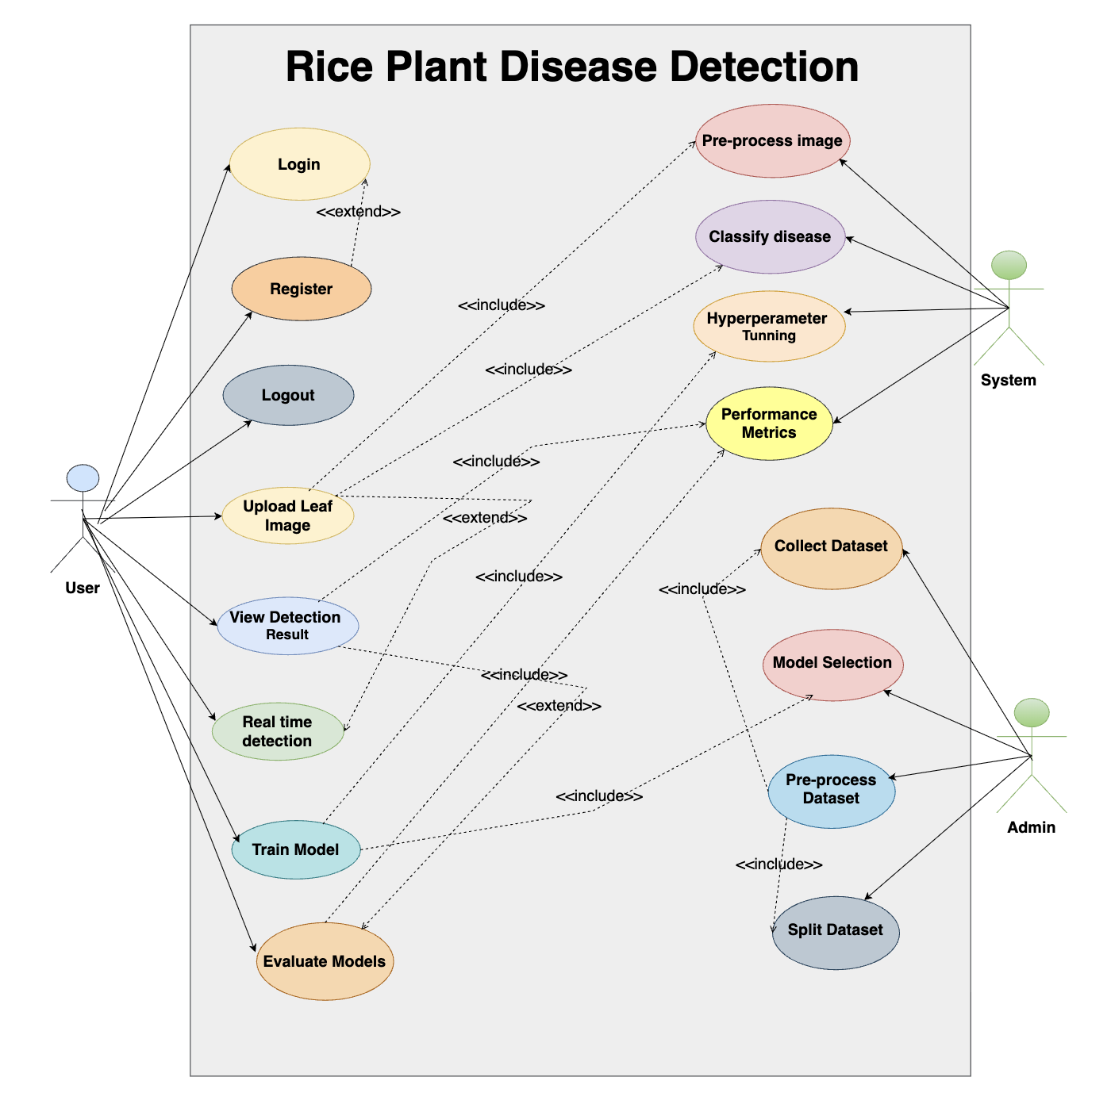

1.6.2 Usage Scenarios
A Usage Scenario is a formal description of the flow of events that take place during the execution of a specific use case instance. It outlines the exact sequence of interactions between the system and external actors. Typically, it is written in textual form and aligns closely with the structure of the corresponding sequence diagram.

Usage Scenario 01:

Field | Details
Use Case Title | Upload Leaf Image
Use Case ID | UC01
Actor | User
Actions | The user uploads an image of a rice plant leaf using the interface.
Description | Initiates the diagnosis process by sending an image to the system.
Alternative Paths | Invalid file format or size, or user cancels upload.
Pre-Conditions | The user is logged in and on the upload screen.
Post-Conditions | Image is successfully received by the system for processing.
Exceptions | Upload failure due to network or file error.
Author | BC220207743

Usage Scenario 02:

Field | Details
Use Case Title | View Detection Result
Use Case ID | UC02
Actor | User
Actions | User receives the classification result after image analysis.
Description | Displays the predicted disease class detected by the model.
Alternative Paths | Display may show "uncertain result" if confidence is low.
Pre-Conditions | The user has successfully uploaded an image.
Post-Conditions | Detection result is shown in a readable format.
Exceptions | No prediction returned or system error.
Author | BC220207743

Usage Scenario 03:

Field | Details
Use Case Title | Real-Time Detection
Use Case ID | UC03
Actor | User
Actions | Initiates quick detection using OpenCV or similar tools.
Description | Offers real-time analysis for immediate feedback on disease presence.
Alternative Paths | Detection is delayed or inaccurate.
Pre-Conditions | The trained model must be deployed.
Post-Conditions | Detection result appears instantly.
Exceptions | Real-time engine not responding.
Author | BC220207743

Usage Scenario 04:

Field | Details
Use Case Title | Train Model
Use Case ID | UC04
Actor | User
Actions | User triggers model training on the system using available dataset.
Description | Starts CNN model training for classification task.
Alternative Paths | Training fails due to parameter issues or system crash.
Pre-Conditions | Dataset must be preprocessed and formatted.
Post-Conditions | New trained model is saved.
Exceptions | Memory overflow, poor dataset, interrupted training.
Author | BC220207743

Usage Scenario 05:

Field | Details
Use Case Title | Evaluate Models
Use Case ID | UC05
Actor | User
Actions | Triggers performance evaluation of the trained model.
Description | Evaluates model using metrics like accuracy, precision, and loss.
Alternative Paths | Use subset of data for quick evaluation.
Pre-Conditions | A trained model must be available.
Post-Conditions | Evaluation summary or report is generated.
Exceptions | Incomplete metrics, system error.
Author | BC220207743

Usage Scenario 06:

Field | Details
Use Case Title | Pre-process Image
Use Case ID | UC06
Actor | System
Actions | Applies resizing, normalization, and augmentation to image.
Description | Prepares image for consistent and reliable classification.
Alternative Paths | Skip augmentation if not needed.
Pre-Conditions | Image is uploaded.
Post-Conditions | Preprocessed image is ready for classification.
Exceptions | Image cannot be read or transformed.
Author | BC220207743

Usage Scenario 07:

Field | Details
Use Case Title | Classify Disease
Use Case ID | UC07
Actor | System
Actions | Uses CNN model to predict rice leaf disease class.
Description | Performs classification into Leaf Smut, Brown Spot, or Bacterial Blight.
Alternative Paths | Multiple predictions if confidence is low.
Pre-Conditions | Preprocessed image must be ready.
Post-Conditions | Disease label is generated.
Exceptions | Misclassification, model failure.
Author | BC220207743

Usage Scenario 08:

Field | Details
Use Case Title | Hyperparameter Tuning
Use Case ID | UC08
Actor | System
Actions | Optimizes training parameters during model training.
Description | Adjusts learning rate, batch size, etc. to improve accuracy.
Alternative Paths | Manual grid search or automatic tuning.
Pre-Conditions | Training process has started.
Post-Conditions | Best model configuration is saved.
Exceptions | Overfitting, underfitting, or convergence failure.
Author | BC220207743

Usage Scenario 09:

Field | Details
Use Case Title | Performance Metrics
Use Case ID | UC09
Actor | System
Actions | Computes and stores model accuracy, loss, F1-score, etc.
Description | Evaluates model performance on validation and test sets.
Alternative Paths | Real-time metrics or offline batch metrics.
Pre-Conditions | Evaluation dataset and trained model must be available.
Post-Conditions | Metrics are displayed or logged.
Exceptions | Evaluation script crash or missing data.
Author | BC220207743

Usage Scenario 10:

Field | Details
Use Case Title | Collect Dataset
Use Case ID | UC10
Actor | Admin
Actions | Admin gathers raw rice plant leaf images from open-source or field sources.
Description | Provides the training base for the AI system by sourcing relevant image data.
Alternative Paths | Admin imports from multiple datasets or merges manually labeled data.
Pre-Conditions | Admin is authenticated.
Post-Conditions | A raw dataset is stored in the system for preprocessing.
Exceptions | Data source unavailable, network errors, or unsupported formats.
Author | BC220207743

Usage Scenario 11:

Field | Details
Use Case Title | Pre-process Dataset
Use Case ID | UC11
Actor | Admin
Actions | Admin initiates resizing, augmentation, and normalization of dataset.
Description | Ensures dataset is clean and uniformly formatted for training.
Alternative Paths | Admin applies only selected techniques (e.g., skips augmentation).
Pre-Conditions | Dataset has been collected.
Post-Conditions | A structured and clean dataset is ready.
Exceptions | Preprocessing script failure, missing labels.
Author | BC220207743

Usage Scenario 12:

Field | Details
Use Case Title | Split Dataset
Use Case ID | UC12
Actor | Admin
Actions | Admin divides the dataset into training, validation, and testing sets.
Description | Enables proper model evaluation and avoids data leakage.
Alternative Paths | Use stratified sampling or fixed-percentage splits.
Pre-Conditions | Preprocessed dataset is available.
Post-Conditions | Datasets are split and saved.
Exceptions | Incorrect split ratios, duplicate data.
Author | BC220207743

Usage Scenario 13:

Field | Details
Use Case Title | Model Selection
Use Case ID | UC13
Actor | Admin
Actions | Admin compares architectures like CNN, ResNet, MobileNet to choose one.
Description | Selects the best model based on performance and speed.
Alternative Paths | Try pretrained models or manually configure layers.
Pre-Conditions | Data split is complete.
Post-Conditions | Selected model is ready for training.
Exceptions | Model incompatibility or unsupported architecture.
Author | BC220207743

1.7 DEVELOPMENT METHODOLOGY

The adopted ways of doing things for this project is VU process model. It is
combination of water-fall model and spiral model. This model is easy to understand and
use. Now first of all discuss water fall model.

Waterfall Model:
- Requirements Gathering and Analysis
Understanding and documenting user needs, system expectations, and functional requirements.
- System Design
Translating requirements into a blueprint for the architecture, components, interface, and data flow.
- Implementation
Actual coding and integration of individual modules based on the design specifications.
- Testing
Verifying functionality, performance, and reliability through unit, integration, and system testing.
- Deployment
Delivering the final product to the user environment, ensuring proper configuration and setup.
- Maintenance
Providing ongoing support, bug fixes, and updates to accommodate changes and improvements post-deployment.
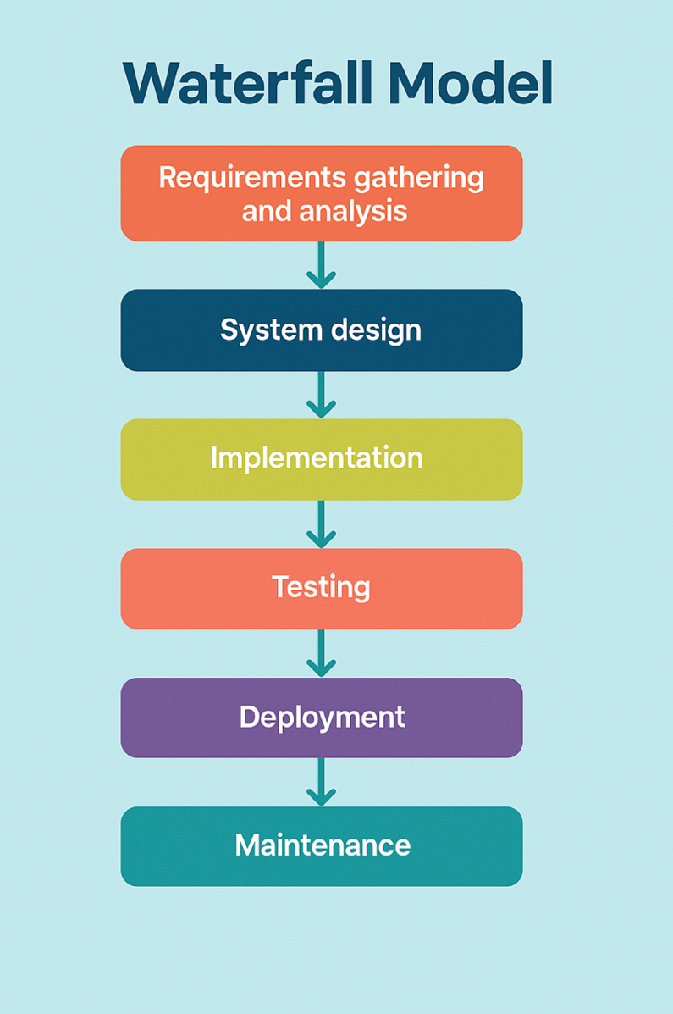

Spiral Model:

The Spiral Model is a software development methodology that blends the structured approach of the Waterfall Model with the flexibility of iterative development. It is especially suitable for large, high-risk projects where frequent revisions and thorough risk management are essential.
Development in the Spiral Model proceeds in loops or cycles, with each loop representing a phase of the software process. At the end of each cycle, the project is reviewed and refined before moving to the next iteration. This allows for early identification and resolution of risks and the ability to accommodate changes based on user feedback.
Each cycle of the Spiral Model includes the following key activities:
- Planning: Define objectives, constraints, and strategies for the current phase.
- Risk Analysis: Identify potential risks and develop strategies to mitigate them.
- Engineering: Design, develop, and implement features or prototypes.
- Evaluation: Review progress, validate outcomes, and decide whether to proceed, repeat, or terminate the cycle.

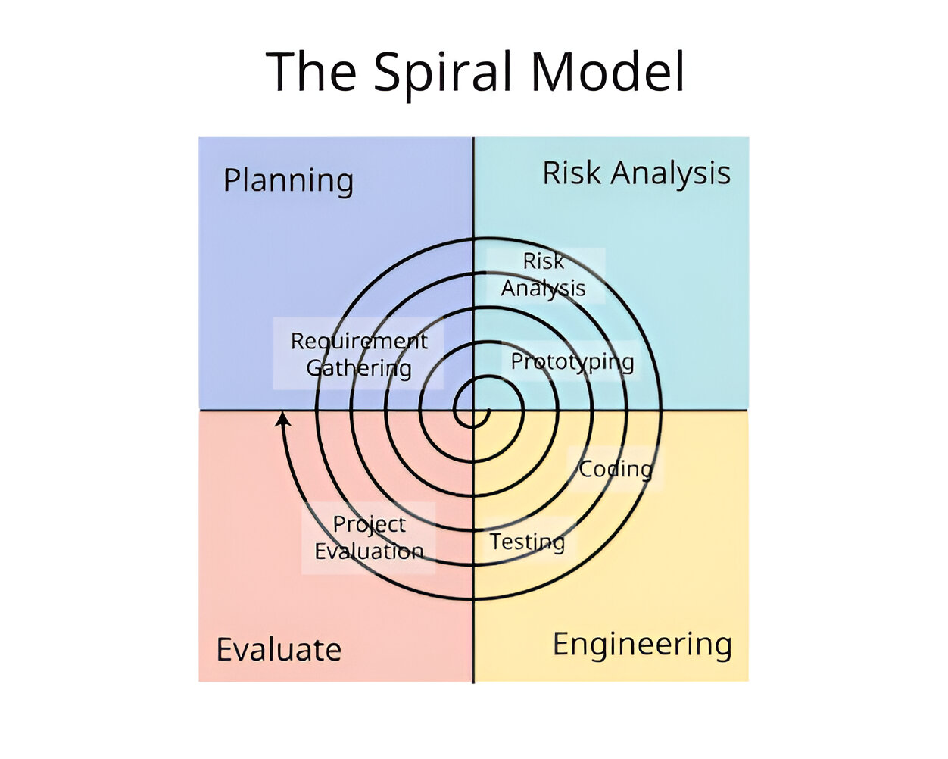

1.7.1 Chosen Methodology

VU Process Model:

VU Process model which is the combination of waterfall model and spiral model. The main idea for selection of this model is that to get the benefits of both these models.

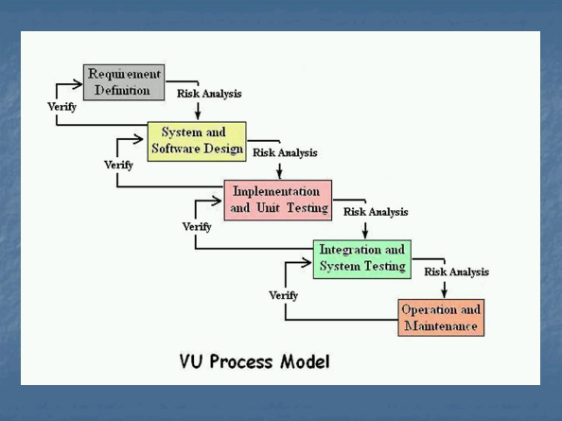

1.7.2 Reason for Chosen Methodology

- The model supports a structured, phase-by-phase development approach, which fits the project requirements set by the supervisor.
- Each phase is completed and submitted for review before moving to the next.
- If any issues are found, we receive feedback for correction, ensuring quality improvement at every stage.
- This reflects the spiral nature of the model, where continuous refinement is encouraged.
- Once a phase is approved, the process moves forward like a waterfall, showing clear progress.
- The model combines both structure and flexibility, making it ideal for academic projects like ours.

1.7.2 Work Plan (Gantt Chart)

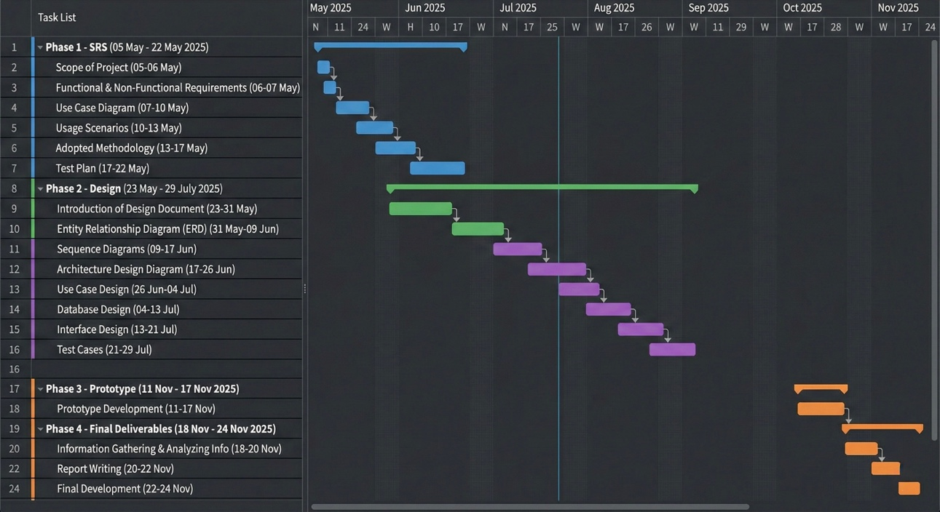

1.7.2 Project Schedule (Submission Calendar)

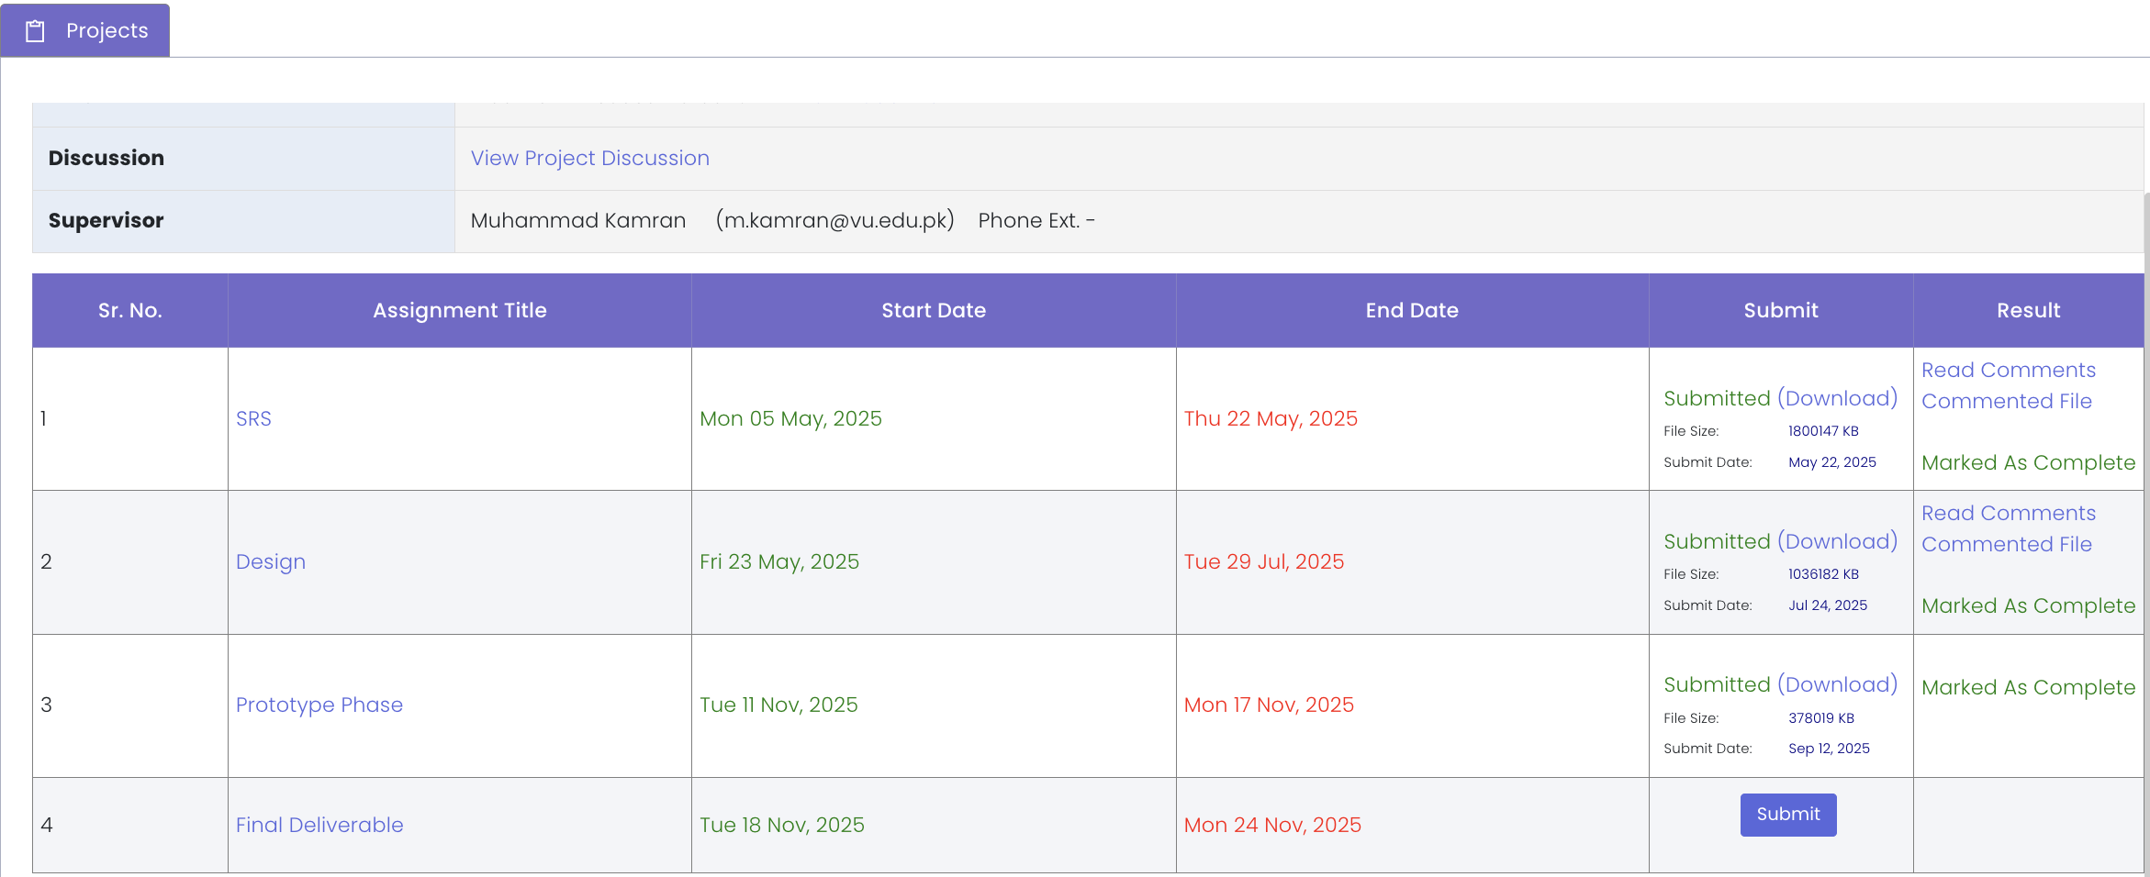

CHAPTER 2

Designing the Project

2.1 Introduction

This Design Document serves as a comprehensive blueprint that translates the requirements defined in the Software Requirements Specification (SRS) into detailed technical designs. It provides clear guidance for the development team, ensuring that the software system is built in a structured, efficient, and maintainable manner.

Scope:
It covers the overall system design strategy, including how different components will interact, how data will flow, and how the software will be structured to ensure performance, scalability, and maintainability. It serves as a reference for developers, testers, and stakeholders throughout the development life cycle.

Purpose:
The main purpose of the Design Document is to provide clear and unambiguous technical guidance for building the system correctly and efficiently. It reduces misunderstandings, minimizes development risks, promotes consistency and reusability of components, and lays the foundation for systematic testing and quality assurance. Ultimately, it ensures that the final product aligns with both user expectations and business objectives.

1. Entity Relationship Diagram (ERD)
An Entity Relationship Diagram (ERD) is a visual representation of the data structure in a system. It shows entities (such as tables in a database), their attributes (data fields), and the relationships between entities. ERDs help ensure that data is organized efficiently and relationships are logically defined to support the system’s data requirements.

2. Sequence Diagrams
Sequence Diagrams illustrate how objects or system components interact with each other over time to perform a specific function or process. They show the sequence of messages exchanged between actors and objects in a time-ordered flow, helping developers understand the dynamic behavior of the system.

3. Architecture Design Diagram
An Architecture Design Diagram provides a high-level structural view of the entire software system. It depicts major components, modules, layers, and their interactions, showing how the system’s parts work together to fulfill requirements. This diagram helps in planning, integration, and ensuring scalability and maintainability.

4. Class Diagram
A Class Diagram is a type of static structure diagram used in object-oriented design. It describes the system’s classes, their attributes and methods, and the relationships between classes (such as inheritance and associations). It serves as a blueprint for coding and ensures clarity in object-oriented programming.

5. Database Design
Database Design is the detailed process of structuring the database schema based on the logical data model. It defines tables, columns, data types, keys, constraints, and indexing strategies to store and manage data efficiently while maintaining integrity and supporting system operations.

6. Interface Design
Interface Design focuses on creating user interfaces (UI) that allow users to interact with the system easily and effectively. It includes the layout, visual elements, input controls, navigation structure, and usability principles to ensure a user-friendly and intuitive experience.

7. Test Cases
Test Cases are detailed descriptions of specific tests that verify whether a particular feature or functionality works as expected. Each test case defines test inputs, execution steps, and the expected outcome. They help identify defects early and ensure the system meets its specified requirements.

2.2 purpose

The main purpose of the Design Document is to provide clear and unambiguous technical guidance for building the system correctly and efficiently. It reduces misunderstandings, minimizes development risks, promotes consistency and reusability of components, and lays the foundation for systematic testing and quality assurance. Ultimately, it ensures that the final product aligns with both user expectations and business objectives.

2.3 scope

It covers the overall system design strategy, including how different components will interact, how data will flow, and how the software will be structured to ensure performance, scalability, and maintainability. It serves as a reference for developers, testers, and stakeholders throughout the development life cycle.

2.4 definitions, acronyms and abbreviations

Term / Acronym | Definition
ERD | Entity Relationship Diagram – a visual representation of data entities and their relationships.
UML | Unified Modeling Language – standard way to visualize the design of a software system.
SRS | Software Requirements Specification – a document that outlines what the system should do.
DD | Design Document – detailed technical plan describing how the system will be built.

2.5 Architectural Representation (Architecture Diagram)

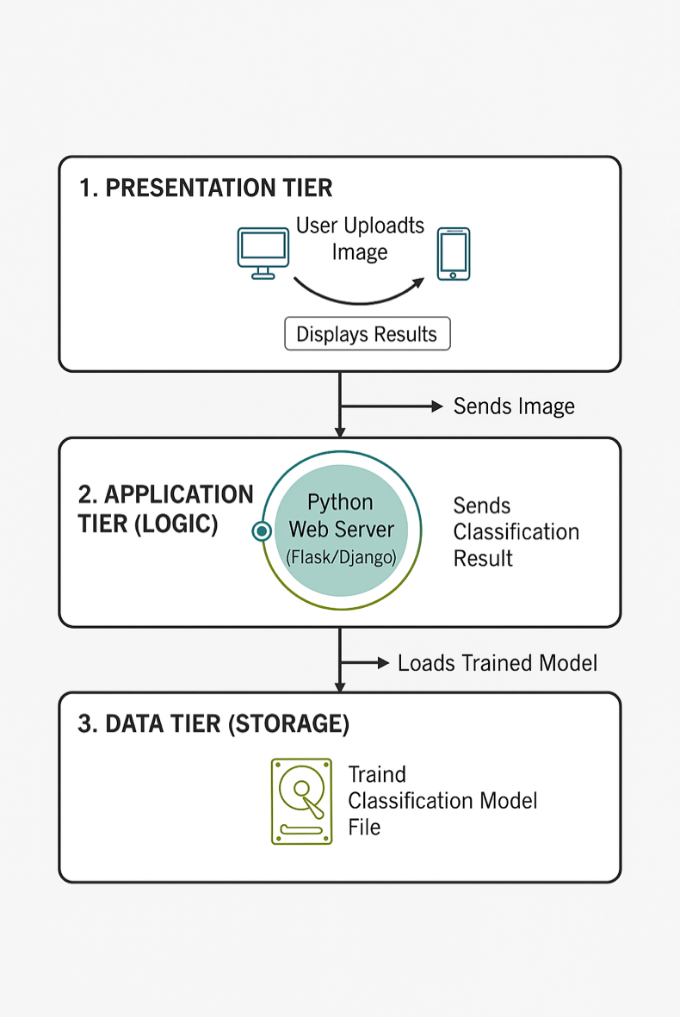

2.6 Dynamic Model: Sequence Diagrams

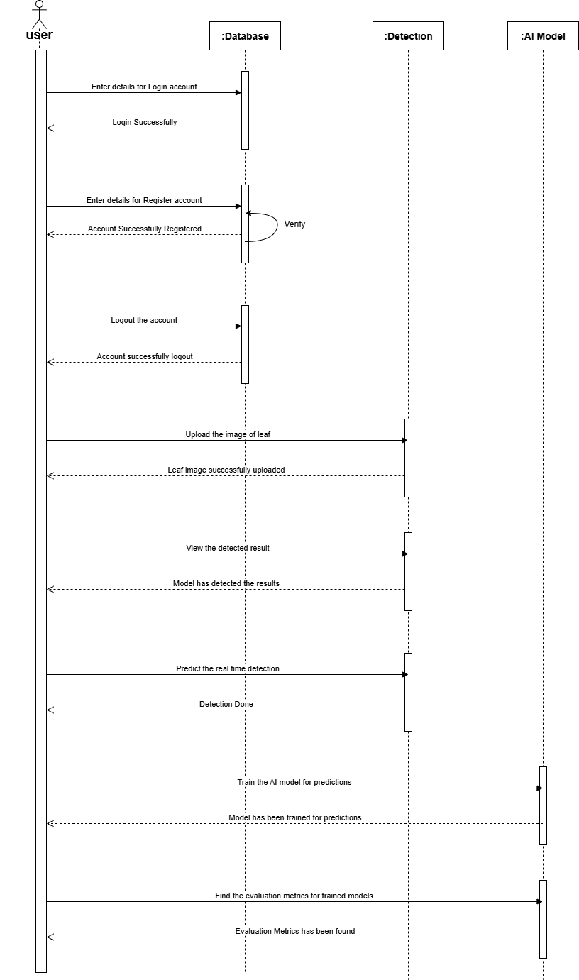

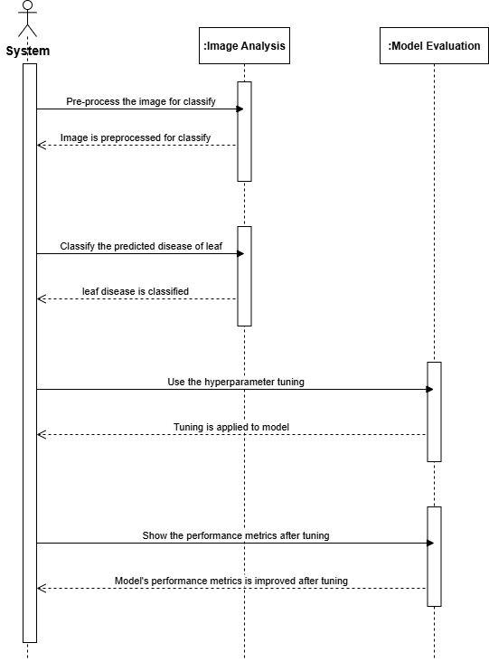

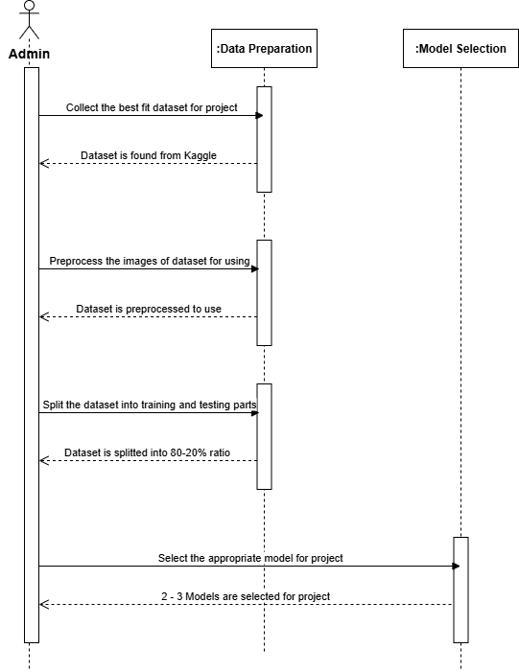

2.7 Object Model/Logical Model: Class Diagram

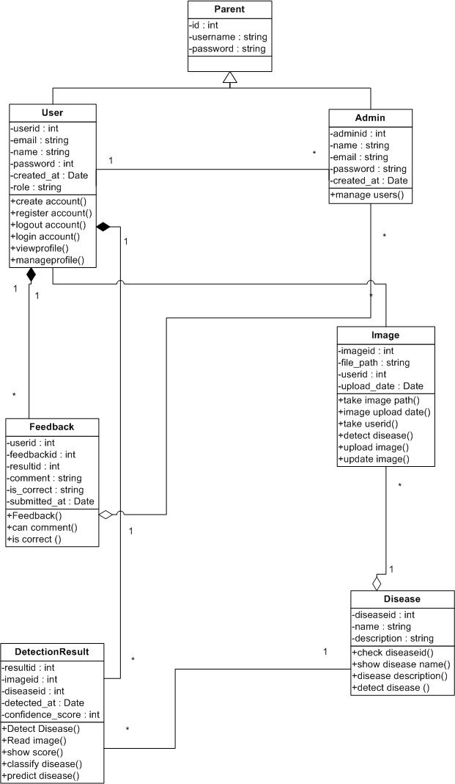

2.8 Database Model (Database Diagram)

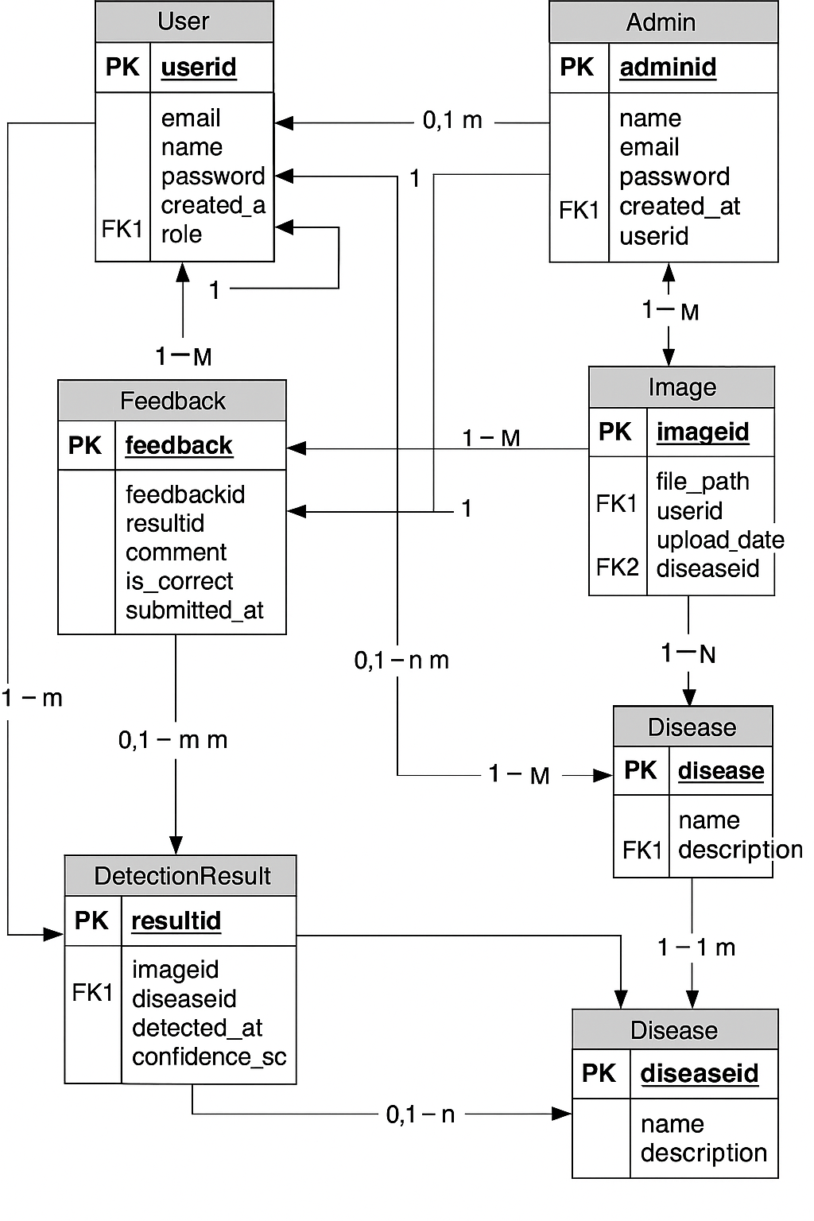

2.9 Graphical User Interfaces

Image upload Section

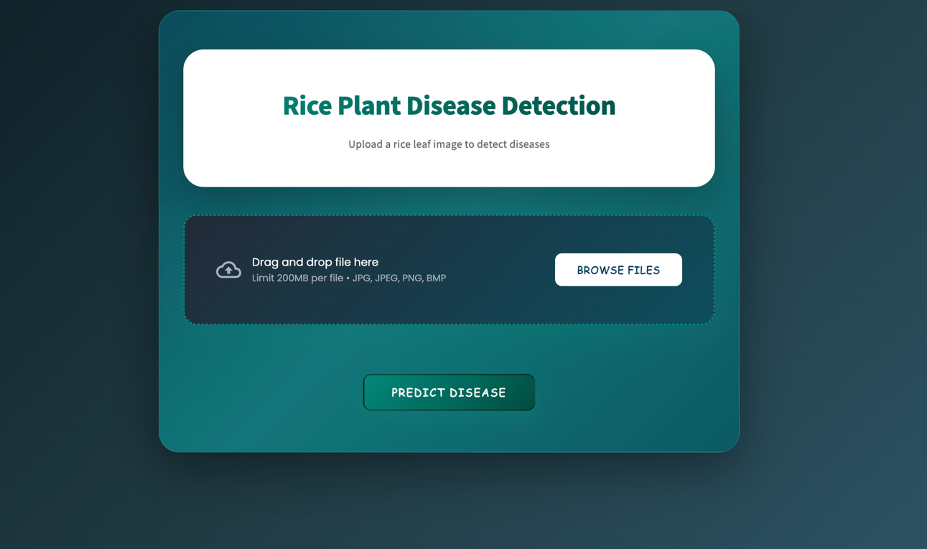

Image showing Interface

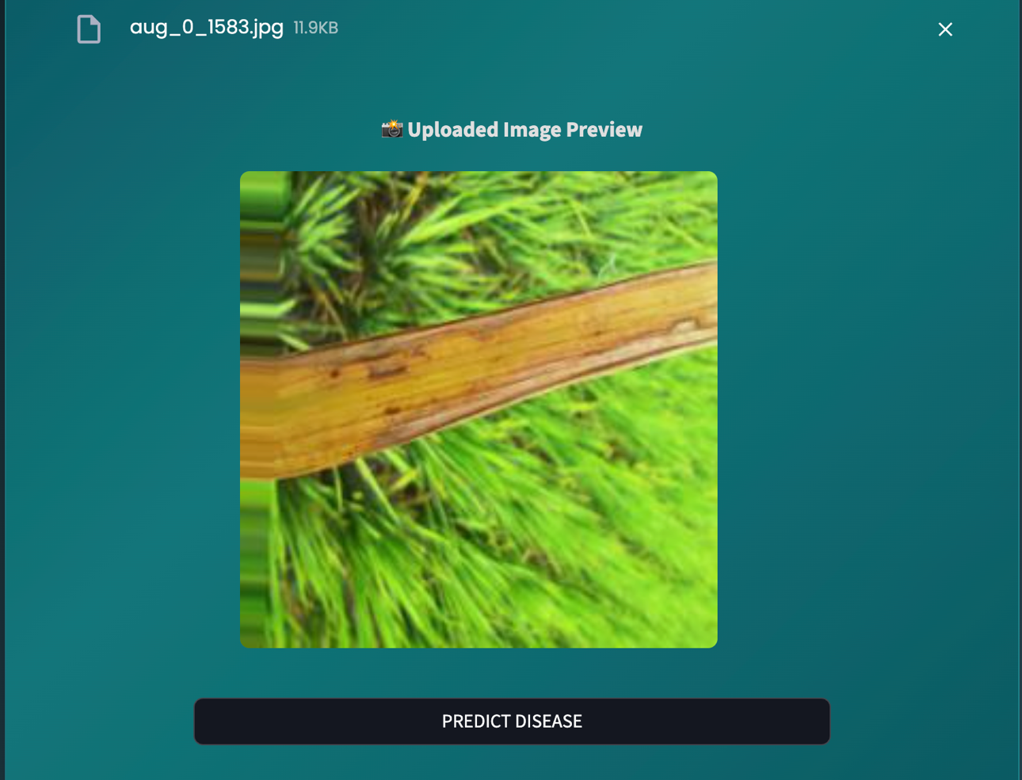
Disease Class show interface.

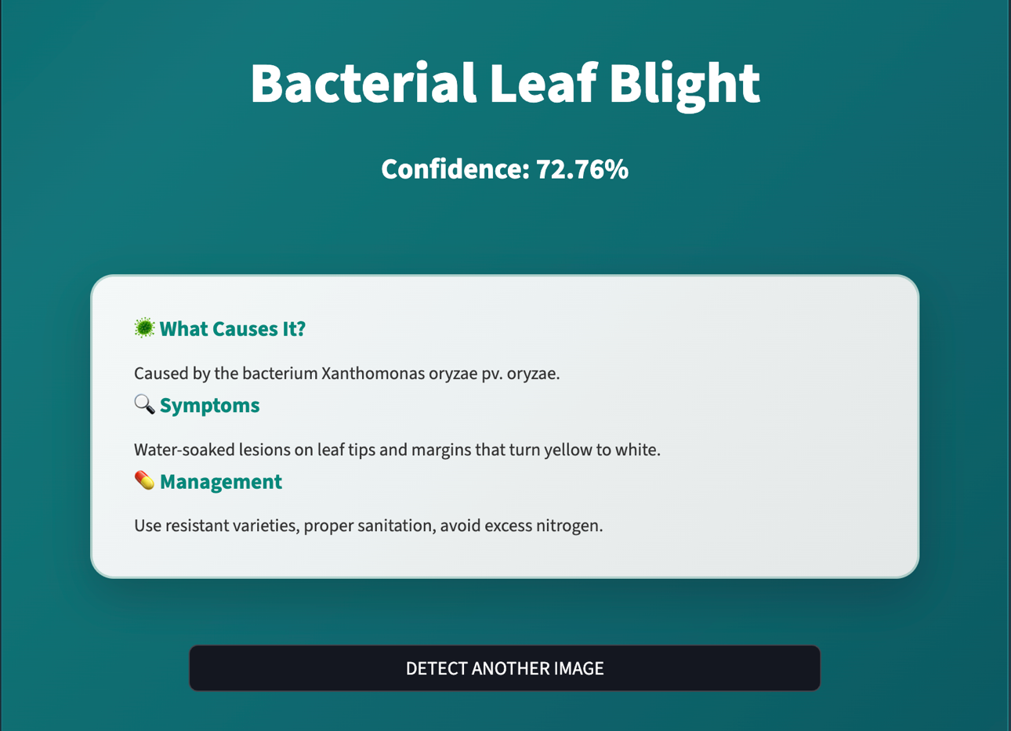

CHAPTER 3

Development

3.1 Deployment Plan (Architecture Diagram)



Development tools and technology

- Python
- TensorFlow / Keras
- OpenCV
- Google Colab
- Jupyter Notebook
- Visual Studio Code (VS Code)
- Streamlit
- Flask
- HTML / CSS / Bootstrap
- Microsoft Visio
- Microsoft Word
- Microsoft PowerPoint

REFERENCES

• Mohanty, S. P., Hughes, D. P., & Salathé, M. (2016). Using deep learning for image-based plant disease detection. Frontiers in Plant Science, 7, 1419. https://doi.org/10.3389/fpls.2016.01419
• Sladojevic, S., Arsenovic, M., Anderla, A., Culibrk, D., & Stefanovic, D. (2016). Deep neural networks-based recognition of plant diseases by leaf image classification. Computational Intelligence and Neuroscience, 2016. https://doi.org/10.1155/2016/3289801
• Ferentinos, K. P. (2018). Deep learning models for plant disease detection and diagnosis. Computers and Electronics in Agriculture, 145, 311-318. https://doi.org/10.1016/j.compag.2018.01.009
• TensorFlow Documentation. Image Classification using CNNs. Retrieved from: https://www.tensorflow.org/tutorials/images/classification
• OpenCV Documentation. Image processing with OpenCV in Python. Retrieved from: https://docs.opencv.org/
• Streamlit Documentation. Build and share beautiful apps using Python. Retrieved from: https://docs.streamlit.io/

- Cs403 book for database
- Cs605 book for methodologies
- Cs304 books for classes and class diagram

APPENDIX

CHAPTER 1 | Gathering and Analyzing Info
CHAPTER 2 | Designing the Project
CHAPTER 3 | Development

