UNIVERSITY OF ENGINEERING AND TECHNOLOGY
Department of Computer Science


Smart Prescription System
Software Engineering Project Report
Group Members
Umaima Hayat
Mian Abdul-Rafay
Rayyan Ahmed

Table of Contents
Contents
Table of Contents 2
1. Project Overview 3
2. Objectives 4
3. Project Scope 5
4. Tools and Technologies 6
5. System Actors 7
7.1 Patient 7
7.2 Doctor 7
6. Domain Model 8
7. Class Diagram: 9
8. Use Case Diagram 10
9. Use Case Descriptions & Diagrams 11
Use Case 01 — Manage Account 11
UC02 — Add Prescription 12
UC03 — Manage Medicine 13
UC04 — Schedule Medicine Reminder 14
UC05 — Receive Reminder Notification 15
UC06 — Confirm Medicine Intake 16
UC07 — View Dashboard 17
UC08 — Generate Medicine Report 18
UC09 — View Calendar Schedule 19
UC10 — View Daily Checklist 20
UC11 — View Missed Medicines 21
UC12 — Prescribe Medicine to Patient 22
UC13 — Send Prescription to Patient 23
UC14 — View Patient Record 24
10. Deployment Diagram 25
11. Package Diagram 26
12. Conclusion 27

1. Project Overview
The Smart Prescription System is a healthcare-based desktop application developed in Java to help patients manage their prescribed medicines efficiently. The system allows users to store prescription details, schedule medication reminders, and track medicine intake history. It provides automated alerts to ensure that patients take medicines on time and helps them maintain proper medication routines.
The application is developed using Java Swing/JavaFX for the graphical user interface and SQL for backend database storage. The system is designed using object-oriented programming principles to ensure modularity, scalability, and maintainability.

2. Objectives
The main objectives of this project are:
- To develop a user-friendly prescription reminder system using Java.
- To store and manage patient, medicine, and prescription data using SQL/Oracle.
- To generate automated reminders based on prescription schedules.
- To allow users to record whether medicines were taken or missed.
- To generate weekly/monthly adherence reports for monitoring medication activity.
- To implement proper object-oriented design for a structured and extensible system.

3. Project Scope
The project scope includes the following features:
- User registration and login authentication for both Patients and Doctors.
- Add, update, delete, and view prescriptions and medicines.
- Scheduling reminders based on prescribed dosage timings and days of week.
- GUI-based notification pop-ups for reminder alerts.
- Maintaining medicine intake history (taken/missed).
- Weekly and monthly report generation for adherence tracking.
- Calendar view to see scheduled medicines per day.
- Daily checklist to manually track intake.
- Doctor functionality: prescribe medicine, send prescription, view patient records.
The system is limited to a desktop environment but may be extended in the future for mobile or web-based integration.

4. Tools and Technologies

Component | Technology / Tool
Programming Language | Java
GUI Framework | Java Swing / JavaFX
Database | SQL
IDE | Eclipse
Database Tools | MySQL Workbench
Design Approach | Object-Oriented Programming (OOP)
Documentation | UML Diagrams (Use Case, Class, Sequence)

5. System Actors

7.1 Patient
The Patient is the primary user of the system. Patients can register and log in, manage their prescriptions and medicines, schedule reminders, confirm medicine intake, view their dashboard, daily checklist, calendar, missed medicines, and generate adherence reports.

7.2 Doctor
The Doctor is a secondary actor who can log in to prescribe medicines to patients, send prescriptions, and view patient records including their prescription history and intake compliance.

6. Domain Model
The domain model below illustrates the key entities in the Smart Prescription System and their relationships. It includes Patient, Doctor, Prescription, Medicine, Reminder, IntakeLog, Notification, and Report entities.

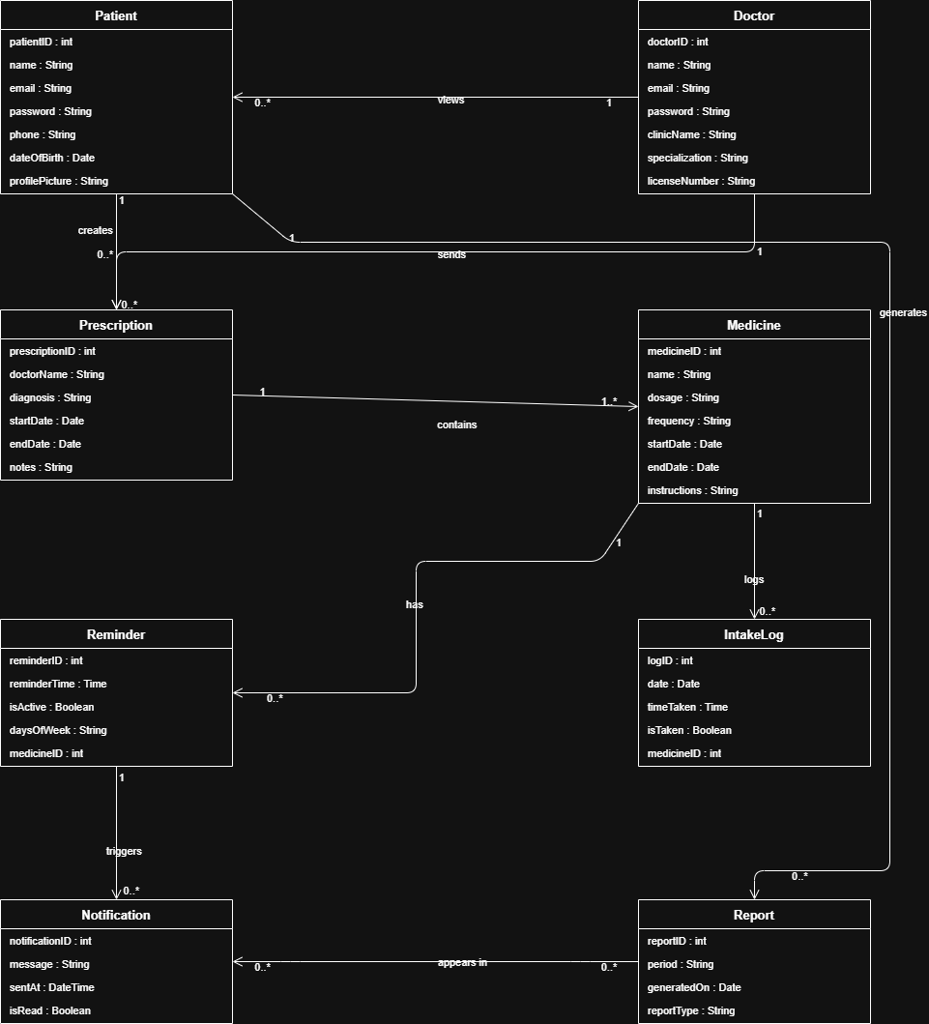
Figure: Domain Model – Smart Prescription System

7. Class Diagram:
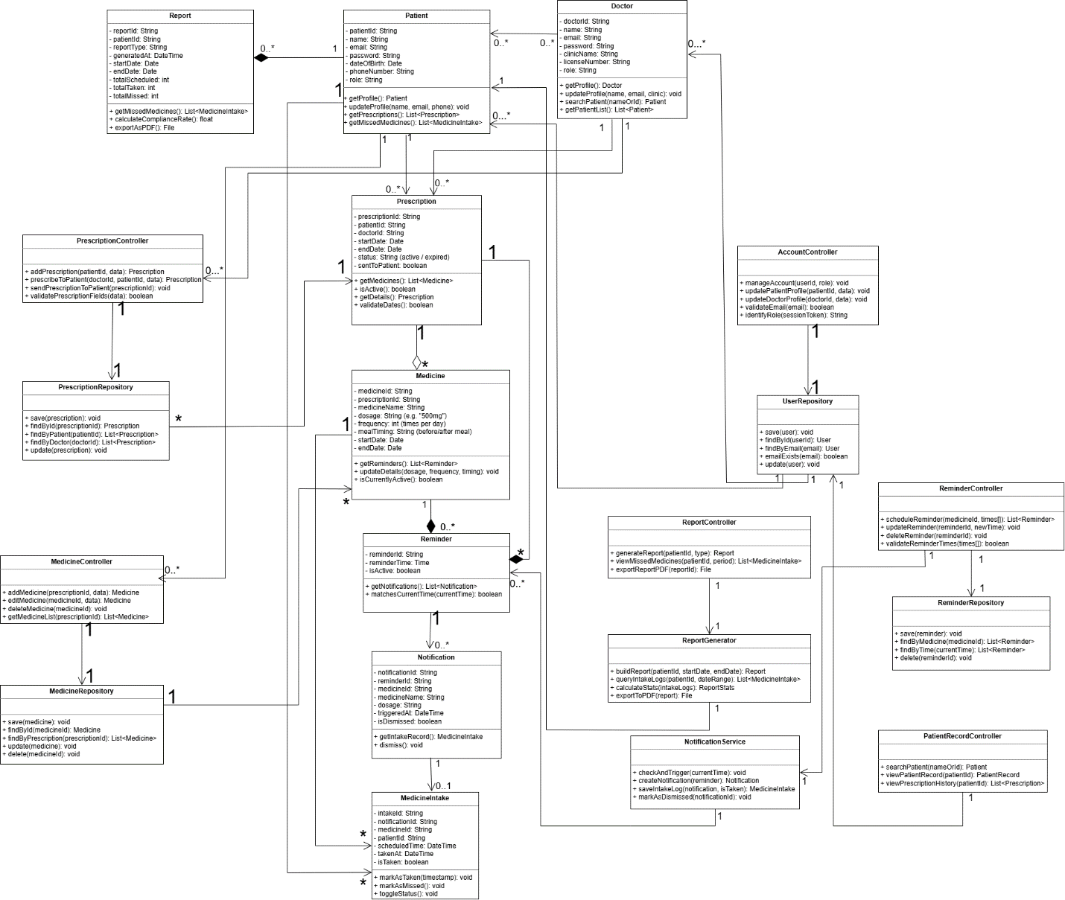

8. Use Case Diagram
The use case diagram below provides an overview of all system interactions.
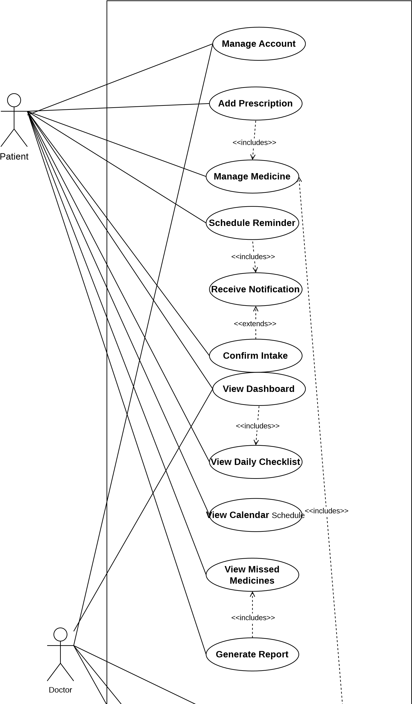
Prescribe Medicine
to Patient
View Patient Record
Send Prescription to
Patient

9. Use Case Descriptions & Diagrams
This section provides a detailed fully-dressed description for each of the 14 use cases, along with their System Sequence Diagrams (SSDs) and detailed sequence diagrams.

Use Case 01 — Manage Account
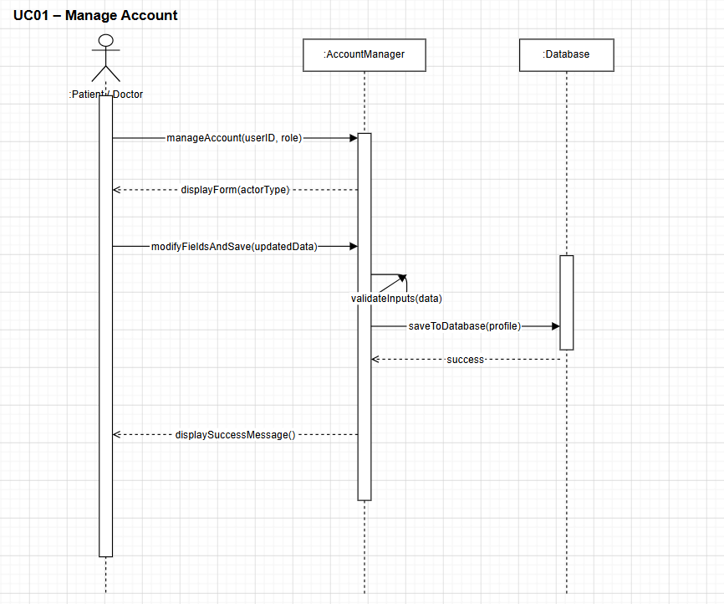
Figure: Use Case 01 — Manage Account | Detailed Sequence Diagram

UC02 — Add Prescription
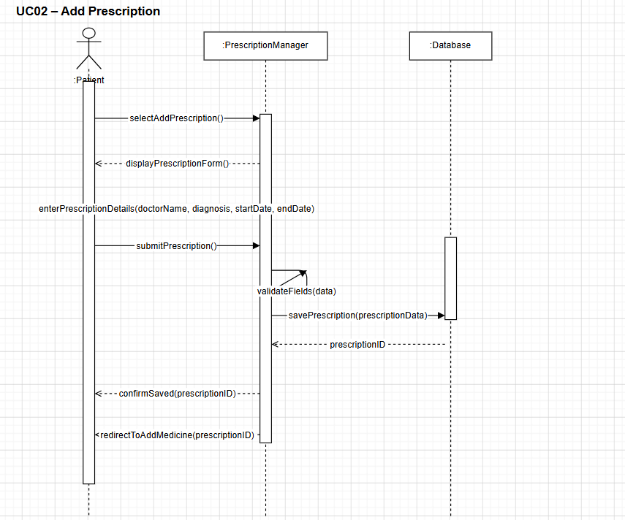
Figure: UC02 — Add Prescription | Detailed Sequence Diagram

UC03 — Manage Medicine

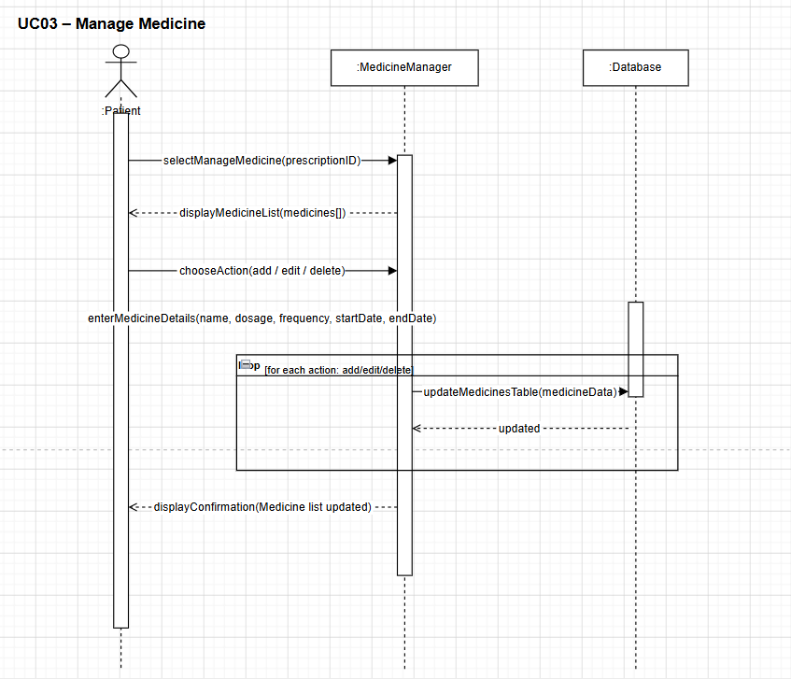
Figure: UC03 — Manage Medicine | Detailed Sequence Diagram

UC04 — Schedule Medicine Reminder

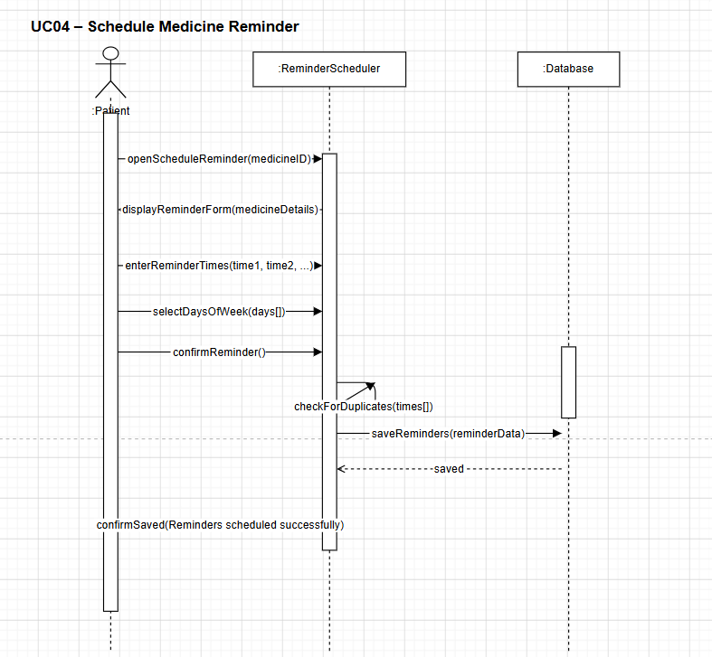
Figure: UC04 — Schedule Medicine Reminder | Detailed Sequence Diagram

UC05 — Receive Reminder Notification

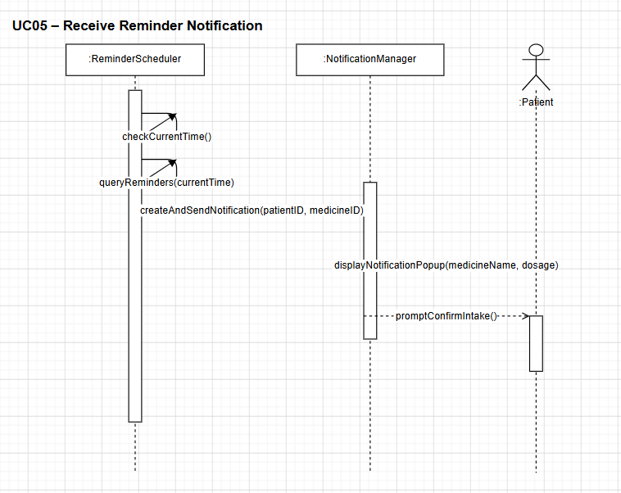
Figure: UC05 — Receive Reminder Notification | Detailed Sequence Diagram

UC06 — Confirm Medicine Intake

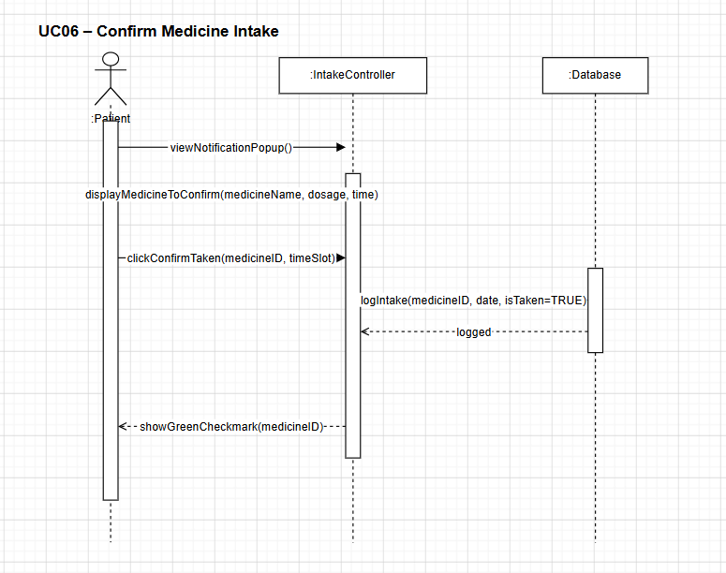
Figure: UC06 — Confirm Medicine Intake | Detailed Sequence Diagram

UC07 — View Dashboard

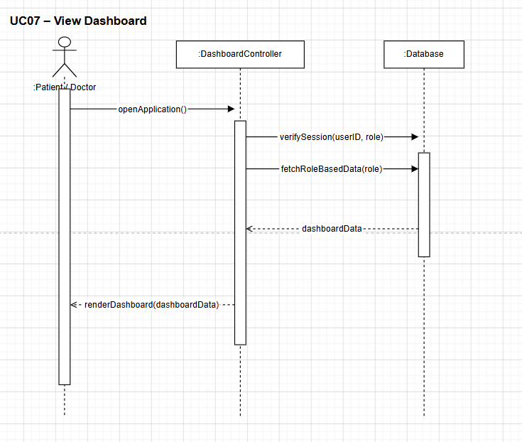
Figure: UC07 — View Dashboard | Detailed Sequence Diagram

UC08 — Generate Medicine Report

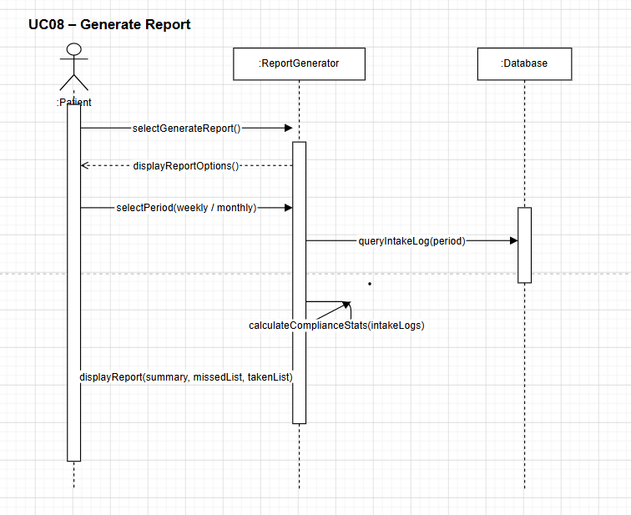
Figure: UC08 — Generate Medicine Report | Detailed Sequence Diagram

UC09 — View Calendar Schedule

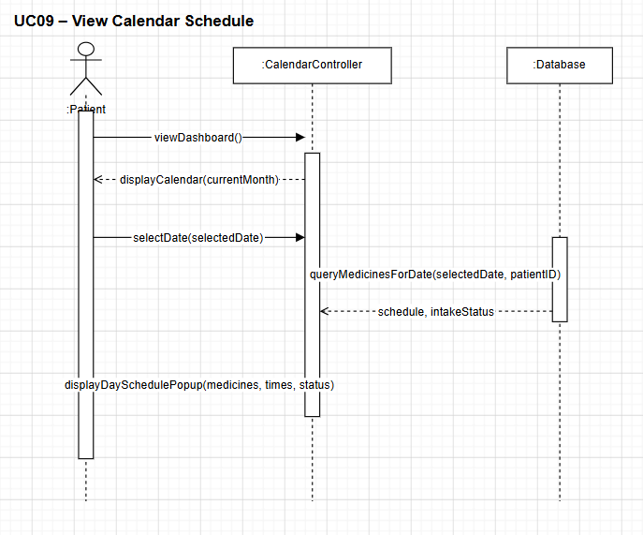
Figure: UC09 — View Calendar Schedule | Detailed Sequence Diagram

UC10 — View Daily Checklist

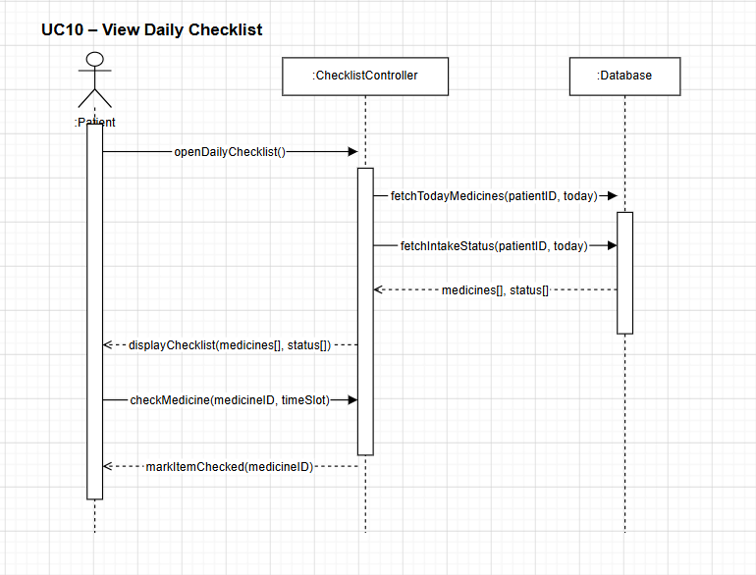
Figure: UC10 — View Daily Checklist | Detailed Sequence Diagram

UC11 — View Missed Medicines

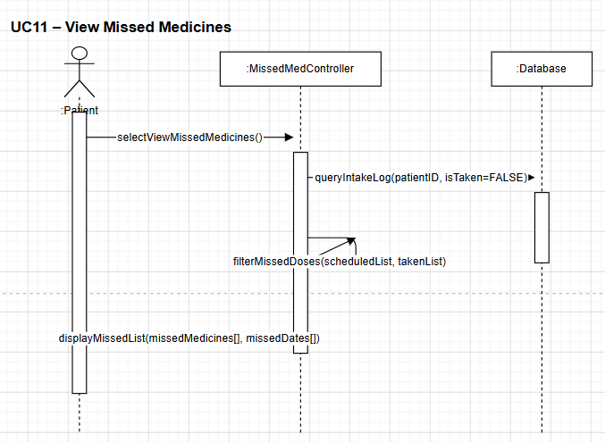
Figure: UC11 — View Missed Medicines | Detailed Sequence Diagram

UC12 — Prescribe Medicine to Patient

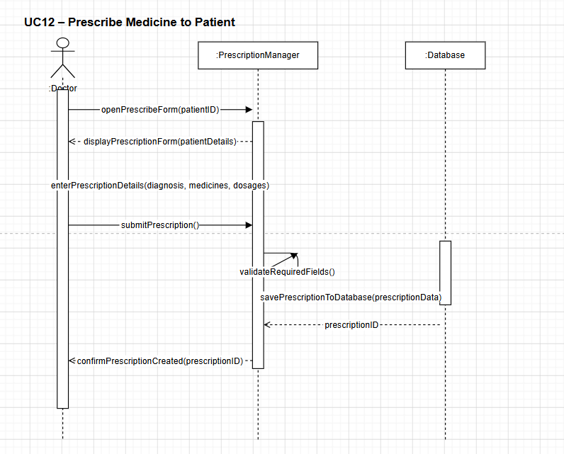
Figure: UC12 — Prescribe Medicine to Patient | Detailed Sequence Diagram

UC13 — Send Prescription to Patient

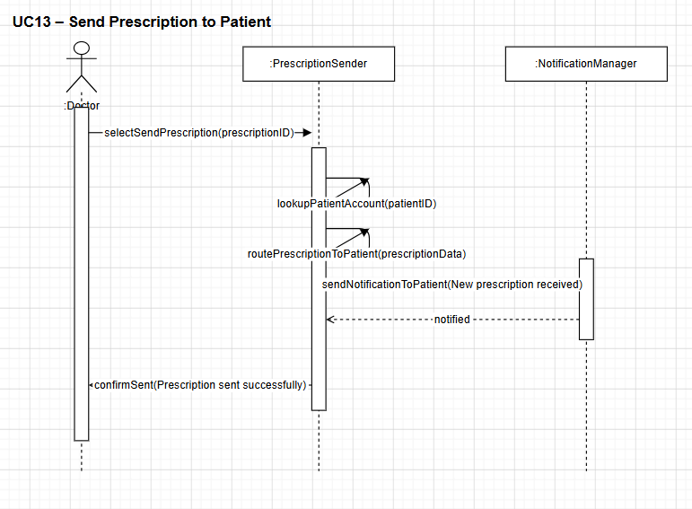
Figure: UC13 — Send Prescription to Patient | Detailed Sequence Diagram

UC14 — View Patient Record

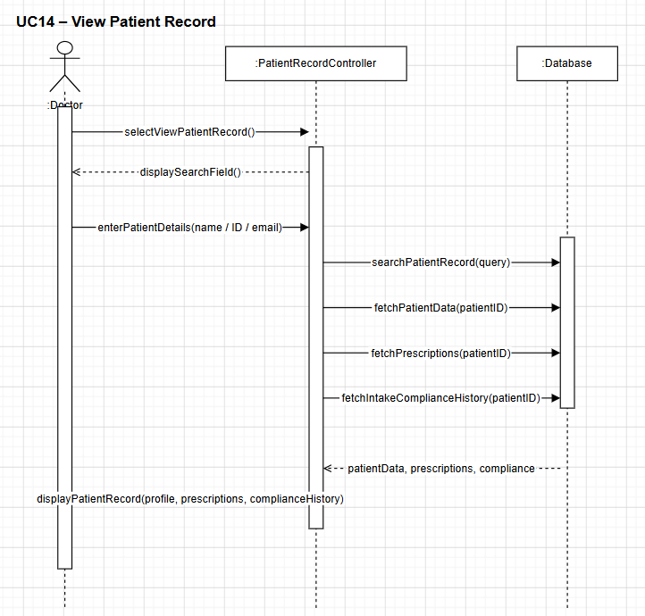
Figure: UC14 — View Patient Record | Detailed Sequence Diagram

10. Deployment Diagram

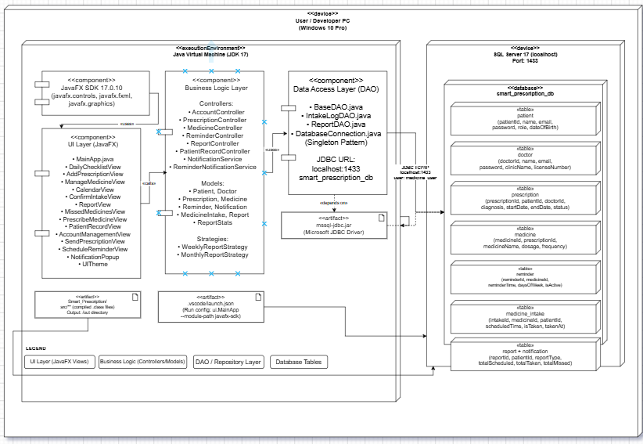

11. Package Diagram

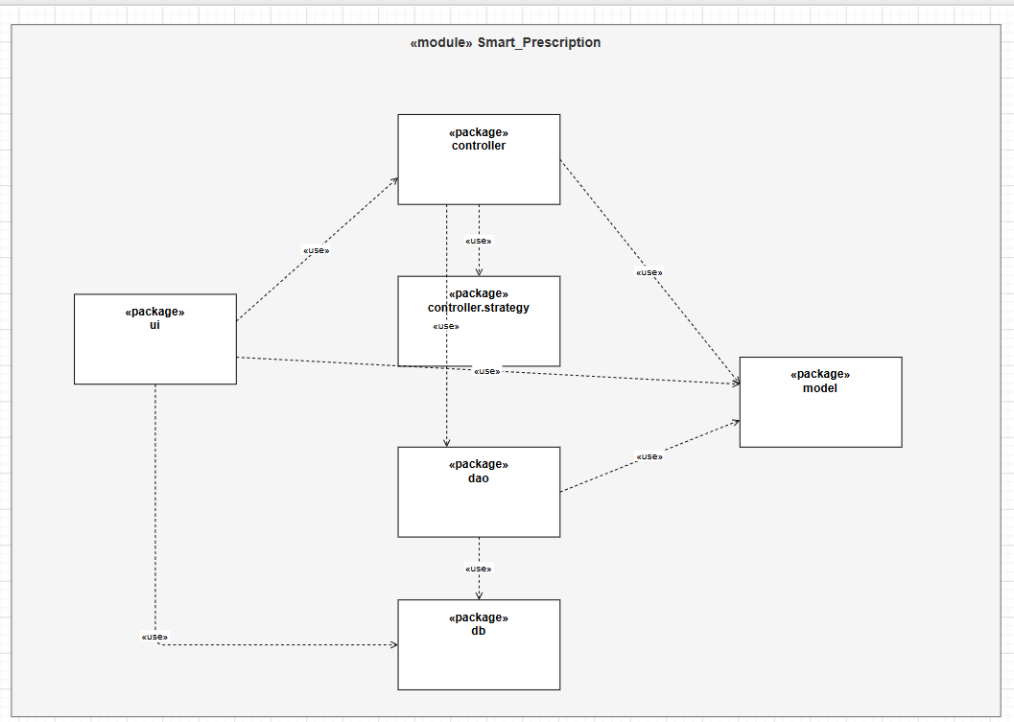

12. Conclusion
The Smart Prescription System addresses a critical need in healthcare — helping patients maintain consistent medication schedules. By combining automated reminders, a structured prescription management interface, an intake logging mechanism, and comprehensive reporting, the system provides a complete solution for medication adherence.
The system is designed with a clear separation of concerns using object-oriented principles, with dedicated controllers and managers for each major function. This modularity ensures the system is maintainable and extensible.
Future enhancements could include mobile application support, integration with electronic health record (EHR) systems, and cloud-based data synchronization for real-time access by healthcare providers.

