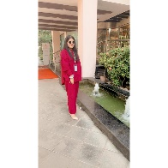



Umm- e-

uU

UMMAIMA

CREATIVE DESIGNER

I am a website Developer

with 2 years of experience project

and

computer aided design. Proven ability to

transform client ideas into beautiful,

functional design solutions.

EDUCATION

BSCS Computer Science

ACCP Prime 2.0 Software

PAF KIET UNIVERSITRY

APTECH LEARNING CENTER

MYSQL

CONTACT

SKILLS

03142030662

Umaimamahmood28@gmail.com

https://www.linkedin.com/in/umaima-mahmood-4a9126290/

HTML

Bootstrap

CSS

PHP

JAVASCRIPPT

MVC.NET

Flutter

Git

Figma