LAB Logbook

Lab 1

**Write one sentence each for any of the five Pandas classes you find interesting.**

**1. pandas.DataFrame:** The most widely used class for managing tabular data is a two-dimensional, labelled data structure with columns of perhaps various sorts.

**2. pandas.Series:** An object containing labels that resembles a one-dimensional array that is frequently used to handle a single dataset row or column.

**3. pandas.Index:** Supports effective lookups and alignment operations by providing DataFrame and Series objects an unchanging pattern of labels.

**4. pandas.Timestamp:** Combines robust datetime operations with date and time functionalities to represent a single point in time.

**5. pandas.Categorical:** Improves performance and memory use by handling categorical data efficiently by storing discrete values with a set number of categories.

Lab 2

**Record the guess you made for the cost of a slightly larger house with a size of SID*0.75. Don't worry if your guess is incorrect.**

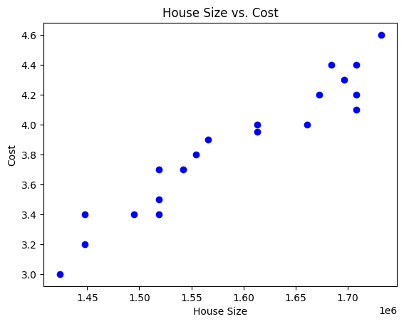

Lab 3

**Plot of anomalies using Z-score and IQR methods.**

**Z-Score:**

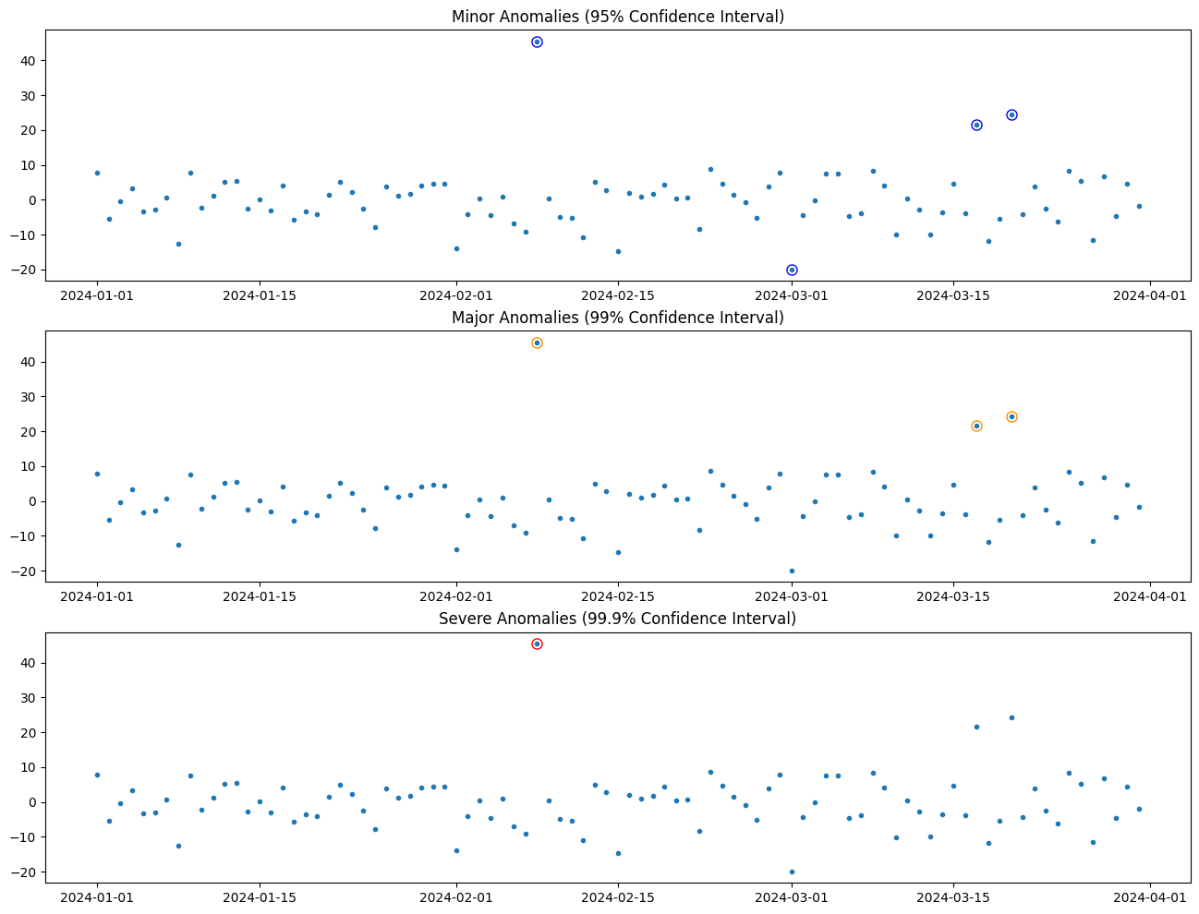

**IQR:**

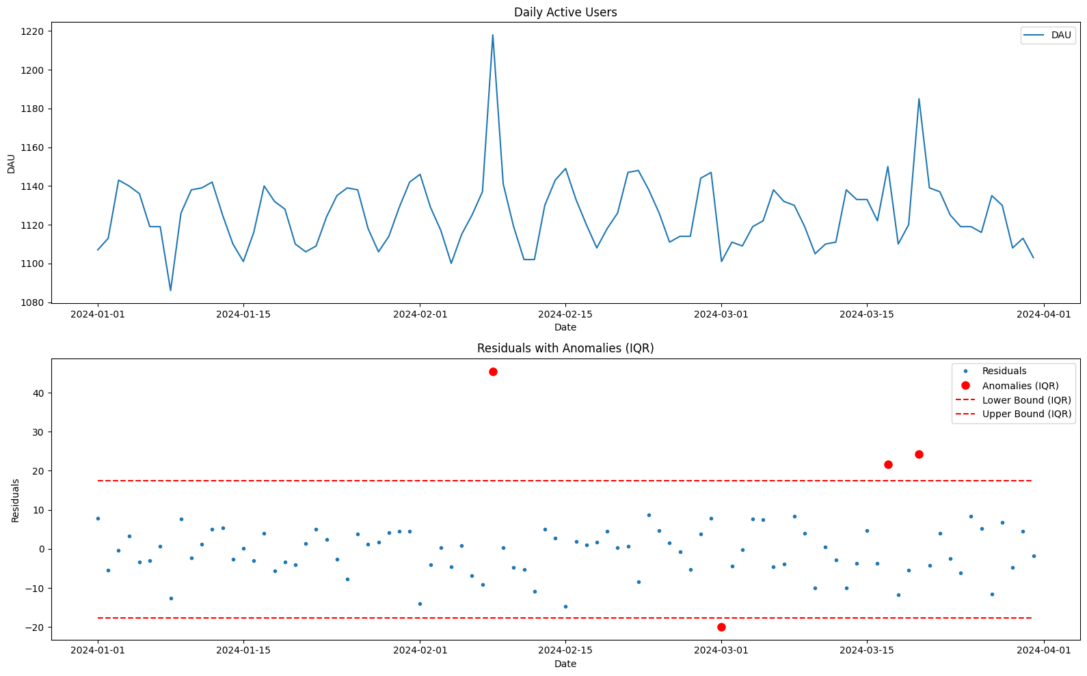

Lab 4

**Plot a graph showing the model's accuracy for each epsilon value. The model accuracy before and after data poisoning.**

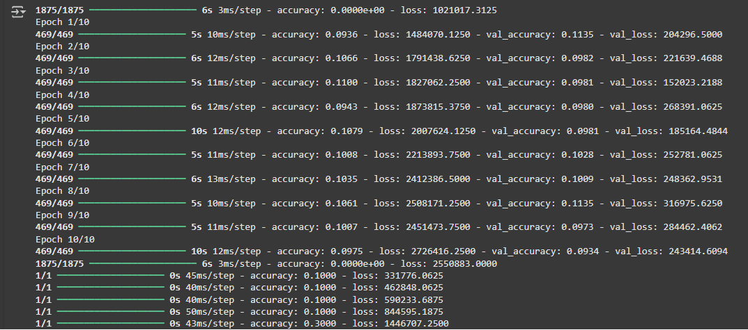

**Model accuracy Plot:**

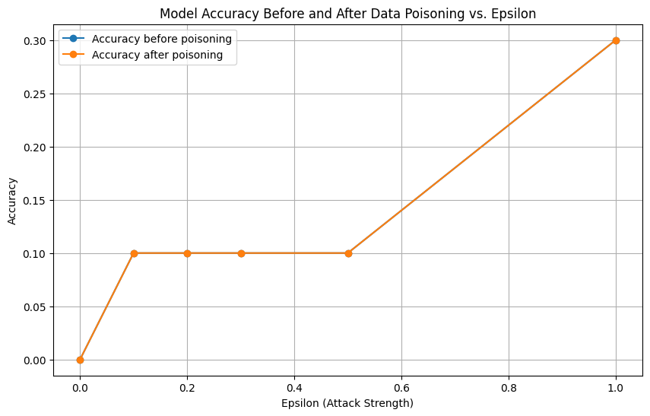

Lab 5

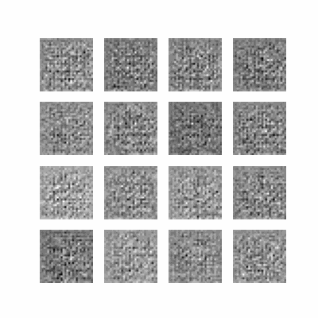SID is 2372735. SO, EPOCHS = 35

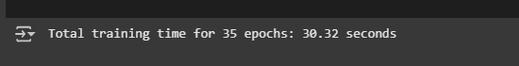

Lab 6

Lab 7

Lab 8

Lab 9

Lab 10

Lab 11

Lab 12