LAB Logbook

Lab 1

# Lab Logbook Requirement:

### *1) Create a vector using np.arange.*

***Determine the number of the vector elements using the following method: Take the last two digits from your SID. It should be from 00 to 99. If this number is 10 or more, it becomes the required number of the vector elements. If it is less than 10, add 100 to your number.***

***For example, if your SID is 2287467, and the last two digits are 67, which is greater than 10. The required number is 67. If your SID is 2287407, and the last two digits are 07, which is less than 10. The required number is 107.***

***Then,***

### *Change matrix a to 2-d array with 1 row. Print the array. You should have the two sets of brackets for a 2-d array with one row.*

### *Save it in another array. Print the array.*

### *Check the shape attribute value.*

### *Solution:*

### Lab 2

**Lab Logbook Requirement:[¶](http://localhost:8889/notebooks/Machine%20Learning%20in%20Finance/Week-2-Pandas-Introduction_ML_in-Finance_Final-1.ipynb?" \l "Lab-Logbook-Requirement:" \t "_self)**

1. ***Determine a number (n) equal to the last digit of your SID.***
2. ***Group by "relationship" and "hours-per-week".***
3. ***Reduce all "hours-per-week" column values ​​in the original DataFrame by the value 'n'.***
4. ***Group ​​by "relationship" and reduced "hours-per-week".***

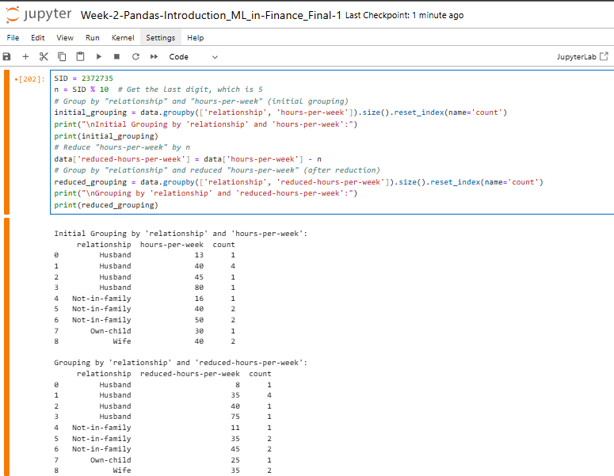***Solution:***

Lab 3

# Lab Logbook Requirement:

### *1) Draw a bicolour features interaction diagram between the columns with the numbers of the last and second to last digits of your SID, where:*

### C:\Users\SMART TECH\AppData\Local\Microsoft\Windows\INetCache\Content.MSO\257D386D.tmp

### *Solution:*

Lab 4

# Lab Logbook Requirement:

### *Create your own Multi-layer Perceptron (MLP) with two hidden layers, where the first hidden layer cells' number equals the last three digits of your SID. The number of cells in the next hidden layer is approximately two times smaller. For example, if your SID is 2287167, the number of cells on the first hidden layer is 167, and on the second - 84. Take epochs=10. Leave other parameters the same as in the practical session.*

### *Compile the model.*

### *Train your MLP with the same datasets and demonstrate the received MAE.*

### *Compare your MAE with the MAE of the MLP in the practical session.*

### *Please only add to your Lab Logbook a print-screen of your MLP architecture using model.summary() and the resulting MAE.*

### *Solution:*

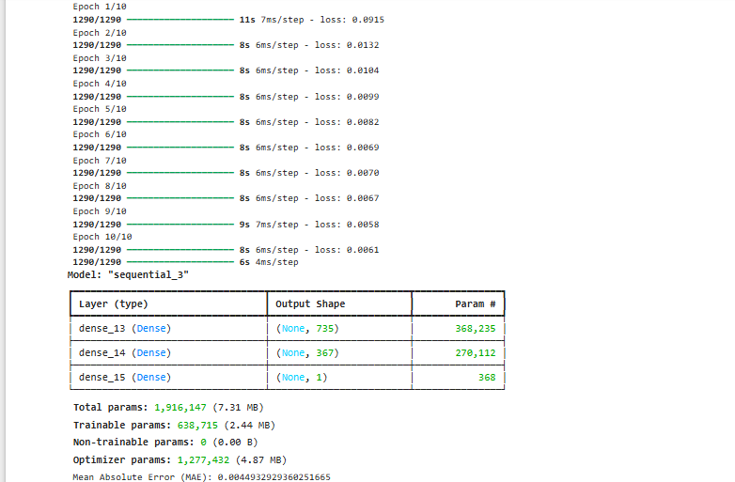

Lab 5

# Lab Logbook Requirement:

1. ***Modify the practical session CNN model by reducing the convolutional core size to 5.***
2. ***Change the batch\_size to 50.***
3. ***Also, change the size of the number of epochs, which is calculated by the formula:***

***Z + Y, if Z = 0***

***10 + Y, if Z = 0 and Y is not 0***

***10, if Z = Y = 0***

***, where your SID is: XXXXXZY***

1. ***Leave other parameters the same as in the practical session.***
2. ***Compile the model.***
3. ***Train your CNN with the same datasets and demonstrate the received test MAE. Compare your MAE with the MAE of the CNN in the practical session.***
4. ***Please only add a print-screen of your CNN architecture using model.summary() and the resulting MAE to your Lab Logbook.***

*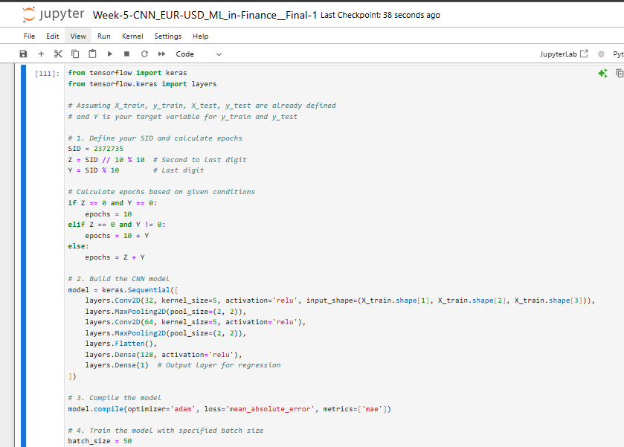Solution:*

*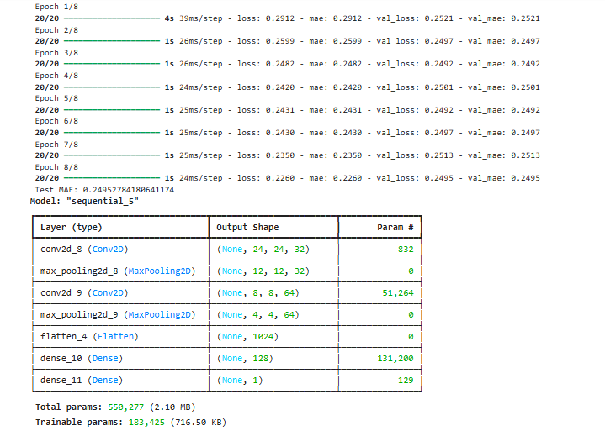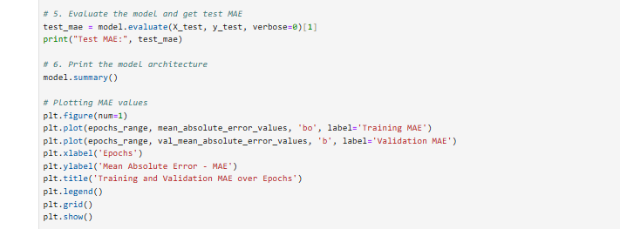*

*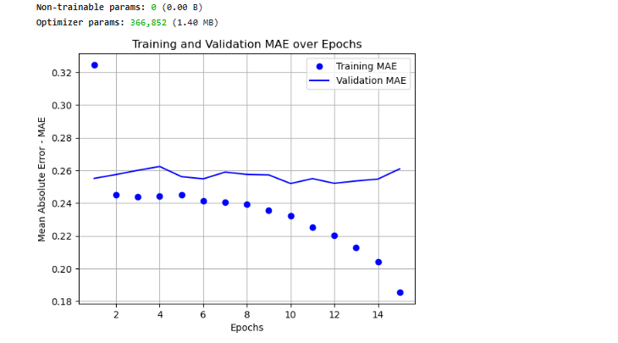*

Lab 6

Lab 7

Lab 8

Lab 9

Lab 10

Lab 11

Lab 12