

**Name: Syed Umair Andrabi**

**Reg No: 22MCB0015**

**Subject: Social Network Analysis**

**ASSIGNMENT 1**

**Question 1:**

Given edge_list.csv, generate directed and undirected graphs.

**Input**:

src,dst,weight

A,B,5.0

B,C,2.0

C,D,7.5

D,E,1.2

A,E,4.6

B,F,3.0

C,G,6.4

D,H,8.1

E,I,2.3

F,G,4.8

**Output:**

Adjacency matrix

[[0. 5. 4.6 0. 0. 0. 0. 0. 0. ]

[0. 0. 0. 0. 0. 3. 0. 2. 0. ]

[0. 0. 0. 2.3 0. 0. 0. 0. 0. ]

[0. 0. 0. 0. 0. 0. 0. 0. 0. ]

[0. 0. 0. 0. 0. 0. 0. 0. 0. ]

[0. 0. 0. 0. 4.8 0. 0. 0. 0. ]

[0. 0. 0. 0. 0. 0. 0. 0. 0. ]

[0. 0. 0. 0. 6.4 0. 0. 0. 7.5]

[0. 0. 1.2 0. 0. 0. 8.1 0. 0. ]]

Undirected graph plot

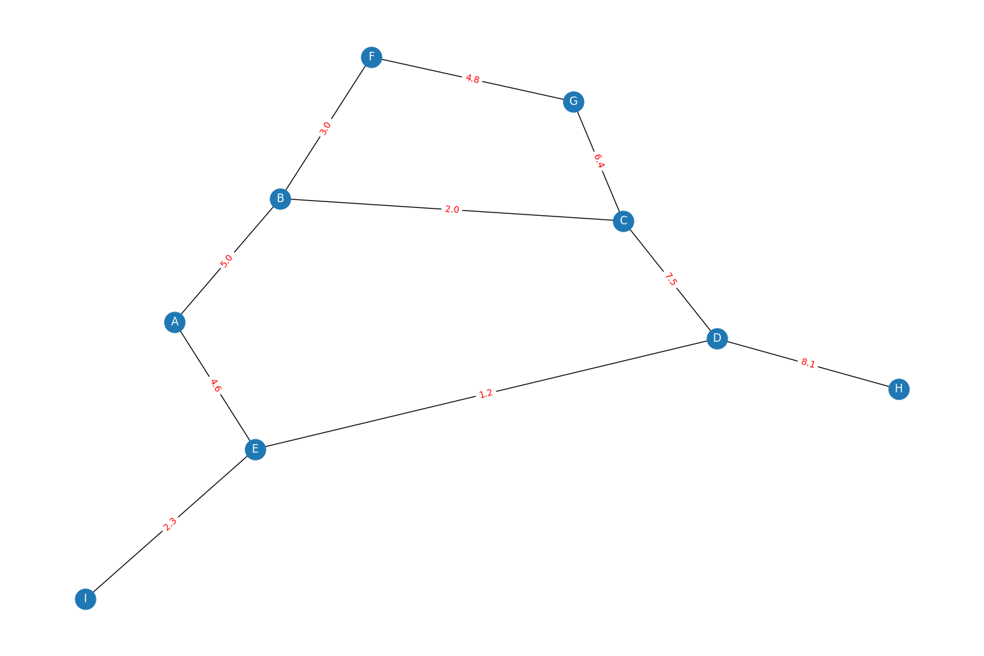

Directed graph plot

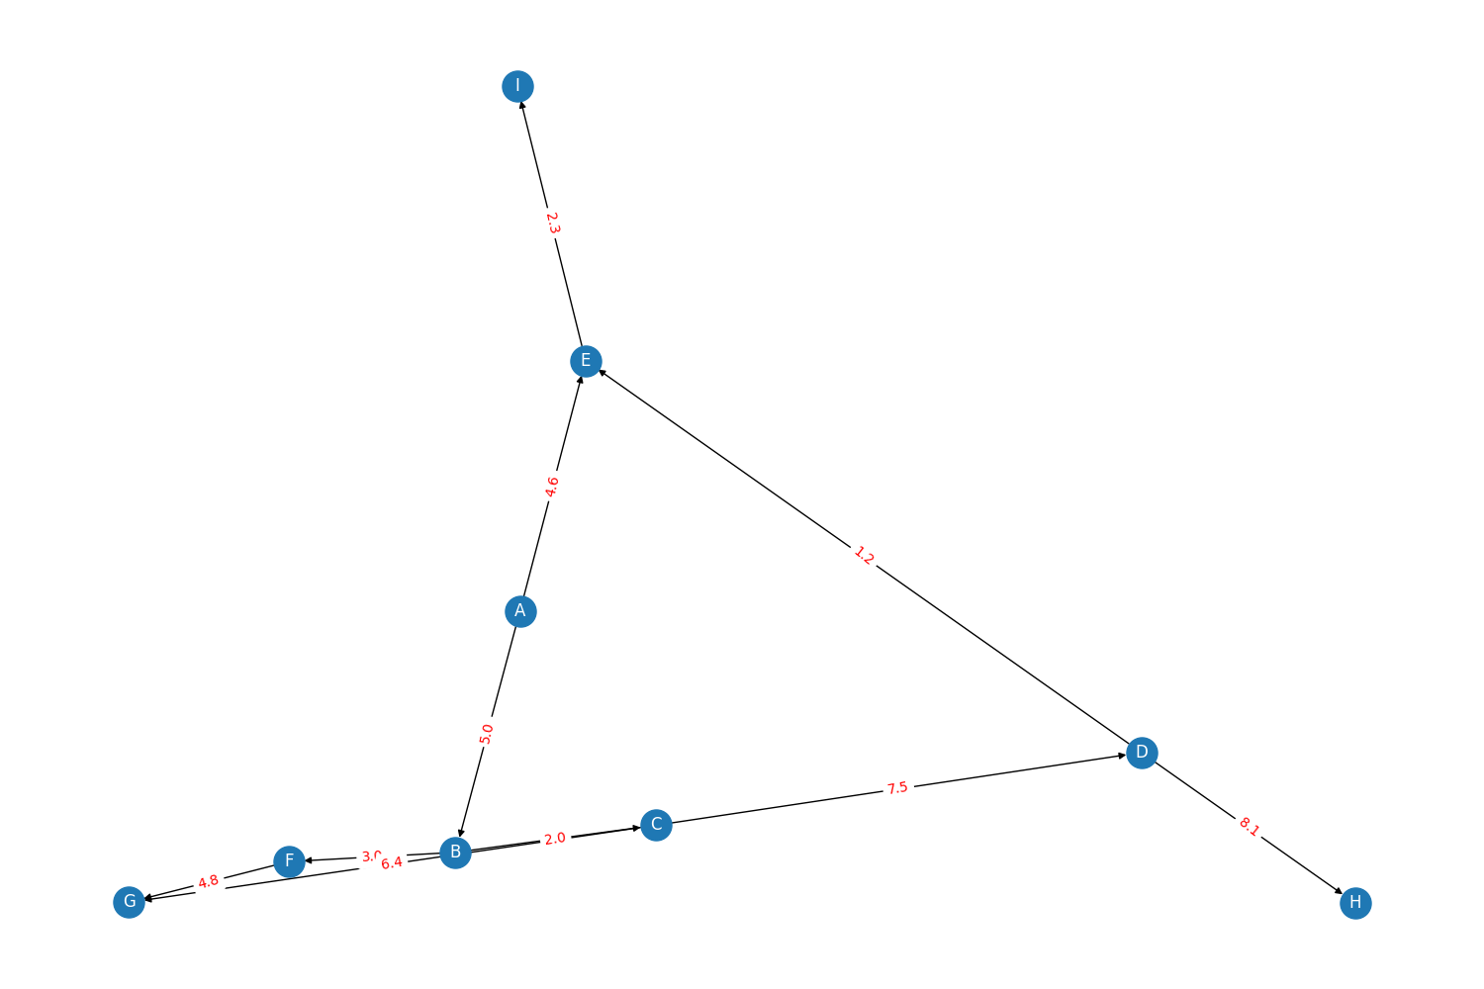

**Question 2:**

**For undirected graph:**

Print number of nodes, number of edges, nodes with max degree, nodes with min degree.

1. Number of nodes and edges:

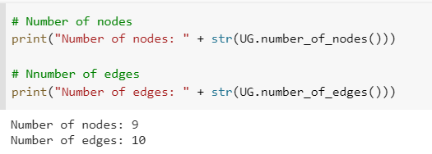

1. Nodes with max degree and min degree

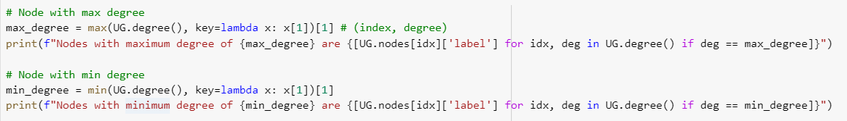

Output:

Nodes with maximum degree of 3 are ['B', 'E', 'C', 'D']

Nodes with minimum degree of 1 are ['I', 'H']

**For directed graph:**

Print number of nodes, number of edges, nodes with max out-degree, nodes with min out-degree, nodes with max in-degree, nodes with min in-degree.

1. Number of nodes and edges:

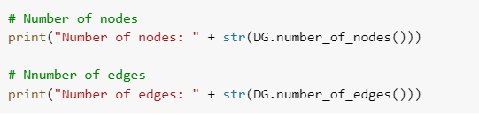

OUTPUT

Number of nodes: 9

Number of edges: 10

1. Nodes with min and max in-degree

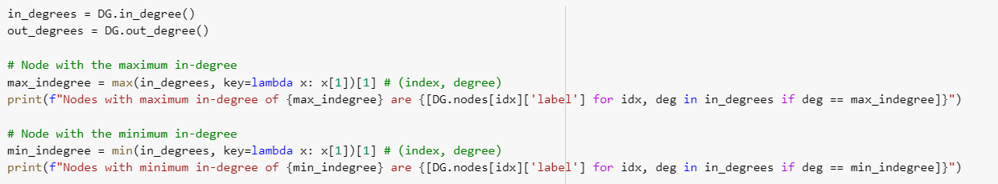

OUTPUT

Nodes with maximum in-degree of 2 are ['E', 'G']

Nodes with minimum in-degree of 0 are ['A']

1. Nodes with min and max out-degree

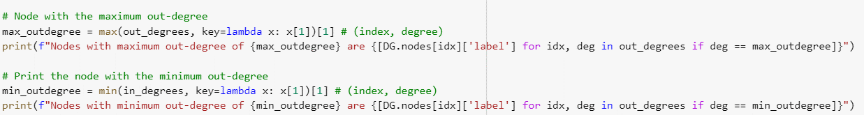

OUTPUT:

Nodes with maximum out-degree of 2 are ['A', 'B', 'C', 'D']

Nodes with minimum out-degree of 0 are ['I', 'G', 'H']

**Question 3:**

**For undirected graph:**

Print sum of all weights of