**LAB # 04**

**HOME ASSIGNMENT**

## **About Dataset**

This data set contains 13 clinicopathologic features aiming to predict recurrence of well differentiated thyroid cancer. The data set was collected in duration of 15 years and each patient was followed for at least 10 years.

**Source**  
The data was procured from [thyroid disease datasets](http://archive.ics.uci.edu/dataset/915/differentiated+thyroid+cancer+recurrence) provided by the UCI Machine Learning Repository.

**Content**  
The size for the file featured within this Kaggle dataset is shown below — along with a list of attributes, and their description summaries:

1. Age: The age of the patient at the time of diagnosis or treatment.
2. Gender: The gender of the patient (male or female).
3. Smoking: Whether the patient is a smoker or not.
4. Hx Smoking: Smoking history of the patient (e.g., whether they have ever smoked).
5. Hx Radiotherapy: History of radiotherapy treatment for any condition.
6. Thyroid Function: The status of thyroid function, possibly indicating if there are any abnormalities.
7. Physical Examination: Findings from a physical examination of the patient, which may include palpation of the thyroid gland and surrounding structures.
8. Adenopathy: Presence or absence of enlarged lymph nodes (adenopathy) in the neck region.
9. Pathology: Specific types of thyroid cancer as determined by pathology examination of biopsy samples.
10. Focality: Whether the cancer is unifocal (limited to one location) or multifocal (present in multiple locations).
11. Risk: The risk category of the cancer based on various factors, such as tumor size, extent of spread, and histological type.
12. T: Tumor classification based on its size and extent of invasion into nearby structures.
13. N: Nodal classification indicating the involvement of lymph nodes.
14. M: Metastasis classification indicating the presence or absence of distant metastases.
15. Stage: The overall stage of the cancer, typically determined by combining T, N, and M classifications.
16. Response: Response to treatment, indicating whether the cancer responded positively, negatively, or remained stable after treatment.
17. Recurred: Indicates whether the cancer has recurred after initial treatment.

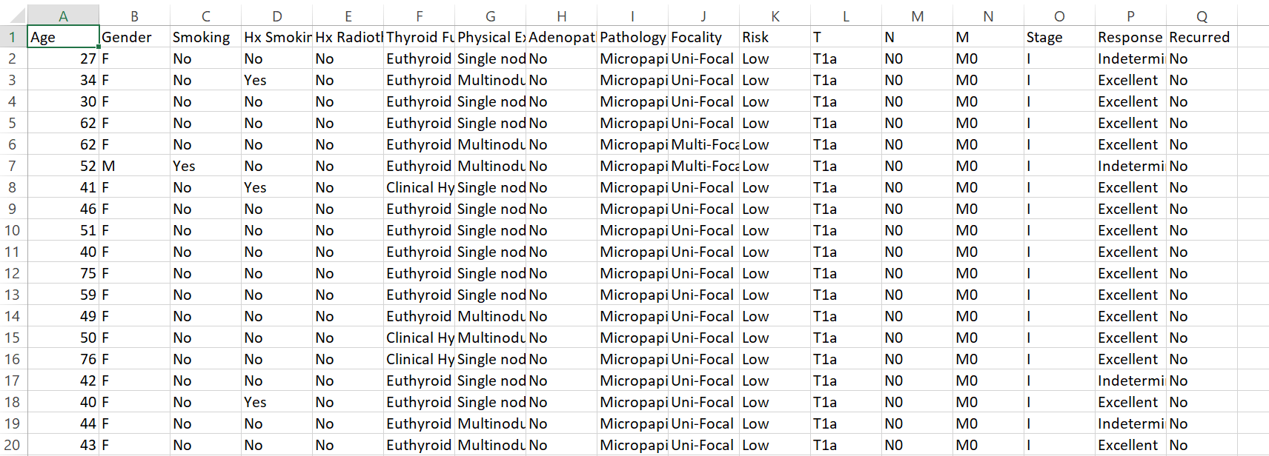

**CODE AND OUTPUT**

