Assignment 6 — AWS Deployment

Name: Umair Khan
Course: DevOps | Tutedude
Date: October 11, 2026
GitHub Repository: https://github.com/Umair-bey/tutedude-assignments
AWS Region: ap-south-1 (Mumbai)

1. Introduction
The objective of this assignment was to deploy a full-stack application — a Flask backend and an Express frontend — on Amazon Web Services using three different deployment architectures:
- Task 1: Both applications on a single Amazon EC2 instance
- Task 2: Applications deployed on separate EC2 instances (backend EC2 + frontend EC2) communicating over the network
- Task 3: Applications dockerized and deployed using AWS ECR, ECS (Fargate), and a custom VPC
The purpose was to demonstrate practical experience with EC2 provisioning, networking, security groups, Linux server administration, Docker containerization, image registries, container orchestration, and network architecture (VPC, subnets, IGW, route tables).

2. Project Structure
Assignment-6/
├── backend/
│ ├── app.py # Flask REST API (port 5000)
│ ├── requirements.txt # flask, flask-cors
│ └── Dockerfile
├── frontend/
│ ├── app.js # Express server (port 3000)
│ ├── package.json
│ ├── views/form.ejs # HTML template
│ └── Dockerfile
└── README.md
Backend (Flask) provides:
- GET /api/items — list items
- POST /api/items — add an item
- GET /health — health check
Frontend (Express) renders a form that displays items fetched from the Flask backend using the BACKEND_URL environment variable.

3. Task 1 — Deployment on a Single EC2 Instance

3.1 EC2 Instance Details
Field | Value
Instance Name | tutede-single-ec2
Instance ID | i-0fd33e246d93e23c4
Region | ap-south-1 (Mumbai)
AMI | Ubuntu Server 24.04 LTS
Instance Type | t3.micro (Free Tier)
Key Pair | tutedude-aws-key-mumbai
Security Group | tutede-aws-sg

3.2 Security Group Rules
Type | Port | Source | Purpose
SSH | 22 | My IP | Remote access
Custom TCP | 3000 | 0.0.0.0/0 | Express frontend
Custom TCP | 5000 | 0.0.0.0/0 | Flask backend

3.3 Deployment Commands
bash
# SSH into the instance
ssh -i "tutedude-aws-key-mumbai.pem" ubuntu@<EC2-IP>

# Install dependencies
sudo apt update && sudo apt install -y python3 python3-pip python3-venv nodejs npm git

# Clone the repository
git clone https://github.com/Umair-bey/tutedude-assignments.git
cd tutede-assignments/Assignment-6

# Deploy backend
cd backend
python3 -m venv venv && source venv/bin/activate
pip install -r requirements.txt
nohup python app.py > backend.log 2>&1 &

# Deploy frontend
cd ../frontend
npm install
BACKEND_URL=http://localhost:5000 nohup node app.js > frontend.log 2>&1 &

3.4 Screenshots
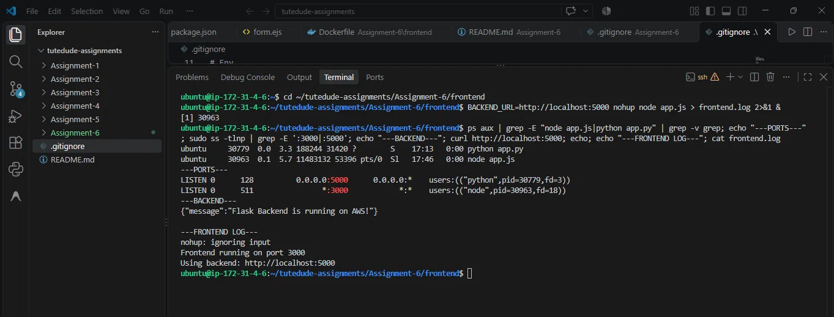
Figure 1: Flask + Express both running on the single EC2 (ports 3000 and 5000 open).
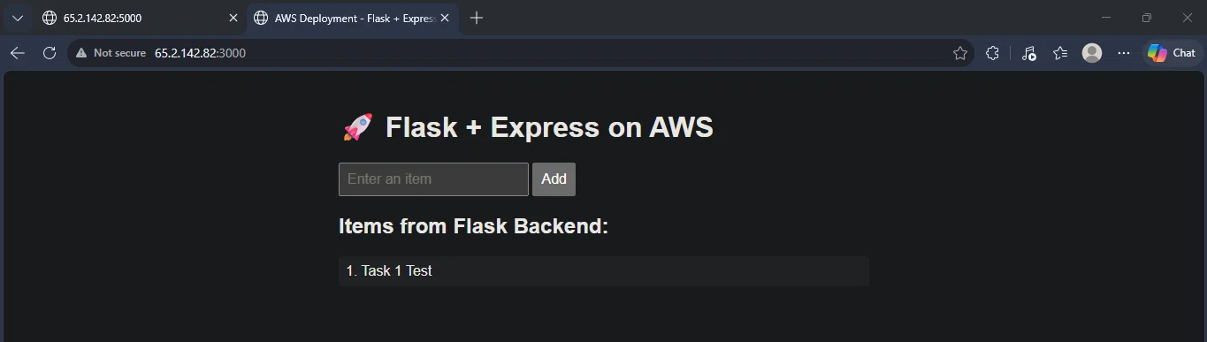
Figure 2: Live application accessible at http://65.2.142.82:3000 with an item added.
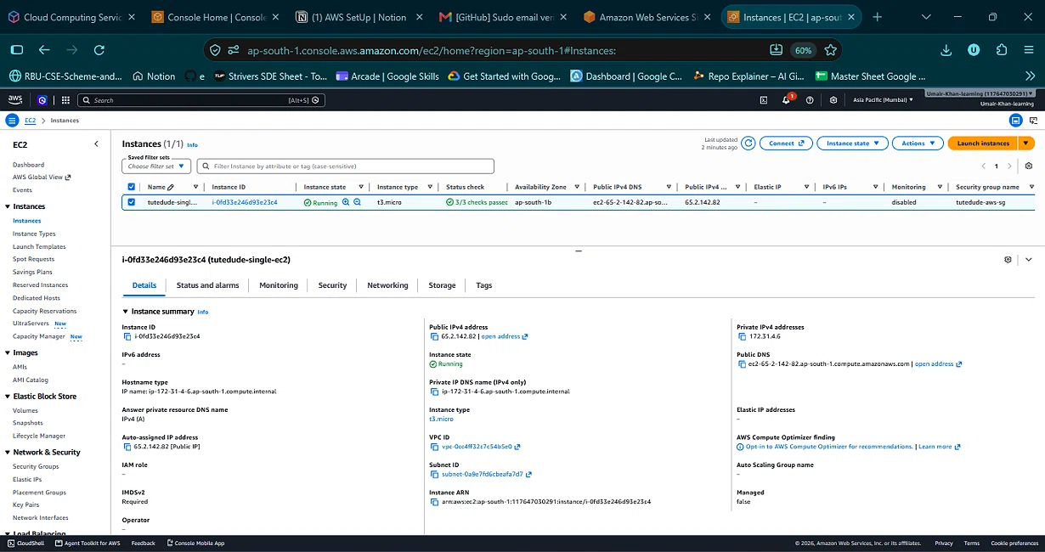
Figure 3: EC2 instance details showing ID, public IP, and security group.

3.5 Live URL
http://65.2.142.82:3000
Instance was stopped after verification to avoid charges, per assignment instructions
.

4. Task 2 — Deployment on Separate EC2 Instances

4.1 Architecture
Browser → Frontend EC2 (15.206.205.213:3000) → HTTP → Backend EC2 (13.203.228.83:5000)

4.2 Backend EC2
Field | Value
Instance Name | tutede-backend-ec2
Instance ID | i-06345c81ec96b3d63
Public IP | 13.203.228.83
Security Group | tutede-backend-sg
Ports Open | 22 (SSH), 5000 (Flask)

4.3 Frontend EC2
Field | Value
Instance Name | tutede-frontend-ec2
Instance ID | i-0353be89a825857c6
Public IP | 15.206.205.213
Security Group | tutede-frontend-sg
Ports Open | 22 (SSH), 3000 (Express)

4.4 Deployment Commands
Backend EC2:
bash
ssh -i tutedude-aws-key-mumbai.pem ubuntu@13.203.228.83
sudo apt install -y python3 python3-pip python3-venv git
git clone https://github.com/Umair-bey/tutedude-assignments.git
cd tutede-assignments/Assignment-6/backend
python3 -m venv venv && source venv/bin/activate
pip install -r requirements.txt
nohup python app.py > backend.log 2>&1 &
Frontend EC2:
bash
ssh -i tutedude-aws-key-mumbai.pem ubuntu@15.206.205.213
sudo apt install -y git curl
curl -fsSL https://deb.nodesource.com/setup_20.x | sudo -E bash -
sudo apt install -y nodejs

git clone https://github.com/Umair-bey/tutedude-assignments.git
cd tutede-assignments/Assignment-6/frontend
npm install
BACKEND_URL=http://13.203.228.83:5000 nohup node app.js > frontend.log 2>&1 &

4.5 Troubleshooting Note
The frontend security group originally had outbound rules restricted to SSH only, which blocked apt update and npm install (they couldn't reach the internet). This was fixed by changing the outbound rules to All traffic / 0.0.0.0/0, allowing package installation to complete.

4.6 Screenshots
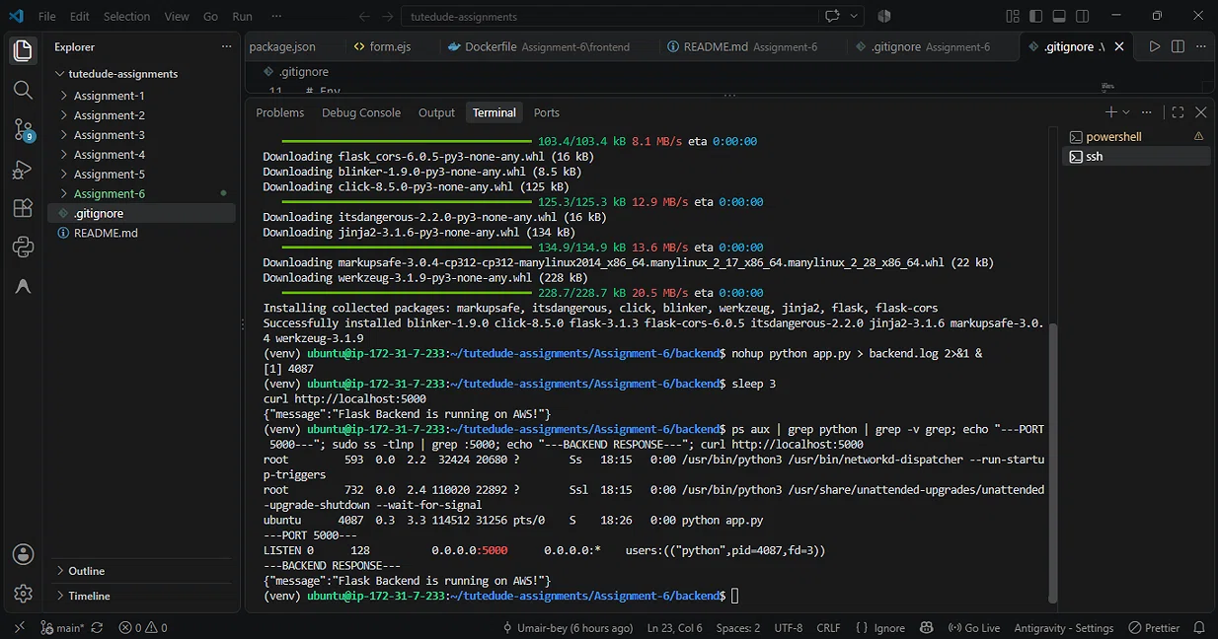
Figure 4: Flask backend running on the dedicated backend EC2.
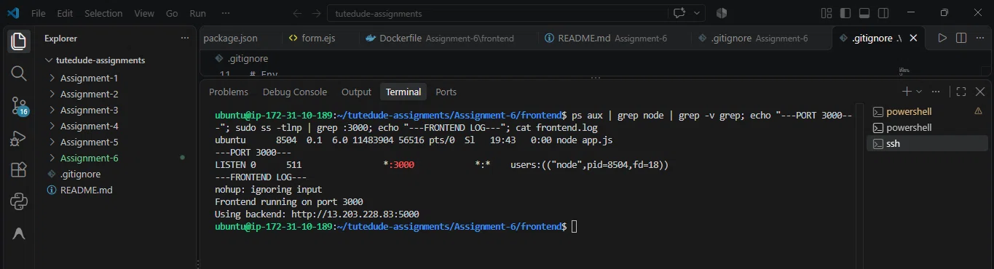
Figure 5: Express frontend running with BACKEND_URL pointing at the backend EC2.
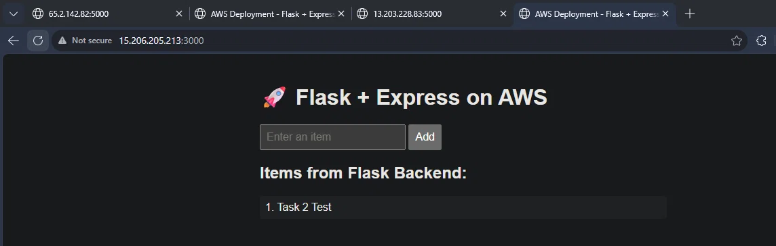
Figure 6: Two-server architecture working live at http://15.206.205.213:3000.

4.7 Live URL
http://15.206.205.213:3000

5. Task 3 — Docker + ECR + ECS + VPC

5.1 Architecture
Browser → ECS Frontend Task (13.201.96.116:3000)
→ HTTP → ECS Backend Task (43.204.231.169:5000)
Both containers run as Fargate tasks inside a custom VPC.

5.2 Docker Images
Both images built locally and pushed to Amazon ECR:
Image | ECR Repository | Size
flask-backend:latest | 117647030291.dkr.ecr.ap-south-1.amazonaws.com/flask-backend | 54.9 MB
express-frontend:latest | 117647030291.dkr.ecr.ap-south-1.amazonaws.com/express-frontend | 73.2 MB
Push commands:
bash
aws ecr get-login-password --region ap-south-1 | docker login --username AWS --password-stdin 117647030291.dkr.ecr.ap-south-1.amazonaws.com
docker tag flask-backend:latest 117647030291.dkr.ecr.ap-south-1.amazonaws.com/flask-backend:latest
docker push 117647030291.dkr.ecr.ap-south-1.amazonaws.com/flask-backend:latest

5.3 Custom VPC
Resource | Value
VPC Name | tutede-vpc-vpc
VPC ID | vpc-0f327aa819d1654a1
IPv4 CIDR | 10.0.0.0/16
Subnet 1 | tutede-vpc-subnet-public1-ap-south-1a
Subnet 2 | tutede-vpc-subnet-public2-ap-south-1b
Internet Gateway | tutede-vpc-igw
Route Table | tutede-vpc-rtb-public (0.0.0.0/0 → IGW)

5.4 Security Groups
SG Name | Port Open | VPC
tutede-ecs-backend-sg | 5000 | tutede-vpc-vpc
tutede-ecs-frontend-sg | 3000 | tutede-vpc-vpc

5.5 ECS Cluster & Task Definitions
Cluster: tutede-cluster (Fargate only)
Task Definition | Container | Image | Port | CPU/Mem
tutede-backend-task:1 | flask-backend | flask-backend:latest | 5000 | 0.25 vCPU / 0.5 GB
tutede-frontend-task:2 | express-frontend | express-frontend:latest | 3000 | 0.25 vCPU / 0.5 GB
The frontend task definition (revision 2) includes the environment variable:
BACKEND_URL = http://43.204.231.169:5000

5.6 ECS Services
Service | Task Definition | Desired Count | Public IP
tutede-backend-service | tutede-backend-task:1 | 1 | 43.204.231.169
tutede-frontend-service | tutede-frontend-task:2 | 1 | 13.201.96.116
Both services use:
- Launch type: Fargate
- Networking: VPC tutede-vpc-vpc with both public subnets
- Public IP: Enabled
- Security groups: ECS-specific

5.7 Screenshots
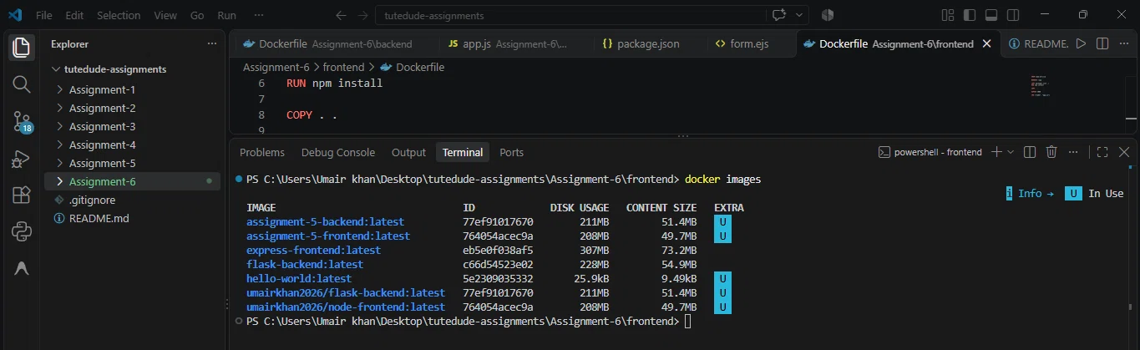
Figure 7: Both Docker images built locally (flask-backend and express-frontend).
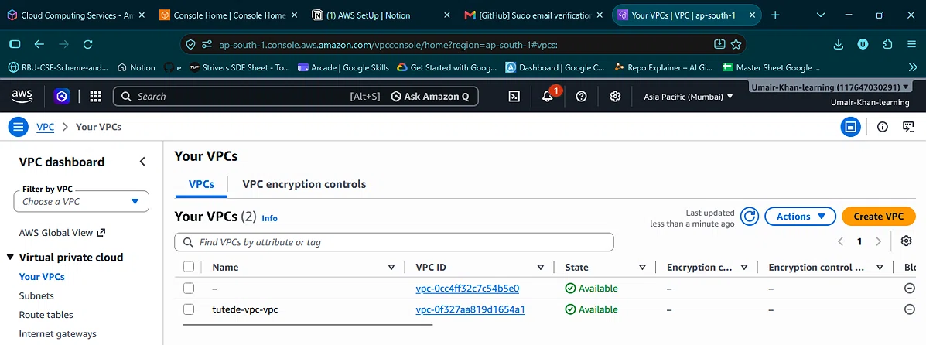
Figure 8: Custom VPC created with 2 public subnets and an Internet Gateway.
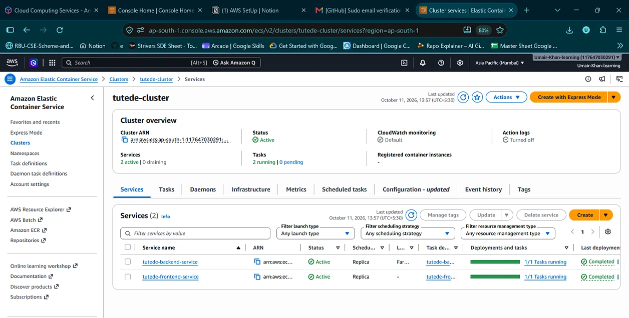
Figure 9: Both ECS services active — 2 running tasks.
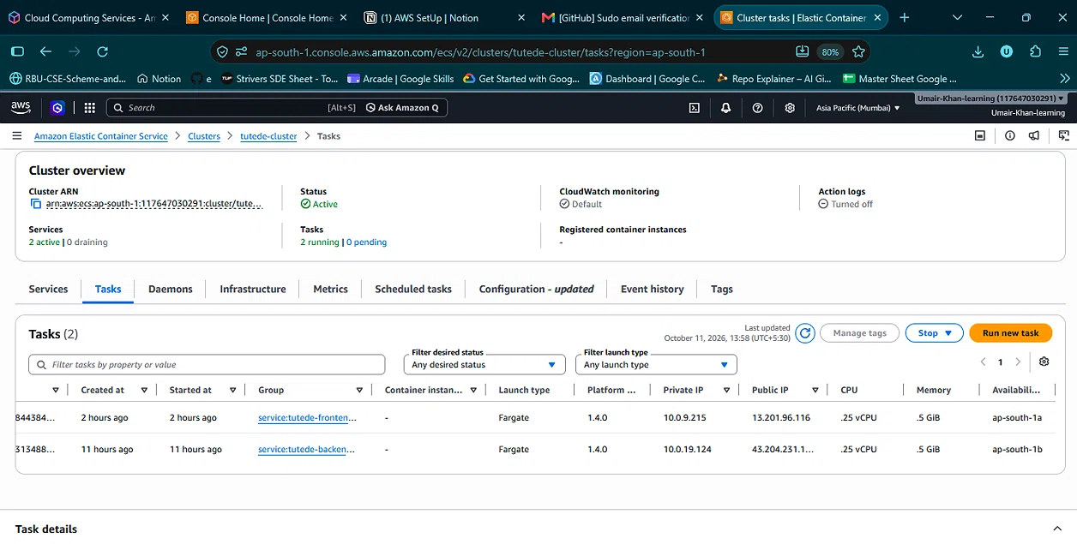
Figure 10: ECS task list showing public IPs for both containers.
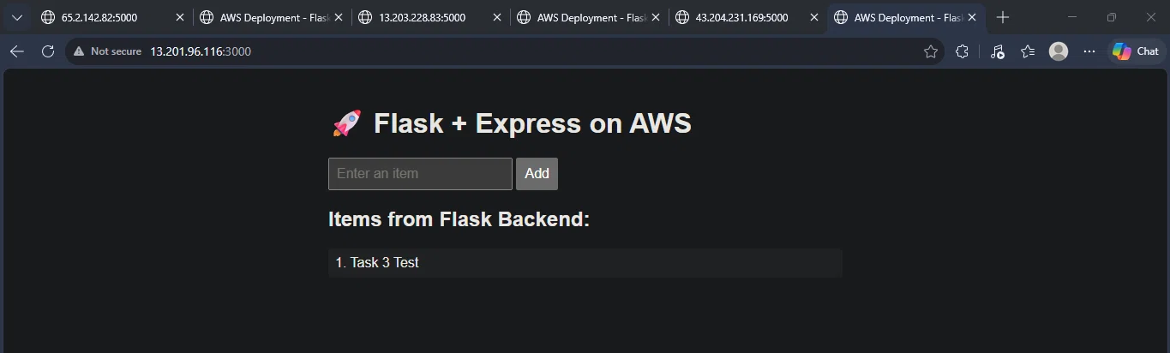
Figure 11: Full application live on ECS Fargate at http://13.201.96.116:3000.

5.8 Live URL
http://13.201.96.116:3000

5.9 Cleanup
After verification, both ECS services were updated to Desired tasks = 0 to stop container charges while preserving the service and task definitions. EC2 instances from Tasks 1 and 2 were also stopped. All resources can be restarted if needed.

6. GitHub Repository
Link: https://github.com/Umair-bey/tutedude-assignments
Complete source code for all assignments, including:
- Assignment-6/backend/ — Flask app + Dockerfile
- Assignment-6/frontend/ — Express app + Dockerfile
- Assignment-6/screenshots/ — All deployment screenshots

7. Summary & Learnings
Task | Deployment Pattern | Status
1 | Single EC2 — monolith | ✅ Complete
2 | Two EC2s — distributed | ✅ Complete
3 | ECS Fargate — containerized | ✅ Complete
Key learnings:
- EC2 provisioning — Launching, securing, connecting to virtual servers
- Security Groups — Inbound AND outbound rules matter; misconfigured egress blocks package installation
- Process management — nohup keeps apps running after SSH disconnect
- Inter-server communication — Frontend EC2 talking to backend EC2 via public IP
- Docker — Building minimal images with layer caching
- ECR — Private Docker registry with token-based authentication
- VPC — Custom networking with public subnets, IGW, route tables
- ECS Fargate — Serverless container orchestration with task definitions and services
- Cost awareness — Stopping instances/services when not in use

8. Conclusion
All three deployment patterns were successfully implemented and verified. The application is fully functional in each architecture, demonstrating practical proficiency with core AWS services and DevOps workflows.

