Assignment 7: Kubernetes Deployment of Full-Stack Application

Submitted by: Umair Khan

Course: DevOps — Tutedude

Date: 12 October 2026

GitHub Repository:
https://github.com/Umair-bey/tutedude-assignments/tree/main/Assignment-7

1. Objective
The objective of this assignment is to deploy a full-stack application consisting of a Flask frontend and an Express backend on a local Kubernetes cluster using Minikube. This involves containerizing both applications using Docker, writing Kubernetes manifests (Deployments and Services) for each, applying them to the cluster, and verifying that the pods and services are running correctly.

2. Prerequisites
The following tools were installed and verified on the local machine (Windows 11):
Tool | Version | Purpose
Docker Desktop | v29.8.2 | Container runtime for building and running images
Minikube | v1.39.0 | Local single-node Kubernetes cluster
kubectl | v1.32.2 | Kubernetes command-line tool
Git | Latest | Version control
VS Code | Latest | Code editor and terminal
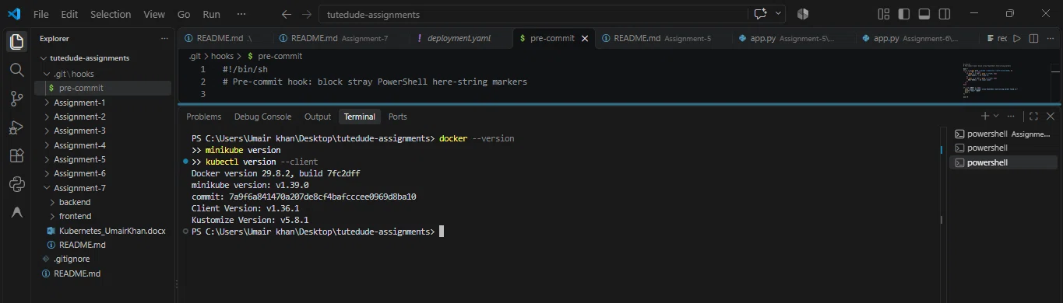

3. Project Structure
The project source code is organized as follows:
Assignment-7/
├── backend/
│ ├── Dockerfile
│ ├── deployment.yaml
│ ├── service.yaml
│ ├── package.json
│ └── server.js
├── frontend/
│ ├── Dockerfile
│ ├── deployment.yaml
│ ├── service.yaml
│ ├── app.py
│ ├── requirements.txt
│ └── templates/
│ └── index.html
├── screenshots/
├── Kubernetes_UmairKhan.docx
└── README.md
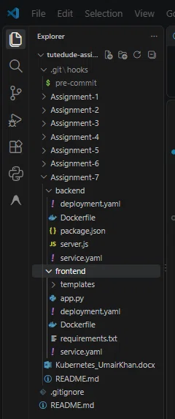

4. Application Architecture
The application consists of two microservices:
- Frontend (Flask): Runs on port 5000. Serves an HTML page and makes an HTTP request to the backend service to fetch data.
- Backend (Express): Runs on port 3000. Exposes a REST API endpoint /api returning a JSON message.

Communication flow:
Browser → frontend-service (NodePort: 5000) → Flask Pod
Flask Pod → backend-service (ClusterIP: 3000) → Express Pod
Kubernetes internal DNS resolves backend-service to the correct pod IP, enabling service discovery without hardcoded IPs.

5. Step-by-Step Deployment

Step 1: Start Minikube Cluster
Started the local Kubernetes cluster using the Docker driver:
powershell
minikube start --driver=docker
[INSERT SCREENSHOT: minikube start output showing "Done!"]
Verify cluster status:
powershell
minikube status
kubectl get nodes
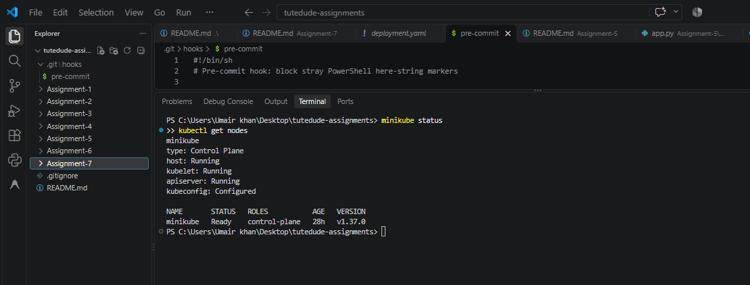
The node minikube shows status Ready with role control-plane.

Step 2: Containerize the Backend (Express)
backend/Dockerfile:
dockerfile
FROM node:18-alpine
WORKDIR /app
COPY package*.json ./
RUN npm install
COPY . .
EXPOSE 3000
CMD ["node", "server.js"]
backend/server.js (excerpt):
javascript
const express = require('express');
const cors = require('cors');

const app = express();
app.use(cors());
app.use(express.json());

app.get('/api', (req, res) => {
res.json({ message: "Hello from Express Backend on Kubernetes!", status: "success" });
});

app.get('/api/health', (req, res) => {
res.json({ status: "healthy" });
});

const PORT = process.env.PORT || 3000;
app.listen(PORT, () => console.log(`Backend running on port ${PORT}`));

Step 3: Containerize the Frontend (Flask)
frontend/Dockerfile:
dockerfile
FROM python:3.10-slim
WORKDIR /app
COPY requirements.txt .
RUN pip install --no-cache-dir -r requirements.txt
COPY . .
EXPOSE 5000
CMD ["python", "app.py"]
frontend/app.py (excerpt):
python
from flask import Flask, render_template
import requests
import os

app = Flask(__name__)
BACKEND_URL = os.getenv("BACKEND_URL", "http://backend-service:3000")

@app.route('/')
def home():
try:
r = requests.get(f"{BACKEND_URL}/api", timeout=5)
data = r.json()
except Exception as e:
data = {"message": f"Backend not reachable: {e}", "status": "error"}
return render_template('index.html', data=data)

if __name__ == '__main__':
app.run(host='0.0.0.0', port=5000)
Note: The frontend reads the backend URL from the BACKEND_URL environment variable, which is injected via the Kubernetes Deployment manifest. The default value points to backend-service:3000 — the Kubernetes Service DNS name.

Step 4: Build Docker Images Inside Minikube
Minikube provides a built-in image builder so images are stored directly in the cluster's Docker daemon, avoiding registry pushes:
powershell
cd backend
minikube image build -t backend:v1 .

cd ..\frontend
minikube image build -t frontend:v1 .
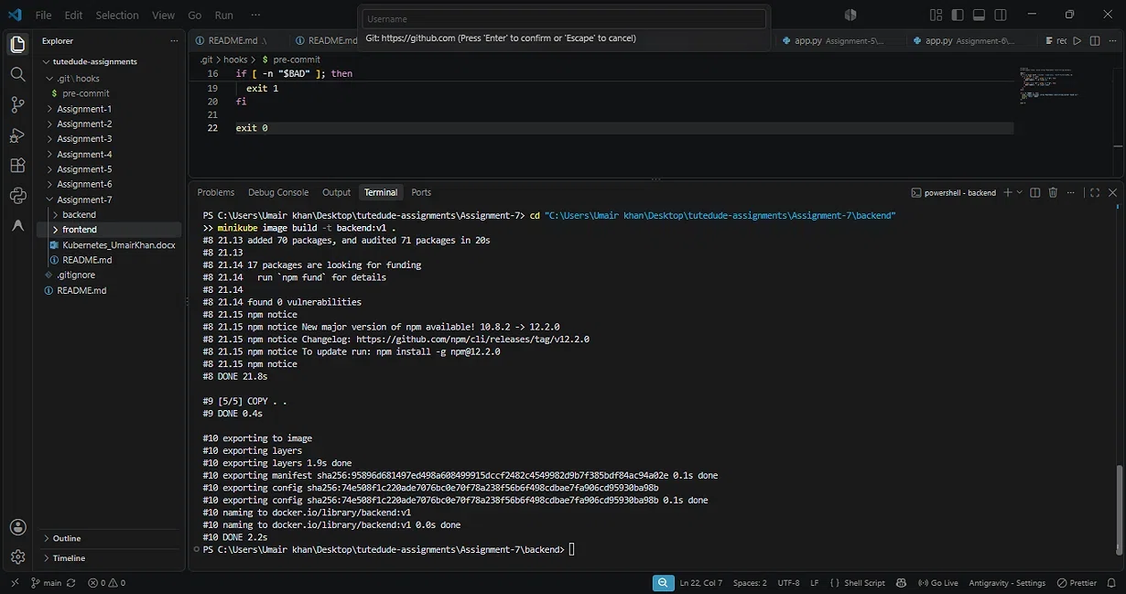
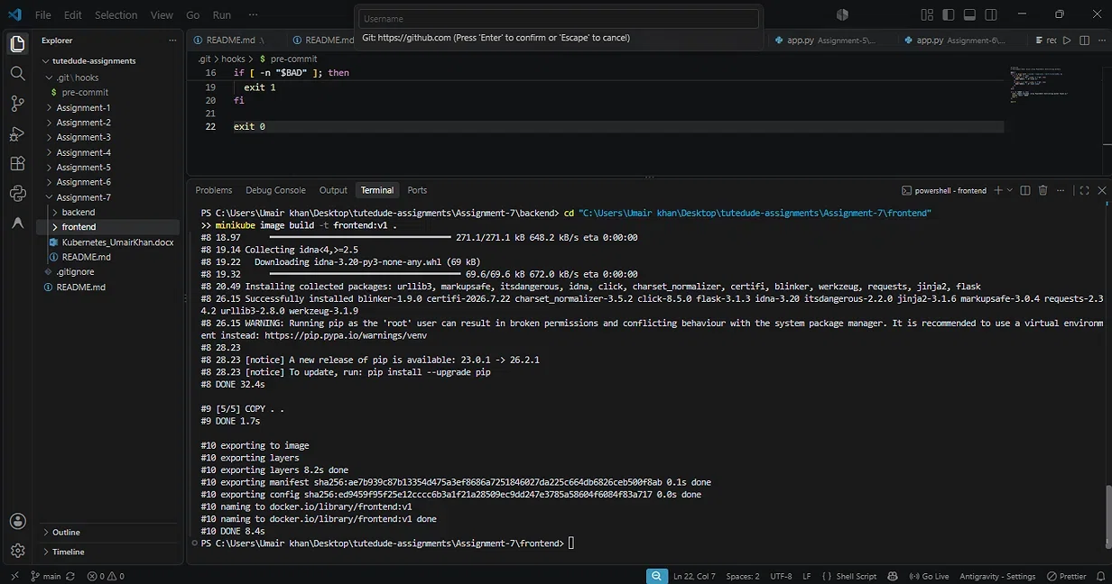
Verify images exist inside Minikube:
powershell
minikube image ls | Select-String "backend|frontend"
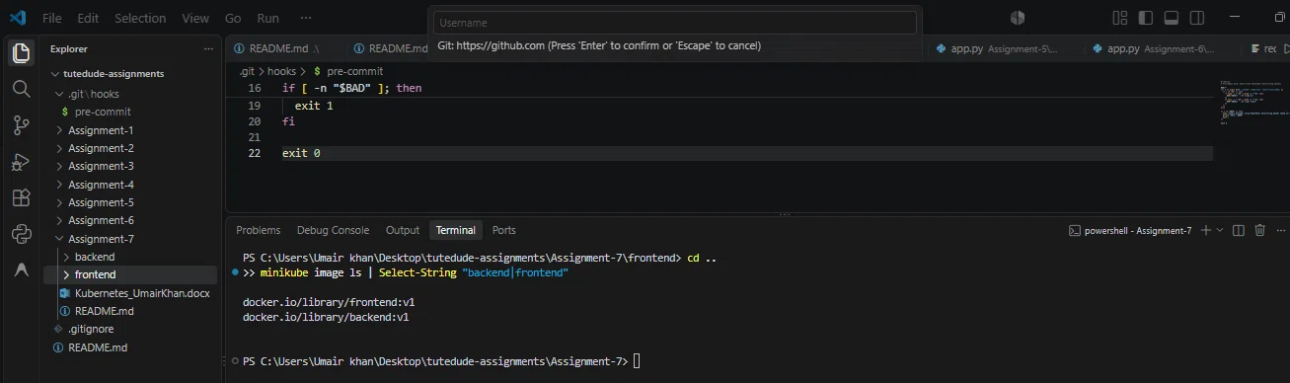

Step 5: Write Kubernetes Manifests

Backend Deployment (backend/deployment.yaml):
yaml
apiVersion: apps/v1
kind: Deployment
metadata:
name: backend-deployment
labels:
app: backend
spec:
replicas: 2
selector:
matchLabels:
app: backend
template:
metadata:
labels:
app: backend
spec:
containers:
- name: backend
image: backend:v1
imagePullPolicy: Never
ports:
- containerPort: 3000
Why imagePullPolicy: Never? Since the image is built locally inside Minikube, Kubernetes should never attempt to pull it from a remote registry. Never ensures it only uses the local image.

Backend Service (backend/service.yaml):
yaml
apiVersion: v1
kind: Service
metadata:
name: backend-service
spec:
selector:
app: backend
ports:
- protocol: TCP
port: 3000
targetPort: 3000
type: ClusterIP
ClusterIP is used because the backend is only accessed internally by the frontend pods — no external exposure needed.

Frontend Deployment (frontend/deployment.yaml):
yaml
apiVersion: apps/v1
kind: Deployment
metadata:
name: frontend-deployment
labels:
app: frontend
spec:
replicas: 2
selector:
matchLabels:
app: frontend
template:
metadata:
labels:
app: frontend
spec:
containers:
- name: frontend
image: frontend:v1
imagePullPolicy: Never
ports:
- containerPort: 5000
env:
- name: BACKEND_URL
value: "http://backend-service:3000"
The env section injects the backend service URL, which the Flask app reads from os.getenv("BACKEND_URL").

Frontend Service (frontend/service.yaml):
yaml
apiVersion: v1
kind: Service
metadata:
name: frontend-service
spec:
selector:
app: frontend
ports:
- protocol: TCP
port: 5000
targetPort: 5000
type: NodePort
NodePort exposes the frontend outside the cluster so it can be accessed from the host browser.

Step 6: Apply Manifests to the Cluster
powershell
kubectl apply -f backend/deployment.yaml
kubectl apply -f backend/service.yaml
kubectl apply -f frontend/deployment.yaml
kubectl apply -f frontend/service.yaml
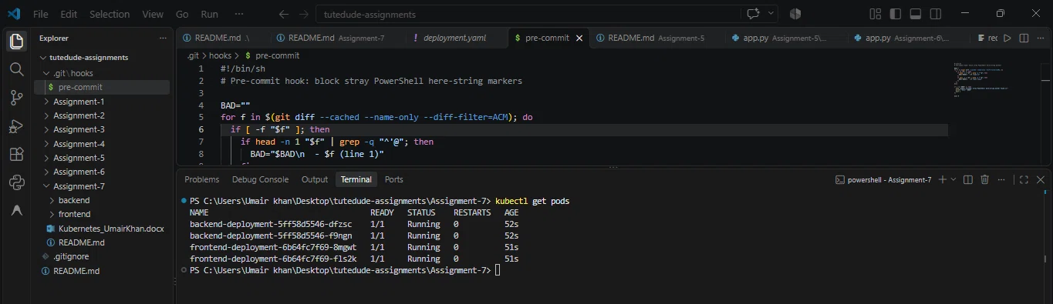

Step 7: Verify Pods Are Running
powershell
kubectl get pods
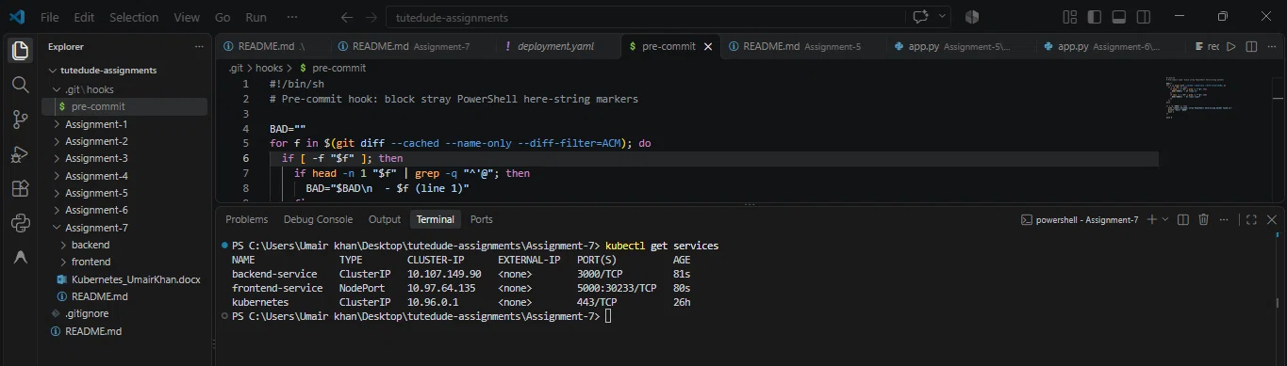
Result: 4 pods running (2 backend replicas + 2 frontend replicas), all 1/1 Ready with 0 restarts.

Step 8: Verify Deployments and Services
powershell
kubectl get deployments
kubectl get services
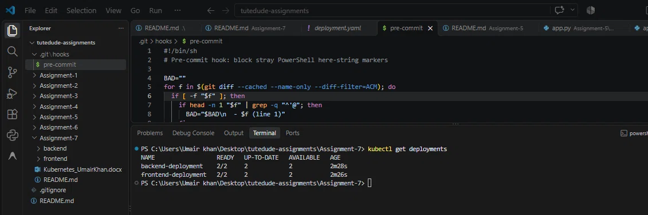

Step 9: Expose Frontend and Access the Application
powershell
minikube service frontend-service --url
This creates a tunnel from the local machine to the NodePort on the Minikube cluster and returns a URL (e.g., http://127.0.0.1:55113).
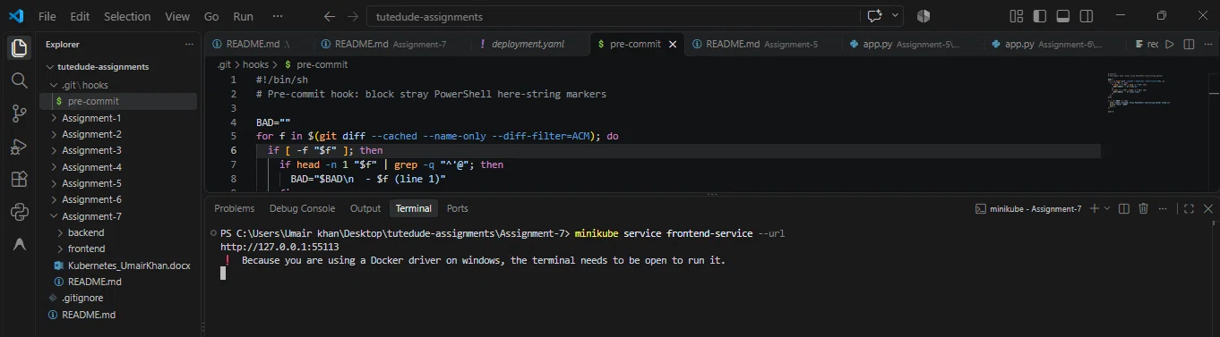
Open the URL in a browser:
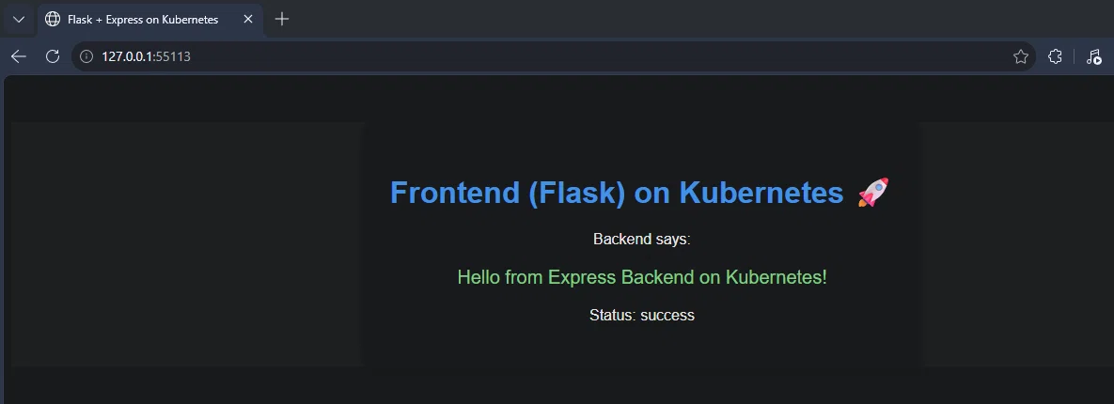
This confirms end-to-end communication between the frontend and backend pods via Kubernetes service discovery.

Step 10: Kubernetes Dashboard
Launched the official Kubernetes Dashboard:
powershell
minikube dashboard
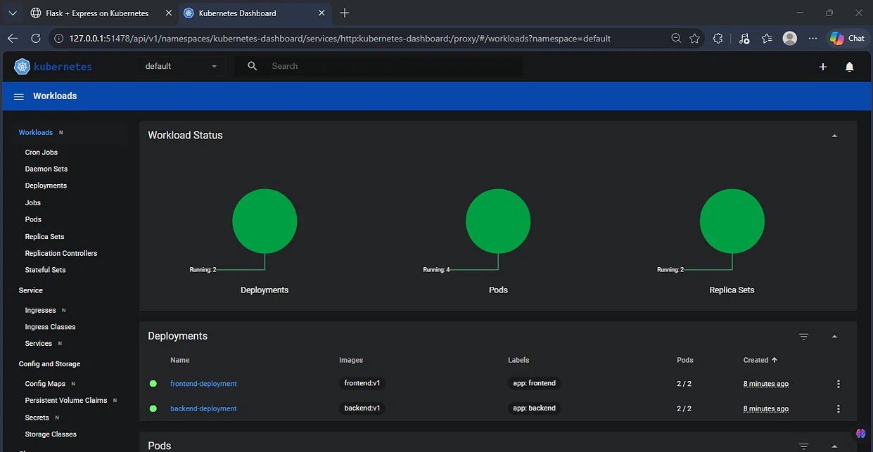
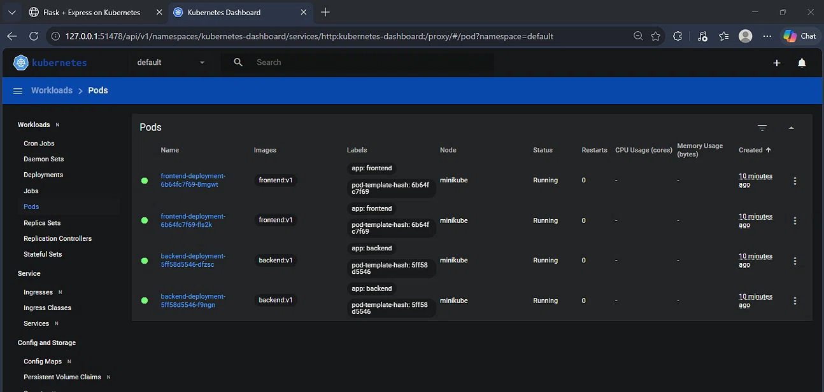
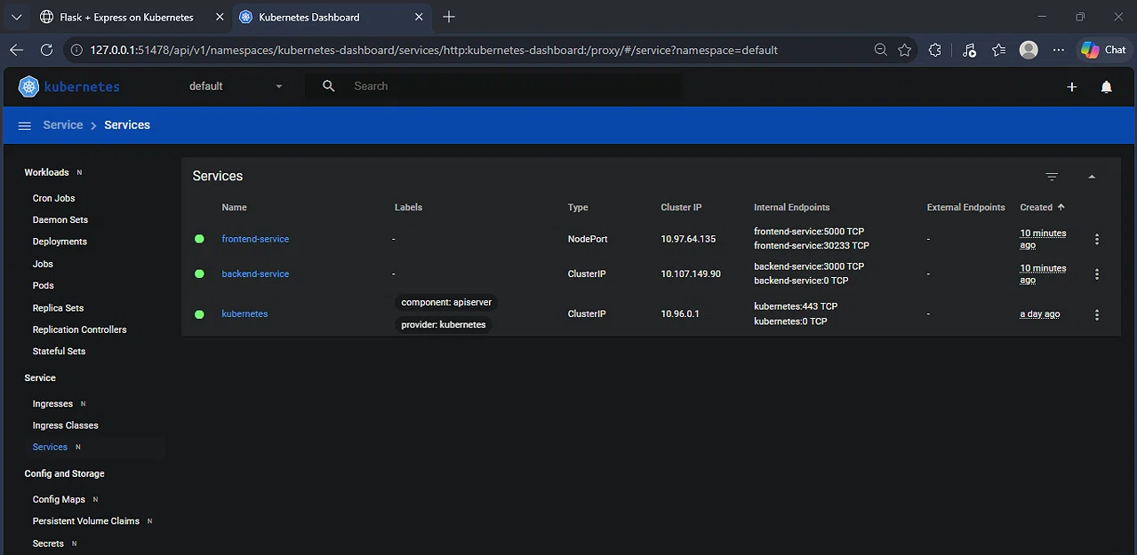
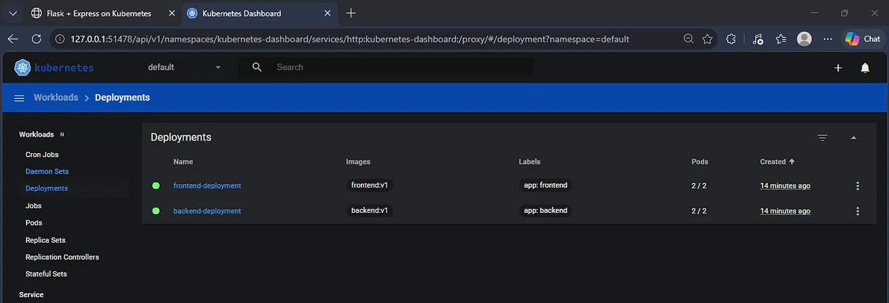

Step 11: Complete Cluster State
powershell
kubectl get all
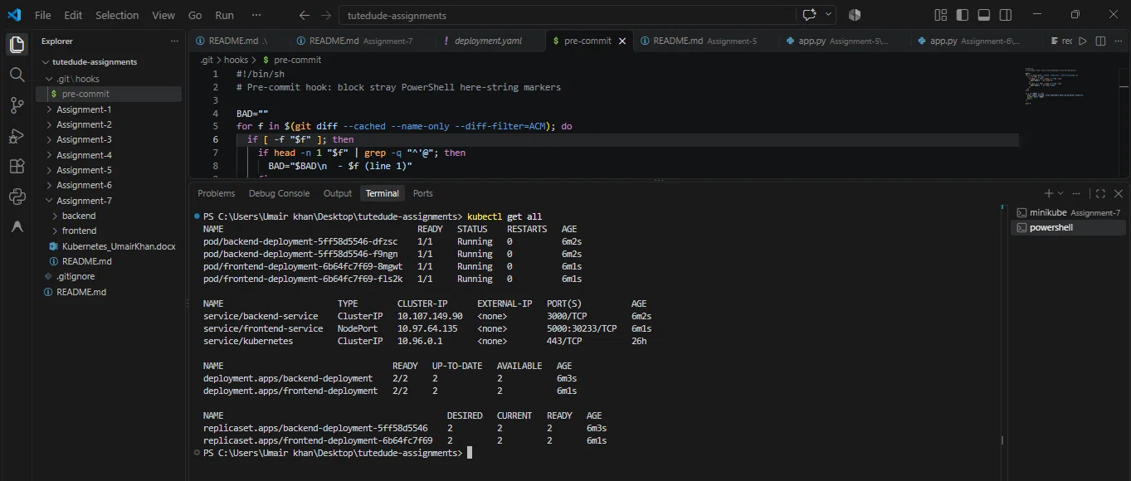

6. Challenges and Troubleshooting

Challenge 1: Stray PowerShell Here-String Markers in Files
When initially creating the YAML, Dockerfiles, and source files via PowerShell here-strings, several files were inadvertently written with '@ (the here-string terminator) as the first line. This caused the Docker build to fail with:
text
dockerfile parse error on line 1: unknown instruction: '@
Resolution: A byte-level PowerShell script was written to detect and strip any line consisting solely of '@ from the first or last line of each file. This resolved the parsing errors and the images built successfully.

Challenge 2: Minikube docker-env Bug on Windows
minikube docker-env | Invoke-Expression failed on Windows with:
text
❌ Exiting due to SSH_AGENT_START: starting an SSH agent on Windows is not yet supported
Resolution: Used the built-in minikube image build command instead, which builds images directly inside Minikube's Docker daemon without needing to modify the local environment.

Challenge 3: Preventing Future Occurrences — Pre-commit Hook
A Git pre-commit hook was installed at .git/hooks/pre-commit that scans all staged files for stray '@ markers and blocks the commit if any are found. This prevents the same bug from being pushed to the repository in the future.
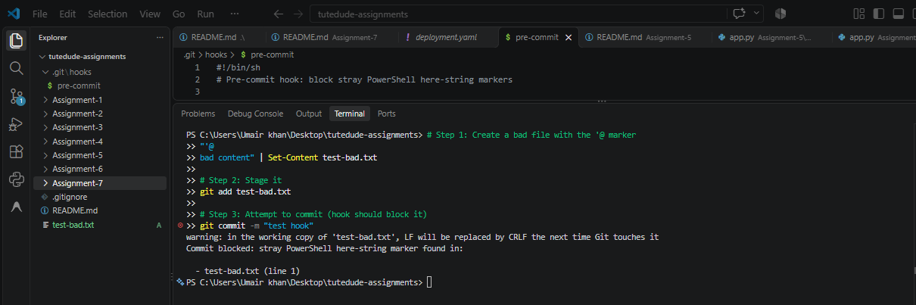

7. Key Learnings
- Containerization: Successfully built Docker images for a Node.js backend and a Python/Flask frontend.
- Kubernetes Manifests: Wrote YAML for Deployments (replica management) and Services (ClusterIP for internal, NodePort for external access).
- Service Discovery: Kubernetes internal DNS allows pods to reach each other by service name — http://backend-service:3000 works across pods without hardcoding IPs.
- Image Handling in Minikube: Building images directly into the cluster's daemon with minikube image build is the recommended approach on Windows where docker-env has known issues.
- Debugging YAML/Dockerfile Errors: Learned to inspect file bytes and fix parsing issues at the byte level.
- DevOps Safety Practices: Added a pre-commit hook to catch future file corruption issues before they reach the repository.

8. Conclusion
This assignment demonstrated a complete end-to-end DevOps workflow for deploying a full-stack application on Kubernetes. Both the Flask frontend and Express backend were containerized, deployed as Kubernetes Deployments with 2 replicas each, and exposed via Services. The application successfully communicates across pods using Kubernetes DNS service discovery. The final state shows a healthy cluster with 4 running pods, 2 services, and 2 deployments — all accessible via the Minikube NodePort tunnel.

9. GitHub Repository
Full source code, Dockerfiles, and Kubernetes manifests are available at:
https://github.com/Umair-bey/tutedude-assignments/tree/main/Assignment-7

10. References
- Kubernetes Documentation: https://kubernetes.io/docs/
- Minikube Documentation: https://minikube.sigs.k8s.io/docs/
- Docker Documentation: https://docs.docker.com/

✅ END OF DOCUMENT

🎯 What to Do Now
- Open Microsoft Word (or Google Docs)
- Save as Kubernetes_UmairKhan.docx inside C:\Users\Umair khan\Desktop\tutedude-assignments\Assignment-7\
- Copy each section from above into the doc
- Paste screenshots at every [INSERT SCREENSHOT: ...] marker
- Bold headings as needed (or use Word's heading styles)
- Save

🎯 Then — Create the Zip for Submission
powershell
cd "C:\Users\Umair khan\Desktop\tutedude-assignments"
Compress-Archive -Path Assignment-7 -DestinationPath Kubernetes_UmairKhan.zip -Force
Then verify:
powershell
Get-ChildItem Kubernetes_UmairKhan.zip
Reply when the doc is done, and I'll give you the final checklist + submission steps.
Great work on the entire deployment. 🎉

