DOCKER ASSIGNMENT – ASSIGNMENT 5

Node.js Frontend + Flask Backend with Docker Compose

Submitted by: Umair Khan
Course: Tutedude – Full Stack Development
Date: 10 October 2026

GitHub Repository:
https://github.com/Umair-bey/tutedude-assignments/tree/main/Assignment-5

Docker Hub Images:
https://hub.docker.com/r/umairkhan2026/flask-backend
https://hub.docker.com/r/umairkhan2026/node-frontend

1. PROJECT OVERVIEW

This assignment demonstrates containerizing a two-service web application using Docker and Docker Compose.

The application consists of:
• A Node.js + Express frontend that serves an HTML form
• A Flask backend that receives form submissions and returns JSON responses
• A Docker Compose configuration that connects both services on a shared bridge network

When the user submits the form on the frontend (port 3000), the frontend forwards the data to the Flask backend (port 5000) using the Docker service name "backend" as the hostname. The backend processes the data and returns a JSON response, which is rendered on the frontend.

Key concepts demonstrated:
• Writing custom Dockerfiles for Node.js and Python applications
• Multi-container orchestration with docker-compose.yml
• Container-to-container communication over a user-defined bridge network
• Docker's internal DNS resolution using service names
• Publishing images to Docker Hub

2. FOLDER STRUCTURE

The project is organized with separate folders for the frontend and backend:

Assignment-5/
├── frontend/
│ ├── views/
│ │ └── form.ejs
│ ├── app.js
│ ├── package.json
│ └── Dockerfile
├── backend/
│ ├── app.py
│ ├── requirements.txt
│ └── Dockerfile
├── docker-compose.yml
└── .gitignore
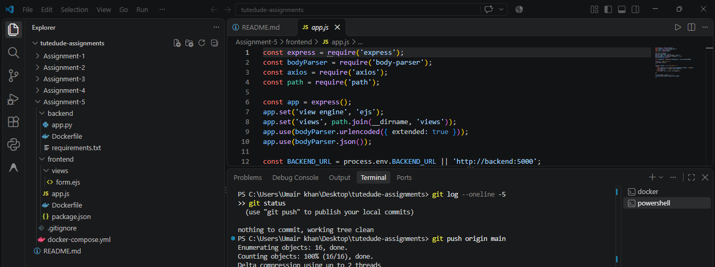

3. BACKEND (FLASK)

File: backend/app.py
The Flask application exposes two endpoints:
• GET / → Health check endpoint returning a JSON message
• POST /submit → Receives form data (name, email, message) and returns them as JSON

Flask-CORS is used to allow cross-origin requests from the frontend.

File: backend/requirements.txt
Flask==3.0.0
flask-cors==4.0.0

File: backend/Dockerfile
• Base image: python:3.11-slim
• Working directory: /app
• Copies requirements.txt and installs dependencies
• Exposes port 5000
• Runs: python app.py

4. FRONTEND (NODE.JS + EXPRESS)

File: frontend/app.js
The Express server:
• Uses EJS as the template engine
• Serves the HTML form at route "/"
• Handles POST /submit by forwarding the form data to the Flask backend
• Backend URL is taken from the environment variable BACKEND_URL (default: http://backend:5000)

File: frontend/views/form.ejs
An HTML form with three fields — Name, Email, Message — and a Submit button.
On successful submission, the JSON response from the backend is displayed in a success box.

File: frontend/package.json
Dependencies: express, ejs, axios, body-parser

File: frontend/Dockerfile
• Base image: node:18-alpine
• Working directory: /app
• Copies package.json and runs npm install
• Exposes port 3000
• Runs: npm start

5. DOCKER COMPOSE CONFIGURATION

File: docker-compose.yml

Two services are defined on a shared bridge network (app-network):

Service: frontend
• Builds from ./frontend
• Container name: frontend_service
• Port mapping: 3000:3000
• Environment: BACKEND_URL=http://backend:5000
• Depends on: backend

Service: backend
• Builds from ./backend
• Container name: backend_service
• Port mapping: 5000:5000

Networks:
• app-network (bridge driver)

Why this works:
Because both services share the same user-defined bridge network, Docker's internal DNS automatically resolves the service name "backend" to the backend container's IP. This lets the frontend reach the backend without hardcoding any IP address.

6. BUILD AND RUN COMMAND

From the Assignment-5 folder, run:

docker compose up --build

This command:
• Builds both Docker images from their Dockerfiles
• Creates the app-network bridge network
• Starts both containers
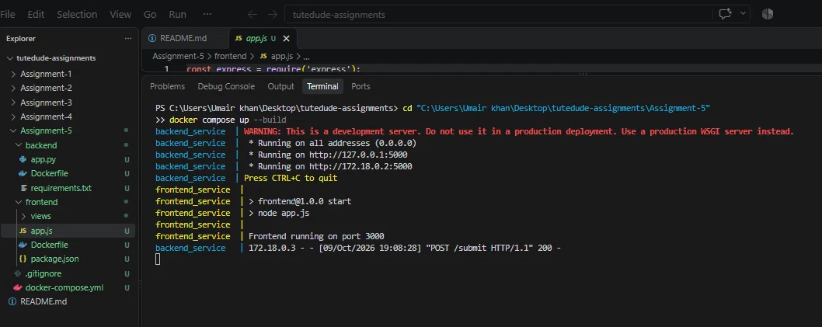

7. APPLICATION WORKING

Step 1: Open the browser at http://localhost:3000 — the form loads.
Step 2: Fill in Name, Email, and Message fields.
Step 3: Click Submit.
Step 4: The frontend forwards the POST request to the Flask backend.
Step 5: The backend returns a JSON response.
Step 6: The frontend renders the success box with the received data.

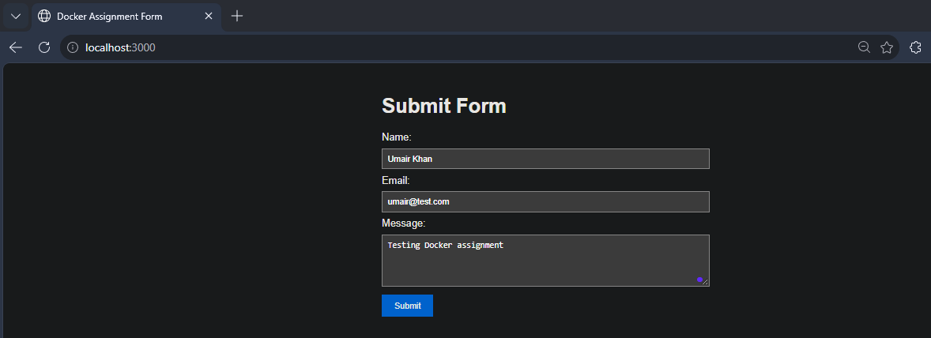
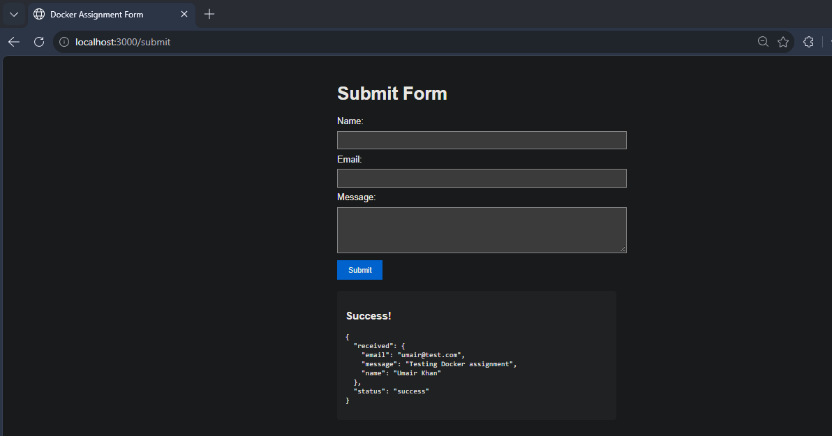

8. RUNNING CONTAINERS AND IMAGES

To verify that both containers are running:

docker ps

To list all locally built images:

docker images

Both containers are named frontend_service and backend_service, and are mapped to host ports 3000 and 5000 respectively.

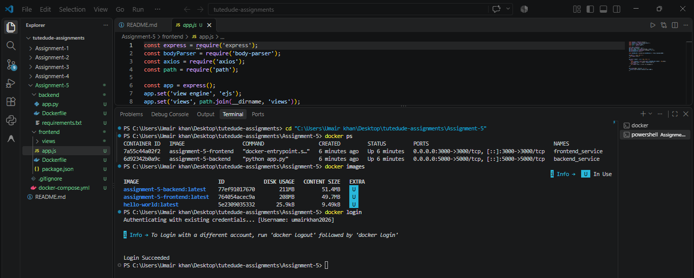

9. PUSHING IMAGES TO DOCKER HUB

The images were tagged and pushed to Docker Hub:

docker login
docker tag assignment-5-frontend umairkhan2026/node-frontend:latest
docker tag assignment-5-backend umairkhan2026/flask-backend:latest
docker push umairkhan2026/node-frontend:latest
docker push umairkhan2026/flask-backend:latest

Both images are now publicly available:
• https://hub.docker.com/r/umairkhan2026/node-frontend
• https://hub.docker.com/r/umairkhan2026/flask-backend

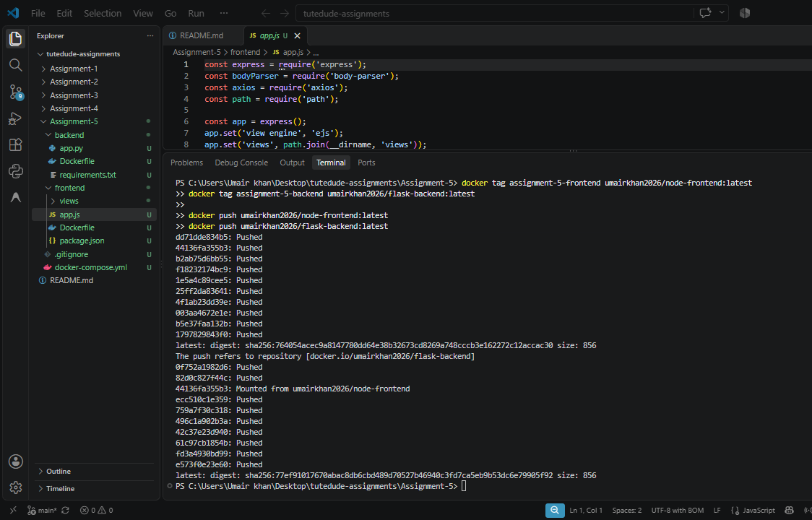
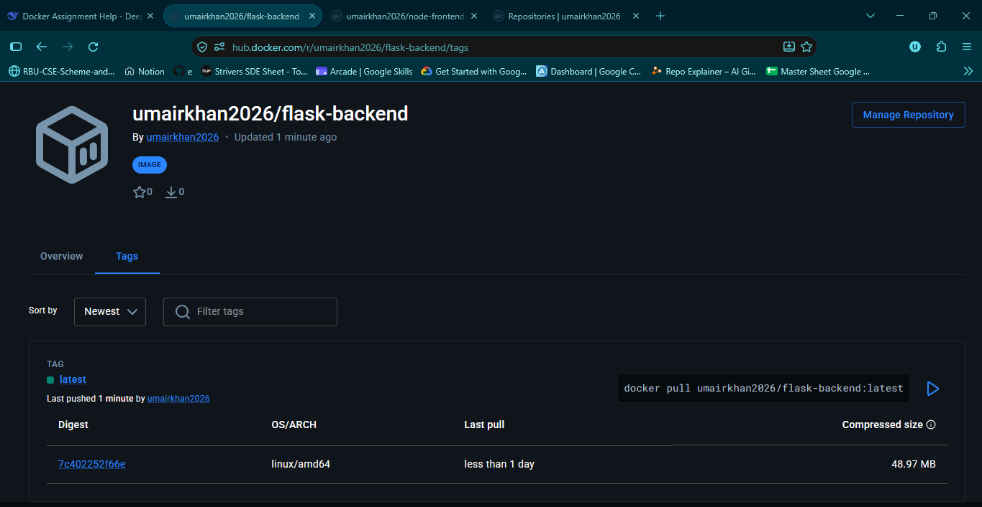
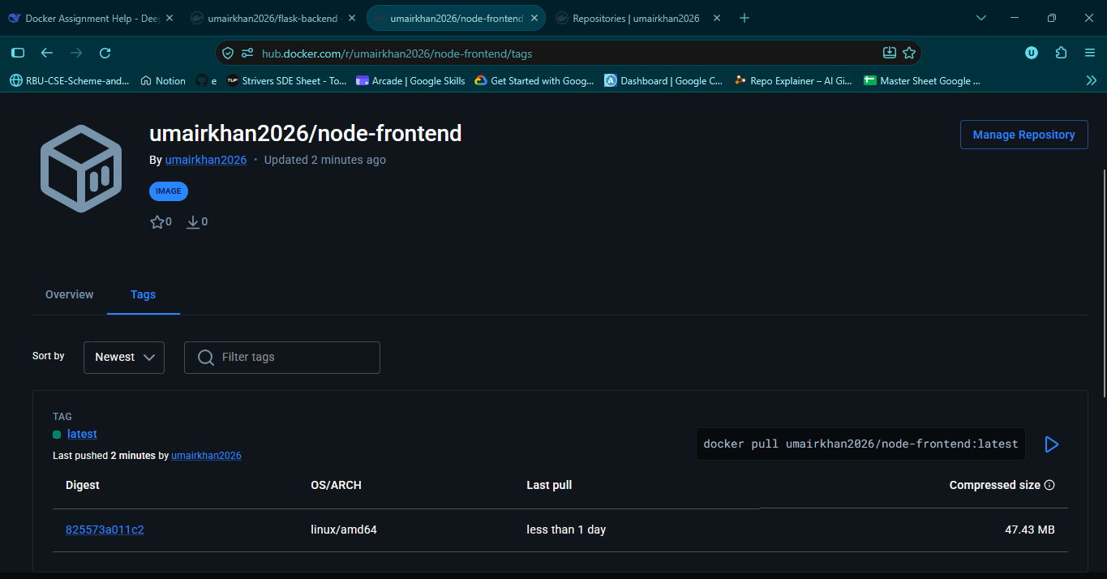

10. GITHUB REPOSITORY

All source code, Dockerfiles, docker-compose.yml, and .gitignore were pushed to GitHub:

Repository: https://github.com/Umair-bey/tutedude-assignments
Assignment folder: https://github.com/Umair-bey/tutedude-assignments/tree/main/Assignment-5

The .gitignore file excludes node_modules/, __pycache__/, .vscode/, and other unnecessary files so that only the actual source code is committed.

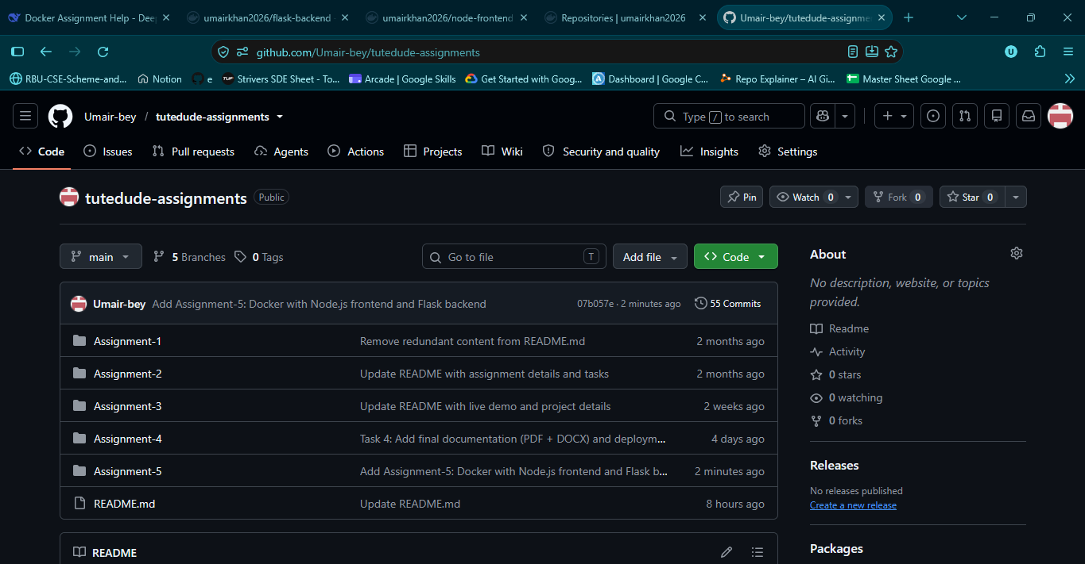
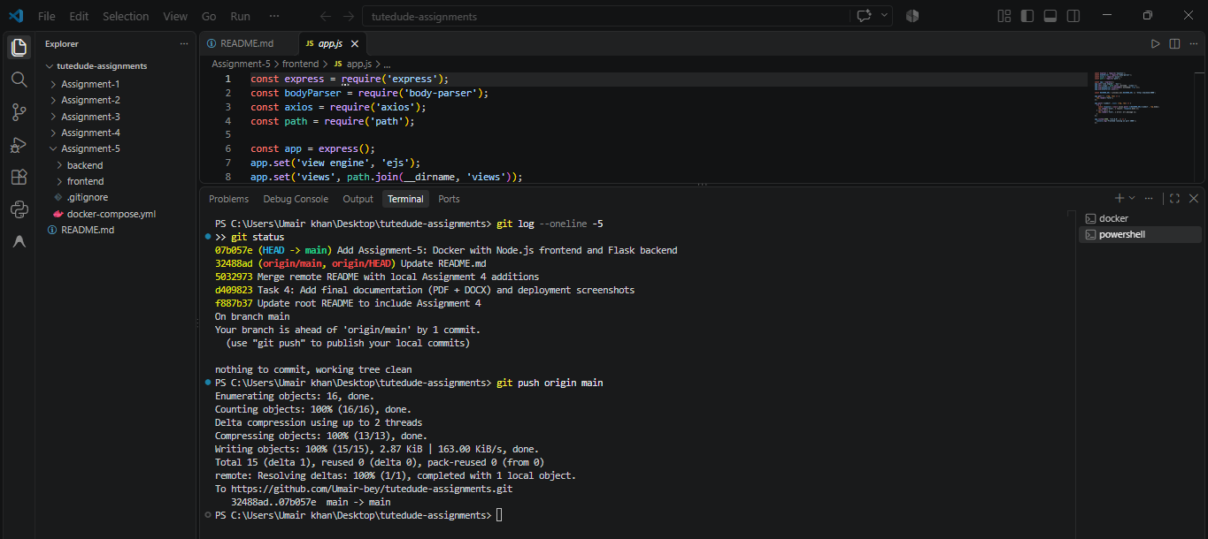

11. CONCLUSION

Through this assignment, I successfully:

• Containerized a Node.js frontend and a Flask backend with separate Dockerfiles
• Connected both services using Docker Compose on a shared bridge network
• Enabled inter-container communication using Docker's internal DNS (service name as hostname)
• Deployed images to Docker Hub and pushed the source code to GitHub
• Applied best practices such as using .gitignore and environment variables

This assignment strengthened my understanding of containerization, multi-service architectures, and Docker networking.

