TUTEDUDE DEVOPS — ASSIGNMENT 4

Git & GitHub

Student: Umair Khan Course: Tutedude DevOps
GitHub: https://github.com/Umair-bey/tutedude-assignments Date: October 2026

TABLE OF CONTENTS
- Environment Verification
- Task 1 — Repository Setup & First Branch
- Task 2 — Update JSON & Resolve Conflicts
- Task 3 — Parallel Feature Development
- Task 4 — Sequential Commits, Reset & Rebase
- GitHub Repository
- Conclusion

============================================================

ENVIRONMENT VERIFICATION
============================================================

Git Version & Config

Commands: git --version
git config --global user.name git config --global user.email

Result:
Git version: 2.54.0.windows.1 User: Umair-bey
Email: umair2025khan.in@gmail.com

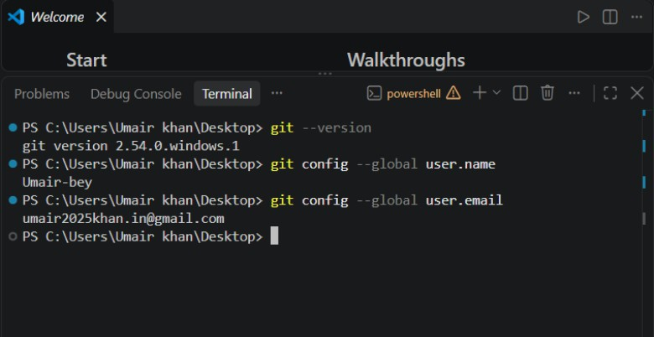

Python, pip & PyMongo

Commands: python --version pip --version
python -c "import pymongo; print(pymongo. version )"

Result:
Python: 3.14.2
pip: 25.3
PyMongo: 4.18.1

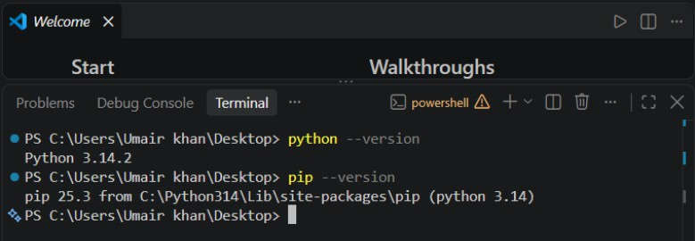
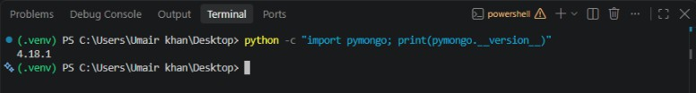

SSH Connection to GitHub

Command:
ssh -T git@github.com

Result:
Hi Umair-bey! You've successfully authenticated...

📸 [Insert Screenshot: env_03_ssh_test.png]

============================================================

TASK 1 — REPOSITORY SETUP & FIRST BRANCH
============================================================

Step 1: SSH Key Generation

Command:
ssh-keygen -t ed25519 -C "umair2025khan.in@gmail.com"

Result:
SSH key pair generated at ~/.ssh/id_ed25519 and id_ed25519.pub

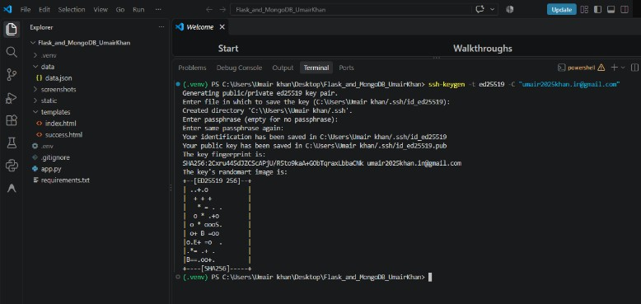

Step 2: SSH Key Added to GitHub

Key labeled "Umair Windows Laptop" added at github.com/settings/keys
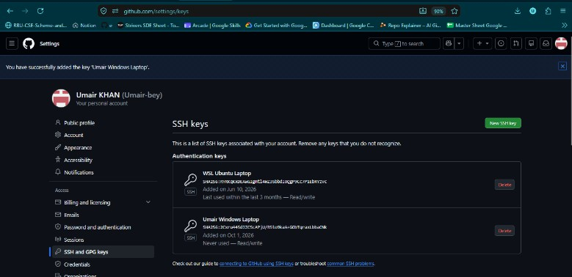

Step 3: Branches Visible

Branches created: Umair, Umair_new, master_1, master_2, main

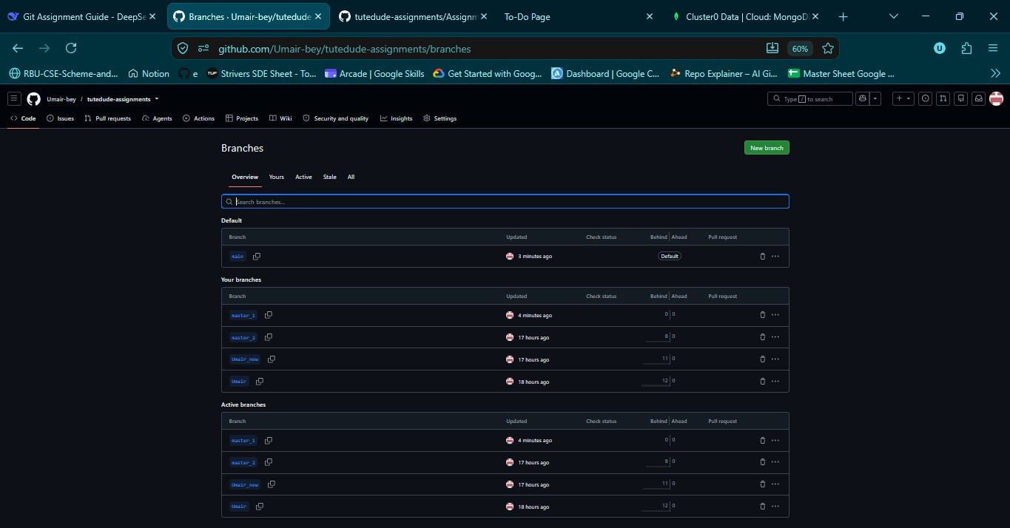

Step 4: Committed Change on Umair Branch

Commit: 600a2e1 — "Task 1: Add author comment to app.py in Umair branch" Added author comment at the top of app.py

Step 5: Merged Umair into main

Commands:
git checkout main git merge Umair
git push origin main

Result:
Fast-forward merge completed successfully

📸 [Insert Screenshot: task1_05_merge_output.png]

============================================================

TASK 2 — UPDATE JSON & RESOLVE CONFLICTS
============================================================

Step 1: Created Branch Umair_new

Command:
git checkout -b Umair_new

Step 2: Updated Assignment-4/data/data.json on Umair_new

New content:
{
"message": "Hello from API - Updated in Umair_new branch", "version": 2,
"items": ["new_item_1", "new_item_2"], "updated_by": "Umair_new"
}

Commit: 9f12c28 — "Task 2: Update data.json in Umair_new branch"

📸 [Insert Screenshot: task2_02_datajson_updated.png]

Step 3: Modified data.json on main Differently

New content:
{
"message": "Hello from API - Updated in main branch", "version": 3,
"items": ["main_item_1"], "updated_by": "main"
}

Commit: 2a8f742 — "Task 2: Update data.json in main branch"

Step 4: Merged Umair_new → main (CONFLICT)

Command:
git merge Umair_new

Output:
CONFLICT (content): Merge conflict in Assignment-4/data/data.json Automatic merge failed; fix conflicts and then commit the result.

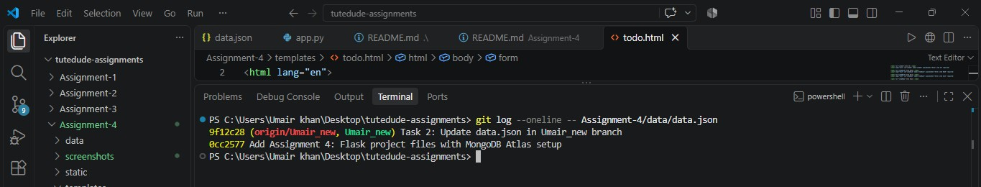

Step 5: Conflict Markers & Resolution

Conflict markers appeared in data.json:
<<<<<<< HEAD
{...main version...}
=======
{...Umair_new version...}
>>>>>>> Umair_new

Resolution: Accepted the Umair_new version (removed all markers)

📸 [Insert Screenshot: task2_05_conflict_markers.png]
📸 [Insert Screenshot: task2_05b_resolved.png]

Step 6: Staged, Committed, Pushed

Commit: 053866f — "Task 2: Resolve merge conflict - accept changes from Umair_new"

============================================================

4. TASK 3 — PARALLEL FEATURE DEVELOPMENT
============================================================

Step 1: Created Two Branches from main

Commands:
git checkout main

git checkout -b master_1 git checkout main
git checkout -b master_2

Step 2: Frontend To-Do Page in master_1

File: Assignment-4/templates/todo.html
Commit: 4d4c0e0 — "Task 3: Add To-Do page with Item Name and Item Description fields"

📸 [Insert Screenshot: task3_02_todo_page.png]

Step 3: Backend API in master_2

Added /submittodotitem POST route to Assignment-4/app.py Routes visible: /api, /submit, /success, /todo, /submittodotitem
Commit: eeddd1a — "Task 3: Add /submittodotitem backend route with MongoDB storage"

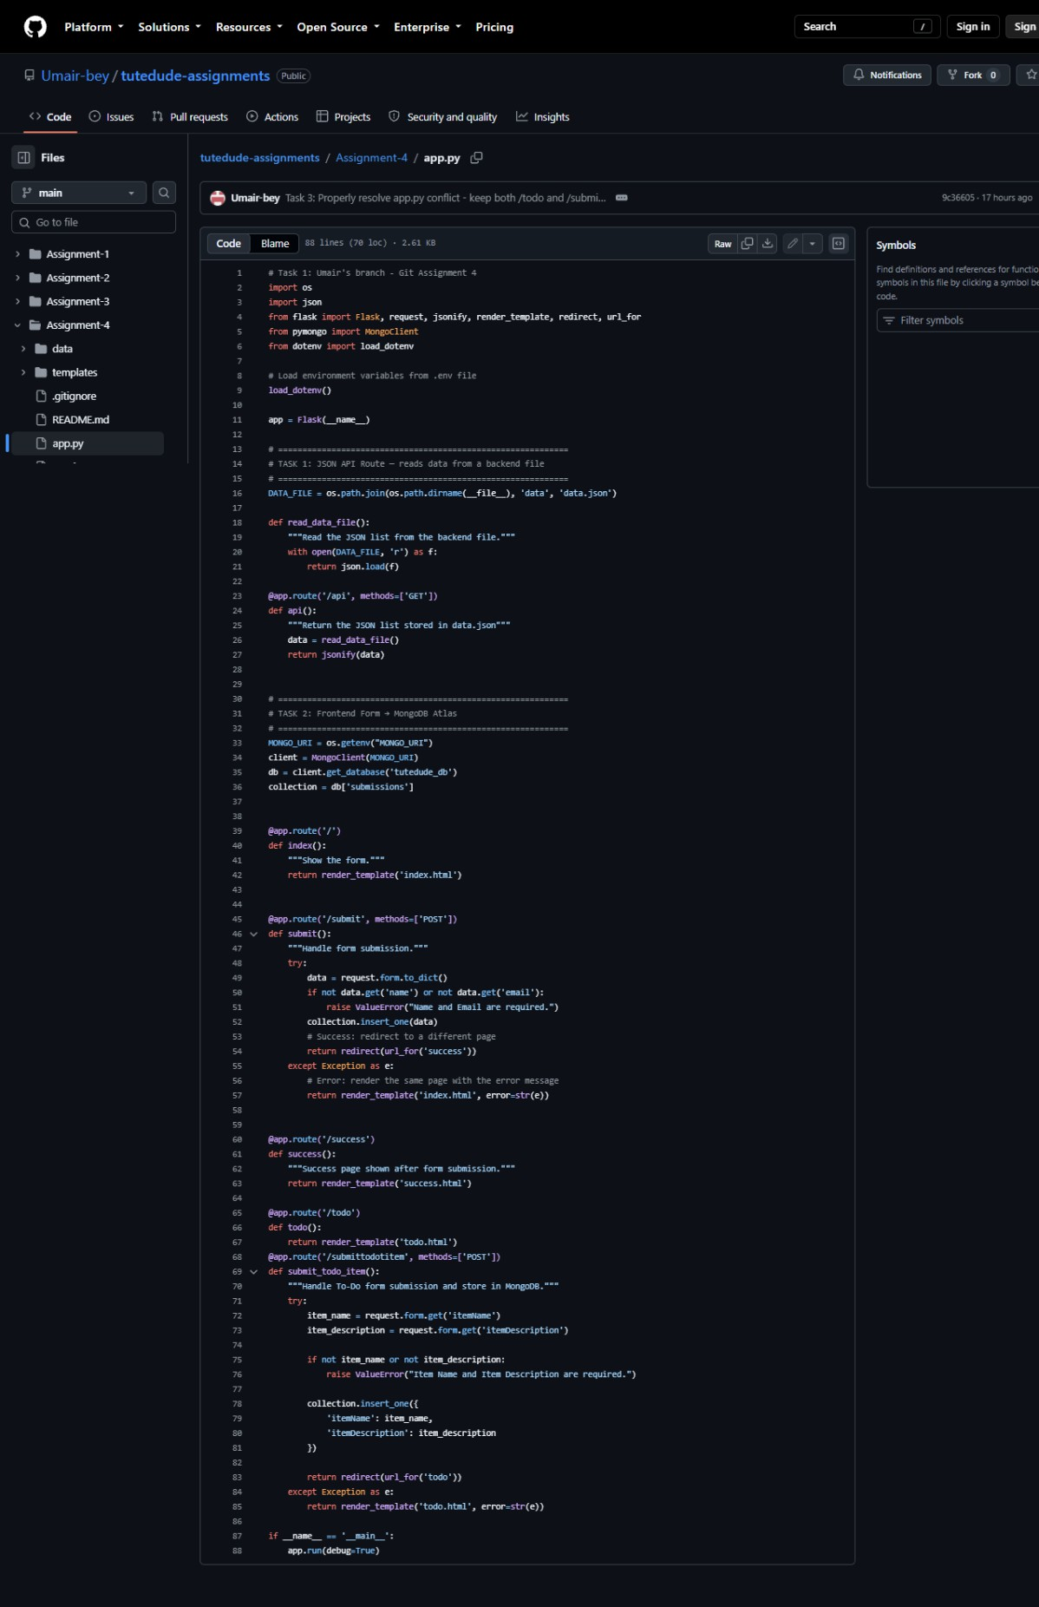

Step 4: Merged Both Branches into main

Commands:
git checkout main git merge master_1 git merge master_2

Conflict in app.py (both branches added routes)
Resolution: Accepted both changes — kept /todo AND /submittodotitem

Commit: 51b7836 — "Task 3: Merge master_1 and master_2 - resolve conflicts, keep both routes"
📸 [Insert Screenshot: task3_04_merge_conflict.png]
📸 [Insert Screenshot: task3_04b_merge_resolved.png]

Step 5: Tested To-Do Form End-to-End

- Flask server running on http://localhost:5000
- Submitted To-Do form
- Data stored in MongoDB Atlas collection tutedude_db.submissions

📸 [Insert Screenshot: task3_05_flask_running.png]
📸 [Insert Screenshot: task3_05b_todo_form_browser.png]
📸 [Insert Screenshot: Task3_mongodb_atlas_todo_items.png]

Step 6: Verified Assignment-4 Folder on GitHub

📸 [Insert Screenshot: Task3_assignment4_folder.png]
📸 [Insert Screenshot: Task3_commit_history.png]

============================================================

5. TASK 4 — SEQUENTIAL COMMITS, RESET & REBASE
============================================================

Step 1: Synced master_1 with main

Command:
git checkout master_1

git merge main

Step 2: Added 3 Fields Sequentially (3 Separate Commits)

Commit 1 — 74212d1 — "Task 4: Add Item ID field to To-Do form" Commit 2 — be02f52 — "Task 4: Add Item UUID field to To-Do form" Commit 3 — cf2bc93 — "Task 4: Add Item Hash field to To-Do form"
📸 [Insert Screenshot: Task4_sequential_log.png]
📸 [Insert Screenshot: Task4_todo_form_5_fields.png]

Final todo.html contains all 5 fields:
Item ID, Item UUID, Item Hash, Item Name, Item Description

Step 3: Merged master_1 into main

Command:
git checkout main git merge master_1

Step 4: Soft Reset to Item ID Commit

Command:
git reset --soft 74212d1

Result:
UUID and Hash changes became staged but not committed

Re-committed: 7f011ce — "Task 4: Re-commit - state with only Item ID field in To-Do form"

📸 [Insert Screenshot: Task4_itemid_detail.png]

Shows difference between original Item ID commit (74212d1) and re-commit (7f011ce)

Step 5: Rebase master_1 onto Updated main

Command:
git checkout master_1 git rebase main

Conflict in todo.html — resolved by keeping all 5 fields
Result: Successfully rebased and updated refs/heads/master_1

📸 [Insert Screenshot: task4_05_rebase_conflict.png]
📸 [Insert Screenshot: task4_05b_rebase_success.png]

Step 6: Force-Pushed master_1

Command:
git push origin master_1 --force

Step 7: Merged Final State into main

Commands:
git checkout main git merge master_1 git push origin main

Step 8: Final Commit Graph

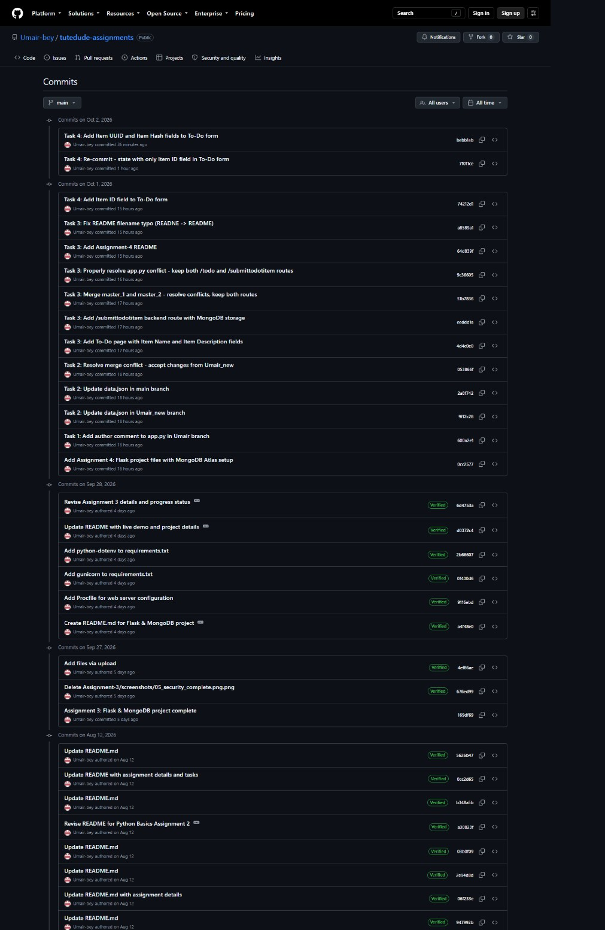

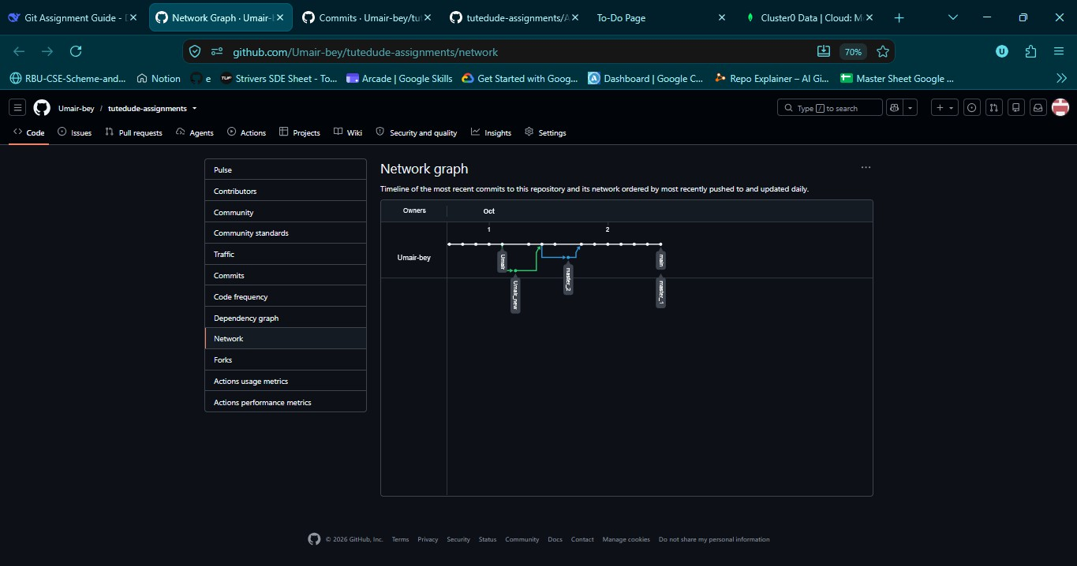

Confirms: sequential commits, reset, and rebase are all visible in history

============================================================

GITHUB REPOSITORY
============================================================

Repository: https://github.com/Umair-bey/tutedude-assignments Assignment 4 folder:
https://github.com/Umair-bey/tutedude-assignments/tree/main/Assignment-4

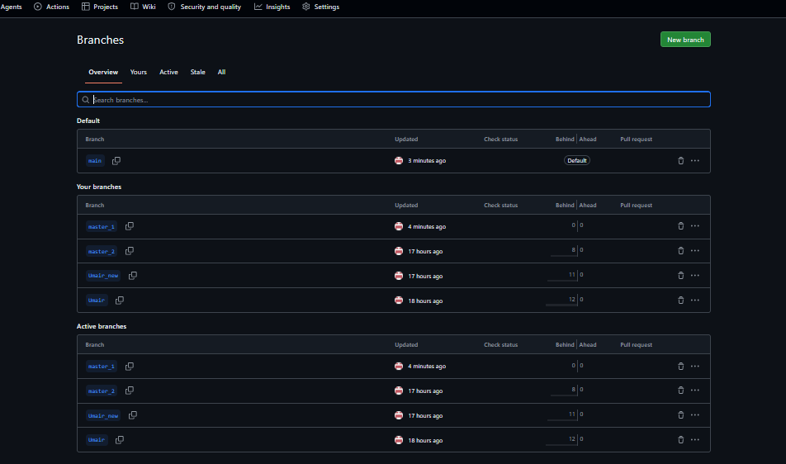

============================================================

CONCLUSION
============================================================

All 4 tasks completed successfully:

Task 1: SSH setup, branch Umair created and merged to main
Task 2: Branch Umair_new, JSON conflict resolved by accepting _new changes Task 3: Parallel branches master_1 (frontend) + master_2 (backend API),
merged with MongoDB Atlas integration
Task 4: Sequential commits (ID → UUID → Hash), soft reset, rebase, and final merge

PROJECT STRUCTURE

Assignment-4/
├── app.py
├── requirements.txt
├── .env (gitignored — contains MongoDB URI)
├── .gitignore
├── data/
│ └── data.json

├── templates/
│ ├── index.html
│ ├── success.html
│ └── todo.html
├── static/
├── screenshots/
│ └── [all task screenshots]
└── README.md

- GitHub Repository: https://github.com/Umair-bey/tutedude-assignments

