Riphah International University
I-14 Main Campus
Faculty of Computing
Class: | FALL-2025  DS 5-1 | Subject: | Data Warehousing and Business Intelligence
Task: | 003 | Lab Instructor: | Mr.Junaid Khan

UMAIR KHITAB

59841

Task 1: Draw pivot table and Pivot chart to answer queries below:
- Who are the sales reps selling in each category.
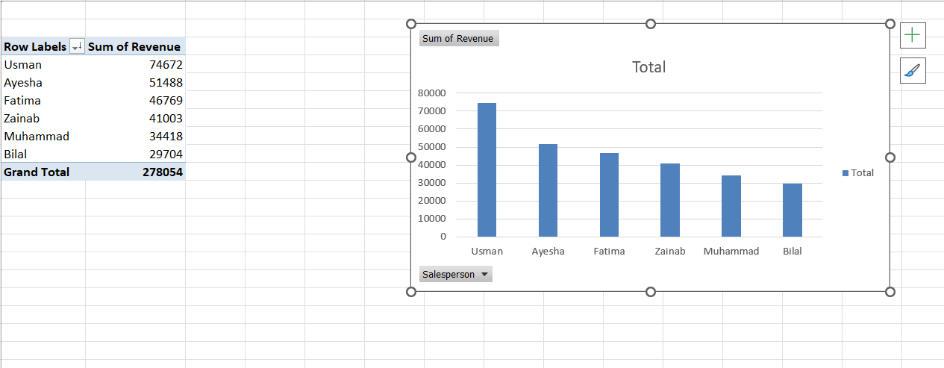

This table shows that usman generate highest ravenue in the given pivot table.

- Display top 5 customers by Revenue.

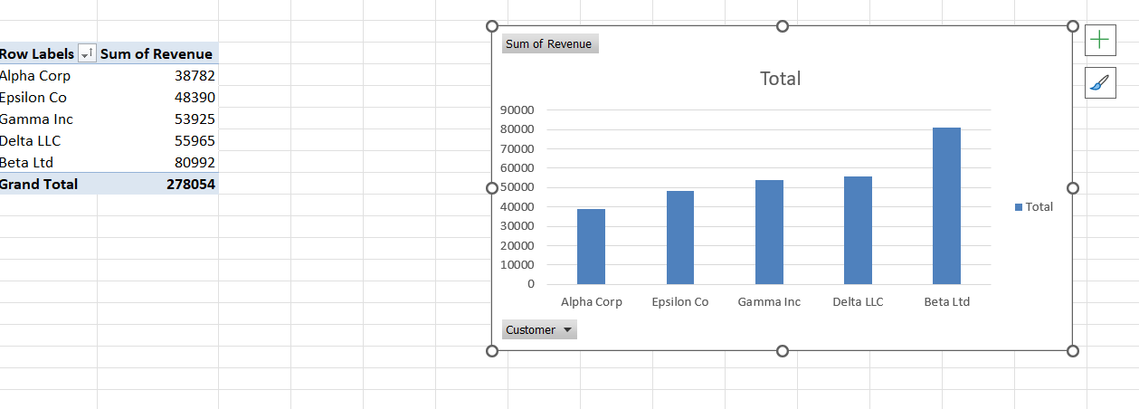

- Display Revenue by Region.
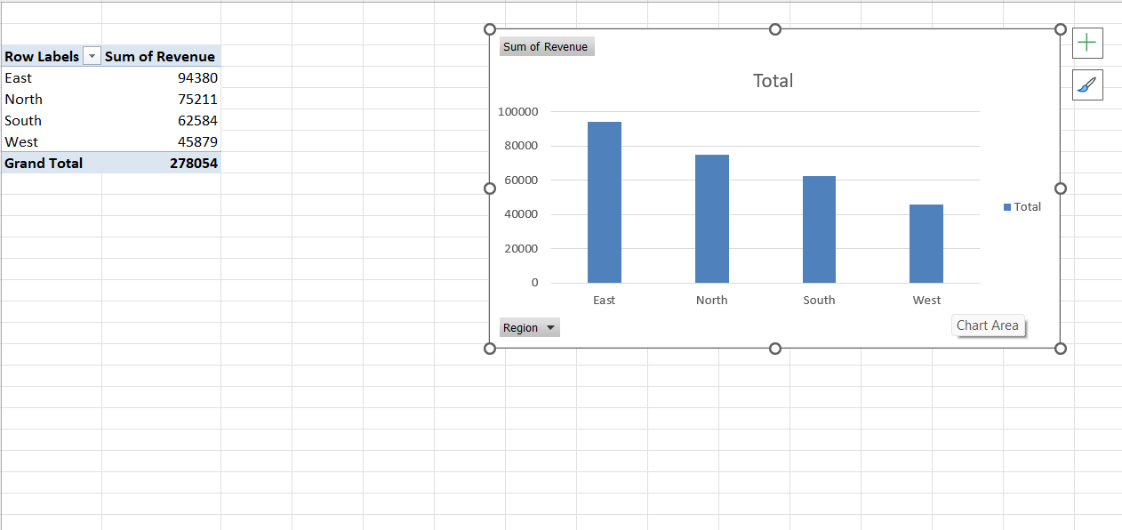

Task 2: Use the provided data and answer the following questions with the help of pivot table:
Pivot Table Investigation Questions
- Which salesperson generated the highest total revenue?
ANS:
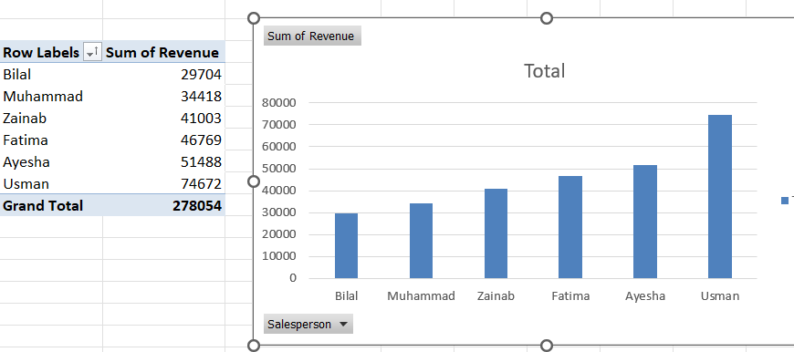
USMAN generated the highest total revenue
- What is the total revenue by region (North, South, East, West)?
ANS:
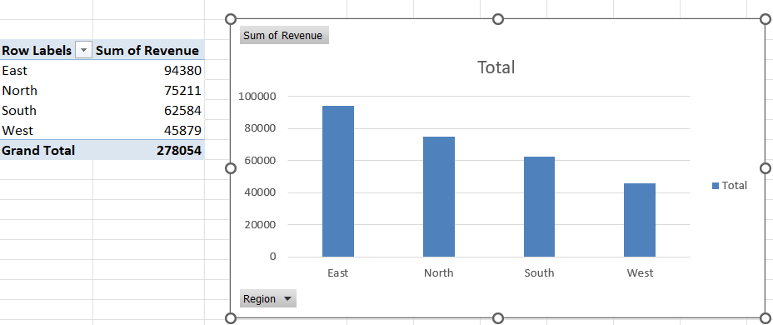

total revenue by region (North, South, East, West) is 278054
- Which customer contributed the most revenue overall?
ANS:
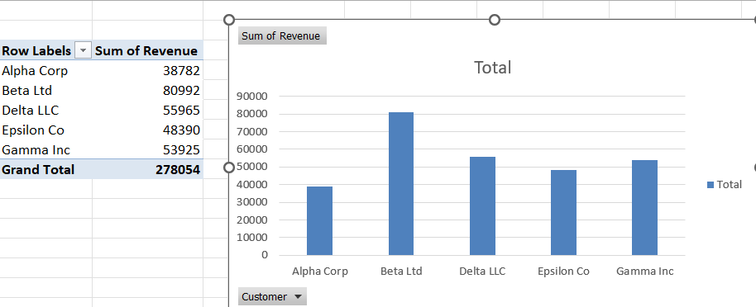
contributed the most revenue overall BETA LTD.
- What is the average revenue per transaction for each product category?
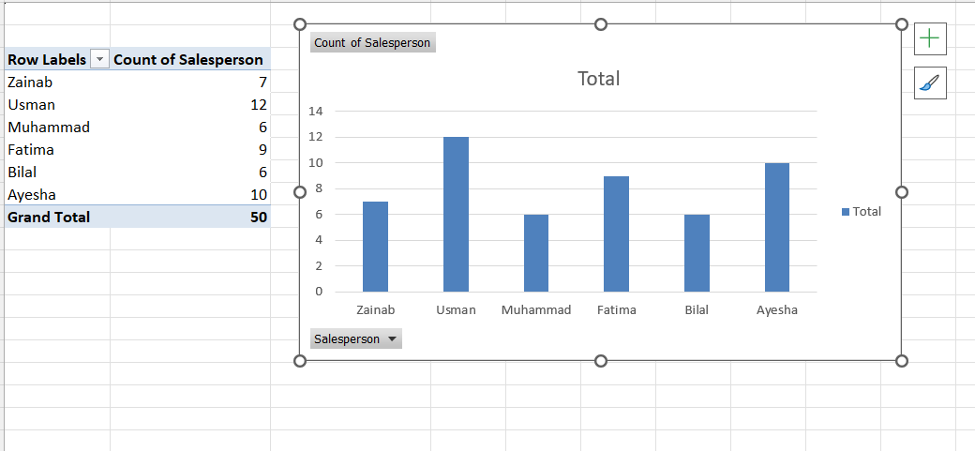

- Which region had the highest sales in the “Electronics” category?
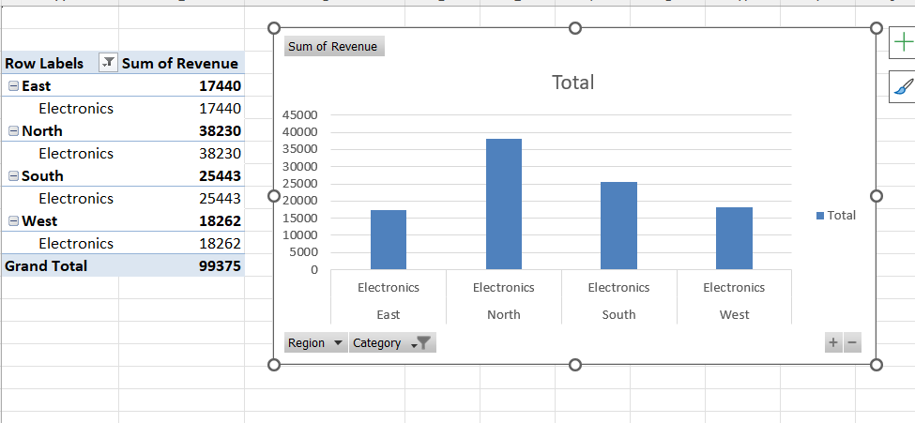
- How does total revenue compare between male vs. female salespersons (if we assume gender mapping to names)?
- What are the top 5 customers by total revenue?
- How has revenue trended month by month in 2024?
- Which salesperson sold the most units (transactions count) across all categories?
- What percentage of total revenue comes from each product category?

