

|  |
| --- |
| Software Requirement Engineering |
| Assignment # 2 |
| Story Boarding |

|  |
| --- |
| Mam Samra  11-8-2019 |

**Group Members:**

**Abdul Rafay Javed FA17-BSE-092**

**Umair Ansar FA17-BSE-069**

**Zunaira Ali FA17-BSE-076**

**Laraib Ishtiaq FA17-BSE-096**

**5B**

**Story Boarding of SE Student Help Desk:**

**Login Form:**

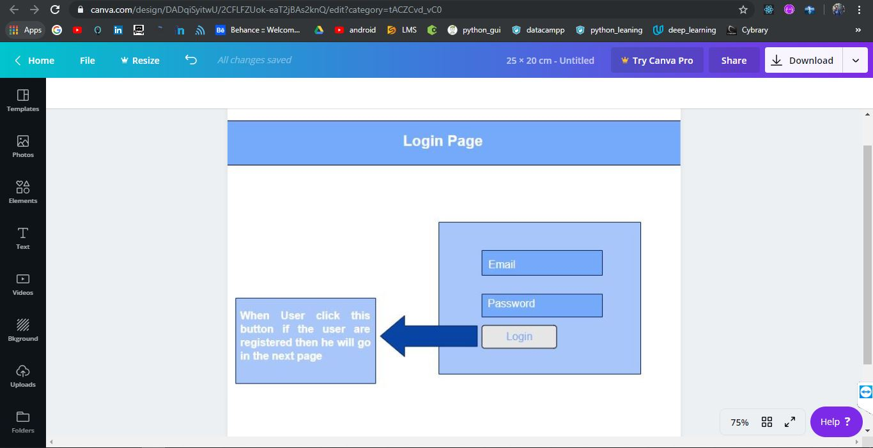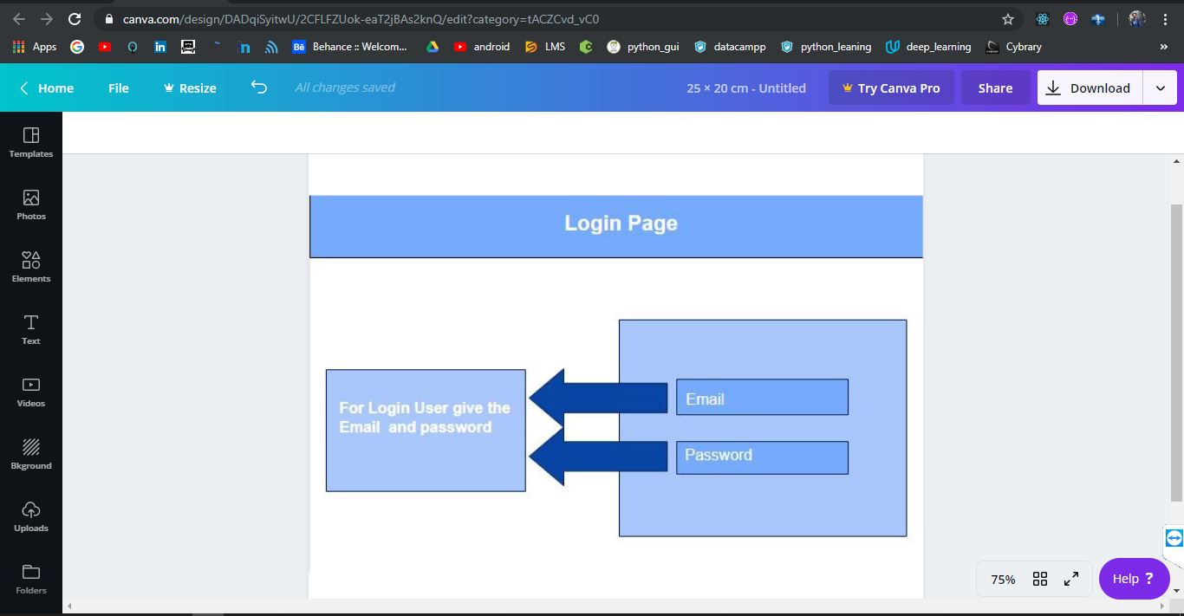

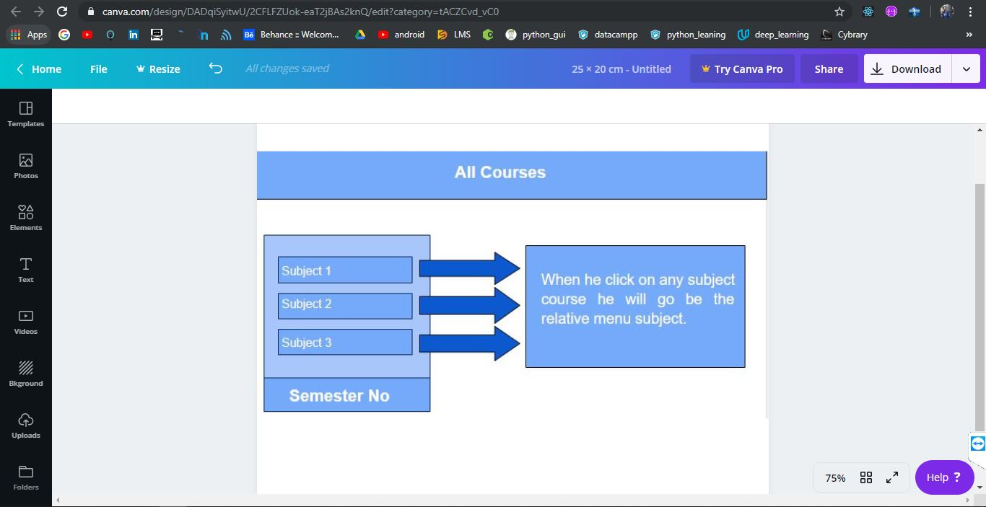

**All Courses:**

**Course Menu:**

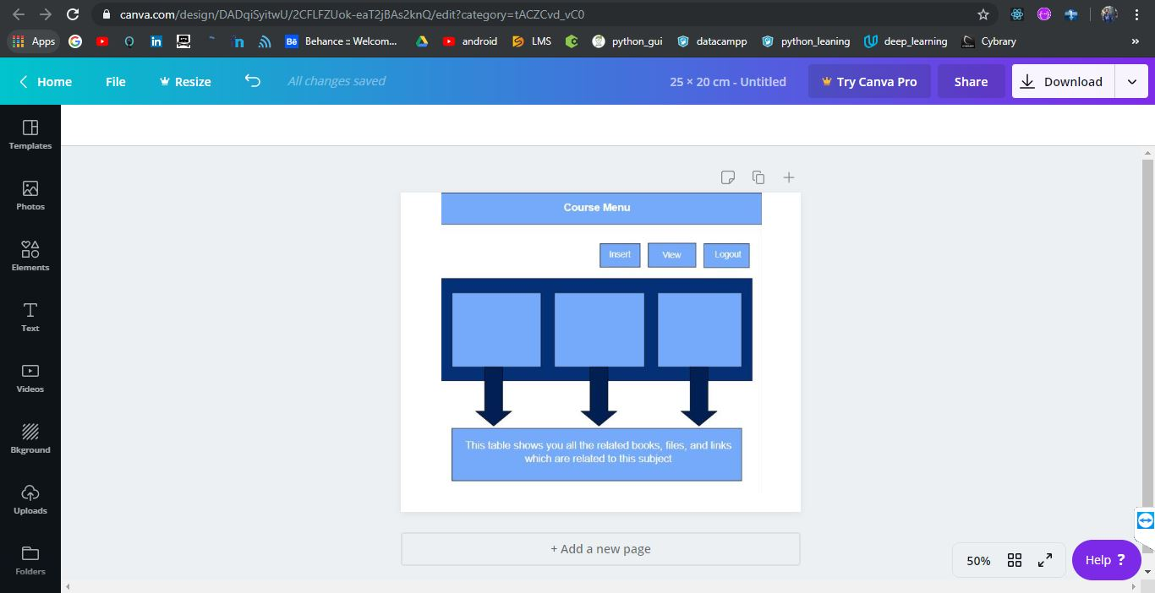

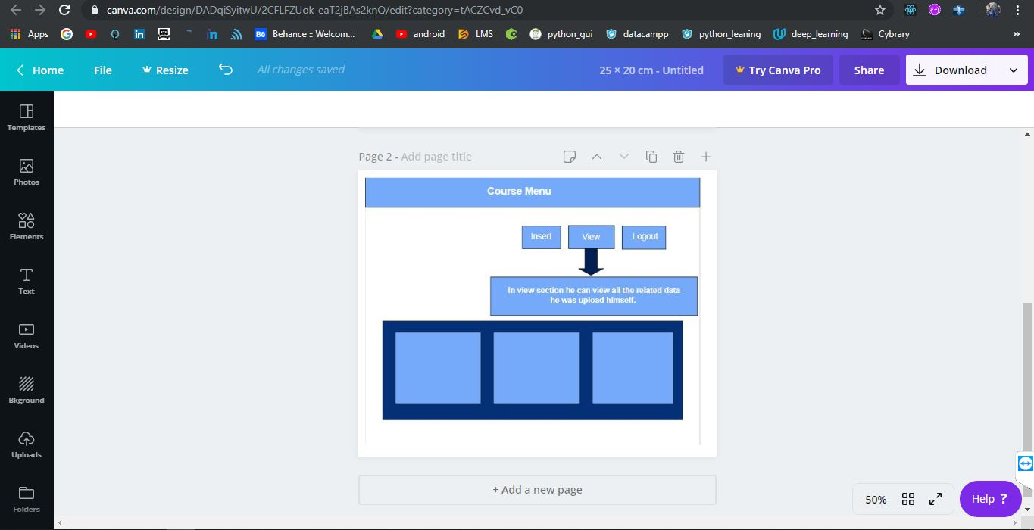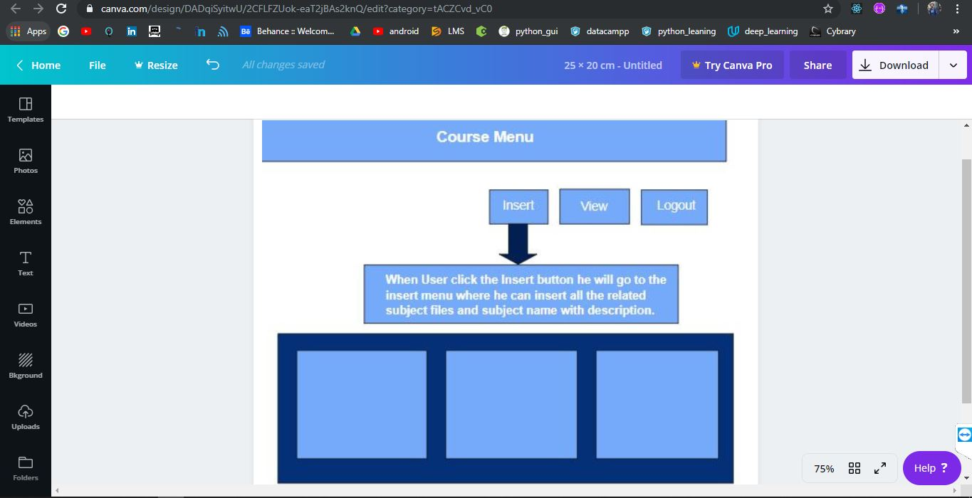

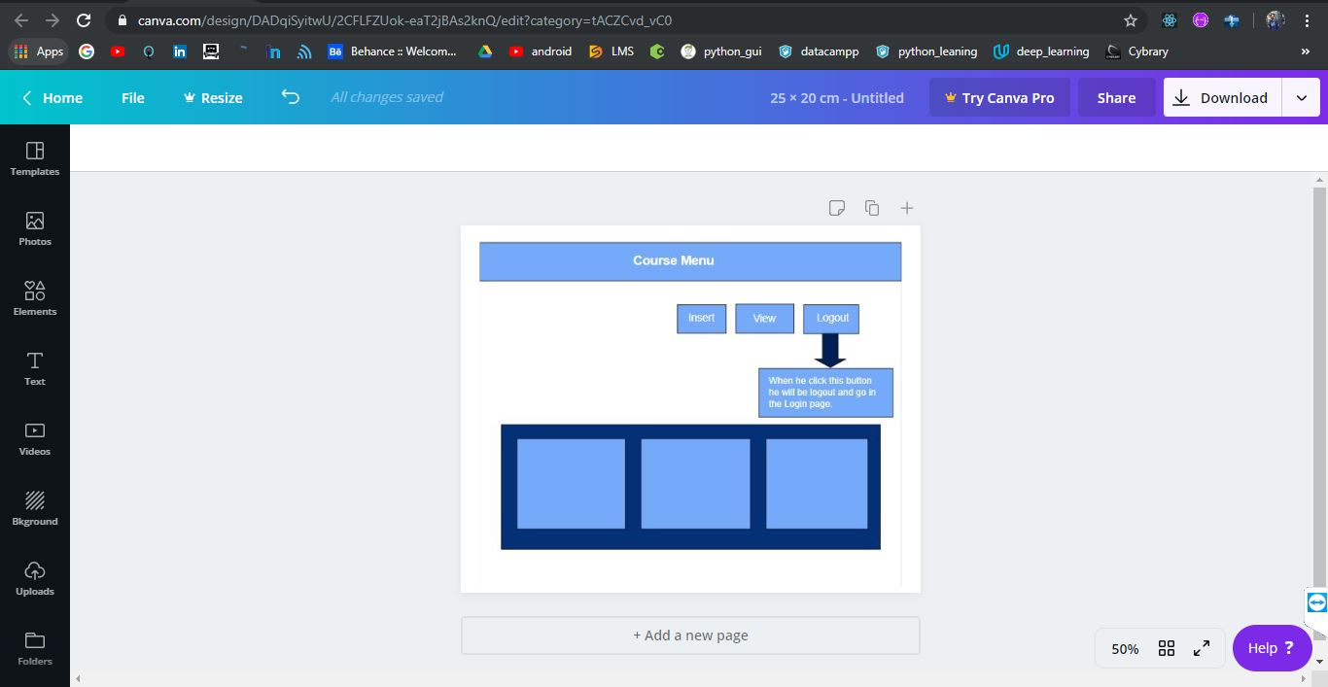

**Insert Menu:**

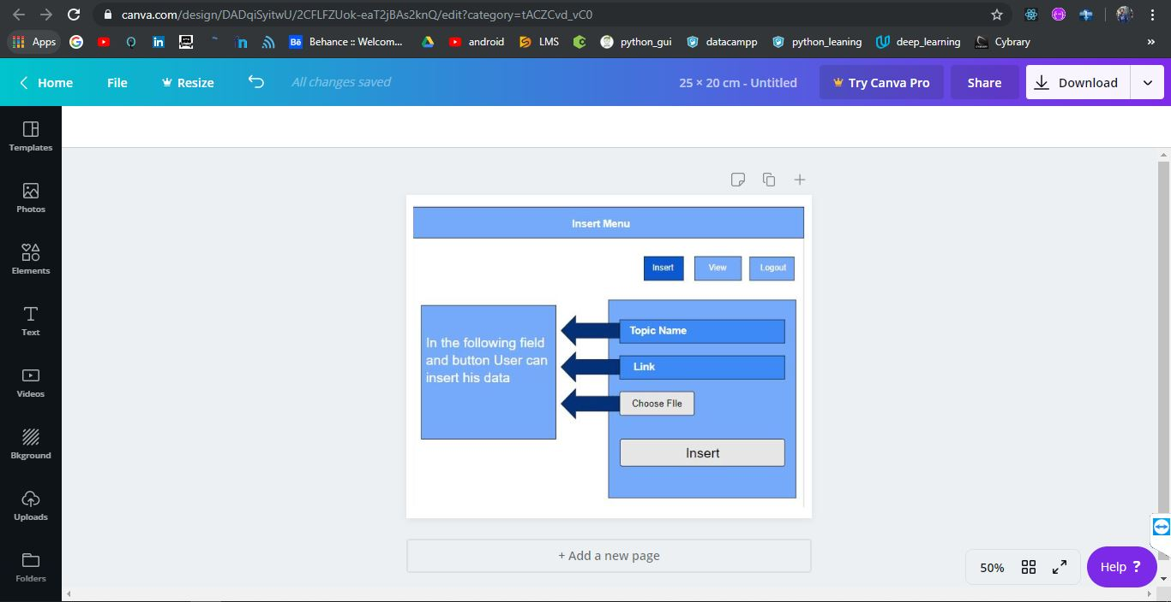

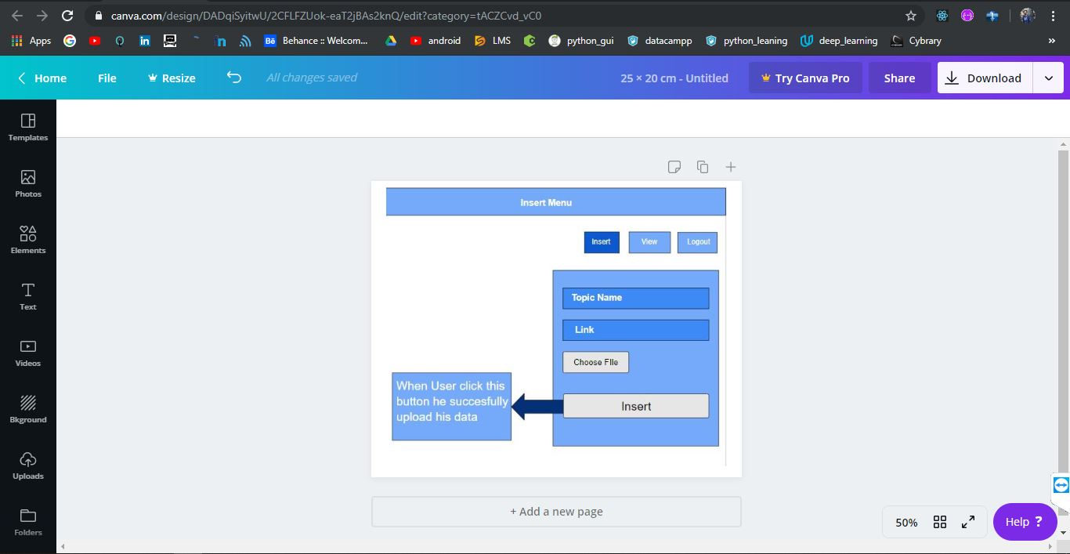

**View Menu:**

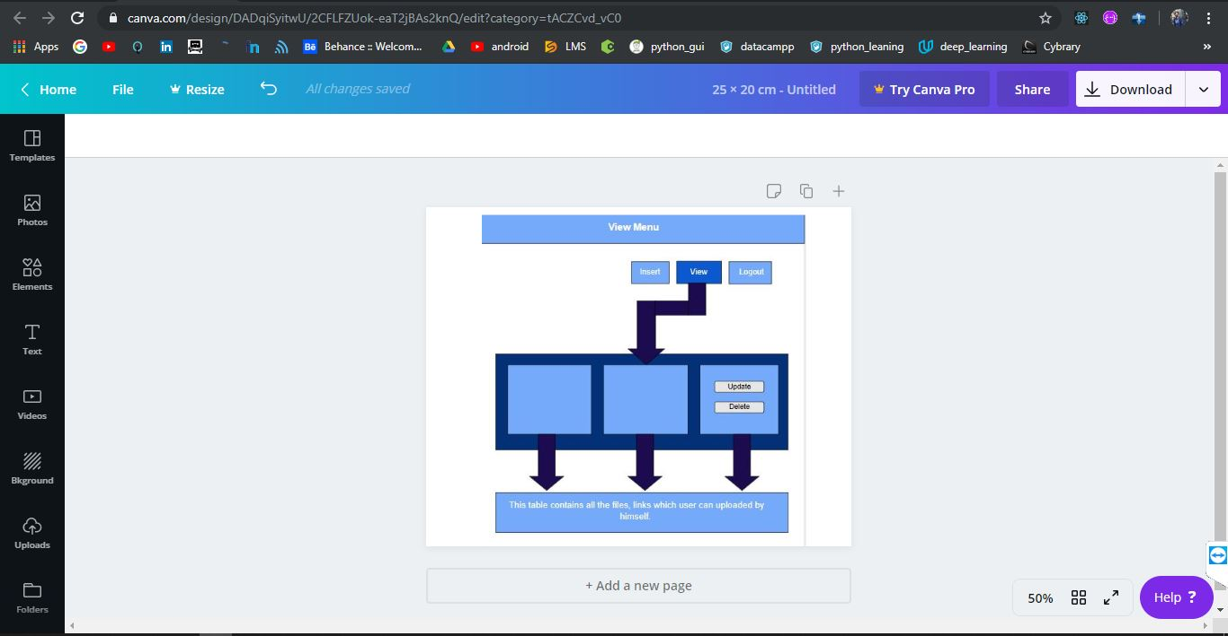

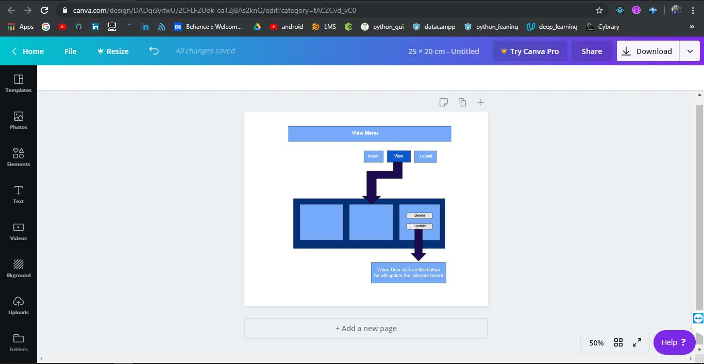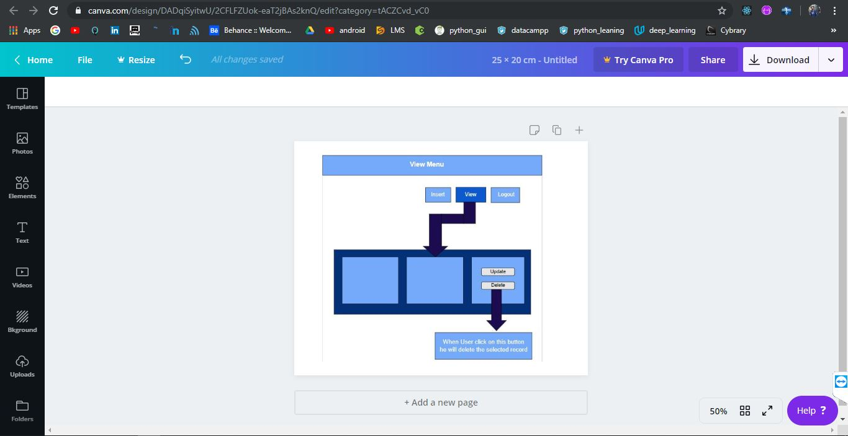

**Update Record:**

**Delete Record:**