Accessibility conformance test report

Page evaluated: ecommerce.html (Vogue & Valor Premium Apparel page, evaluated locally using the WAVE browser extension)
Evaluator: Muhammad Umair

Summary of the conformance test
The conformance test was carried out on the ecommerce.html page using the WAVE browser extension by WebAIM, which automatically scans web pages and reports accessibility issues against WCAG 2.1 standards. The test was performed locally on 15 May 2026. WAVE returned 9 errors, 10 contrast errors and 10 alerts across the page, distributed between the header, the hero section, the product grid, the modal pop-up forms and the footer. The overall WAVE AIM Score was 4.7 out of 10, indicating that the page currently has substantial accessibility barriers.
The most significant issues identified were the absence of alt attributes on the product images, very low colour contrast on the gold accent colour and the muted grey text (the headline Level AA failure on the page), missing and duplicated form labels in the Size Guide modal, a missing lang attribute on the <html> element, and a number of navigation and modal controls implemented as <div> and <span> elements with onclick handlers, which prevents keyboard users from reaching them. The page also has no <h1> heading, a broken skip link, an empty button on the custom order card, and vague link text in the footer. Taken together, these findings show that the page does not currently meet WCAG 2.1 Level AA, and that remediation is required across both Level A and Level AA success criteria before it can be considered accessible.

Results of the conformance test
Note that the information you will be reporting is in your own words, but is based on the ‘Details’ and ‘Reference’ sections in your WAVE conformance test results report.
Error type | Give one or two examples (images of the relevant part of the screen can be useful) | Why is this considered to be an issue? | What should be done? | What level of conformance does it break?
Error title | You can take a screen snippet around the error shown in the page | From “Why it matters” | From “How to fix it” | From “standards and guidance”
Missing alternative text | 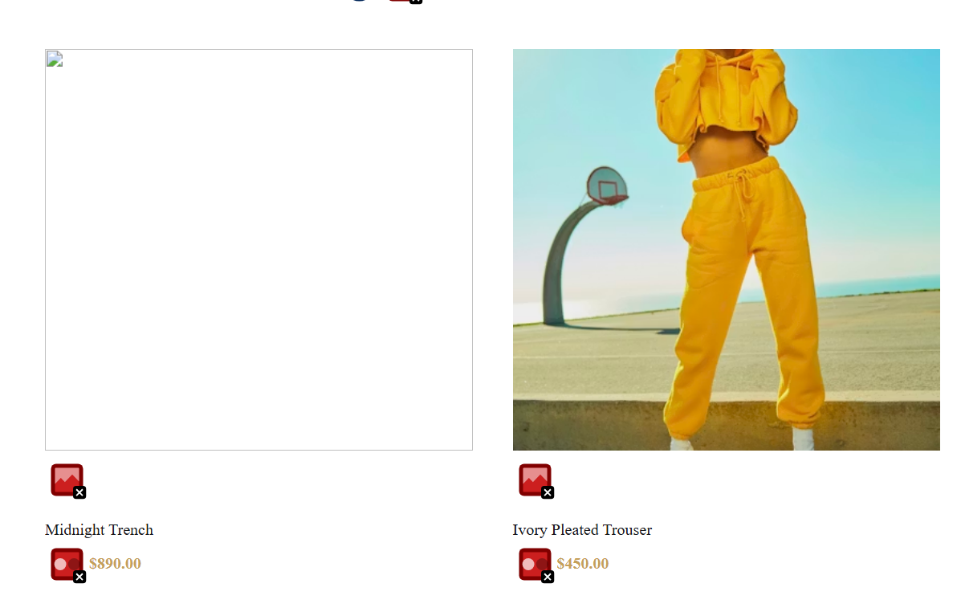 | Screen readers rely on the alt attribute to describe what an image shows. When this attribute is missing, users who are blind or have low vision either hear nothing useful or hear the raw image file name read aloud, which gives no information about the product. This prevents them from understanding what is being sold and blocks them from completing a purchase. Missing alternative text also harms search engine optimisation, since search engines use it to index image content. | Add a descriptive alt attribute to each <img> element that conveys what the image shows in its context. For these product photos, use values such as alt="Black wool midnight trench coat" and alt="Ivory pleated wide-leg trouser". The text should describe the product clearly enough that a user who cannot see the image still understands what it represents. For purely decorative images that add no information, use an empty alt="" so screen readers skip them. | WCAG 2.1 Success Criterion 1.1.1 Non-text Content — Level A
Missing form label | In the "Size Guide" modal (the Fit Consultant pop-up), the input field for Weight (kg) has no usable <label> attached. Although a label element exists in the HTML, both the Height and Weight inputs share the same id="usr-h", so only the Height input is correctly labelled. WAVE flags this with the red "missing label" tag icon next to the Weight input.  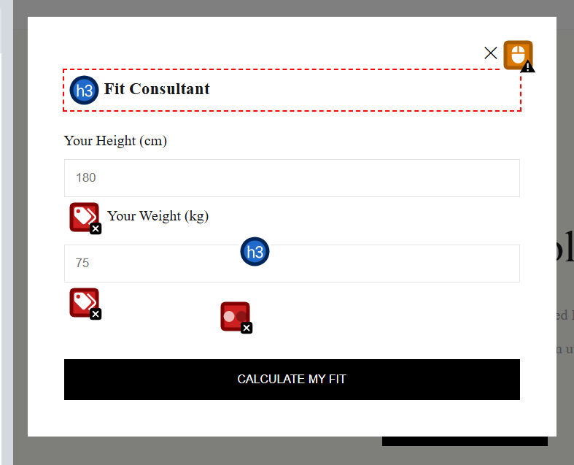 | Form labels tell users what to type into each input field. Screen readers announce the label when focus moves to an input, without one, the input is announced only as "edit text" with no purpose, so users with visual impairments do not know what data to enter. Users with cognitive disabilities also rely on visible labels to stay oriented. In addition, clicking on the visible "Your Weight (kg)" text does not move keyboard focus into the input, because the underlying HTML association is broken. This makes the form harder to use for everyone, not only assistive technology users. | Give each input a unique id and bind the matching <label> to it using the for attribute. For example, change the Height input to id="usr-height" with <label for="usr-height">Your Height (cm)</label>, and the Weight input to id="usr-weight" with <label for="usr-weight">Your Weight (kg)</label>. Every form control on the page should have a unique ID and a directly associated label. | WCAG 2.1 Success Criterion 1.3.1 Info and Relationships — Level A, and 4.1.2 Name, Role, Value — Level A
Multiple form labels | In the same Size Guide modal as Row 2, the Height input is associated with two <label> elements at once. Both labels ("Your Height (cm)" and "Your Weight (kg)") use for="usr-h", and because the Height input is the first element with that id, both labels attach to it. WAVE flags this with the red "multiple labels" icon. This is the same screenshot as Row 2, since the duplicate id="usr-h" is the root cause of both errors.   | HTML requires every element's id to be unique on the page. When two inputs share the same id, the browser and assistive technologies cannot reliably associate either label with the correct input. Screen readers may announce the wrong label, both labels stacked together, or none at all, depending on the user's assistive technology and browser combination. This produces inconsistent and confusing behaviour, and means users cannot trust what they are being told about each form field. It also breaks the semantic link that allows clicking a label to focus its input. | Replace the duplicate id="usr-h" attributes with unique IDs on each input (for example usr-height and usr-weight). Update each <label> element's for attribute to point to its matching input. Each form control on the page should have exactly one unique id and exactly one <label> element pointing to it. | WCAG 2.1 Success Criterion 1.3.1 Info and Relationships (Level A), and 3.3.2 Labels or Instructions (Level A)
Language missing or invalid | The <html> element at the top of the document has no lang attribute set. In the source code, the opening tag is simply <html> instead of <html lang="en">. WAVE flags this with the red globe icon in the "applies to the entire page" section at the top of the WAVE overlay. | The lang attribute tells assistive technologies and browsers which language the page is written in. Screen readers use this information to select the correct pronunciation engine and voice (English, French, Arabic and so on). Without a lang value, a screen reader may default to the user's system language and mispronounce the entire page, making the content hard or impossible to understand. The attribute is also used by automatic translation tools, by search engines for indexing, and by browsers when offering to translate a page for the user. | Set the language of the page by adding a lang attribute to the <html> element at the top of the document. For this page, change <html> to <html lang="en">. The value should be a valid two-letter language code matching the primary language of the content. If a specific section of the page is written in a different language, the lang attribute can also be applied to individual elements as needed. | WCAG 2.1 Success Criterion 3.1.1 Language of Page (Level A)
Empty button | The third product card in the "Featured Curations" grid is the "Request Custom Order" card. Its main interactive element is a large <button> containing only an SVG plus-sign icon, with no text label and no aria-label attribute. WAVE flags this with the red "empty button" icon directly on the control.  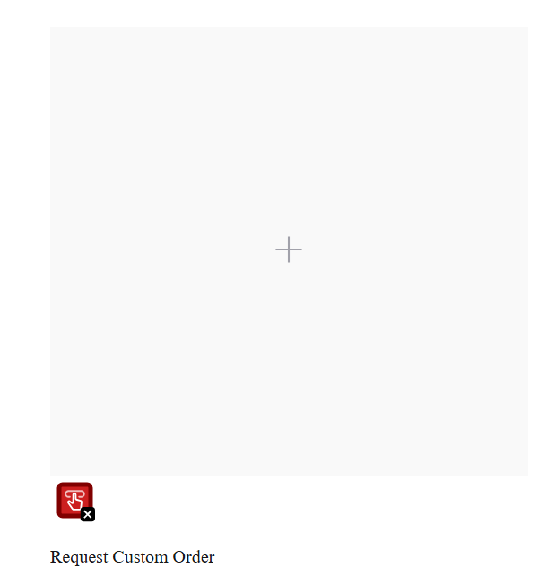 | Buttons need an accessible name so that users know what they do before activating them. When a button is empty, screen readers announce it only as "button" with no further information. A visually impaired user has no way to know that this button opens a custom order request. The visible "Request Custom Order" text below the button is not programmatically associated with it, so assistive technology cannot pair them together. This blocks the user from using a key feature of the page. | Give the button a clear accessible name in one of two ways. The simplest option is to add an aria-label attribute to the <button> element, for example aria-label="Request a custom order". Alternatively, place visually hidden text inside the button using a CSS-hidden span, such as <span class="visually-hidden">Request a custom order</span>. In both cases, the SVG icon itself should also be marked with aria-hidden="true" so it is not announced separately. | WCAG 2.1 Success Criterion 1.1.1 Non-text Content (Level A), and 4.1.2 Name, Role, Value (Level A)
Broken skip link | At the very top of the page there is a skip link with the text "Skip to Inventory" and href="#main-inventory". However, no element on the page has the matching id="main-inventory". The product catalog uses id="catalog" instead. WAVE flags this with the red "broken skip link" icon at the top of the page.  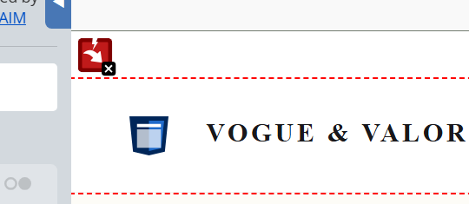 | Skip links exist so that keyboard-only users and screen reader users can bypass repetitive content (such as the header and navigation) and jump straight to the main content of the page. When the target of a skip link does not exist, activating the link does nothing. The user remains stuck at the top of the page and has to tab through every navigation item to reach the products. This wastes time and energy for users who depend on the keyboard, and undermines a core mechanism that WCAG requires for navigation. | Make the skip link target match an existing element on the page. The cleanest fix is to wrap the product catalog in a <main> landmark element and give it the expected ID, for example <main id="main-inventory">, which also adds a proper landmark for screen readers. Alternatively, change the skip link itself to href="#catalog" to match the existing ID on the catalog <div>. Either approach restores the skip link's function.
Very low contrast | WAVE detects 10 instances of very low contrast across the page. The main offenders are the gold accent colour #c5a059 used for prices ("$890.00", "$450.00"), section titles, and footer links on a white background; the muted grey #a1a1aa used for navigation items and the hero subtitle text on white; and the footer body text in #71717a on the dark #18181b background. WAVE marks each occurrence with the red "very low contrast" icon.  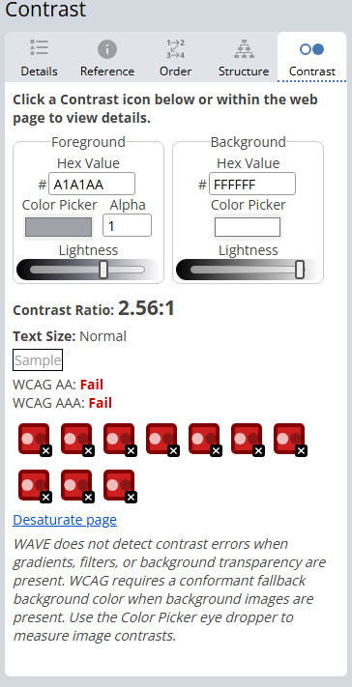 | WCAG 2.1 at Level AA requires a contrast ratio of at least 4.5 to 1 for normal text and 3 to 1 for large text. The gold accent on white sits at roughly 2.4 to 1, and the muted greys on their respective backgrounds fall well below the threshold too. Low contrast creates a real barrier for users with low vision, age-related sight loss, and certain forms of colour blindness. It also affects users in challenging environments such as bright sunlight or low-quality screens. Since prices, section titles, and footer links are critical information for buying decisions, putting them in colours that many users cannot read comfortably undermines the basic usability of the shop. This is the most widespread Level AA failure on the page. | Adjust each colour until it meets the 4.5 to 1 ratio on its background. The WebAIM Contrast Checker (https://webaim.org/resources/contrastchecker/) is the standard tool for this. For the gold accent, replace #c5a059 with a darker shade such as #8b6914 or similar that passes 4.5 to 1 on white. For the muted grey on white, lighten the foreground to at least #595959. For the dark footer, use a much lighter grey such as #d4d4d8 for body text. Test each value in the checker before committing the change. Do not rely on colour alone for meaning anywhere on the page. | WCAG 2.1 Success Criterion 1.4.3 Contrast (Minimum) (Level AA)
Missing first level heading | The page has no <h1> element anywhere in the document. The hero section uses <h3> ("The Equinox Collection"), the section title uses <h4> ("Featured Curations"), and the footer columns use <h5> ("Boutique Info", "Support", "Newsletter"). The heading hierarchy starts at level 3 and skips levels in both directions. WAVE flags this with the orange "h1" alert icon at the top of the page.  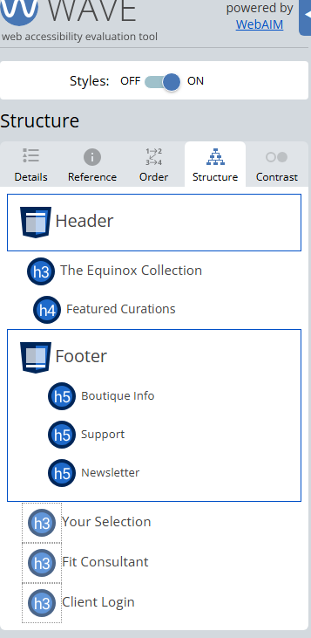 | The <h1> is the primary heading of a page and tells users (and assistive technology) what the page is about. Screen reader users often press a single keystroke to jump straight to the <h1> as a way of orienting themselves on a new page. Without one, this navigation shortcut fails and the user is left without a clear starting point. Skipping heading levels (going from <h3> straight to <h5> for example) also breaks the logical document outline, which makes the page harder to scan with assistive technology. Search engines also use the <h1> heavily when indexing the page, so its absence harms SEO and discoverability of the shop. | Add a clear <h1> near the top of the page that describes the page or site, for example <h1>Vogue & Valor - Premium Apparel</h1>. This can be styled visually to fit the design, or visually hidden using a screen-reader-only CSS class if the layout already communicates the brand. Then correct the rest of the heading hierarchy so it follows a logical order without skipping levels: the hero section should become <h2>, the "Featured Curations" section title also <h2> (a sibling), product names <h3>, and footer column titles <h2> or <h3>. | WCAG 2.1 Success Criterion 1.3.1 Info and Relationships (Level A), and 2.4.6 Headings and Labels (Level AA)
Suspicious link text | Two links in the footer "Support" column use vague text that gives no information about where they lead. The first reads "For return policies, click here" with the link text being only "click here", and the second reads "For shipping updates, read more" with the link text being only "read more". WAVE flags both with the orange "suspicious link text" alert icon.  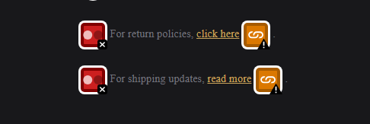 | Screen reader users frequently navigate a page by pulling up a list of all links, separated from the surrounding text. In that list, "click here" and "read more" appear with no context and look identical to dozens of other vague links across the web. The user has no way to tell what either link does without restoring focus to the surrounding paragraph, which defeats the point of the shortcut. Vague link text also harms search engine optimisation, because search engines use the visible link text to understand and rank the destination page. Descriptive link text is one of the cheapest accessibility improvements available and benefits every user, not only those using assistive technology. | Rewrite each link so that the link text alone describes the destination. The first link should become something like <a href="...">View our return policy</a>, and the second should become <a href="...">Read shipping information</a>. The surrounding sentence can be adjusted or removed since the link text now stands on its own. As a general rule, the visible text of every link on the page should make sense when read out of context. | WCAG 2.1 Success Criterion 2.4.4 Link Purpose (In Context) (Level A)
Device dependent event handler | Seven elements on the page use onclick handlers on non-interactive HTML elements such as <div> and <span>. These include the "VOGUE & VALOR" logo, the three navigation items in the header ("Bag (0)", "Size Guide", "Account"), and the three modal close triggers (the small "✕" symbols inside each pop-up). WAVE flags each of these with the orange "device dependent event handler" alert icon.  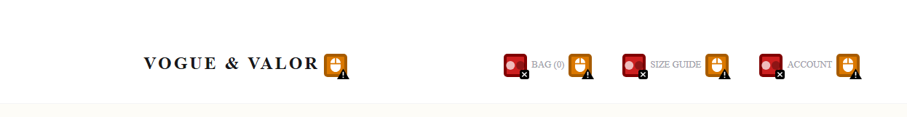 | <div> and <span> elements are not focusable by keyboard by default and are not announced as interactive controls by screen readers. Attaching an onclick handler to them only responds to mouse clicks, which means keyboard users (including people with motor impairments who cannot use a mouse, and screen reader users who navigate with the Tab key) cannot reach or activate these controls at all. On this page, that means a keyboard-only user cannot open the shopping bag, the size guide, the account panel, or close any of the pop-up modals once opened. This effectively breaks the site for anyone who does not use a mouse, which is a fundamental Level A failure. | Replace each non-interactive element that has an onclick handler with a proper interactive element. The navigation items and modal close triggers should become <button> elements (which are focusable, keyboard activatable, and announced correctly by assistive technology). The logo, if it is meant to act as a link to the homepage, should be wrapped in an <a href="/"> element. The onclick attributes can then be replaced with addEventListener calls in the script tag for cleaner separation of behaviour from markup. Keyboard support (Enter and Space keys) is then provided automatically by the browser. | WCAG 2.1 Success Criterion 2.1.1 Keyboard (Level A)

