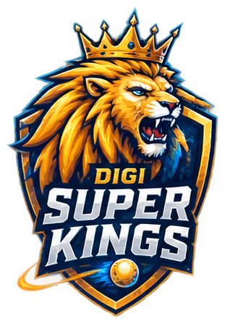
DIGI SUPER KINGS

DSK


SAHYADRICHE MAVALE

SM

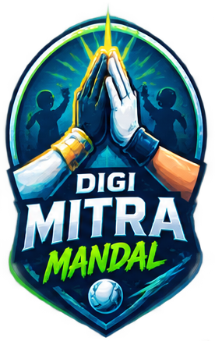
DIGI MITRA MANDAL

DMM

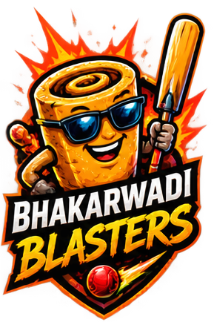
BHAKARWADI BLASTERS

BB

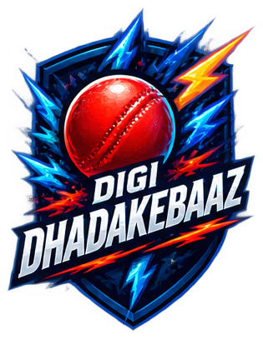
DIGI DHADAKEBAAZ

DD


CRICKET WALA

CW

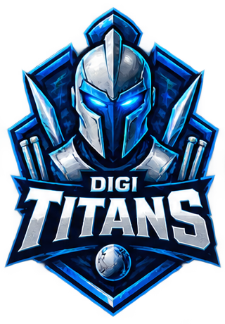
DIGI TITANS

DT

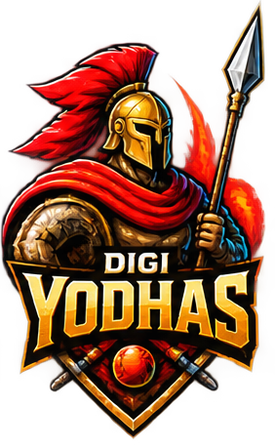
DIGI YODHAS

DY

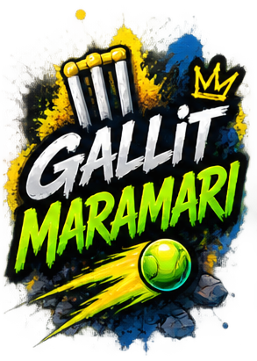
GALLIT MARAMARI

GM

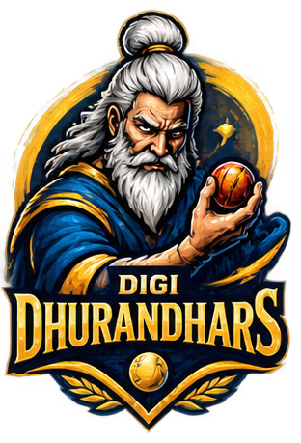
DIGI DHURANDHARS

DDH

