**COMPARE AND CONTRAST**

**Some of the items have been removed, fill these gaps.**

| **Comparison chart:** Hardware versus Software comparison chart | | |
| --- | --- | --- |
|  | **Hardware** | **Software** |
| **Definition** | Devices that are required to store and execute (or run) the software. | Collection of instructions that enables a user to interact with the computer. Software is a program that enables a computer to perform a specific task, as opposed to the physical components of the system (hardware). |
| **Types** | Input, storage, processing, control, and output devices. | System software, Programming software, and Application software. |
| **Examples** | CD-ROM, monitor, printer, video card, scanners, label makers, routers , and modems. |  |
| **Inter dependency** |  | To deliver its set of instructions, Software is installed on hardware. |
| **Failure** |  | Software failure is systematic. Software does not have an increasing failure rate. |
| **Durability** |  | Software does not wear out over time. However, bugs are discovered in software as time passes. |
| **Nature** | Hardware is physical in nature. |  |

**Using the above chart, write the similarities and differences between a “Computer” and “Laptop” in a paragraph.**

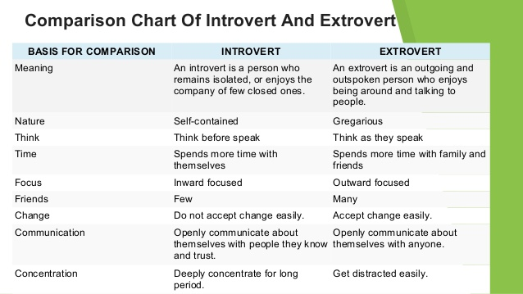

*Gregarious:fond of company

**Read the above chart, use the above example and list some of the similarities between citizens of India and Pakistan. Also, write a comparison of your favorite personal personality/character with your friend in a paragraph.**

|  |
| --- |
|  |
|  |

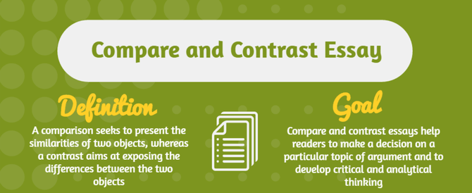

* **Intro (background)**

Start with a capturing and interesting hook. Outline what your topic is. Point to the main argument of your topic known as a thesis statement. This sentence or two usually come in the last sentence of your first paragraph.

* **Developing your arguments**

You need to research your topic to choose **three claims**. Include evidence with the supporting points next to each argument. There should be up to three supporting points in each body paragraphs.

* **Refuting opponent's arguments**

This time, you need to **research the topic to view the facts that contradict your thesis**. It is important to choose at least one example and develop a paragraph with the counter-argument as well. Write down maximum two opposing views followed by a couple of your refutations.

* **Conclusion**

Restate your thesis statement and stress why your side is right once again.

**Generating Ideas: Brainstorm three claims and contradictory ideas. Use visuals for effective points.**

1. Coffee and Tea: The Effects of Both
2. School vs. College: What's New
3. Academic writing before and after the eighth week.
4. US President vs. Canadian Prime Minister
5. World War I and World War II: Difference in Events
6. Comparing Writing and Mathematics Classes

