**\*\*\*\*\*\*\*\*\*\*\*\*\*\*\*\*\*\*\*\*\*First Week After Mid Work \*\*\*\*\*\*\*\*\*\*\*\*\*\*\*\*\*\*\*\*\***

**Task-1: Creating Fragments:  
  
Fragments:**

A fragment represents a reusable portion of our android app UIs. It has its own lifecycle, and is always created either in an activity or in an another fragment.

**Steps:**

1. **Create a new project in android studio with Empty Activity.  
   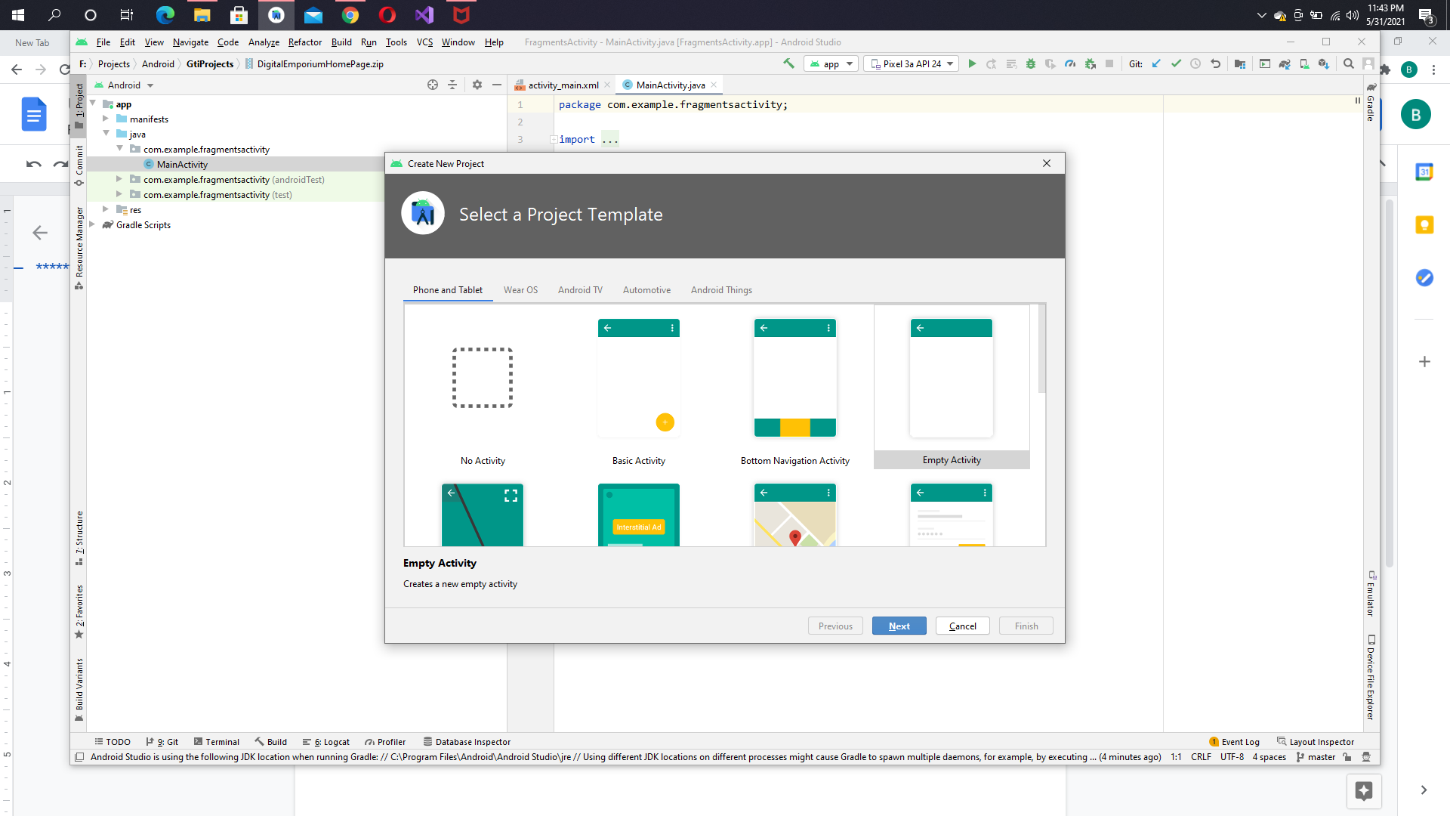**
2. **Write down the project name  
   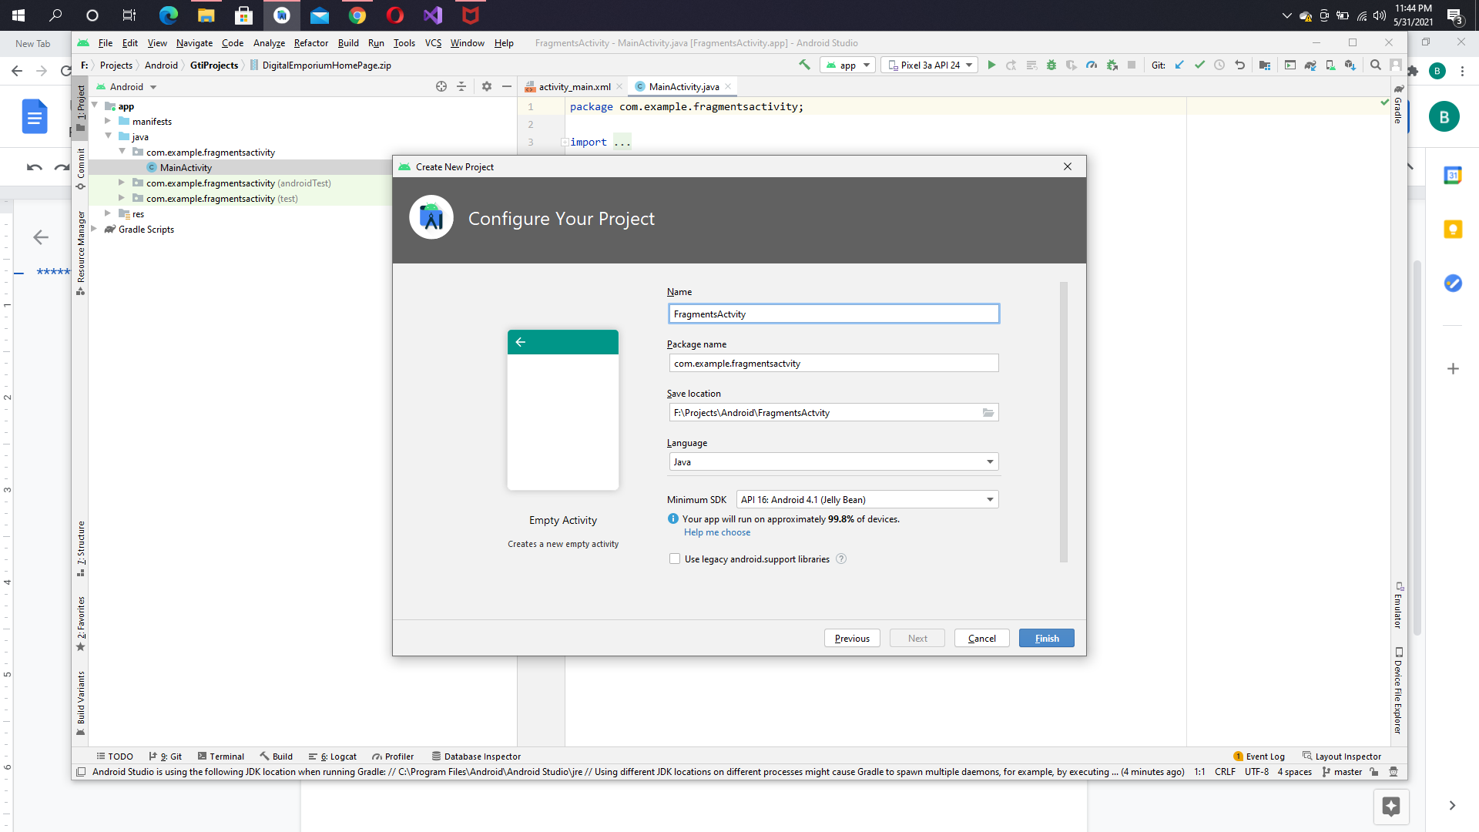**
3. **So here you have an empty activity   
   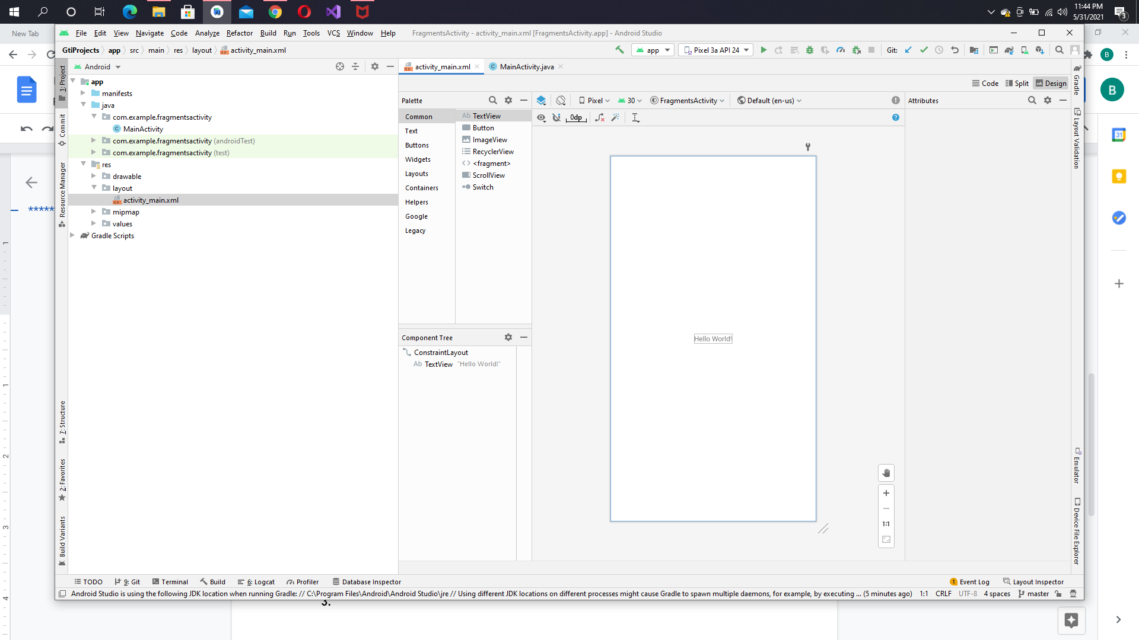**
4. **First of all, we’ll create a frame layout in which our fragment will live.  
   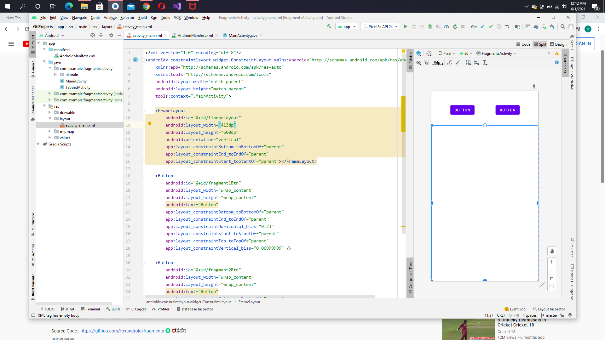**
5. **Now, we’ll add fragment in java   
   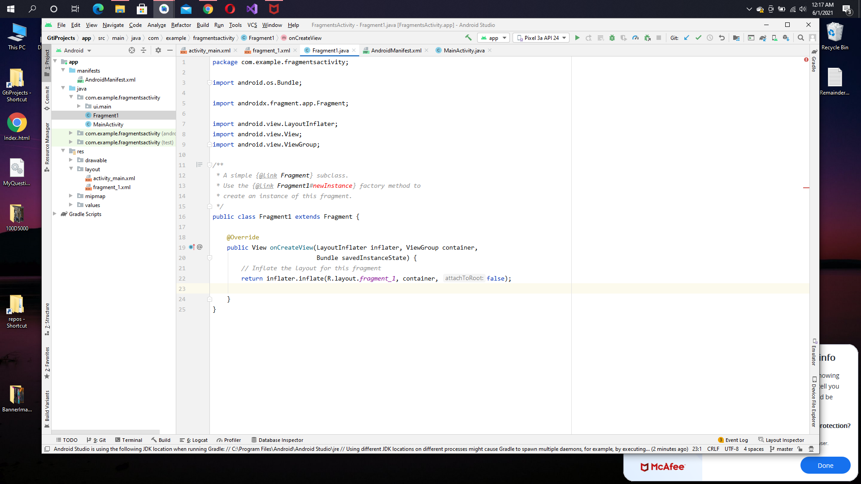**
6. **Add a text view in fragment_1.xaml and fragment_2.xaml  
   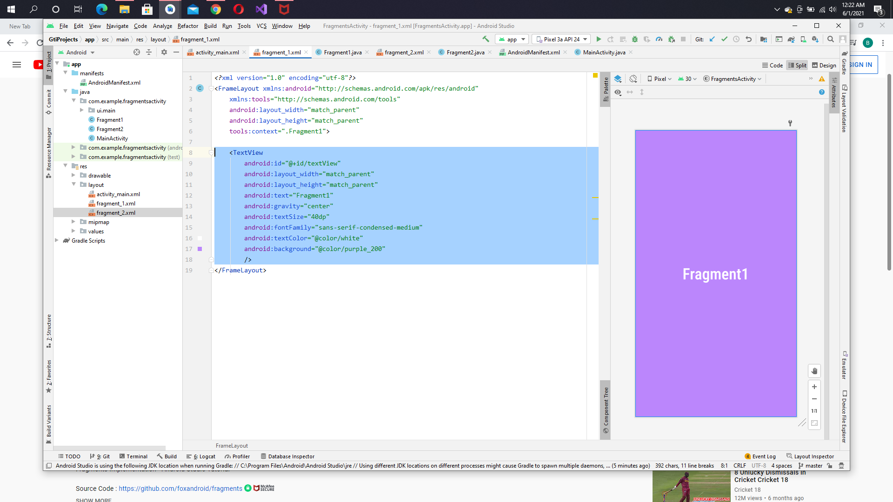**
7. **Now add some code in Fragment1.java and also in fragmewnt2.java  
   Override the method, onCreateView and inflate the view (fragment_1 and fragment_2.xaml) we’ve just created above like this.  
   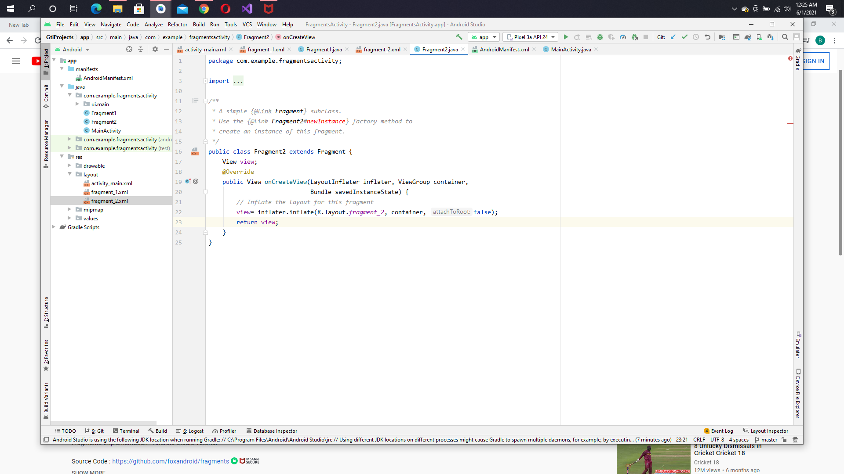**
8. **Now get the button elements which will be used to navigate through the fragments in the MainActivity.java   
   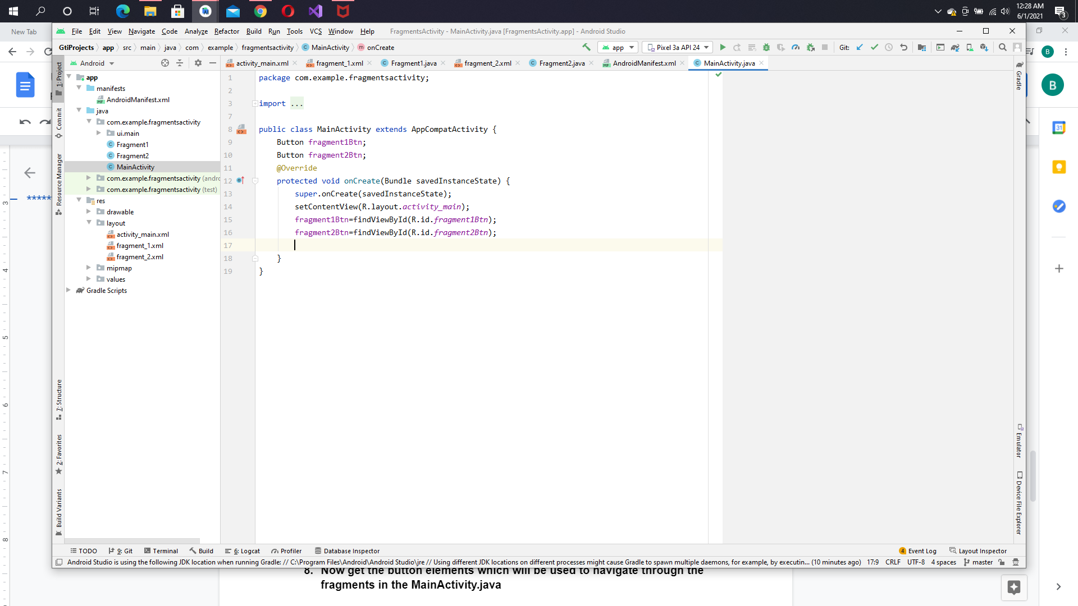**
9. **Now we have to change/replace the frame layout of out activity_main with the fragment in responses of click events so we’ll add onclick methods for buttons like this.,  
   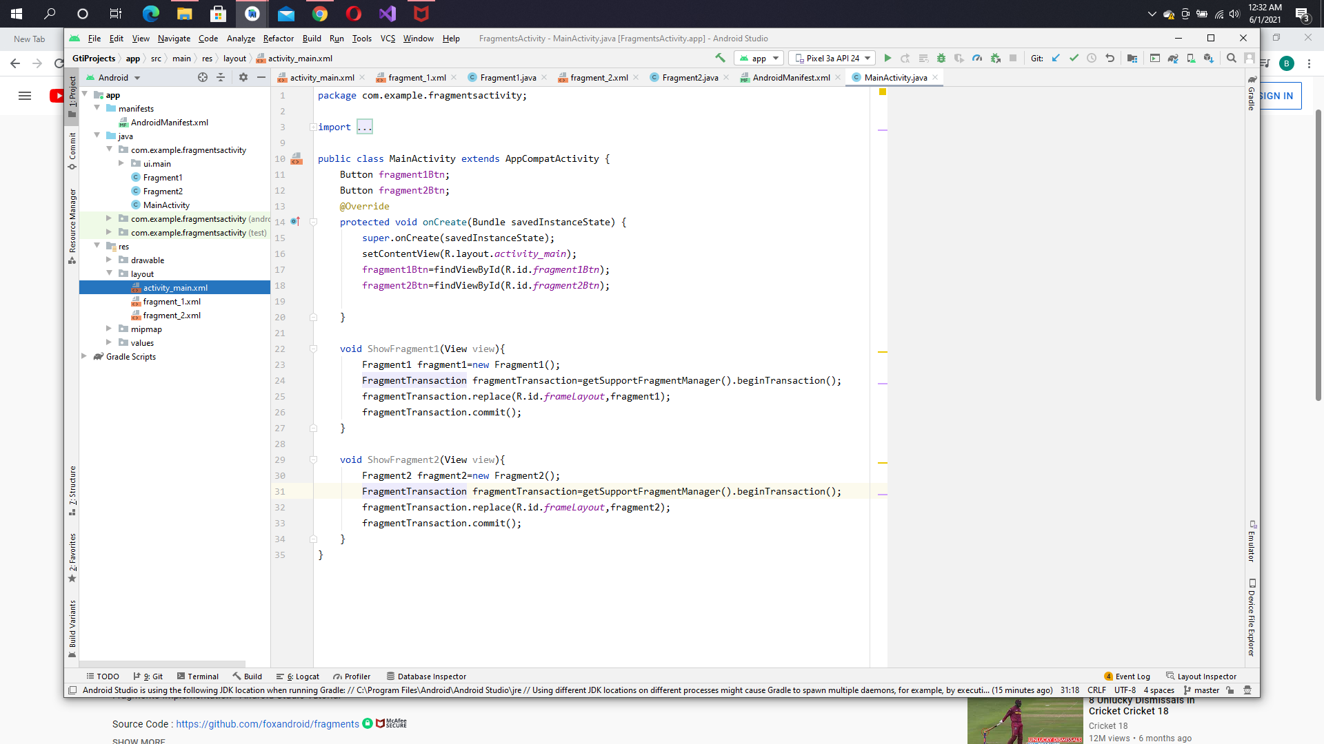**
10. **Now, we are all set, we just have to add these methods on OnCLick attribute of our buttons ,  
    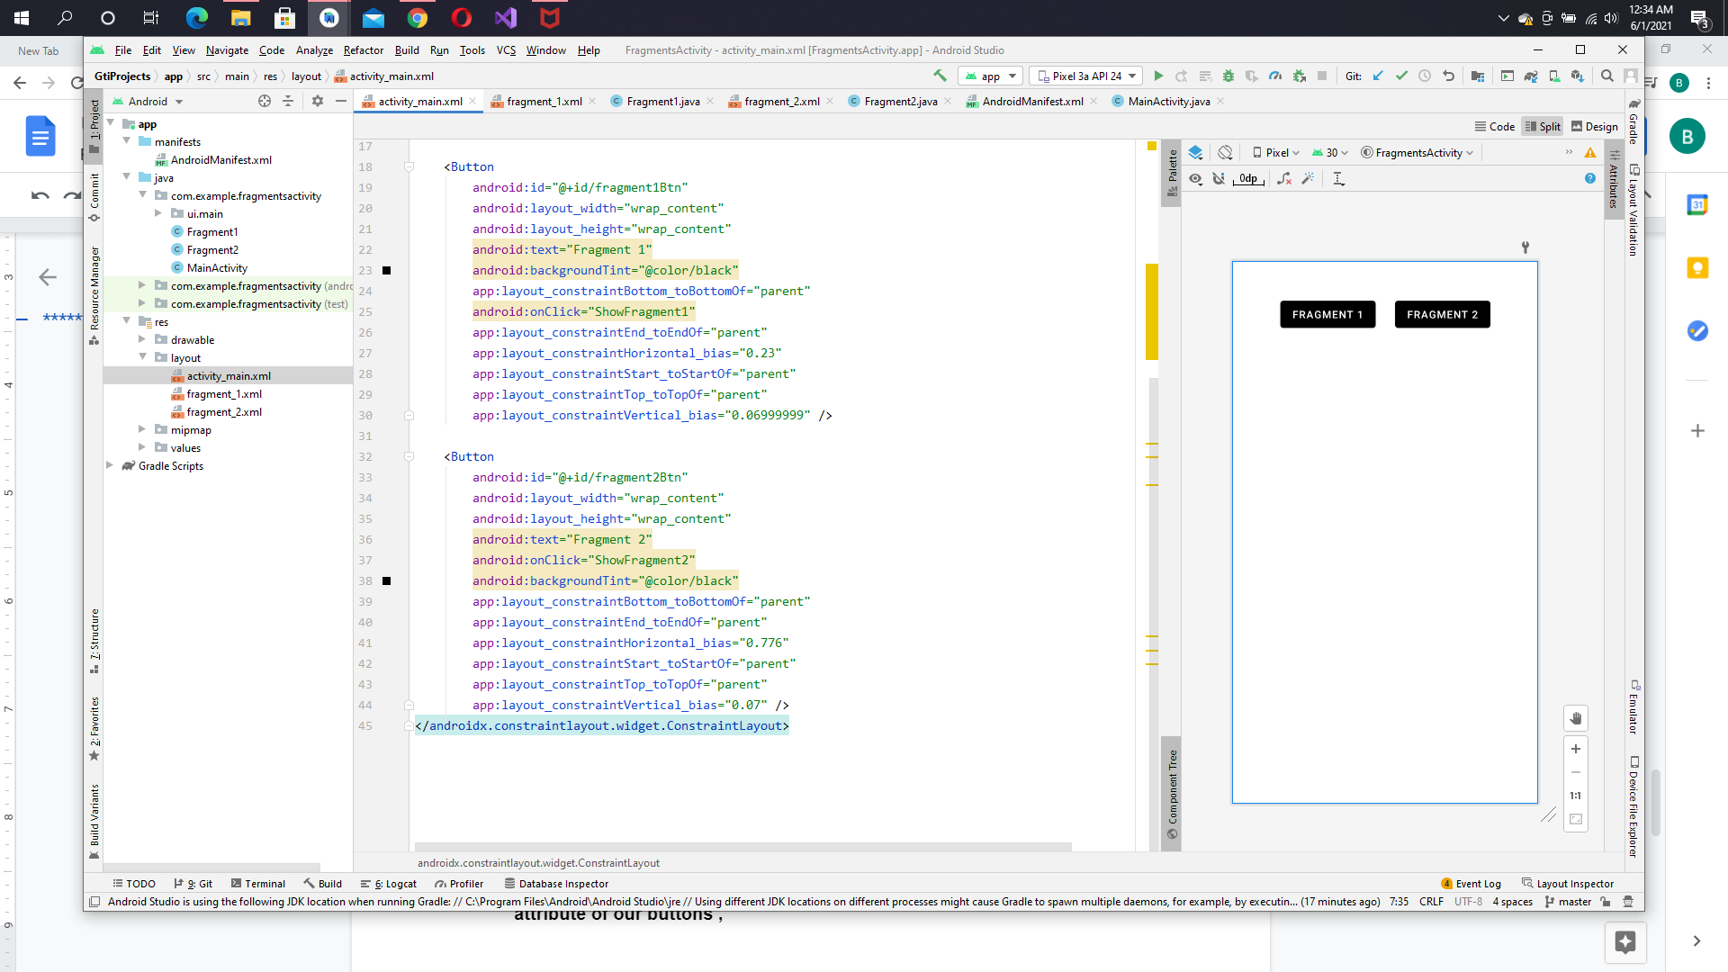**
11. **Now we’ll run our app to see the results.**
12. **Now, add two button to navigate into the fragments. Add button in activity_main.xaml  
    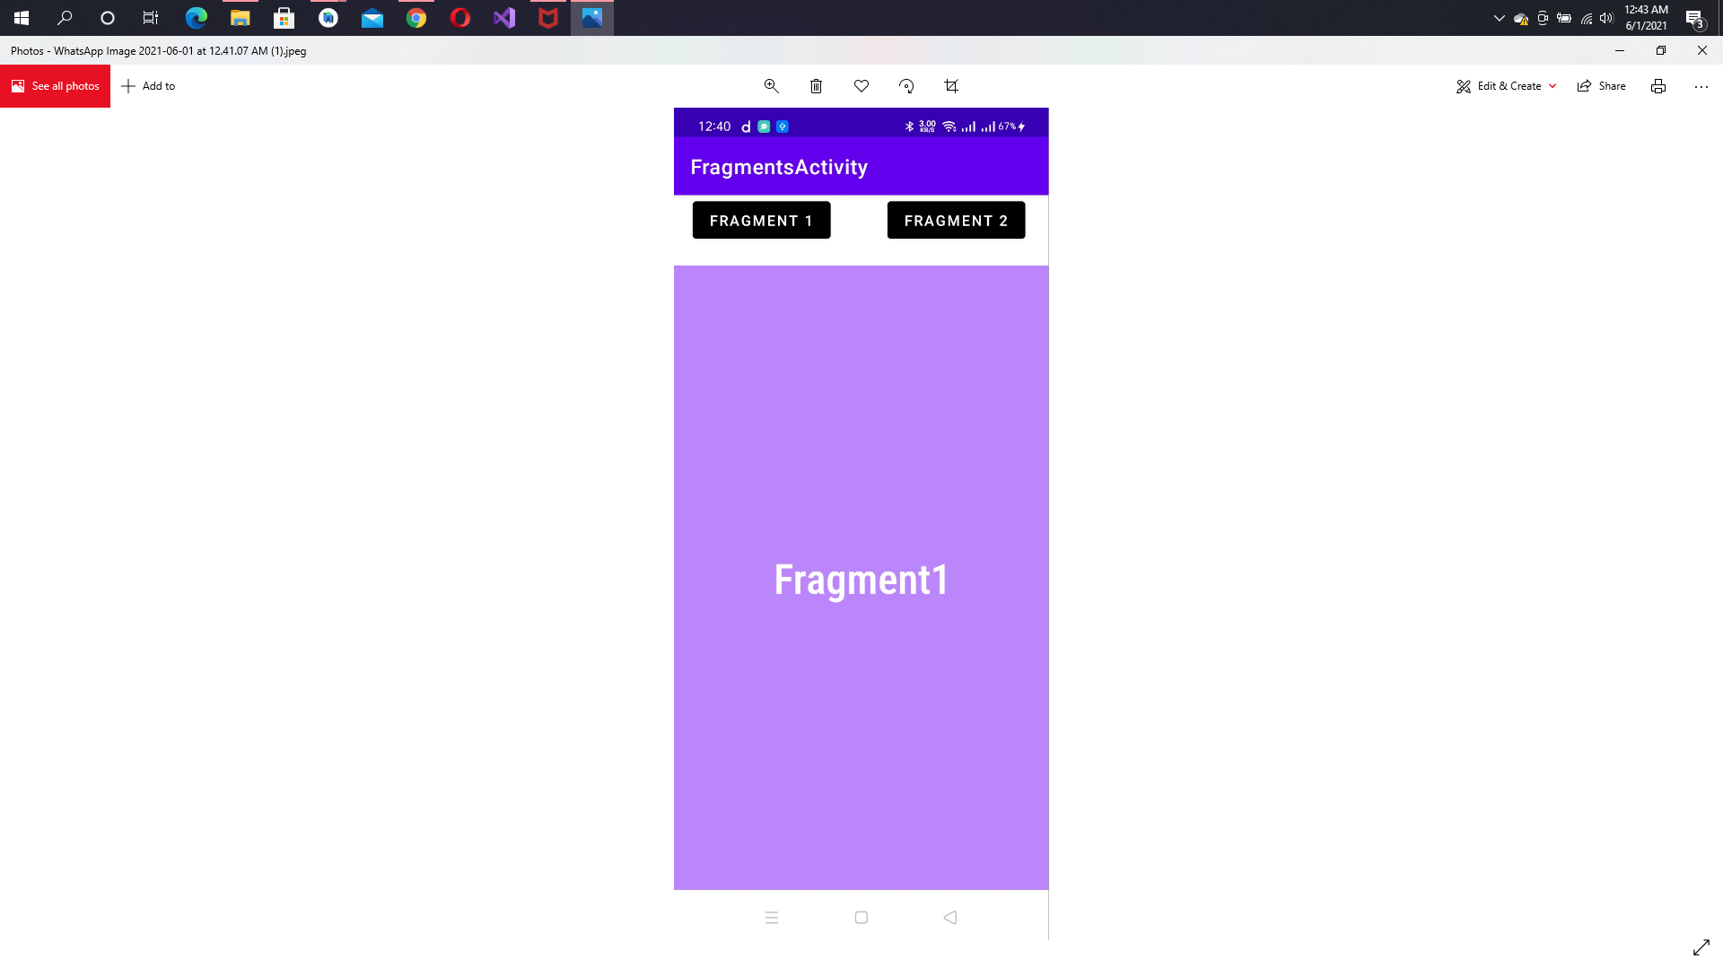**

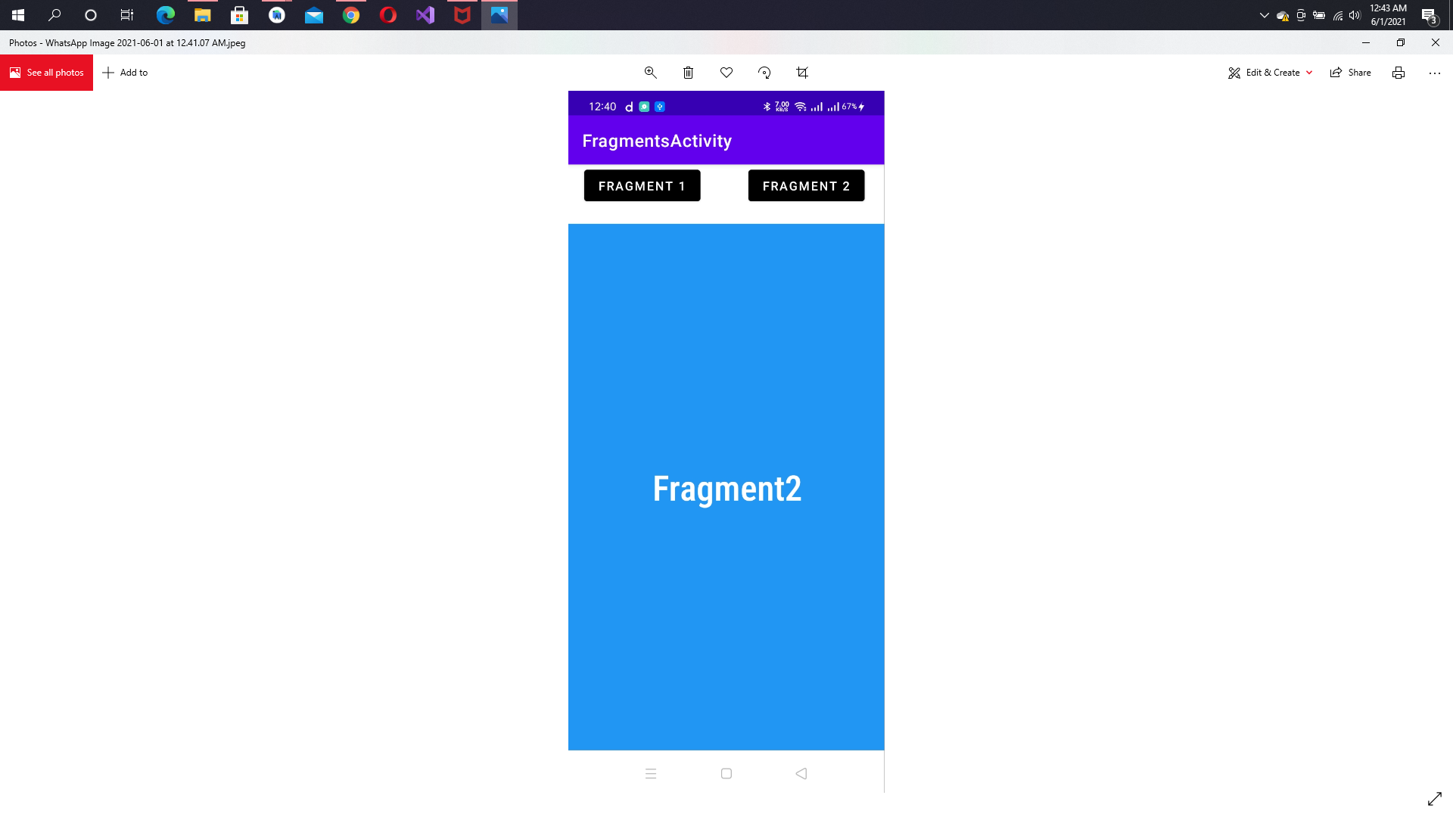

**\*\*\*\*\*\*\*\*\*\*\*\*\*\*\*\*\*\*\*\*\*\*\*\*\*\*END\*\*\*\*\*\*\*\*\*\*\*\*\*\*\*\*\*\*\*\*\*\*\***