**\*\*\*\*\*\*\*\*\*\*\*\*\*\*\*\*\*\*\*\*\*\*\*\*\*\*\*\*\*\*\*\*\*\*\*WEEK_7\*\*\*\*\*\*\*\*\*\*\*\*\*\*\*\*\*\*\*\*\*\*\*\*\*\*\*\*\*\*\*\*\*\***

**Topics:**

1. **Dialog Box**

**What is a Dialog Box?**

A dialog is a small window which prompts the user to take a decision or to enter some additional information.  
Sometimes in your application, if you wanted to ask the user about taking a decision between yes or no in response to any particular action taken by the user, by remaining in the same activity and without changing the screen, you can use *Alert Dialog*.

Dialog class is base class of dialogs but we should avoid instantiating it directly, rather we should always initiate its derived classes named as

1. Alert Dialog
2. Date Picker Dialog /time Picker Dialog

**Alert Dialog:**

It is a dialog with a list of selectable items, upto three buttons, and a title or a custom layout etc.

**Date/Time Picker Dialog:**

A dialog with a pre-defined UI which enables the user to select a particular date/time.

Now we’ll implement above dialogs in android studio.

1. First create a new project with empty activity.
2. Add a button in to show a dialog box in activity_main.xaml.
3. Write the code for dialog.

**Single_Item_Dialog:**

***MainActivity.java:***

|  |
| --- |
| **package com.umairmaik.alertdialogs;  import androidx.appcompat.app.AlertDialog; import androidx.appcompat.app.AppCompatActivity;  import android.content.DialogInterface; import android.os.Bundle; import android.view.LayoutInflater; import android.view.View; import android.widget.Toast;  import java.util.ArrayList;  public class MainActivity extends AppCompatActivity {   @Override  protected void onCreate(Bundle savedInstanceState) {  super.onCreate(savedInstanceState);  setContentView(R.layout.activity_main);   }   public void ShowDialog(View view) {  String[] COLORS = {"Red", "Green", "Blue", "Yellow"};  AlertDialog.Builder builder = new AlertDialog.Builder(this);  builder.setTitle("Choose a color");  int checkedItem = -1, selectedItem = -1;  builder.setSingleChoiceItems(COLORS, checkedItem, new DialogInterface.OnClickListener() {  @Override  public void onClick(DialogInterface dialog, int which) {  Toast.makeText(MainActivity.this, COLORS[which], Toast.LENGTH_SHORT).show();  }  }).setPositiveButton("OK", new DialogInterface.OnClickListener() {  @Override  public void onClick(DialogInterface dialog, int which) {  Toast.makeText(MainActivity.this, "Thank You", Toast.LENGTH_SHORT).show();  }  }).setNegativeButton("Cancel", new DialogInterface.OnClickListener() {  @Override  public void onClick(DialogInterface dialog, int which) {  Toast.makeText(MainActivity.this, "Negative Button Selected", Toast.LENGTH_SHORT).show();  }  }).setCancelable(false);  AlertDialog alertDialog = builder.create();  alertDialog.show();  } }** |

Output:

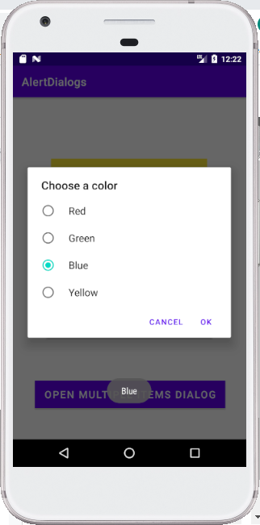

**Multiple_Item_Dialog:**

***MainActivity.java:***

|  |
| --- |
| package com.umairmaik.alertdialogs;  import androidx.appcompat.app.AlertDialog; import androidx.appcompat.app.AppCompatActivity;  import android.content.DialogInterface; import android.os.Bundle; import android.view.LayoutInflater; import android.view.View; import android.widget.Toast;  import java.util.ArrayList;  public class MainActivity extends AppCompatActivity {   @Override  protected void onCreate(Bundle savedInstanceState) {  super.onCreate(savedInstanceState);  setContentView(R.layout.activity_main);   }    public void ShowMultipleItemsDialog(View view) {  String[] COLORS = {"Red", "Green", "Blue", "Yellow"};  ArrayList<Integer> selectedItemsIndex = new ArrayList<Integer>();   AlertDialog.Builder builder = new AlertDialog.Builder(this);  builder.setTitle("Choose a color").setMultiChoiceItems(COLORS, null, new DialogInterface.OnMultiChoiceClickListener() {  @Override  public void onClick(DialogInterface dialog, int which, boolean isChecked) {  if (isChecked)  selectedItemsIndex.add(which);  else if (selectedItemsIndex.contains(which))  selectedItemsIndex.remove(which);  }  }).setPositiveButton("OK", new DialogInterface.OnClickListener() {  @Override  public void onClick(DialogInterface dialog, int which) {  if(selectedItemsIndex.size()==0) {  Toast.makeText(MainActivity.this, "No Items selected", Toast.LENGTH_SHORT).show();  return;  }  String itemsList="";  for(int i=0;i<selectedItemsIndex.size();i++){  itemsList+=i+1+"."+COLORS[selectedItemsIndex.get(i)]+"\n";  }  Toast.makeText(MainActivity.this, "Total "+selectedItemsIndex.size()+" Items selected.\n "+itemsList, Toast.LENGTH_SHORT).show();  }  }).setNegativeButton("Cancel", new DialogInterface.OnClickListener() {  @Override  public void onClick(DialogInterface dialog, int which) {  Toast.makeText(MainActivity.this, "Dialog Box cancelled", Toast.LENGTH_SHORT).show();  }  }).setCancelable(false);  AlertDialog alertDialog = builder.create();  alertDialog.show();  }  } |

Output:

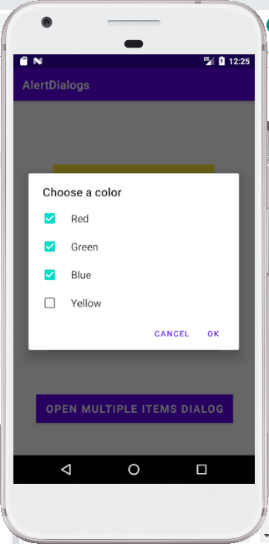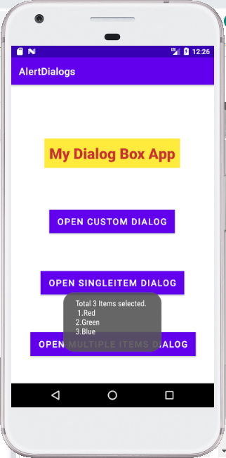

**Custom_Item_Dialog:**

***MainActivity.java:***

|  |
| --- |
| ***package com.umairmaik.alertdialogs;  import androidx.appcompat.app.AlertDialog; import androidx.appcompat.app.AppCompatActivity;  import android.content.DialogInterface; import android.os.Bundle; import android.view.LayoutInflater; import android.view.View; import android.widget.Toast;  import java.util.ArrayList;  public class MainActivity extends AppCompatActivity {   @Override  protected void onCreate(Bundle savedInstanceState) {  super.onCreate(savedInstanceState);  setContentView(R.layout.activity_main);   }    public void ShowCustomDialog(View view) {  String[] COLORS = {"Red", "Green", "Blue", "Yellow"};  AlertDialog.Builder builder = new AlertDialog.Builder(this);  LayoutInflater inflater=this.getLayoutInflater();  builder.setView(inflater.inflate(R.layout.dialog_design,null));  builder.setPositiveButton("OK", new DialogInterface.OnClickListener() {  @Override  public void onClick(DialogInterface dialog, int which) {  Toast.makeText(MainActivity.this, "Thank You", Toast.LENGTH_SHORT).show();  }  }).setNegativeButton("Cancel", new DialogInterface.OnClickListener() {  @Override  public void onClick(DialogInterface dialog, int which) {  Toast.makeText(MainActivity.this, "Negative Button Selected", Toast.LENGTH_SHORT).show();  }  }).setCancelable(false);  AlertDialog alertDialog = builder.create();  alertDialog.show();  }***  ***}*** |

***Dialog_design.xaml***

|  |
| --- |
| ***<?xml version="1.0" encoding="utf-8"?> <androidx.constraintlayout.widget.ConstraintLayout  xmlns:android="http://schemas.android.com/apk/res/android"  xmlns:app="http://schemas.android.com/apk/res-auto"  xmlns:tools="http://schemas.android.com/tools"  android:layout_width="match_parent"  android:layout_height="match_parent">   <LinearLayout  android:layout_width="381dp"  android:layout_height="409dp"  android:layout_margin="10dp"  android:layout_marginLeft="10dp"  android:layout_marginTop="28dp"  android:layout_marginEnd="10dp"  android:orientation="vertical"  android:padding="10dp"  app:layout_constraintEnd_toEndOf="parent"  app:layout_constraintStart_toStartOf="parent"  app:layout_constraintTop_toTopOf="parent">   <TextView  android:id="@+id/textView2"  android:layout_width="match_parent"  android:layout_height="wrap_content"  android:layout_marginBottom="20dp"  android:background="#C3FAB0"  android:text="Add Student Information"  android:textAlignment="center"  android:textColor="#0ED27E"  android:textSize="25dp"  android:textStyle="bold" />   <TextView  android:id="@+id/textView3"  android:layout_width="match_parent"  android:layout_height="wrap_content"  android:layout_margin="10dp"  android:layout_marginTop="10dp"  android:text="Full Name"  android:textSize="20dp" />   <EditText  android:id="@+id/editTextTextPersonName"  android:layout_width="match_parent"  android:layout_height="wrap_content"  android:layout_margin="10dp"  android:ems="10"  android:hint="Enter Full Name"  android:inputType="textPersonName" />   <TextView  android:id="@+id/textView4"  android:layout_width="match_parent"  android:layout_height="wrap_content"  android:layout_margin="10dp"  android:layout_marginTop="10dp"  android:text="Age"  android:textSize="20dp" />   <EditText  android:id="@+id/editTextNumber"  android:layout_width="match_parent"  android:layout_height="wrap_content"  android:layout_margin="10dp"  android:ems="10"  android:hint="Enter Age"  android:inputType="number" />   <TextView  android:id="@+id/textView5"  android:layout_width="match_parent"  android:layout_height="wrap_content"  android:layout_margin="10dp"  android:layout_marginTop="10dp"  android:text="DOB"  android:textSize="20dp" />   <EditText  android:id="@+id/editTextDate2"  android:layout_width="match_parent"  android:layout_height="wrap_content"  android:layout_margin="10dp"  android:ems="10"  android:hint="Enter Date of Birth"  android:inputType="date"  android:textSize="20dp" />   </LinearLayout> </androidx.constraintlayout.widget.ConstraintLayout>*** |

***Output:***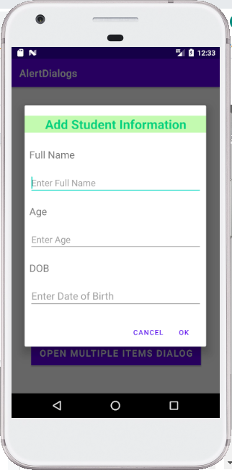

***APP_HOME_PAGE:***

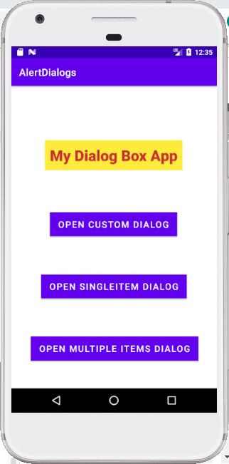

***----------------------------------------------END-----------------------------------------***