WEBSITE DEVELOPMENT SPECIFICATION
Personal Link-in-Bio Website with Booking, Reviews & Admin Portal
Item | Detail
Client | Dn. Bushra Naseem, Clinical Dietitian
Document version | 1.1 (for developer review and quotation)
Date | 29 September 2026
Scope of this document | Full functional specification. This document is a brief for the developer; the website itself is not part of it.
Based on | Client requirements document, Beacons.ai reference page (beacons.ai/nourwellness), and additional recommendations marked as Suggested.

How to read this document
Requirements taken from the client are written as "must" statements. Items labelled "Suggested" are practical additions recommended by the document author; the client should confirm them before development starts. Section 11 lists all suggestions with priorities.

1. Project Overview
The client is a clinical dietitian who wants a standalone personal website that works like a Beacons.ai "link-in-bio" page. Followers arriving from Instagram, Facebook or TikTok should land on a clean, mobile-first page, see who she is, and book a consultation in as few taps as possible. Beyond the reference, the site needs an admin portal so the owner can manage her profile, appointments, and the reviews and success stories submitted by clients.

Primary goal
Convert social media followers into booked consultation sessions.

Key capabilities
- Public homepage: editable profile photo, name, experience, tagline, social icons, Book a Session button, link buttons, featured success stories, footer.
- Booking: visitors choose WhatsApp or Email; the admin gets a private calendar to create and manage appointments and send an appointment card.
- Reviews and success stories: visitors submit (with optional photos); the admin approves, rejects, features on the homepage, or deletes.
- Admin portal: secure login, profile editing, booking calendar, moderation, homepage curation, link management.

2. Client & Brand Details
Field | Value
Full name | Dn. Bushra Naseem
Professional title | Clinical Dietitian
Experience | 6 years of clinical dietetics experience
Brand / page name | Dn. Bushra Naseem
Tagline | Achieve Your Wellness Goals
Short bio | Helping people to achieve their wellness goals
Contact email | naseembushra383@gmail.com
Contact phone | +92 320 8728620
Theme colour | Light green (see Section 3)
Consultation areas | Weight management, diabetic diet plans, uric acid, hypo/hypertension, sports nutrition, PCOS diet plans
Audience (assumed) | Pakistan-based social media followers, mostly on mobile phones. Client testimonials are often in Roman Urdu, so the site must handle mixed English/Urdu text correctly.

3. Reference & Design Direction
Reference: https://beacons.ai/nourwellness (a dietitian link-in-bio page). Replicate the structure and feel, not the content. The Nour Wellness logo, text, photos and testimonial images must not be reused.

What to take from the reference
- Single centred column, mobile-first, with a circular profile image at the top.
- Name, credential and tagline stacked directly beneath the image.
- A row of round brand-icon links to social accounts.
- Large pill-shaped buttons, with the main call to action most prominent.
- Soft light-green gradient background and rounded cards for testimonials.

Visual style (light green theme, final shades to follow the client's logo)
Element | Suggestion
Colours (client choice: light green theme) | Primary light green #A8D8B0 for buttons and icons; very light mint gradient background (#F3FAF3 to #E4F3E6); deep green #2F6B45 for headings and button text so contrast stays readable; white cards. Exact shades to be matched to the client's logo and approved by her.
Typography | Elegant serif for the name and headings, clean sans-serif for body text. Must render Urdu script and Roman Urdu cleanly.
Shape language | Fully rounded (pill) buttons, 16-24 px card radius, soft shadows
Layout on desktop | Same centred column (max width about 520 px) on a soft background, so it looks intentional and not stretched
Design order | Design at 390 px width first, then scale up. Minimum supported width 320 px.

4. User Roles
Role | Access | Description
Visitor | Public, no login | Views the homepage, taps Book a Session, contacts via WhatsApp or Email, reads approved reviews and stories, submits a review or story.
Admin | Login required | Dn. Bushra Naseem. Full control: profile, links, calendar and appointments, moderation, homepage curation, settings.
Assistant (Suggested, later) | Login required | Optional restricted role (for example a receptionist) who can manage bookings but not settings or deletion.

5. Homepage Specification
The homepage is one mobile-first scrolling page. Sections appear in the order below.
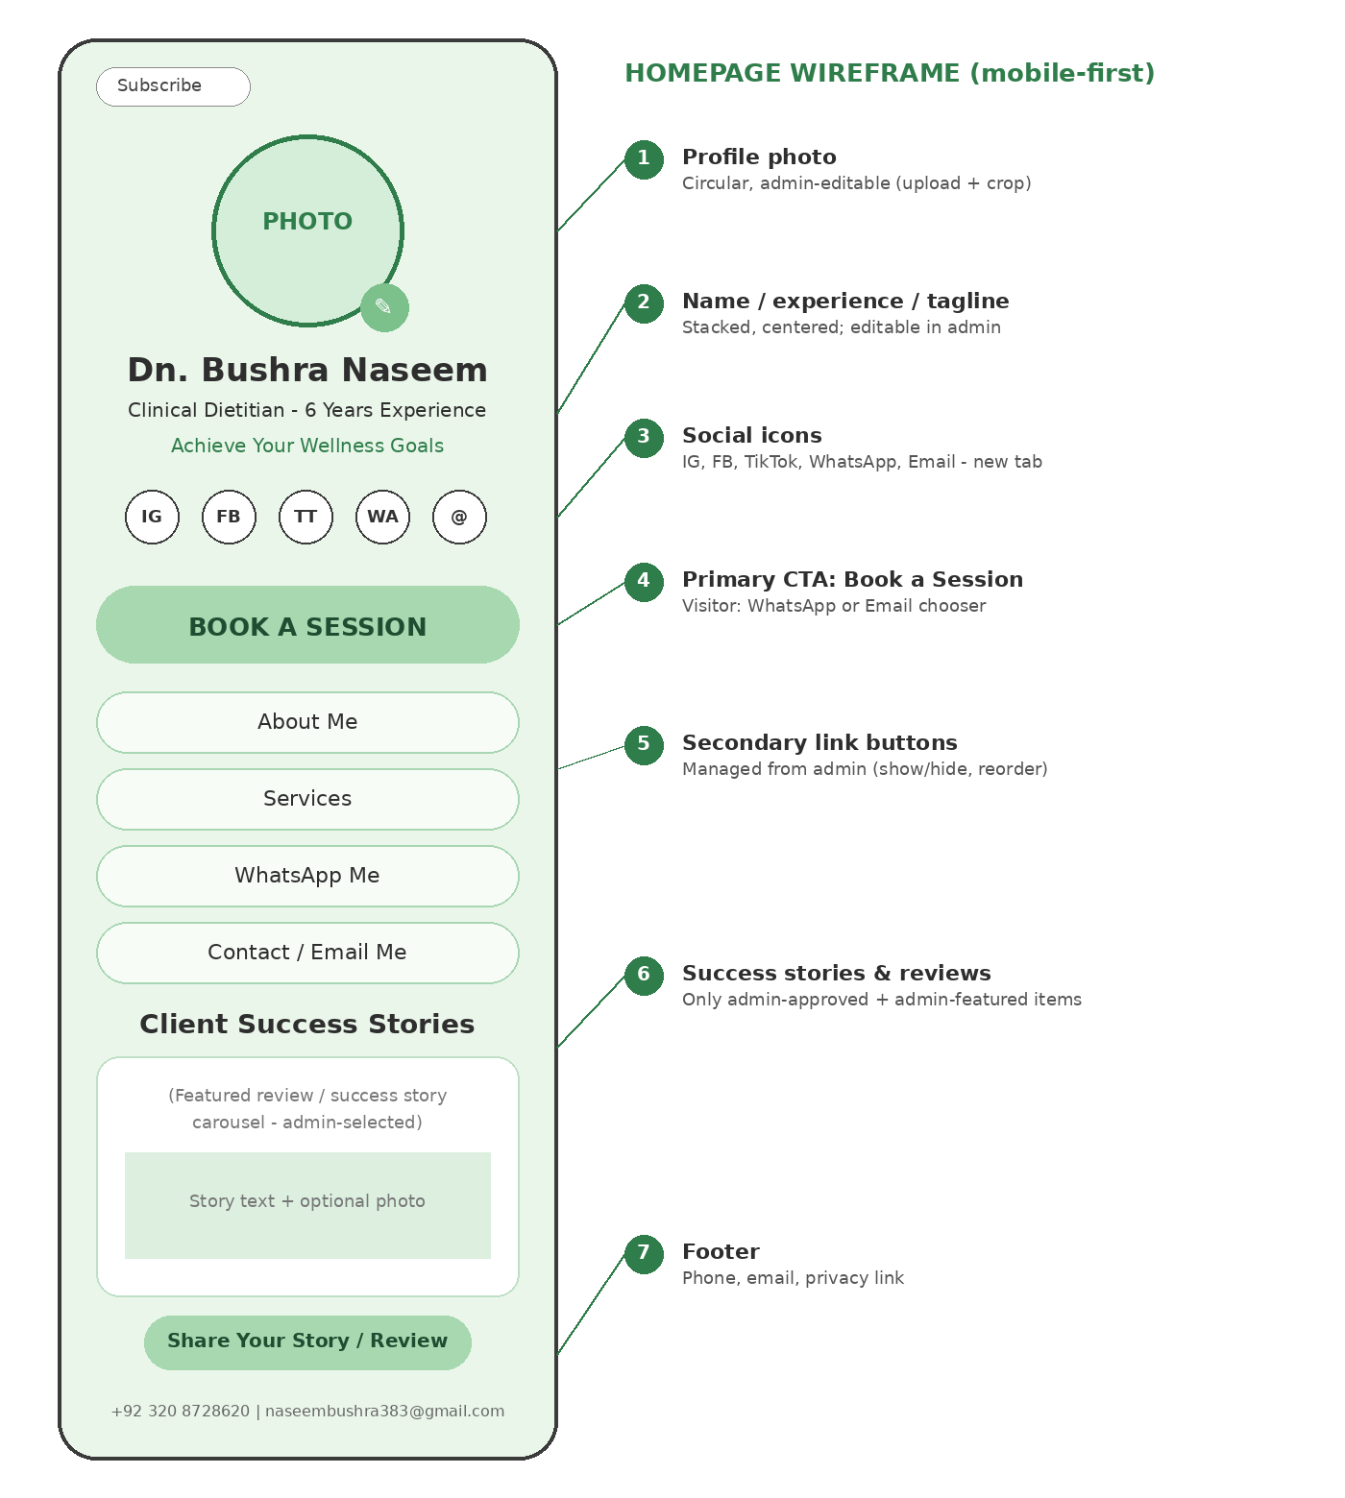
# | Section | Specification
1 | Profile photo | Circular, centred at top. Admin can upload, crop and replace it from the portal (see 9.2). Shows a neutral placeholder until a photo is uploaded. Serve responsive sizes and include alt text.
2 | Name, experience, tagline | Stacked and centred, in this order: name ("Dn. Bushra Naseem"), experience line ("Clinical Dietitian - 6 Years of Experience"), tagline ("Achieve Your Wellness Goals"). All three editable from the portal.
3 | Social icons | Round brand icons for Instagram, Facebook, TikTok, WhatsApp and Email, each linking to the owner's link in Section 6. Opens in a new tab. Icons visible and tappable on all devices (minimum 44 px touch target).
4 | Book a Session | Large, high-contrast primary button above all other buttons. Behaviour depends on who is viewing (Section 7).
5 | Link buttons | About Me, Services, WhatsApp Me, Client Testimonials, Contact / Email Me (Section 10). Admin can show, hide, rename and reorder them.
6 | Client Success Stories | Carousel or stacked cards showing only stories and reviews that are approved and selected for the homepage by the admin. Includes a "Share your story / review" button and a "View all" link to the full testimonials page.
7 | Footer | Contact details (phone, email, clinic address if applicable), privacy policy link, copyright. Contact details editable from the portal.

6. Social Media & Contact Links
The links below come from the client and must be used exactly as given, including their parameters. Each opens in a new tab (target="_blank" with rel="noopener noreferrer") and uses the platform's recognisable brand icon. On phones, these links should open the native app when it is installed.
Platform | URL to use
Instagram | https://www.instagram.com/dn.bushra?stkn=d2FjdnBwbnZvN3Ni
Facebook | https://www.facebook.com/share/1EJUQhMRuR/
TikTok | https://www.tiktok.com/@bushranaseem383?_r=1&_t=ZS-9A52n9lIouz
WhatsApp | https://wa.me/message/SAOMQFECCL7ZC1
Email | mailto:naseembushra383@gmail.com (used for the Email icon, the footer and admin notifications)
Phone | +92 320 8728620 (footer and appointment card; tap-to-call on mobile)

Note for the client to confirm
In the original requirements document the WhatsApp entry was hyperlinked to the TikTok address by mistake. The visible text (wa.me/message/SAOMQFECCL7ZC1) has been used here. Please also confirm whether +92 320 8728620 is her WhatsApp number (see 7.1).
All links must be stored in the admin portal (Links & Buttons) so the owner can change them later without a developer. Seed the database with the values above.

7. Book a Session
The Book a Session button behaves differently for visitors and for the logged-in admin. The same button and the same page URL are used; the behaviour depends on whether an admin session exists.

7.1 Visitor flow
- Visitor taps Book a Session. A bottom sheet (mobile) or modal (desktop) asks: "How would you like to book?"
- Option A - WhatsApp: opens the client's WhatsApp chat link in a new tab. The visitor books the appointment in the chat.
- Option B - Email: opens an on-site enquiry form (name, phone, preferred date and time, health concern or service, message). On submit, the backend emails the admin at naseembushra383@gmail.com and stores the request in the portal under Booking Requests. The visitor sees a confirmation message.
- The visitor never sees the admin calendar or any slot availability.
Suggested: use a form that sends the email from the server, with a plain "mailto:" link only as a fallback. Many mobile users have no mail app configured, so a bare mailto: link loses enquiries.
Technical note on WhatsApp
The wa.me/message/... link is a WhatsApp Business short link and cannot carry a pre-filled message. If the client wants a pre-filled greeting such as "Hi, I would like to book a session", the developer can use https://wa.me/923208728620?text=... instead, provided +92 320 8728620 is the WhatsApp number. Decision required from the client.

7.2 Admin flow
When the admin is logged in, Book a Session (and the "Bookings" item in the portal menu) opens the booking calendar.
Feature | Requirement
Calendar views | Month, week, day and list views. Time zone fixed to Pakistan Standard Time (Asia/Karachi). Works on mobile.
Create appointment | Click a date/time slot or press "New appointment" to open the form below.
Edit / reschedule / cancel | Drag to reschedule (with confirmation), edit details, cancel with optional reason.
Double-booking | Warn when a new appointment overlaps an existing one; the admin may override.
Availability (Suggested) | Working hours, days off, blocked dates and buffer time between sessions, configurable in Settings.
Booking requests inbox | Email enquiries from visitors appear here. One click "Convert to appointment" pre-fills the form.

Appointment form fields
Field | Type | Notes
Client name | Text, required
Client phone / WhatsApp | Phone, required | Used to send the appointment card
Client email | Email, optional
Date | Date picker, required
Start time and duration | Time + choice, required | Default durations 30 / 45 / 60 min, configurable
Meeting source | Dropdown, required | Microsoft Teams, WhatsApp (call or video), Zoom, Google Meet (Suggested), Voice call, Office / clinic visit, Other (free text)
Meeting link / location | Text | Shown for online sessions (link) or office visits (address). Can be defaulted per meeting source in Settings.
Service / concern | Dropdown, optional | Weight management, Diabetes, PCOS, Uric acid, Hypo/Hypertension, Sports nutrition, Other
Session type (Suggested) | Choice | First consultation / Follow-up
Internal notes | Long text | Visible to admin only
Status | Choice | Scheduled, Confirmed, Completed, Cancelled, No-show

7.3 Appointment card
After saving, the admin can generate an appointment card to give to the client. The card is a clean, branded image or PDF (portrait, phone-friendly) containing:
- Logo/brand name and the dietitian's name
- Client name
- Date and time (with time zone) and duration
- Session method (Teams, WhatsApp, Zoom, Office, Voice call, and so on)
- Meeting link or clinic address
- Appointment reference number
- Contact number and a short note (for example "Please join 5 minutes early")
Admin actions on the card: Download (PNG/PDF), Send via WhatsApp (opens WhatsApp with a pre-filled message and the card to attach), Send via Email (sent from the server with the card attached), and Suggested: an .ics calendar file so the client can add it to their phone calendar. Rescheduling or cancelling regenerates the card and marks the old one as superseded.

8. Reviews & Success Stories

8.1 Public display
- A dedicated page (for example /stories) with two tabs: Reviews and Success Stories. It is reached from the Client Testimonials button and the "View all" link on the homepage.
- Each card shows: display name, review text, star rating (reviews), date, and optional images. Success stories can also show a result line (for example "4 kg in 3 weeks").
- Images open in a lightbox. The list uses "load more" or pagination.
- Only items with status Approved are ever visible to the public.

8.2 Visitor submission form
Field | Rules
Type | Review or Success story
Name | Required. Visitor chooses how it is shown: full name, first name only, or "Anonymous"
Private contact (phone or email) | Required, never shown publicly. Lets the admin verify the client.
Star rating | 1 to 5 (reviews)
Story / review text | Required, 30 to 1000 characters, Urdu and English allowed
Result summary | Optional (success stories), for example "Lost 4 kg in 3 weeks"
Photos | Optional, up to 3 images. JPG, PNG or WebP, max 5 MB each. Server compresses, resizes, validates the file type and removes EXIF/location data.
Consent | Required checkbox: "I agree that my review and photos may be published on this website." A separate checkbox is required if photos are attached.
Spam protection | CAPTCHA (Cloudflare Turnstile or reCAPTCHA), rate limiting, hidden honeypot field
After submitting, the visitor sees: "Thank you. Your submission will appear on the website after review."

8.3 Status workflow
Status | Meaning | Visible to public
Pending | Newly submitted, awaiting admin decision | No
Approved | Admin approved for publishing | Yes (on the stories page)
Featured | Approved and selected for the homepage | Yes (homepage and stories page)
Rejected | Admin declined (optional reason recorded) | No
Hidden | Previously approved, taken down by admin | No
Deleted | Removed by admin. Soft delete, restorable for 30 days, then purged permanently. | No
The admin can edit the text before approving (fix typos, remove phone numbers or names of other people). The original submission is kept for reference. The admin can also add a story herself, for example from a WhatsApp screenshot a client shared.
The admin is notified of each new submission by email and by an unread badge in the portal (Suggested: WhatsApp notification later).

9. Admin Portal

9.1 Access and security
- Login at a private URL (for example /admin) with email and password. Passwords stored hashed (bcrypt or Argon2). Password reset by email.
- Suggested: two-factor authentication, automatic logout after inactivity, lockout after repeated failed attempts.
- The public site must never expose admin controls to visitors. The admin sees a discreet "Edit" entry point only after logging in.

9.2 Portal modules
Module | What the admin can do
Dashboard | Today's appointments, pending reviews and stories, new booking requests, quick links. Suggested: link click and booking counts.
Profile & branding | Upload, crop and replace the profile photo (JPG, PNG, WebP up to 5 MB, circular crop preview, automatic resizing). Edit name, experience line, tagline, bio and alt text. Preview before saving. Keep the last 5 photos so a previous one can be restored.
Bookings | Calendar, appointment creation and editing, appointment cards, booking requests inbox (Section 7).
Reviews & stories moderation | List with filters (status, type, rating, date) and search. Open an item to preview it exactly as visitors will see it. Actions: Approve, Reject, Edit, Hide, Delete, Restore, Feature on homepage. Bulk approve and reject.
Homepage curation | Choose which approved items appear on the homepage, drag to reorder, toggle on or off. Suggested limit of 6 featured items for fast loading. Live preview.
Links & buttons | Edit social links and link buttons: label, URL, icon, visibility, order.
Services & About | Edit About Me and the Services list shown by those buttons.
Settings | Contact details, notification email, working hours, session durations, meeting defaults, appointment card text, admin account and security.

10. Link Buttons
The primary button is Book a Session (Section 7). The buttons below sit under it. Which ones are shown is decided by the admin. Items marked "to confirm" were listed in the client's document as suggestions.
Button | Behaviour | Content
About Me | Expands in place (accordion) or opens a modal | "I help clients achieve their wellness goals through personalized, practical, and sustainable nutrition plans - making healthy living simple and achievable."
Services | Expands a list | Weight management, diabetic diet plans, uric acid, hypo/hypertension, sports nutrition, PCOS diet plans. Editable, with an optional short description for each.
WhatsApp Me | Opens the WhatsApp chat link in a new tab | Link from Section 6
Client Testimonials | Opens the reviews and success stories page | Section 8
Contact / Email Me | Opens the contact form or email action | Uses the same server-side email form as the booking enquiry

11. Suggested Additions (Practical Recommendations)
These go beyond the client's brief. Priority: Must = strongly recommended for launch; Should = recommended for launch if time allows; Later = future phase.
Suggestion | Why it matters | Priority
Admin-editable links and buttons | The owner can change links, labels and order without paying for developer time. | Must
Consent checkbox and privacy policy page | Reviews and photos are personal data. Consent protects the client and the dietitian. | Must
Health disclaimer near success stories | A short note such as "Results vary from person to person and are not a guarantee" avoids implied medical claims. | Must
Spam and abuse protection | Public forms attract bots. CAPTCHA, rate limiting and manual approval keep the site clean. | Must
Image safety | Strip EXIF/location data, limit file size and type, compress on upload. Protects clients' privacy and keeps pages fast. | Must
New booking and new review notifications | Email to the admin the moment something needs her attention, so leads are not missed. | Must
Automatic daily backups | Database and uploaded images backed up daily, with a tested restore procedure. | Must
Custom domain with HTTPS | A professional address builds trust. Suggested to register a name such as her name .com or .pk. | Must
Confirmation message to visitor | After an email enquiry, an automatic "We received your request" email. | Should
.ics calendar file with appointment card | Lets the client save the appointment to their phone calendar. | Should
SEO and social preview | Page title, description, Open Graph image and structured data so links look good when shared on WhatsApp and Instagram, and the site can be found on Google. | Should
Click and booking analytics | Count taps on each button and icon and Book a Session conversions, to learn what works. Use a privacy-friendly tool or GA4. | Should
Floating WhatsApp button | Always-visible chat shortcut for long pages. | Should
Accessibility basics | Alt text, AA colour contrast, 44 px tap targets, keyboard-friendly forms. | Should
Appointment reminders | Automatic reminder 24 hours and 2 hours before a session by email, and by WhatsApp when practical. | Later
Availability settings and optional self-serve booking | Working hours and blocked dates; a switch to allow visitors to pick free slots later if the client changes her mind. | Later
Google Calendar sync | Two-way sync so personal and work calendars never clash. | Later
Pre-consultation intake form | A secure health questionnaire (goals, conditions, medications) completed before the first session. Needs strict access control. | Later
Payment details and status | Show bank, Easypaisa or JazzCash details on the appointment card and track paid or unpaid. | Later
English / Urdu toggle | Full Urdu interface with right-to-left support. | Later
Lead magnet | A free downloadable sample diet chart in exchange for name and phone number, to grow the enquiry list. | Later
Admin activity log | Record of approvals, edits and deletions for accountability if a second user is added. | Later

12. Suggested Technical Approach
The developer may propose a different stack. The requirements below matter more than the specific tools.
- Front end: a modern framework with server-side rendering or static generation for speed and SEO (for example Next.js or similar).
- Back end and database: a managed backend (for example Supabase or Firebase) or a custom API (Node.js, Django or Laravel) with PostgreSQL or MySQL, providing authentication, database and file storage.
- Email: a transactional email service (for example Resend, SendGrid or SMTP) for notifications and appointment cards.
- Media: object storage with a CDN, and server-side image processing for resizing, compression and EXIF stripping.
- Hosting: a host with automatic HTTPS, deploy previews and daily backups. Monthly cost should be stated in the quotation.
- Not recommended: a page-builder approach that cannot support the custom approval workflow, calendar and admin curation described here.

13. Non-Functional Requirements
Area | Requirement
Performance | Largest Contentful Paint under 2.5 s on a mid-range phone over 4G. Lighthouse mobile performance score of 90 or higher. Images lazy-loaded and served in modern formats.
Responsiveness | Fully usable from 320 px width up to large desktop. Tested on Android Chrome, iOS Safari, desktop Chrome, Edge, Firefox and Safari (latest two versions).
Security | HTTPS everywhere. Protection against XSS, CSRF and SQL injection. Sanitise all visitor-submitted text. Validate uploads server-side. Follow OWASP Top 10 guidance.
Privacy | Collect only what is needed. Private contact details are never shown publicly. Data deleted on request.
Time zone | All dates and times in Asia/Karachi unless otherwise stated.
Accessibility | WCAG 2.1 AA as a target for colour contrast, labels, focus states and alt text.
Availability | Target uptime 99.5% or better. Friendly error and 404 pages.

14. Data Model Overview
A guide only; the developer will finalise the schema.
Entity | Key fields
AdminUser | id, email, password hash, 2FA secret, last login
Profile | name, experience line, tagline, bio, photo URL (current and history), footer contact details
Link | id, type (social or button), label, URL, icon, visible, sort order
Appointment | id, reference, client name, phone, email, start, end, duration, meeting source, link or location, service, session type, notes, status, created and updated
BookingRequest | id, name, phone, preferred date and time, concern, message, status (new, converted, closed), created
Submission (review or story) | id, type, display name and preference, private contact, rating, text, result summary, images, consent flags and timestamp, status, featured flag, featured order, rejection reason, original text, timestamps, deleted-at
Setting | working hours, session durations, notification email, meeting defaults, card text
AuditLog (Suggested) | id, admin, action, target, timestamp

15. Acceptance Criteria
The website is accepted when every item below has been demonstrated to the client.
# | Criterion | Done
1 | Homepage shows profile photo, name, experience and tagline stacked in that order, matching the reference layout. | ☐
2 | Admin can upload, crop and replace the profile photo, and the change is live immediately after saving. | ☐
3 | Instagram, Facebook, TikTok, WhatsApp and Email icons open the exact links in Section 6 in a new tab on mobile and desktop. | ☐
4 | Visitor taps Book a Session and can choose WhatsApp or Email. WhatsApp opens the chat; Email submits a form and the admin receives it. | ☐
5 | When logged in as admin, Book a Session opens the calendar, and visitors can never reach it. | ☐
6 | Admin can create, edit, reschedule and cancel an appointment with name, date, time and meeting source (Teams, WhatsApp, Zoom, Office, Voice call, Other). | ☐
7 | Appointment card is generated with date, time and method, and can be downloaded and sent through WhatsApp and email. | ☐
8 | Visitor can submit a review or success story with up to 3 photos and consent; it does not appear publicly. | ☐
9 | Admin receives a notification, and can approve, reject, edit, hide and delete submissions. | ☐
10 | Admin can select which approved stories appear on the homepage and change their order. | ☐
11 | Only approved items appear on the public site; rejected, hidden and deleted items are never accessible, including by direct URL. | ☐
12 | Admin can edit social links and link buttons without developer help. | ☐
13 | Site meets performance and responsiveness targets in Section 13. | ☐
14 | Automatic backups are running and a restore has been tested. | ☐

16. Information Needed from the Client
Item | Status
Profile photo or logo (high resolution). Theme is light green; exact shades to be matched to the logo | Required before design
Email (naseembushra383@gmail.com) and phone (+92 320 8728620): provided | Received
Confirm +92 320 8728620 is also the WhatsApp number (for pre-filled messages) | Confirm
Clinic address, if office visits are offered | If applicable
Domain name choice (or approval to register one) | Required
Admin login email | Required
Working days and hours, standard session durations | Required for calendar
Default Teams and Zoom meeting links, if any | Optional
Final list of link buttons to show (About Me, Services, WhatsApp Me, Client Testimonials, Contact) | Confirm
Existing reviews and success stories, with the clients' permission to publish | Optional, for launch content
Privacy policy and terms text (or approval for the developer to draft standard text) | Required
Decision on Suggested items in Section 11 | Confirm

17. Delivery Phases & Handover
Phase | Scope
Phase 1 - Launch | Homepage, editable profile, social links, Book a Session (visitor choice and admin calendar), appointment cards, review and story submission, moderation, homepage curation, all "Must" items from Section 11.
Phase 2 - Enhancements | "Should" items: SEO, analytics, floating WhatsApp button, visitor confirmation emails, .ics files, accessibility polish.
Phase 3 - Growth | "Later" items: reminders, calendar sync, intake form, payments, Urdu interface, lead magnet.

Handover checklist
- Source code in a private repository transferred to the client
- Admin and hosting credentials, delivered securely
- Short admin guide (with screenshots) covering profile photo, bookings, moderation and homepage curation
- Deployment notes and backup/restore instructions
- Suggested: 30 days of post-launch bug-fix support included in the quotation

