Change 1: Remove WhatsApp
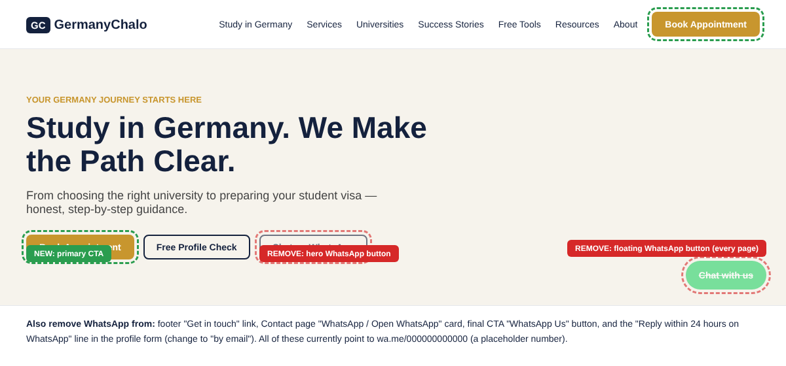
Mockup 1. Header and hero with "Book Appointment" replacing WhatsApp (green = add, red = remove).
- Delete the floating "Chat with us" button on all pages.
- Delete the "Chat on WhatsApp" button in the hero and the "WhatsApp Us" button in the final call to action.
- Delete the WhatsApp card on the Contact page and the WhatsApp link in the footer "Get in touch" list.
- Replace those buttons with "Book Appointment" (primary) and "Free Profile Check" (secondary).
- Change text: "Reply within 24 hours on WhatsApp" becomes "Reply within 24 hours by email".
- Form field: rename "WhatsApp Number" to "Phone number". Keep the field, since you still need a way to call the student.
- Decision for the owner: the footer also links to your WhatsApp Channel (news channel). Keep it only if you want it, because it is a different feature from the chat button.
- Search the whole code for "wa.me", "whatsapp" and "WhatsApp" so none is missed, including metadata and structured data.

5. Change 2: Book Appointment with payment

5.1 The screen
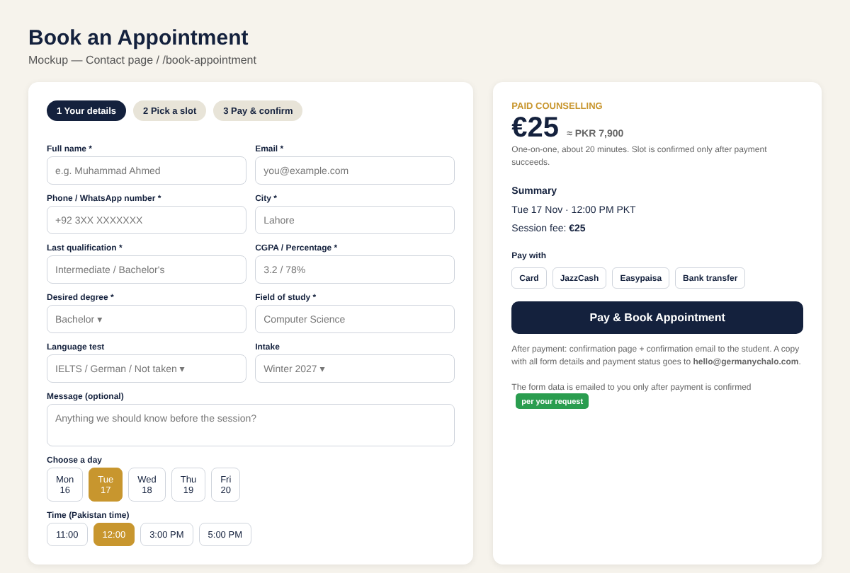
Mockup 2. Booking form with slot picker, price summary and payment button.
Place the form on the Contact page (replacing the current paid counselling box) and also on its own page, /book-appointment, so every "Book Appointment" button can link to it.

5.2 Fields
Field | Required | Notes
Full name | Yes | Text.
Email | Yes | Validate format. The confirmation goes here.
Phone number | Yes | Pakistan format check (+92) but allow other countries.
City | Yes | Text.
Last qualification | Yes | Dropdown: Matric, Intermediate, Bachelor, Master, Other.
CGPA / percentage | Yes | Text.
Desired degree | Yes | Bachelor, Master, PhD.
Field of study | Yes | Text.
Language test | No | Same list as the current form (IELTS, TOEFL, PTE, Duolingo, German, Not taken) plus score.
Intake | No | Winter / Summer and year.
Message | No | Free text, limited length.
Day and time | Yes | Only free slots are shown. Time zone is Pakistan time and must be stated on screen.
Consent checkbox | Yes | Agrees to the privacy policy and the cancellation and refund policy.

5.3 How payment and email work
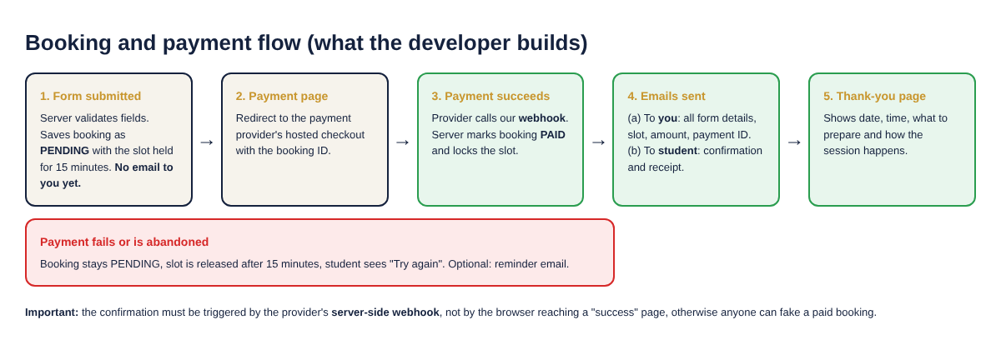
Mockup 3. Order of events. The email to the consultancy is sent only after confirmed payment.
- Save first. When the form is submitted, store it in a database as PENDING and hold the chosen slot for about 15 minutes.
- Send the student to a secure payment page hosted by the payment provider. Do not store or handle card numbers on your own server.
- Confirm by webhook. When the provider's server tells your server that the payment succeeded, mark the booking PAID. Never trust the browser landing on a "success" page by itself.
- Send two emails. (a) To hello@germanychalo.com: every form field, chosen slot, amount, payment reference. (b) To the student: confirmation, receipt and what to prepare.
- If payment fails or is abandoned, release the slot after the hold time and send no email to the consultancy (optional reminder to the student).
- Duplicate safety: the webhook must be safe if it arrives twice (no double emails, no double bookings).
- Admin view: a simple protected page listing bookings with status (pending, paid, cancelled) and the ability to export.

5.4 Payment provider (owner decision, developer to verify)
Please verify current availability before choosing, because this changes often:
- Stripe has historically not onboarded businesses registered in Pakistan directly. Check whether it is possible for your business setup.
- Pakistani gateways (for example Safepay or PayFast) and wallet or bank options (JazzCash, Easypaisa, 1Link) are the usual route. Choose one that supports a hosted checkout and webhooks.
- Charge in PKR through a local gateway. Show the EUR price only as a reference, because the exchange rate moves. Decide whether to fix the PKR amount instead.
- Support more than one method if possible: card plus a wallet. Many students prefer mobile wallets.

5.5 Technical notes for the developer
- The site appears to be built with Next.js. A server route for the booking, a payment webhook route and an email service (for example Resend, SendGrid or SMTP) fit well.
- Add spam protection to the form (for example Cloudflare Turnstile) and rate limiting.
- Send emails from a verified domain (SPF, DKIM, DMARC) so they do not land in spam. See the email domain note in section 2.
- Keep personal data protected: HTTPS only, store only what is needed, and link a privacy policy.
- Policy text to show before payment: rescheduling rule, refund rule, what the session includes. These need to be written by the owner.
- Test with the provider's sandbox for success, failure, cancel, and duplicate webhook before going live.

6. Change 3: Stronger Success Stories
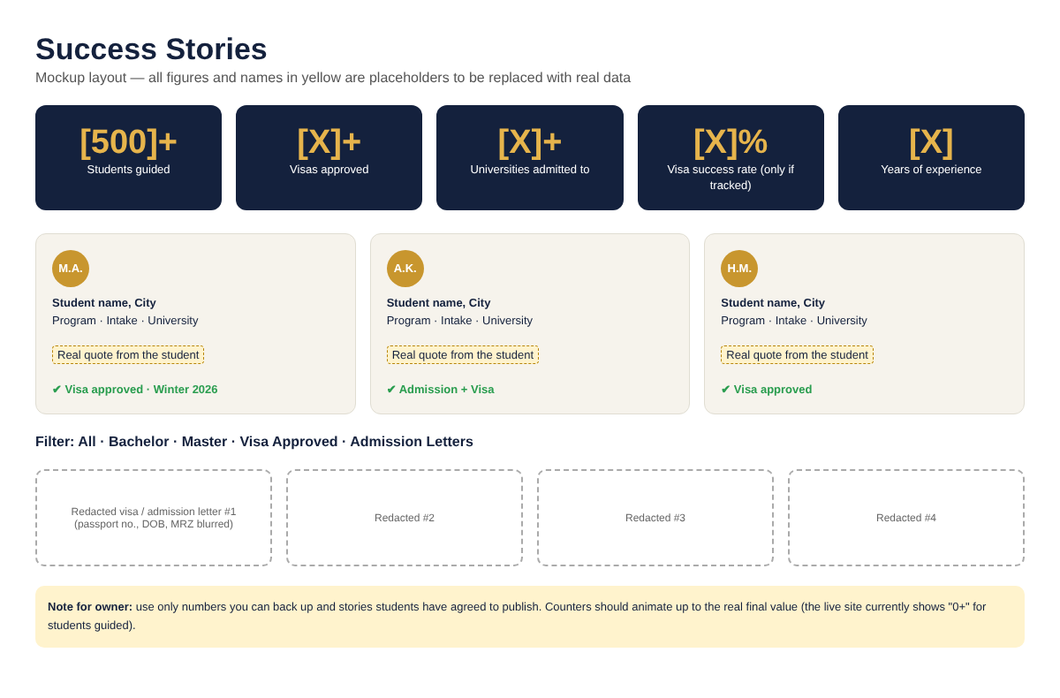
Mockup 4. Statistics band, story cards, filters and redacted proof wall (yellow = real data needed).

6.1 What to add
- Statistics band at the top of Success Stories and on the Home page: students guided, visas approved, universities, years of experience. The "500+" style numbers go here.
- More story cards: student name or initials, city, program, intake, university, a short quote, and an outcome badge (admission, visa approved).
- Filters: Bachelor, Master, Visa Approved, Admission Letters.
- Proof wall: more redacted visa and admission letter images, with passport number, date of birth and the machine-readable lines blurred.
- Video stories: short student clips from your YouTube channel (with permission).
- Link to proof: a Book Appointment button after the stories.

6.2 Rules for the data
This section is the most important one for your reputation, so please read it carefully.
- Use only real numbers. If you have guided 500 or more students, show "500+". If the real number is different, show that one. I have written [1000]+ in the mockup only as a placeholder for you to confirm. I cannot confirm your figures.
- Use only real students who agreed to be shown like 500+.
- Build a simple way to collect them: ask each student after the visa result for a short written quote, a photo (optional) and permission by message or email. Keep that consent.
- Counters: make them count up to the real value and fall back to the full number if JavaScript is slow. Today they can look like "0+".
- Do not promise results. Avoid wording such as "100% visa guarantee".

6.3 Easy way to maintain it
Ask the developer to store stories and statistics in one data file or a small admin screen, so the owner can add a new story or change the totals without editing code.

7. Other suggestions, in priority order
# | Suggestion | Why
1 | Fix the broken contact paths | All WhatsApp links use a placeholder number. After removal, make sure there is still a working email and a phone number.
2 | Show the price and what the session covers | Students book more when they see the fee, duration and a sample agenda before they pay.
3 | Add FAQ and policy pages | Fees, refunds, rescheduling, privacy, and what you can and cannot guarantee.
4 | Add trust details | Advisor name and photo, office address or city, phone, years of experience, registration if you have one.
5 | Free assessment and paid booking: explain the difference | Right now both look like one flow. Say "Free profile check (reply by email)" versus "Paid one-to-one session".
6 | Reduce the navigation | Seven menu items plus a button is a lot on a phone. Consider grouping Tools and Resources.
7 | Check mobile speed | Most Pakistani students will use phones. Test on a mid-range Android phone.
8 | Analytics | Track "Book Appointment" clicks, form starts, payments completed. This tells you where students drop off.

8. Acceptance checklist for the developer
- No occurrence of WhatsApp or wa.me remains in visible text, links or code (except the channel link if the owner keeps it).
- Every "Book Appointment" button opens the booking form.
- A booking cannot be marked paid unless the provider's server confirms it.
- The consultancy email arrives only after confirmed payment and contains all form fields.
- The student receives a confirmation and receipt email.
- Two people cannot book the same slot.
- Failed, cancelled and duplicate payments are handled correctly (tested in sandbox).
- Success Stories shows the statistics band, more stories, filters and proof wall with real data supplied by the owner.
- Everything works on phone screens and in common browsers.

