BuildScan3D
Metric 3D Gaussian Splatting of built rooms from a commodity phone video
FYP Mid-Evaluation: progress summary | October 2026

1. Goal
Turn a normal phone video of a built room into an accurate, true-to-scale 3D model (3D Gaussian Splatting) that a site supervisor can view and measure. It uses a commodity Android phone (realme), with no LiDAR and no special hardware.

2. Initial plan: trust ARCore
- Capture app (ARCore on Android). Records video plus ARCore camera poses, IMU (gyroscope and accelerometer), feature points and depth.
- Processing pipeline:
  - use ARCore poses as the camera positions;
  - refine them with our own GPU bundle adjustment;
  - estimate dense depth (our stereo matcher, filled in with Metric3D single-image depth);
  - train 3DGS with a custom trainer, plus Nerfstudio splatfacto as a baseline.
- Why this plan: ARCore gives real-world scale and gravity directly, and papers like PocketGS build on phone-tracker poses.

3. What we built along the way
- Live capture-quality checks in the app: warnings for blur, fast motion, darkness and plain surfaces, a vibration alert, and a live overlay showing unmapped areas.
- Featureless-tracking fallback (our novelty): when ARCore loses tracking on plain walls, the gap is bridged with the phone's IMU; when the camera returns to a familiar area, the segment is re-aligned to the map.
  - Simulated 9 s gap: 3.8 cm error vs 30.6 cm for simple interpolation.
  - Re-alignment cut the error of post-gap frames from 49.7 px to 8.2 px.
- PocketGS-style improvements: keyframe selection, a multi-view-consistent geometry prior, flat surface-aligned starting splats and short training.

4. The problem
Even after all of that, the models were blurry and "cotton-like": objects shifted position as the view rotated, and splats floated in mid-air.
We tried many fixes (better depth from COLMAP dense stereo, depth supervision, floater pruning, median filtering). None of them solved it; the best model reached only about 22.7 dB on held-out frames.

5. Key finding: ARCore poses are not good enough for 3DGS
A diagnostic showed the models could not even reproduce their own training images (22–24 dB, misaligned by 7–30 px). The causes:
- Silent ARCore re-anchor. About 60 s into the recording, ARCore corrected its world map without any tracking loss. Every earlier pose was off by ~1 m and 28°, so part of the room existed twice in the model: the cause of the moving objects and floaters.
- No lens distortion in ARCore's calibration. The real distortion (k1 ≈ 0.09, k2 ≈ −0.22) is several pixels, which blurs every view.
- 8% of frames were never properly aligned, and training ran at half resolution.
Takeaway: ARCore is an excellent live AR tracker, but not an offline 3D-scanning system. On commodity Android it needs image-based refinement. This is a measured, evidence-backed finding for the thesis.

6. The changed plan: image-based poses, ARCore for scale
- COLMAP structure-from-motion estimates camera poses and the lens from the images themselves; images are then undistorted.
- ARCore provides what it is good at: real-world scale and gravity (alignment error ~3 cm), plus live guidance during capture.
- Training: full-resolution splatfacto with per-image colour correction for the phone's auto-exposure.

Results (held-out frames never used in training)
 | Before | After (v3)
Training-view fit | 21.9 dB, 12–30 px misaligned | ~28 dB, 2–3 px
Held-out SSIM | 0.78 | 0.86 (second room: 0.91)
Badly placed surfaces | 7–23% | 3% (second room: 1%)

The ghosts and floating splats are gone, and views from the room centre (where no camera stood) are coherent.
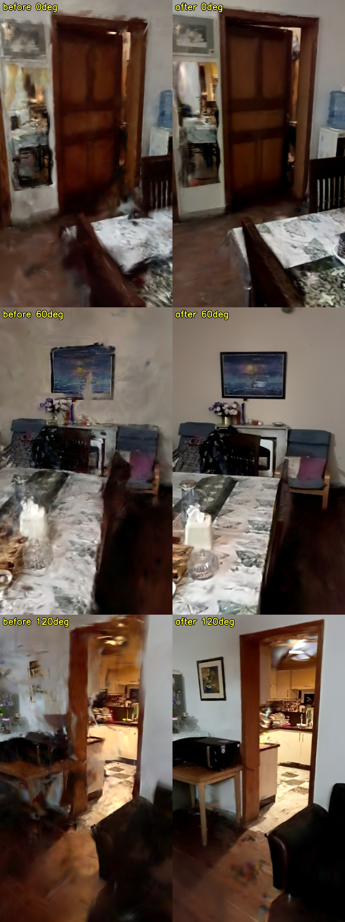
View from the room centre: old ARCore-pose pipeline (left) vs image-based pipeline (right).

7. Metric accuracy (tape measure)
Object | Model | Tape | Error
Table (short side) | 0.458 m | 0.459 m | −1 mm (0.22%)
Table (long side) | 1.748 m | 1.750 m | −2 mm (0.11%)
Wall | 2.792 m | 2.800 m | −8 mm (0.29%)
Room length | 6.692 m | 6.700 m | −8 mm (0.12%)

- Rigid objects: mean error 4.8 mm (0.19%).
- Room scale: ≤ 8 mm over 6.7 m, from a casual video with no LiDAR.
- The error does not grow with distance, so the scale is accurate; the small remaining offset is mostly from where we click in the viewer.

8. Further improvement: motion blur (current best, v6)
- Finding: the gyroscope shows the median training frame is blurred by 6–12 px from turning the phone while walking.
- Fix 1: select the stillest frame in every 0.2 s using the gyroscope (2× more frames, less blur).
- Fix 2: start training from COLMAP's dense point cloud instead of sparse points.

Model (42 frames not used for training) | PSNR (dB) | SSIM
v3 (image-based poses) | 26.04 | 0.8756
+ gyro-selected sharp frames | 26.30 | 0.8849
+ dense MVS initialisation | 26.51 | 0.8879
v6 (+ finer densification), current best | 26.52 | 0.8886
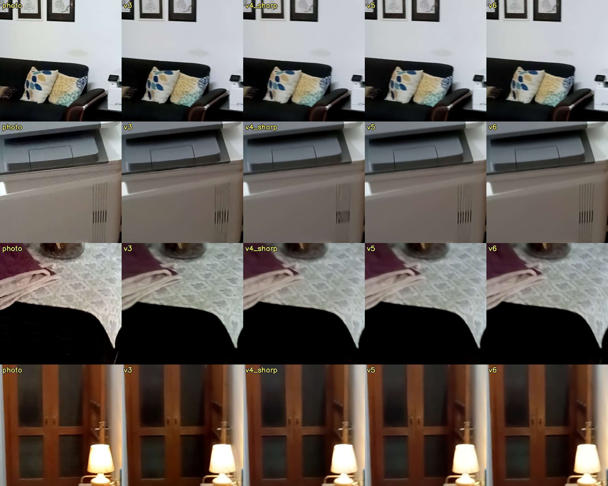
Full-resolution crops: photo | v3 | sharp frames | v5 | v6.

9. Explored and parked
- Forcing walls and floor flat after training: rejected. It destroyed the glossy floor's reflections and crushed door frames.
- Structural layer (kept for measurement): automatic wall planes, corners and wall lengths (6.65–6.68 × 4.45–4.48 m), and 5 doors detected automatically. This is the basis for automatic floor plans.

10. App updated for the next recordings
- Per-frame exposure time and rolling-shutter readout, needed for blur modelling.
- ARCore anchor logging, which makes silent re-anchors like the 1 m / 28° event directly detectable.
- The phone's factory lens calibration, for comparison with COLMAP's self-calibration.

11. Next plan
- Make v6 the one-command pipeline and validate it on the second room; speed up matching by using ARCore poses to choose which frames to compare (target under 30 min per room, from ~75).
- IMU-driven motion-blur and rolling-shutter modelling in training. The biggest remaining quality gain and a strong novelty: ARCore/IMU data improving image quality, not just scale.
- ARCore-started image-only alignment with re-anchor detection. Could give COLMAP-quality poses much faster: a methods contribution.
- Structural layer and floor plan: wall-to-wall dimensions, doors and openings, measure clicks that snap to walls.
- Web workspace (Three.js) with 1:1 measurement for the final demo, plus more tape-measure evidence across rooms.

Contributions so far
- Measured evidence of why commodity ARCore poses fail for 3DGS (silent re-anchor, missing lens model) and a working fix.
- A featureless-tracking IMU fallback, validated on simulated gaps.
- Live capture-quality guidance and a coverage overlay in the app.
- Gyro-aware frame selection that measurably improves quality.
- Millimetre-level metric accuracy from a phone video, without LiDAR.

