|  |
| --- |
| C:\xampp\htdocs\ficse_conference\assets\img\ficselogo.jpg  **FUSST International Conference on Computer Science and Engineering**  **FICSE**  Research Article |
| **Article Citation:**  Author1\_lastName et al. (2024). “ A Short, Easy-to-Comprehend Title Representing Your Research Idea”. *FUSST International Conference on Computer Science and Engineering* |
| copyRight  This work is licensed under a Creative Commons Attribution 4.0 International License, which permits unrestricted use, distribution, and reproduction in any medium, provided the original work is properly cited. |
| **Copyright**  Copyright © 2024 Author1\_lastName et al.    Published by  Foundation University Islamabad.  Web: <https://fui.edu.pk/> |

**A Short, Easy-to-Comprehend Title Representing Your Research Idea**

**First Author** a, b, **\***  **Second Author** c, a

a Department of Software Engineering, Foundation University, Islamabad, Rawalpindi, Pakistan.

(author@fui.edu.pk).

b Department of Computer Science, International Islamic University, Islamabad, Pakistan

(author@iiu.edu.pk).

c Department of Artificial Intelligence, University of Jeddah, Jeddah, Saudi Arabia.

(author@uoj.edu.sa).

\* **Corresponding author**: author@uni.edu.pk

**Abstract:**

An abstract is a summary. In academic articles, the abstract is a one-paragraph synopsis of the content of the article that follows it. While it does appear first, it is meant to stand apart from the article as a whole and to enable researchers to quickly decide whether the article discusses an applicable problem, subject, and/or methodology. It provides a brief glimpse of the topics covered, the research methods used, and the general findings discovered. The abstract is useful for helping you decide, relatively quickly, whether or not the article overlaps with your research question(s). This short paragraph is sometimes followed by a list of author-supplied keywords that if used as search terms. It is better to specify minimum and relevant keywords separated by a semicolon. The use of well-known keywords helps in a quick search of the article.

Keywords: HEI Rankings; Subject Specific Academic Rankings; Sub-Discipline Rankings.

# Introduction

This section is the beginning of the article, but don’t expect it to contain any sort of position or argument. In academic articles, this section has one, principal purpose: to demonstrate that the authors are familiar with all previous relevant research on the issue they are writing about. Therefore, this section is usually the most “citation-heavy” section of the paper. It is not uncommon to have one or more citations at the end of each sentence. This review of prior studies is a very important exercise because it demonstrates the depth of their understanding. None of the articles you read occur in a vacuum; they are usually part of an evolving web of scholarship. Each new article picks up the thread (or, usually, several threads) left by articles published recently.

It is recommended to include the following elements in the Introduction:

1. A brief history of your research domain
2. Summary of the work done by earlier researchers
3. The research gap and its importance
4. Brief description of the proposed solution
5. Some experts suggest adding an example of the proposed solution   
    to attract more readers.
6. Listing of the research contribution
7. Mention the organization of the subsequent sections in the article

## Research Objectives

Research objectives describe what your research is trying to achieve and explain why you are pursuing it. They summarize the approach and purpose of your project and help to focus your research. Your objectives should appear in the introduction of your research paper, at the end of your problem statement. They should:

* Establish the scope and depth of your project
* Contribute to your research design
* Indicate how your project will contribute to existing knowledge.

### Research Objective 1

Specify the most important objective of your research effort [12].

### Research Objective 2

Specify the second objective of your research effort [19].

### Research Objective 3

Specify the other objectives of your research effort. If you are specifying a mathematical model, then provide the mathematical model (equation) in the following format:

|  |  |  |
| --- | --- | --- |
|  | **Resank** = ${\left(x+a\right)}^{n}=\sum_{k=0}^{n}{\left({n \atop k}\right)x^{k}a^{n-k}}$ | (3) |

## Research Contributions

The contribution of the research is making the world a better place by solving a problem. Research is usually conducted on a problem to solve it. A research contribution is made when a manuscript adds, embellishes, or creates something beyond what is already known”. Such findings, therefore, present something that the researchers did not know so far; that is what makes the research article interesting. The contributions of a study can be conceptual/theoretical, empirical, or methodological in nature.

**Conceptual contributions could involve such things as:**

1. Improved conceptual definitions of the original constructs.
2. The identification and conceptual definition of additional constructs to be added to the conceptual framework (e.g., additional dependent, independent, mediating, and/or moderator variables).
3. The development of additional theoretical linkages (i.e., research hypotheses) with their accompanying rationale.
4. The development of an improved theoretical rationale for existing linkages.

**Empirical contributions would include such things as:**

1. Testing a theoretical linkage between two constructs that have not previously been tested.
2. Examining the effects of a potential moderator variable on the nature of the relationship between two constructs.
3. Determining the degree to which a variable mediates the relationship between two constructs.
4. Investigating the psychometric properties of an important scale.

# Related Work

Keeping in mind the research objectives – fine-grained analysis of the academic rankings and sub-discipline-specific academic rankings, we focused on two types of existing research efforts. First, that was aimed at the fine-grain analysis of the academic ranking dimensions or parameter(s). Second, the research efforts focus the sub-discipline-specific academic rankings based on publicly verifiable data sources. Table 1 shows the different sub-disciplines. A summary of the review is following.

Table 1: Use a short but comprehensive title at the top of each table

|  |  |  |
| --- | --- | --- |
| **Field (Sub-Discipline)** | **Researchers' Count** | |
| When the author’s second field is NOT restricted | When the author’s second field is restricted to the 8 sub-disciplines |
| Artificial Intelligence & Image Processing | 215114 | 1939 |
| Computation Theory & Mathematics | 16572 | 240 |
| Computer Hardware & Architecture | 17080 | 163 |
| Networking & Telecommunications | 161179 | 1262 |
| Software Engineering | 21211 | 329 |
| **Total** | **470,403** | **4,272** |

# The Research Problem

The statement of the problem is one of the first things that a colleague or potential client will read. With the vastness of the information available at one’s fingertips in the online9 world, your work may have just a few seconds to draw in a reader to take a deeper look at your proposal before moving on to the next option. It explains quickly to the reader, the problem at hand, the need for research, and how you intend to do it. A strong, clear description of the problem that drew you to your research has to be straightforward, easy to read, and, most important, relevant. Why do you care about this problem? How can solving this problem impact the world? The problem statement is your opportunity to explain why you care and what you propose to do in the way of researching the problem.

A problem statement is an explanation in research that describes the issue that needs study. What problem is the research attempting to address? Having a Problem Statement allows the reader to quickly understand the purpose and intent of the research. The importance of writing your research proposal cannot be stressed enough. Check for more information on Writing a Scientific Research Project Proposal.

It is expected to be brief and concise, and should not include the findings of the research or detailed data. The average length of a research statement is generally about one page. It is going to define the problem, which can be thought of as a gap in the information base. There may be several solutions to this gap or lack of information, but that is not the concern of the problem statement. Its purpose is to summarize the current information and where a lack of knowledge may be presenting a problem that needs to be investigated.

# Proposed Solution

Your proposed solution should relate the current situation to a desired result and describe the benefits that will accrue when the desired result is achieved. So, begin your proposed solution by briefly describing this desired result. Your proposed solution section should offer your solution specifically, with enough detail so that your reader understands exactly what you’re proposing. Indicate how your proposed solution will solve the problem and provide tangible benefits. Identifying possible solutions is part of logical problem-solving\* and, as such, is an important strategy in proposal writing. To identify possible solutions for your proposal, you may find the following process helpful:

* Brainstorm all possible solutions to the problem.  Let your imagination range freely.
* Hone your results to a few feasible possibilities.
* List out the pros and cons of the feasible possibilities.
* From the pros and cons, develop a list of criteria common to the feasible possibilities – and your proposed solution as well – so that you can compare solutions using those common criteria.
* Write about possible solutions, analyzing them according to your common criteria.

# Experiments

The Results (or Findings) section follows the Methods and precedes the Discussion section. This is where the authors provide the data collected during their study. That data can sometimes be difficult to understand because it is often quite technical. Do not let this intimidate you; you will discover the significance of the results next. [18].

The Discussion section follows the Results and precedes the Conclusions and Recommendations section. It is here that the authors indicate the significance of their results. They answer the question, “Why did we get the results we did?” This section provides logical explanations for the results of the study. Those explanations are often reached by comparing and contrasting the results to prior studies’ findings, so citations to the studies discussed in the Literature Review generally reappear here. This section also usually discusses the limitations of the study and speculates on what the results say about the problem(s) identified in the research question(s). This section is very important because it is finally moving toward an argument. Since the researchers interpret their results according to theoretical underpinnings in this section, there is more room for differences of opinion. The way the authors interpret their results may be quite different from the way you would interpret them or the way another researcher would interpret them.

# Results and Discussion

Restate briefly the work carried out, the aims and hypotheses, or research questions. Highlight the most important findings. State what you consider to be the achievements and limitations of your work. Assess how far the aims of your research have been satisfied. Here you can include a personal assessment of what you have learned (if you are asked to provide it).

# Conclusions and Future Direction

The Conclusion and the Future Direction section allows you to highlight the most important points in your manuscript and is sometimes the only section read. Think about what your research/ study has achieved, and the most important findings and ideas you want the reader to know. As all studies have limitations also think about what you were not able to cover (this shows that you can evaluate your work objectively). how your work reported in this paper opens new research possibilities. Give specific suggestions for real-world actions to be taken based on the research. Figure 1 shows a sample graph.

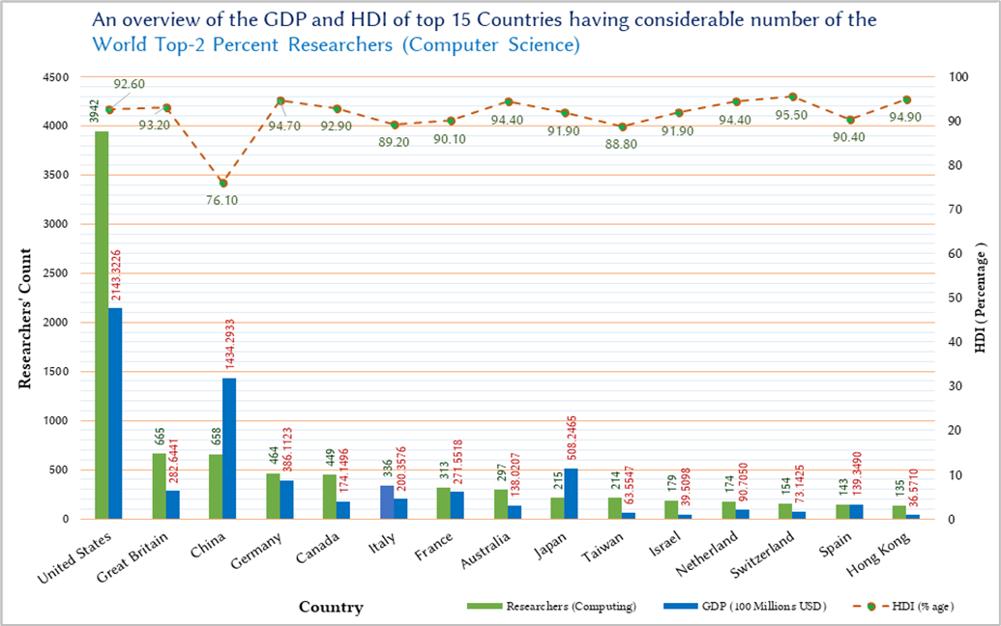

Figure 1: Adding graph labels, legends, and data labels increases the effectiveness of a graph

Under the future direction section, place the study in a wider context of research in the discipline and/ or a situation in the real world. Here you can suggest

**Acknowledgment**

We are thankful to the research reviewers who helped in writing and improving these guidelines.

**Conflict of Interests**

Publication of this research article has no conflict of interest.

**Funding Statement**

This research article is not a product of a funded research project.

# References

|  |  |
| --- | --- |
| [1] | Q. S. Writer, "QS World University Rankings Methodology," 11 Sep 2015. [Online]. Available: http://www.topuniversities.com/university-rankings-articles/world-university-rankings/qs-world-university-rankings-methodology?page=1. [Accessed 25 Mar 2016]. |
| [2] | T. O. Writer, "THE Ranking Methodology 2016," 2016. [Online]. Available: https://www.timeshighereducation.com/news/ranking-methodology-2016. [Accessed 10 Aug 2016]. |
| [3] | S. Jamil, The challenge of establishing world-class universities., WashingtonDC: TheWorldBank. ,ISBN978-0-8213-7865-6., 2009. |
| [4] | S. Hussain, Z. Wang and C.A. Sun, "A comparative study of open-source learning management systems," In *Proceedings of 2011 IEEE International Workshop on Open-source Software for Scientific Computation*, IEEE, 2011, pp. 86–93). |

# Appendix

Using the appendix section is highly recommended to provide summary tables, detailed results, and other related documents.

* Summary tables
* Detailed results
* Related documents