**Management Companies – changes to be made:**

***Need to add a “Add Management” above the Inactive Button that is located under the Management List.***

We would like to change the flow of the information on this page. Please see our mock up below, on how we would like the layout of the information.

1. “Management Company” to be the only words bolded
2. A bigger space in between Management Company and all information to follow
3. Line 2- Address
4. Line 3- City and State
5. Line 4- Zip Code and Country
6. Line 5- Phone # and Fax #
7. Alternate # and E-Mail
8. Line 7- Active and Inactive with check boxes
9. Everything else to remain the same

Please see layout below:

|  |  |
| --- | --- |
| **Management Company:** | |
| Address: | |
| City: | State: |
| Zip: | Country: |
| Phone #: | Fax #: |
| Alternate #: | E-Mail: |
| Active      □                                              Inactive       □ | |

**Property Screen – changes to be made:**

We would like to change the flow of the information on the page. Please see our mock up below. We would like the information to be in this layout.

Where the Property Name and information will be in a box on the left side. And the Management name and information will be in a box on the right side.

We would like to move the Alternative notes box underneath the property & management boxes. Followed by the Alternative Billing information box. At the bottom we would like 2 boxes sided by side, Alternative Billing Requirements and checklist in the left box, and the Contract information and checklist in the right box.

***I would also like to bring the Property Name, Address & Management Company box moved underneath the property list scroll down.***

***Need to add a “Search Property” Bar above the “Property List”.***

***Need to add a “Add Property” button above the Show Inactive Button that is located under the Property List.***

***Need to add a “Delete Property” button below the Show Inactive Button that is located under the Property List***

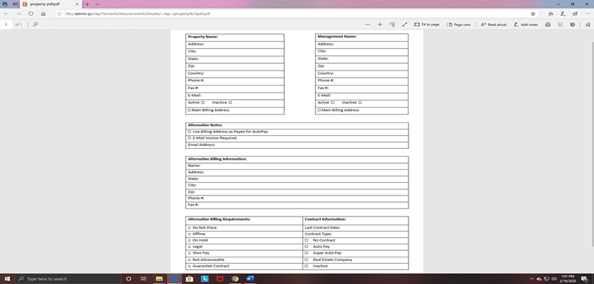

**Forms Page – Changes to be made:**

We would like to remove ADMIN at the top.

Also everything after the View Forms List we would like to remove all information after view forms list.

**Search Invoices Page – changes to be made:**

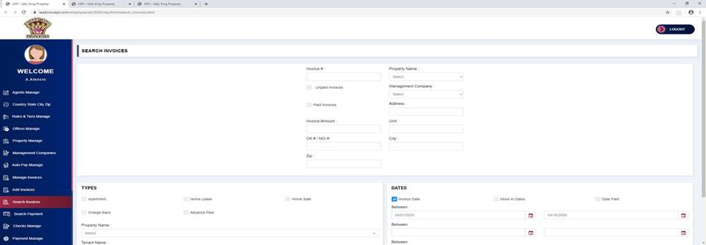

In the first box can you please move the Zip Code Box and move underneath the City: Box

Underneath the Types and Dates boxes - We need to add a box for search criteria

Please see Example below:

|  |
| --- |
| **SEARCH CRITERIA**  **□ Auto Pay       □ No Contract        □ Do Not Place       □ Not Advanceable        □ Slow Pay** |

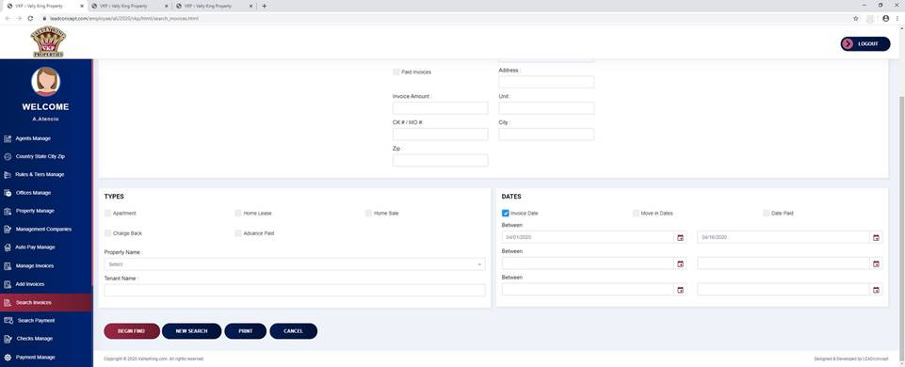

1. Where the dates are if we could list the dates with the calendar’s underneath.

Please see Example below:

□ Invoice Date

**Between**

|  |
| --- |
|  |

|  |
| --- |
|  |

           □ (Calendar)            □ (Calendar)

□ Move in Date

**Between**

|  |
| --- |
|  |

|  |
| --- |
|  |

           □ (Calendar)            □ (Calendar)

□ Date paid

**Between**

|  |
| --- |
|  |

|  |
| --- |
|  |

           □ (Calendar)            □ (Calendar)